

**Blessed be the Holy Trinity**

**and the undivided Unity.**

**Let us give glory to Him because**

**He has shown His mercy to us.**

|  |  |  |
| --- | --- | --- |
|  | Mt. Calvary Ev. Lutheran Church |  |
|  | 908 W. Hanssler Pl., Peoria, Illinois 61604 |  |
|  | Church Office: (309/688-4321) Fax: (309/688-3062) |  |
|  | E-Mail: [MtCalvary@MtCalvaryPeoria.org](mailto:MtCalvary@MtCalvaryPeoria.org) |  |
|  | Web Site: [www.MtCalvaryPeoria.org](http://www.MtCalvaryPeoria.org) |  |
|  | Pastor: The Rev. Barry A. Long (309/243-2042) |  |
|  | Royal Priests: The People of Mt. Calvary |  |
|  | Trinity Sunday |  |
|  | June 15, 2025 |  |

TO OUR VISITORS

It is a special joy to have you worshipping with us today, and we pray that the Holy Spirit would confirm within you, through the Good News of the Gospel, faith in Jesus Christ, God’s Son, as your personal Lord and Savior. If you have no church home of your own, please consider joining us at Mt. Calvary. We would love to have you! As you leave today, please sign our GUEST REGISTER located in the Narthex.

REGISTRATION FOR HOLY COMMUNION

Members of Mt. Calvary and visitors, who are confirmed members in good standing of congregations of the Lutheran Church-Missouri Synod, are asked to announce attendance at Holy Communion by means of the registration cards in the pews. Non-member visitors and guests, who may desire to attend Holy communion, are asked to speak in person with the pastor before doing so. Those who desire a blessing, but choose not to commune, may come forward and simply cross their hands over their chest.

In accord with Holy Scripture, our church teaches that Holy Communion is open only to those who: (1) have been baptized in the name of the Triune God; Matt. 28:19, Acts 2:41-42; (2) are able to examine themselves both as to what this meal is and also its purpose; 1 Cor. 11:26-30; (3) have confessed and repented of their sins; 1 John 1:8-2:3; (4) believe that in, with, and under the bread and wine all communicants receive the true body and blood of our Lord Jesus Christ for the forgiveness of sins: 1 Cor. 11:23-27, 1 Cor. 10:16, Matt. 26:26-28; and who (5) are united in belief in the same teaching: 1 Cor. 10:17, Rom. 16:18, 2 John 10-11, Matt. 28:20, Heb. 13:9.

NURSERY

Our nursery is located in the lower level.

HEARING ASSIST DEVICE

A hearing assist device is available for those who have trouble hearing. If you are in need of this help, please ask an usher or the elder of the day, and they will get it for you and help you adjust it.

RESTROOMS

**The handicapped-accessible Ladies’ Room** is located in the hallway between the offices.

**The handicapped-accessible Men’s Room** is located in the hallway just inside the back entrance off the Parish Hall.

*Looking for extra help in focusing your thoughts for the Lord’s Supper? “Christian Questions with Their Answers” was prepared by Luther to address just that. They can be found in your hymnal on pages 329-330. Review them if you get to church early, or during the offering, or if you are waiting to be invited forward.*

|  |
| --- |
| Trinity Sunday |
| June 15, 2025 |
| Divine Service I/Holy Communion |
| LSB Page 151 |

|  |  |  |  |  |  |  |
| --- | --- | --- | --- | --- | --- | --- |
| PRAYER BEFORE WORSHIP | | | | | | |
|  | *O Lord, my Creator, Redeemer, and Comforter, as I come to worship You in spirit and in truth, I humbly pray that You would open my heart to the preaching of Your Word so that I may repent of my sins, believe in Jesus Christ as my only Savior, and grow in grace and holiness. Hear me for the sake of His name. Amen.* | | | | | |
|  |  | | | | | |
| PRELUDE | | | |  | | |
|  | | | |  | | |
| RINGING BELL CALLS US TO WORSHIP | | | |  | | |
|  | | | |  | | |
| WELCOME | | | |  | | |
|  | | | |  | | |
| PRAYER FOR FATHERS | | | |  | | |
|  | | | |  | | |
| OPENING HYMN | |  | *Holy, Holy, Holy* | | *LSB 507* | |
|  | |  | | | |  |
| CONFESSION AND ABSOLUTION | | | | *Page 151* | | |
|  | | | |  | | |
| INTROIT | | | | Ps. 16:8–11; antiphon: Liturgical Text | | |
|  | | | |  | | |

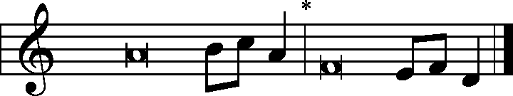

Blessèd be the Holy Trinity and the undivided **|** Unity.**\***

Let us give glory to Him because He has shown His mer- **|** cy to us.

I have set the Lord always be- **|** fore me;**\***

because He is at my right hand, I shall not be **|** shaken.

Therefore my heart is glad, and my whole being re- **|** joices;**\***

my flesh also **|** dwells secure.

For You will not abandon my soul **|** to Sheol,**\***

or let Your Holy One see cor- **|** ruption.

You make known to me the **|** path of life;**\***

in Your presence there is fullness of joy; at Your right hand are pleasures for- **|** evermore.

**Glory be to the Father and | to the Son\***

**and to the Holy | Spirit;**

**as it was in the be- | ginning,\***

**is now, and will be forever. | Amen.**

Blessèd be the Holy Trinity and the undivided **|** Unity.**\***

Let us give glory to Him because He has shown His mer- **|** cy to us.

|  |  |  |  |  |
| --- | --- | --- | --- | --- |
|  |  | | | |
| KYRIE | | | Pages 152-53 | |
|  | | |  | |
| HYMN OF PRAISE | | *Gloria in Excelsis* | | Page 154 |
|  |  | | | |
| SALUTATION | | | *Page 156* | |
|  | | |  | |
| COLLECT OF THE DAY | | |  | |
| P: | Let us pray. | | | |
| C: | Almighty and everlasting God, You have given us grace to acknowledge the glory of the eternal Trinity by the confession of a true faith and to worship the Unity in the power of the Divine Majesty. Keep us steadfast in this faith and defend us from all adversities; for You, O Father, Son, and Holy Spirit, live and reign, one God, now and forever. Amen. | | | |
|  | | |  | |
| THE GOSPEL FOR YOUNGER FOLK | | |  | |
|  | | |  | |
| FIRST READING | | | Proverbs 8:1–4, 22–31 | |

1Does not wisdom call? Does not understanding raise her voice? 2On the heights beside the way, at the crossroads she takes her stand; 3beside the gates in front of the town, at the entrance of the portals she cries aloud: 4“To you, O men, I call, and my cry is to the children of man.

22“The Lord possessed me at the beginning of His work, the first of His acts of old. 23Ages ago I was set up, at the first, before the beginning of the earth. 24When there were no depths I was brought forth, when there were no springs abounding with water. 25Before the mountains had been shaped, before the hills, I was brought forth, 26before He had made the earth with its fields, or the first of the dust of the world. 27When He established the heavens, I was there; when He drew a circle on the face of the deep, 28when He made firm the skies above, when He established the fountains of the deep, 29when He assigned to the sea its limit, so that the waters might not transgress His command, when He marked out the foundations of the earth, 30then I was beside Him, like a master workman, and I was daily His delight, rejoicing before Him always, 31rejoicing in His inhabited world and delighting in the children of man.”

|  |  |  |  |
| --- | --- | --- | --- |
|  |  | | |
| P: | This is the word of the Lord. | | |
| C: | Thanks be to God. | | |
|  |  | | |
| PSALM | | Psalm 8 | *(Sung responsively by verse)* |
|  | |  |  |

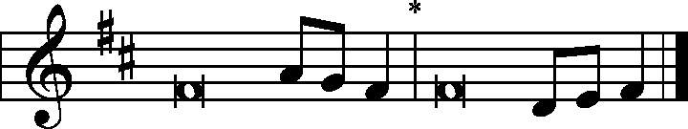

O Lord, our Lord, how majestic is Your Name in **|** all the earth!**\***

You have set Your glory above the **|** heavens.

Out of the mouth of babes and infants, You have established strength because **|** of Your foes,**\***

to still the enemy and the a- **|** venger.

When I look at Your heavens, the work of Your **|** fingers,**\***

the moon and the stars, which You have **|** set in place,

what is man that You are mind- **|** ful of him,**\***

and the son of man that You **|** care for him?

Yet You have made him a little lower than the heavenly **|** beings**\***

and crowned him with glory and **|** honor.

You have given him dominion over the works **|** of Your hands;**\***

You have put all things under **|** his feet,

all sheep and **|** oxen,**\***

and also the beasts **|** of the field,

the birds of the heavens, and the fish **|** of the sea,**\***

whatever passes along the paths **|** of the seas.

O **|** Lord, our Lord,**\***

how majestic is Your Name in **|** all the earth!

**Glory be to the Father and | to the Son\***

**and to the Holy | Spirit;**

**as it was in the be- | ginning,\***

**is now, and will be forever. | Amen.**

|  |  |  |
| --- | --- | --- |
|  |  |  |

|  |  |
| --- | --- |
| SECOND READING | Acts 2:14a, 22–36 |

14But Peter, standing with the eleven, lifted up his voice and addressed them, “Men of Judea and all who dwell in Jerusalem, let this be known to you, and give ear to my words.

22“Men of Israel, hear these words: Jesus of Nazareth, a man attested to you by God with mighty works and wonders and signs that God did through Him in your midst, as you yourselves know— 23this Jesus, delivered up according to the definite plan and foreknowledge of God, you crucified and killed by the hands of lawless men. 24God raised Him up, loosing the pangs of death, because it was not possible for Him to be held by it. 25For David says concerning Him, “‘I saw the Lord always before me, for He is at my right hand that I may not be shaken; 26therefore my heart was glad, and my tongue rejoiced; my flesh also will dwell in hope. 27For You will not abandon my soul to Hades, or let your Holy One see corruption. 28You have made known to me the paths of life; You will make me full of gladness with Your presence.’

29“Brothers, I may say to you with confidence about the patriarch David that he both died and was buried, and his tomb is with us to this day. 30Being therefore a prophet, and knowing that God had sworn with an oath to him that he would set one of his descendants on his throne, 31he foresaw and spoke about the resurrection of the Christ, that He was not abandoned to Hades, nor did His flesh see corruption. 32This Jesus God raised up, and of that we all are witnesses. 33Being therefore exalted at the right hand of God, and having received from the Father the promise of the Holy Spirit, He has poured out this that you yourselves are seeing and hearing. 34For David did not ascend into the heavens, but he himself says, “‘The Lord said to my Lord, sit at my right hand, 35until I make Your enemies Your footstool.’

36Let all the house of Israel therefore know for certain that God has made Him both Lord and Christ, this Jesus Whom you crucified.”

|  |  |  |
| --- | --- | --- |
|  |  | |
| P: | This is the word of the Lord. | |
| C: | Thanks be to God. | |
|  |  | |
| GOSPEL VERSE | | *Page 156* |
|  | |  |

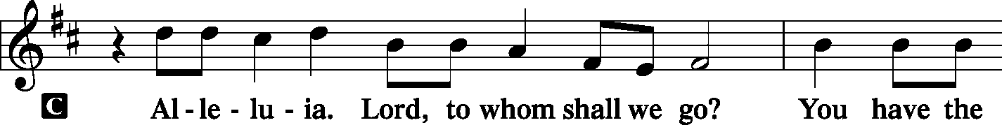

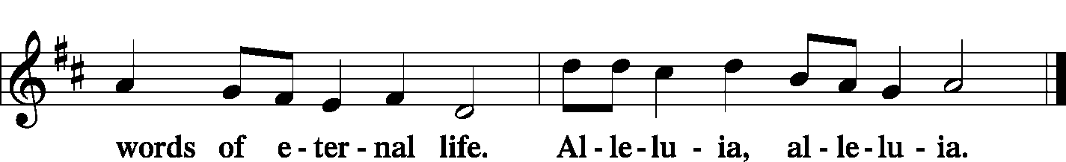

|  |  |  |
| --- | --- | --- |
|  | |  |
| INTRODUCTION | |  |
| P: | The Holy Gospel according to St. John, the eighth chapter. | |
|  |  | |

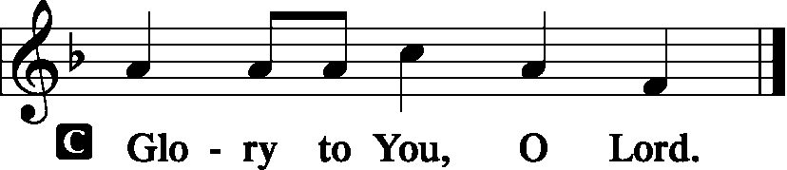

|  |  |
| --- | --- |
|  |  |
| GOSPEL LESSON | John 8:48-59 |

48The Jews answered him, “Are we not right in saying that you are a Samaritan and have a demon?” 49Jesus answered, **“I do not have a demon, but I honor My Father, and you dishonor Me. 50Yet I do not seek My own glory; there is One Who seeks it, and He is the judge. 51Truly, truly, I say to you, if anyone keeps My word, he will never see death.”** 52The Jews said to Him, “Now we know that You have a demon! Abraham died, as did the prophets, yet You say, ‘If anyone keeps My word, he will never taste death.’ 53Are You greater than our father Abraham, who died? And the prophets died! Who do You make Yourself out to be?” 54Jesus answered**, “If I glorify Myself, My glory is nothing. It is My Father Who glorifies Me, of Whom you say, ‘He is our God.’ 55But you have not known Him. I know Him. If I were to say that I do not know Him, I would be a liar like you, but I do know Him and I keep His word. 56Your father Abraham rejoiced that he would see My day. He saw it and was glad.”** 57So the Jews said to Him, “You are not yet fifty years old, and have You seen Abraham?” 58Jesus said to them**, “Truly, truly, I say to you, before Abraham was, I am.”** 59So they picked up stones to throw at Him, but Jesus hid Himself and went out of the temple.

|  |  |
| --- | --- |
|  |  |
| P: | This is the Gospel of the Lord. |
|  |  |

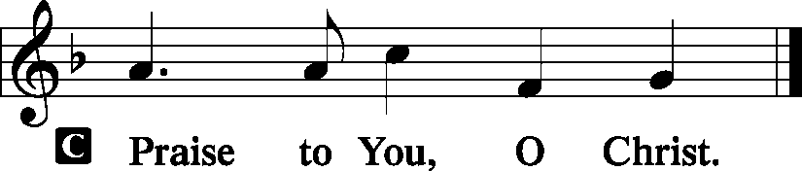

|  |  |  |  |
| --- | --- | --- | --- |
|  |  |  | |
| HYMN OF THE DAY | *I Bind unto Myself Today* | | *LSB 604* |

|  |  |
| --- | --- |
|  | *Note: Stanza 1 concludes at the end of the fourth line, at which point we return to the beginning to sing stanza 2.* |

|  |  |  |  |  |
| --- | --- | --- | --- | --- |
|  |  | | |  |
| SERMON |  | | |  |
|  | | | | |
| ATHANASIAN CREED | | (8:00) |  | |

|  |  |
| --- | --- |
| P: | Whosoever will be saved, before all things it is necessary that he hold the catholic* faith. Which faith except every one do keep whole and undefiled, without doubt he shall perish everlastingly. |
| C: | And the catholic faith is this: That we worship one God in Trinity, and Trinity in Unity, neither confounding the persons, nor dividing the substance. |
| P: | For there is one Person of the Father, another of the Son, and another of the Holy Spirit. But the godhead of the Father, of the Son, and of the Holy Spirit, is all one, the glory equal, the majesty co-eternal. |
| C: | Such as the Father is, such is the Son, and such is the Holy Spirit. The Father uncreated, the Son uncreated, and the Holy Spirit uncreated. The Father incomprehensible, the Son incomprehensible, and the Holy Spirit incomprehensible. |

|  |  |
| --- | --- |
| P: | The Father eternal, the Son eternal, and the Holy Spirit eternal. And yet they are not three eternals, but one Eternal. |
| C: | As also there are not three incomprehensibles, nor three uncreated, but one Uncreated, and one Incomprehensible. So likewise the Father is Almighty, the Son Almighty, and the Holy Spirit Almighty. And yet they are not three almighties, but one Almighty. |
| P: | So the Father is God, the Son is God, and the Holy Spirit is God. And yet they are not three gods, but one God. So likewise the Father is Lord, the Son Lord, and the Holy Spirit Lord. And yet not three lords, but one Lord. |
| C: | For as we are compelled by the Christian truth to acknowledge each Person by Himself to be both God and Lord, so we are also forbidden by the catholic religion to say that there are three gods or three lords. |
| P: | The Father is made of none, neither created, nor begotten. The Son is of the Father alone, not made, nor created, but begotten. The Holy Spirit is of the Father, neither made, nor created, nor begotten, but proceeding. So there is one Father, not three fathers; one Son, not three sons; one Holy Spirit, not three holy spirits. |
| C: | And in the Trinity none is before or after another; none is greater or less than another, but all three Persons are co-eternal together and co-equal. So that in all things, as is aforesaid, the Unity in Trinity and the Trinity in Unity is to be worshipped. He therefore that will be saved must think thus of the Trinity. |
| P: | Furthermore, it is necessary to everlasting salvation that he also believe rightly the Incarnation of our Lord Jesus Christ. For the right faith is, that we believe and confess, that our Lord Jesus Christ, the Son of God, is God and man; God, of the substance of the Father, begotten before the worlds; and man of the substance of His mother, born in the world; perfect God and perfect man, of a rational soul and human flesh subsisting. |
| C: | Equal to the Father, as touching His godhead; and inferior to the Father, as touching His manhood; Who, although He is God and man, yet he is not two, but one Christ; one, not by conversion of the godhead into flesh but by taking of the manhood into God; one altogether; not by confusion of substance, but by unity of person. For as the rational soul and flesh is one man, so God and man is one Christ; Who suffered for our salvation, descended into hell, rose again the third day from the dead. He ascended into heaven, |

|  |  |
| --- | --- |
| P: | He sits at the right hand of the Father, God Almighty, from whence He will come to judge the quick and the dead. At His coming all men will rise again with their bodies and shall give account for their own works. And they that have done good shall go into life everlasting; and they that have done evil into everlasting fire. |
| All: This is the catholic* faith, which except a man believe faithfully, he  cannot be saved. | |
|  |  |
|  | *“catholic” with the small “c” means “universal,” or believed by all Christians, at all times, and in all places where they are gathered. |

|  |  |  |  |  |  |  |  |  |  |  |  |  |  |  |  |  |
| --- | --- | --- | --- | --- | --- | --- | --- | --- | --- | --- | --- | --- | --- | --- | --- | --- |
|  |  | | | | | | | | | | | | | | | |
|  | | | | | | | | | | | | | | | | |
|  |  | | | | | | | | | | | | | | | |
| PRAYER OF THE CHURCH | | | | | | | | | *Page 159* | | | | | | | |
|  | | | | | | | | |  | | | | | | | |
| Hymn | | | *Lamb of God* | | | | | | | | | *LSB #550* | | | | |
|  | | |  | | | | | | | | |  | | | | |
| PREFACE | | | | | | | | | Page 160 | | | | | | | |
|  | | | | | | | | |  | | | | | | | |
| PROPER PREFACE | | | | | | | | |  | | | | | | | |
| P: | It is truly good, right, and salutary that we should at all times and in all places give thanks to You, holy Lord, almighty Father, everlasting God, who with Your only-begotten Son and the Holy Spirit are one God, one Lord. In the confession of the only true God, we worship the Trinity in person and the Unity in substance, of majesty coequal. Therefore with angels and archangels and with all the company of heaven we laud and magnify Your glorious name, evermore praising You and singing: | | | | | | | | | | | | | | | |
|  |  | | | | | | | | | | | | | | | |
| SANCTUS | | *Holy, Holy, Holy Lord* | | | | | | | | | | | | | *Page 161* | |
|  | |  | | | | | | | | | | | | |  | |
| PRAYER OF THANKSGIVING | | | | | | | | |  | *Page 161* | | | | | | |
|  |  | | | | | | | | | | | | | | | |
| LORD’S PRAYER | | | | | | | | Page 162, Right Column | | | | | | | | |
|  |  | | | | | | | | | | | | | | | |
| WORDS OF OUR LORD | | | | | | *(Words of Institution)* | | | | | *Page 162, Right Column* | | | | | |
| PAX DOMINI | | | | | | *The Peace of the Lord* | | | | | | | *Page 163* | | | |
|  | | | | | |  | | | | |  | | | | | |
| AGNUS DEI | | | | | | *Lamb of God* | | | | | *Page 163* | | | | | |
|  | | | | | |  | | | | |  | | | | | |
|  | *Prayer before Communing: Dear Savior, at Your gracious invitation I come to Your table to eat and drink Your holy body and blood. Let me find favor in Your eyes to receive this holy Sacrament in faith for the salvation of my soul and to the glory of Your holy name; for You live and reign with the Father and the Holy Spirit, one God, now and forever. Amen.* | | | | | | | | | | | | | | | |
|  |  | | | | | | | | | | | | | | | |
|  | *Thanksgiving after Receiving the Sacrament: Almighty and everlasting God, I thank and praise You for feeding me the life-giving body and blood of Your beloved Son, Jesus Christ. Send Your Holy Spirit that, having with my mouth received the holy Sacrament, I may by faith obtain and eternally enjoy Your divine grace, the forgiveness of sins, unity with Christ, and life eternal; through Jesus Christ, my Lord. Amen.* | | | | | | | | | | | | | | | |
|  |  | | | | | | | | | | | | | | | |
| DISTRIBUTION | | | | | | | | |  | | | | | | | |
|  | *LSB 637* | | | *Draw Near and Take the Body of the Lord* | | | | | | | | | | | | |
|  | *LSB 642* | | | *O Living Bread from Heaven* | | | | | | | | | | | | |
|  |  | | |  | | | | | | | | | | | | |
| POST-COMMUNION BLESSING | | | | | | | | | | | | | | | | |
| P: | May the true Body of our Lord Jesus Christ, and His most precious Blood, strengthen you in true faith, granting you the forgiveness of sins, unto life everlasting. | | | | | | | | | | | | | | | |
| C: | Amen. | | | | | | | | | | | | | | | |
|  |  | | | | | | | | | | | | | | | |
| POST-COMMUNION CANTICLE | | | | | | | *Nunc Dimittis – Song of Simeon*  *Lord, Now You Let Your Servant* | | | | | | | | | Page 165 |
|  | | | | | | |  | | | | | | | | |  |
| POST-COMMUNION COLLECT | | | | | | |  | | | | | | | | | Page 166 |
|  |  | | | | | | | | | | | | | | |  |
| BENEDICTION | | | | | | | | |  | | | | | | | Page 166 |
|  | | | | | | | | |  | | | | | | |  |
| CLOSING HYMN | | | | | *Father Most Holy* | | | | | | | | | *LSB 504* | | |
|  | | | | |  | | | | | | | | |  | | |
| SILENT PRAYER | | | | |  | | | | | | | | |  | | |
|  | *Almighty and merciful God, I have again worshiped in Your presence and received both forgiveness for my many sins and the assurance of Your love in Jesus Christ. I thank You for this undeserved grace and ask You to keep me in faith until, with all Your saints, I inherit eternal salvation; through Jesus Christ, my Lord. Amen.* | | | | | | | | | | | | | | | |
|  |  | | | | | | | | | | | | | | | |
| ANNOUNCEMENTS | | | | | | | | | | | | | | | | |
|  | | | | | | | | | | | | | | | | |
| POSTLUDE | | | | | | | | | | | | | | | | |

T T T

Acknowledgments

Divine Service, Setting One from Lutheran Service Book

Unless otherwise indicated, all scripture quotations are from *The Holy Bible, English Standard Version*, copyright © 2001 by Crossway Bibles, a division of Good News Publishers. Used by permission. All rights reserved.

Created by Lutheran Service Builder © 2006 Concordia Publishing House.

|  |  |  |  |  |
| --- | --- | --- | --- | --- |
| SERVING THE LORD WITH GLADNESS | | | | |
| ELDER | - |  | - | Daniel Keehner |
| ORGANIST |  |  |  |  |

