|  |
| --- |
| The Second Sunday after Pentecost |
| June 22, 2025 |
| + The Order of Matins + |
| Lutheran Service Book – Pages 219-228 |

|  |  |  |
| --- | --- | --- |
| Prayer Before Worship | |  |
|  | *O Lord, my Creator, Redeemer, and Comforter, as I come to worship You in spirit and in truth, I humbly pray that You would open my heart to the preaching of Your Word so that I may repent of my sins, believe in Jesus Christ as my only Savior, and grow in grace and holiness. Hear me for the sake of His name. Amen.* | |
|  |  | |
| PRELUDE | | |
|  | | |

|  |
| --- |
| RINGING BELL CALLS US TO WORSHIP |

|  |  |  |  |  |  |  |
| --- | --- | --- | --- | --- | --- | --- |
|  | | | |  | | |
| WELCOME | | | |  | | |
|  | | | |  | | |
| OPENING HYMN | | Lord Jesus Christ, Be Present Now | | | LSB 902 |
|  | |  | | |  |
| CONFESSION AND ABSOLUTION | | | *Page 151* | | |
| P: | In the name of the Father and of the T Son and of the Holy Spirit. | | | | |
| C: | Amen. | | | | |
| P: | If we say we have no sin, we deceive ourselves, and the truth is not in us. | | | | |
| C: | But if we confess our sins, God, Who is faithful and just, will forgive our sins and cleanse us from all unrighteousness. | | | | |
|  |  | | | | |
|  | *(Silence for reflection on God’s Word and for self-examination.)* | | | | |
|  |  | | | | |
| P: | Let us then confess our sins to God our Father. | | | | |
| C: | **Most merciful God, we confess that we are by nature sinful and unclean. We have sinned against You in thought, word, and deed, by what we have done and by what we have left undone. We have not loved You with our whole heart; we have not loved our neighbors as ourselves. We justly deserve Your present and eternal punishment. For the sake of Your Son, Jesus Christ, have mercy on us. Forgive us, renew us, and lead us, so that we may delight in Your will and walk in Your ways to the glory of Your holy name. Amen.** | | | | |
| P: | Almighty God in His mercy has given His Son to die for you and for His sake forgives you all your sins. As a called and ordained servant of Christ, and by His authority, I therefore forgive you all your sins in the name of the Father and of the T Son and of the Holy Spirit. | | | | |
| C: | Amen. | | | | |
|  |  | | | | |

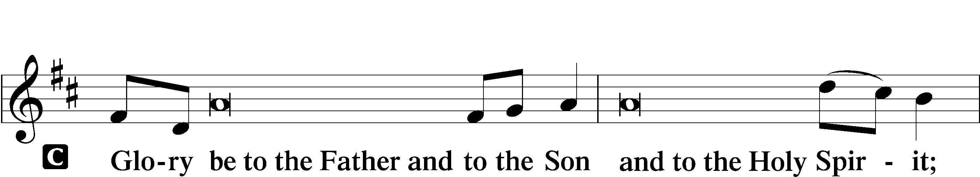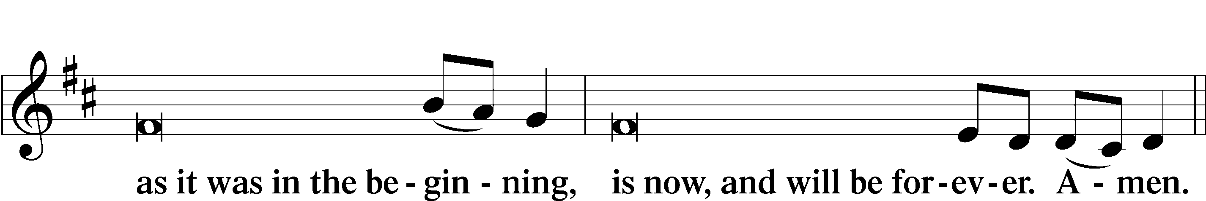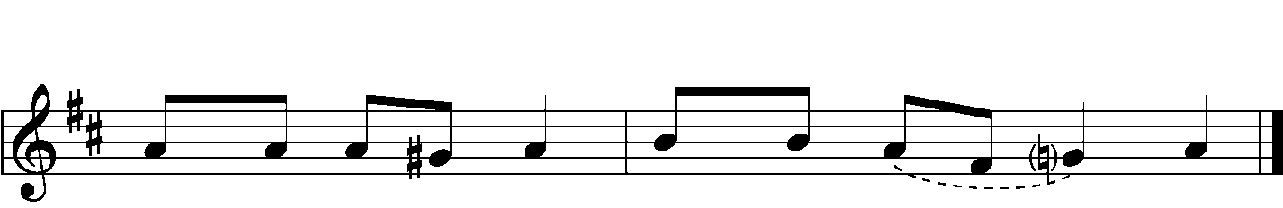

|  |  |  |  |
| --- | --- | --- | --- |
|  |  | | |
| PSALMODY | | Venite | *O Come, Let Us Sing* |
|  | Antiphon | | |
|  |  | | |



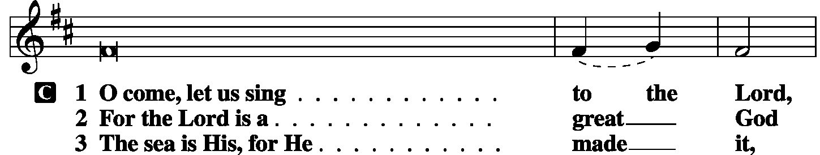

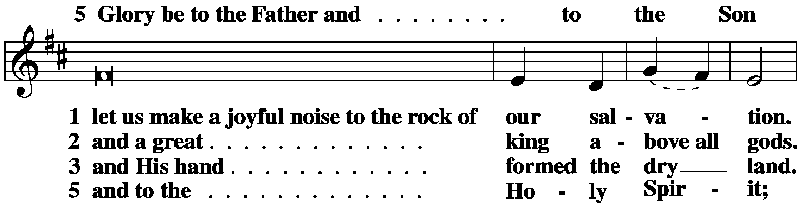

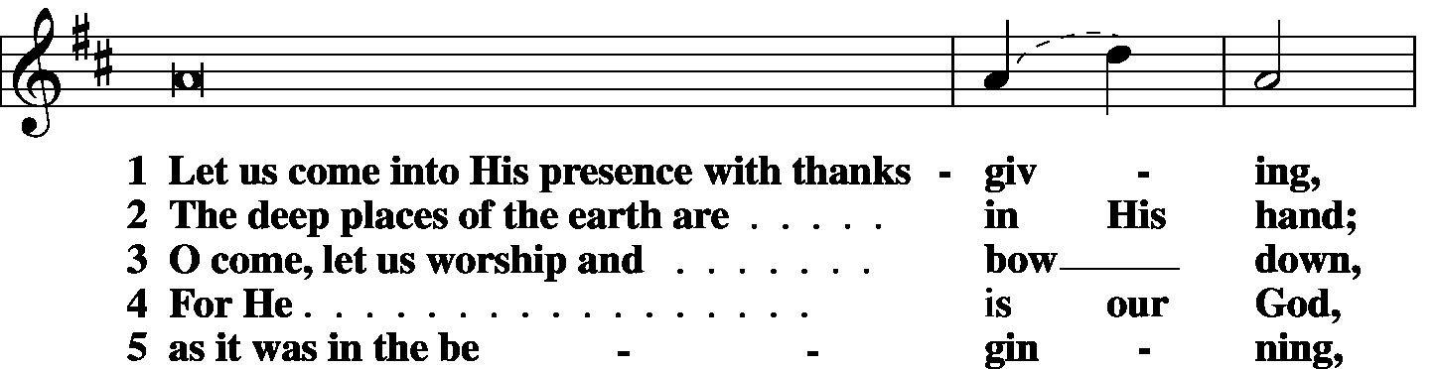

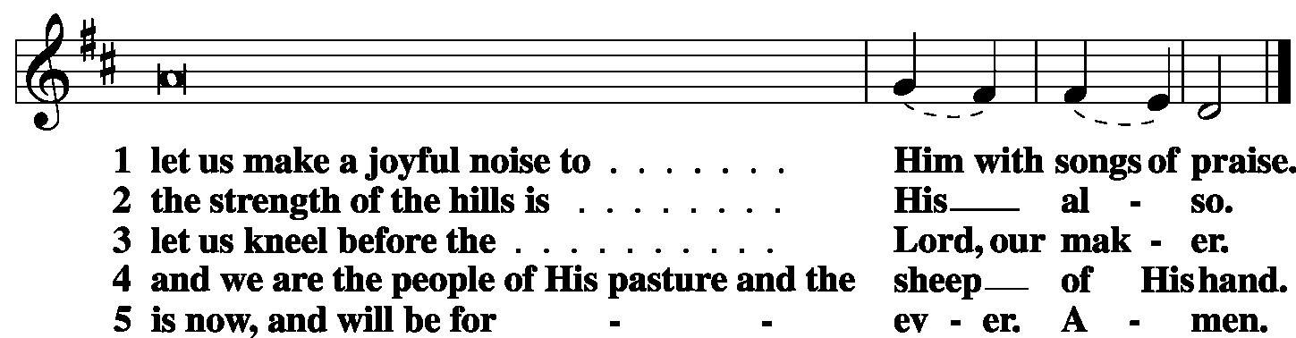

|  |  |  |  |
| --- | --- | --- | --- |
|  |  |  |  |
|  | Second Psalm | Psalm 3 | *(Sung responsively by verse)* |
|  |  |  | |

O Lord, how many **|** are my foes!**\***

Many are rising a- **|** gainst me;

many are saying **|** of my soul,**\***

there is no salvation for **|** him in God.

But You, O Lord, are a shield a- **|** bout me,**\***

my glory, and the lifter **|** of my head.

I cried aloud **|** to the Lord,**\***

and He answered me from His **|** holy hill.

I lay **|** down and slept;**\***

I woke again, for the Lord sus- **|** tained me.

I will not be afraid of many thousands of **|** people**\***

who have set themselves against me **|** all around.

Arise, O Lord! Save me, O my God!

For You strike all my enemies **|** on the cheek;**\***

You break the teeth of the **|** wicked.

Salvation belongs **|** to the Lord;**\***

Your blessing be on Your **|** people!

**Glory be to the Father and | to the Son\***

**and to the Holy | Spirit;**

**as it was in the be- | ginning,\***

**is now, and will be forever. | Amen.**

|  |  |  |  |
| --- | --- | --- | --- |
|  |  | |  |
| OFFICE HYMN | *Awake, My Soul, and with the Sun* | | LSB 868 |
|  |  | |  |
| THE GOSPEL FOR YOUNG FOLK | | | | |
|  | |  | | |
| FIRST LESSON | | Isaiah 65:1-9 | | |

1I was ready to be sought by those who did not ask for Me; I was ready to be found by those who did not seek Me. I said, “Here am I, here am I,” to a nation that was not called by My Name. 2I spread out My hands all the day to a rebellious people, who walk in a way that is not good, following their own devices; 3a people who provoke Me to My face continually, sacrificing in gardens and making offerings on bricks; 4who sit in tombs, and spend the night in secret places; who eat pig’s flesh, and broth of tainted meat is in their vessels; 5who say, “Keep to yourself, do not come near me, for I am too holy for you.” These are a smoke in My nostrils, a fire that burns all the day. Behold, it is written before Me: “I will not keep silent, but I will repay; I will indeed repay into their bosom 7both your iniquities and your fathers’ iniquities together, says the Lord; because they made offerings on the mountains and insulted Me on the hills, I will measure into their bosom payment for their former deeds.” 8Thus says the Lord: “As the new wine is found in the cluster, and they say, ‘Do not destroy it, for there is a blessing in it,’ so I will do for My servants’ sake, and not destroy them all. 9I will bring forth offspring from Jacob, and from Judah possessors of My mountains; My chosen shall possess it, and My servants shall dwell there.”

|  |  |  |
| --- | --- | --- |
|  |  | |
| P: | O Lord, have mercy on us. | |
| C: | **Thanks be to God.** | |
|  | |  |
| SECOND LESSON | | Galatians 3:23-4:7 |

23Now before faith came, we were held captive under the law, imprisoned until the coming faith would be revealed. 24So then, the law was our guardian until Christ came, in order that we might be justified by faith. 25But now that faith has come, we are no longer under a guardian, 26for in Christ Jesus you are all sons of God, through faith. 27For as many of you as were baptized into Christ have put on Christ. 28There is neither Jew nor Greek, there is neither slave nor free, there is neither male nor female, for you are all one in Christ Jesus. 29And if you are Christ’s, then you are Abraham’s offspring, heirs according to promise. 1I mean that the heir, as long as he is a child, is no different from a slave, though he is the owner of everything, 2but he is under guardians and managers until the date set by his father. 3In the same way we also, when we were children, were enslaved to the elementary principles of the world. 4But when the fullness of time had come, God sent forth His Son, born of woman, born under the law, 5to redeem those who were under the law, so that we might receive adoption as sons. 6And because you are sons, God has sent the Spirit of his Son into our hearts, crying, “Abba! Father!” 7So you are no longer a slave, but a son, and if a son, then an heir through God.

|  |  |  |
| --- | --- | --- |
|  |  | |
| P: | O Lord, have mercy on us. | |
| C: | **Thanks be to God.** | |
|  | |  |
| GOSPEL VERSE | | Is. 6:3b |
| P: | Alleluia. Holy, holy, holy is the Lord of hosts; | |
| C: | the whole earth is full of his glory! Alleluia. | |
|  |  | |
| HOLY GOSPEL | | Luke 8:26-39 |
| P: | The Holy Gospel according to St. Luke, the eighth chapter. | |
| C: | **Glory to You, O Lord.** | |
|  |  | |

26Then they sailed to the country of the Gerasenes, which is opposite Galilee. 27When Jesus had stepped out on land, there met Him a man from the city who had demons. For a long time he had worn no clothes, and he had not lived in a house but among the tombs. 28When he saw Jesus, he cried out and fell down before Him and said with a loud voice, “What have You to do with me, Jesus, Son of the Most High God? I beg You, do not torment me.” 29For He had commanded the unclean spirit to come out of the man. (For many a time it had seized him. He was kept under guard and bound with chains and shackles, but he would break the bonds and be driven by the demon into the desert.) 30Jesus then asked him, **“What is your name?”** And he said, “Legion,” for many demons had entered him. 31And they begged Him not to command them to depart into the abyss. 32Now a large herd of pigs was feeding there on the hillside, and they begged Him to let them enter these. So He gave them permission. 33Then the demons came out of the man and entered the pigs, and the herd rushed down the steep bank into the lake and were drowned. 34When the herdsmen saw what had happened, they fled and told it in the city and in the country. 35Then people went out to see what had happened, and they came to Jesus and found the man from whom the demons had gone, sitting at the feet of Jesus, clothed and in his right mind, and they were afraid. 36And those who had seen it told them how the demon-possessed man had been healed. 37Then all the people of the surrounding country of the Gerasenes asked Him to depart from them, for they were seized with great fear. So He got into the boat and returned. 38The man from whom the demons had gone begged that he might be with Him, but Jesus sent him away, saying, **39“Return to your home, and declare how much God has done for you.”** And he went away, proclaiming throughout the whole city how much Jesus had done for him.

|  |  |  |
| --- | --- | --- |
| P: | This is the Gospel of the Lord. | |
| C: | **Praise to You, O Christ.** | |
|  | |  |
| RESPONSORY | |  |
|  |  | |

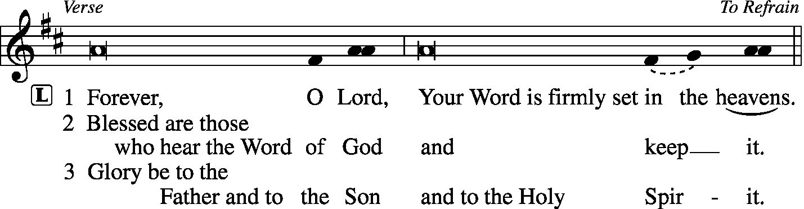

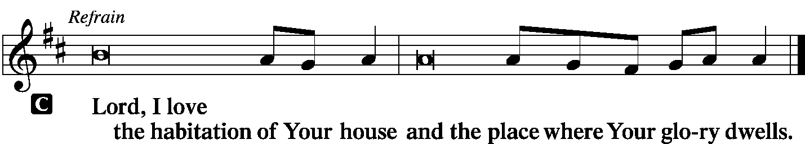

|  |  |  |  |  |  |  |
| --- | --- | --- | --- | --- | --- | --- |
|  | |  | | |  | |
| HYMN OF THE DAY | | “Away from Us!” the Demon Cried | | | LSB 541 | |
|  | | | | | | |
| SERMON | | | | | | |
|  | | | | | | |
| CANTICLE | **Te Deum** (*We Praise You, O God)* | | | *LSB p. 223* | |
|  |  | |  | | |

|  |  |  |  |
| --- | --- | --- | --- |
|  | |  | |
| **INSTALLATION OF OFFICERS, BOARDS, AND COMMITTEES** | | |  |
|  | |  | |
| PRAYER OF THE CHURCH | | | |
|  | |  | |
|  | Kyrie |  | |

|  |  |  |
| --- | --- | --- |
|  |  | |
| LORD’S PRAYER | | |
| C: | Our Father Who art in heaven, hallowed be Thy name, Thy kingdom come, Thy will be done on earth as it is in heaven; give us this day our daily bread; and forgive us our trespasses as we forgive those who trespass against us; and lead us not into temptation, but deliver us from evil. For Thine is the kingdom and the power and the glory forever and ever. Amen. | |
| COLLECTS | |  |

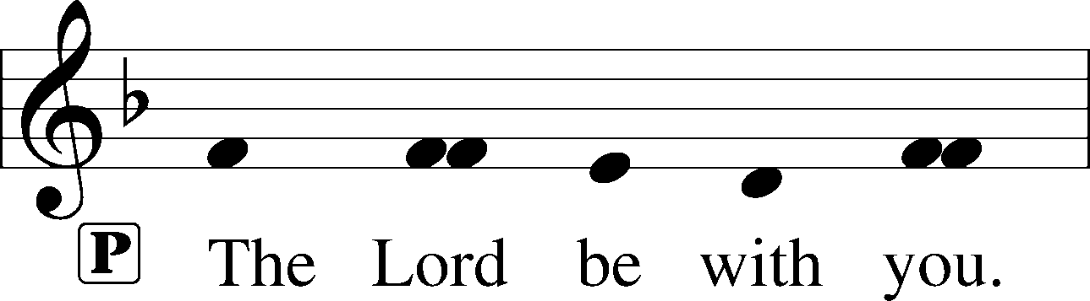

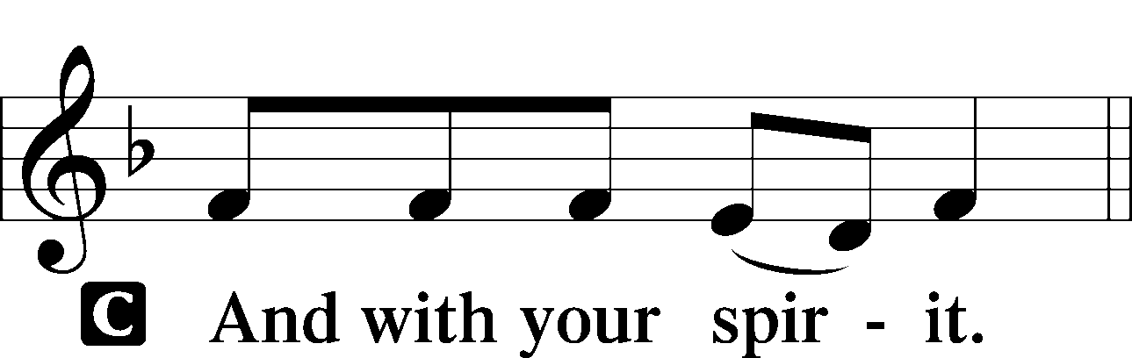

|  |  |
| --- | --- |
|  | |
| Collect of the Day | |
| P: | O God, You have prepared for those who love You such good things as surpass our understanding. Cast out all sins and evil desires from us, and pour into our hearts Your Holy Spirit to guide us into all blessedness; through Jesus Christ, Your Son, our Lord. |



|  |  |
| --- | --- |
|  |  |
| Collect for Matins | |
| P: | Almighty God, heavenly Father, Your mercies are new to us every morning, and You abundantly provide for all our wants of body and soul. Give us we humbly pray, Your Holy Spirit that we may heartily acknowledge Your merciful goodness toward us, give thanks for all Your benefits, and cheerfully serve You. |



|  |  |  |
| --- | --- | --- |
|  | |  |
| For Guidance in Our Calling | | *LSB p. 311* |
| P: | Lord God, You have called Your servants to ventures of which we cannot see the ending, by paths as yet untrodden, through perils unknown. Give us faith to go out with good courage, not knowing where we go but only that Your hand is leading us and Your love supporting us; through Jesus Christ, our Lord. | |



|  |  |  |
| --- | --- | --- |
| For Responsible Citizenship | | *LSB p.313* |
| P: | Lord, keep this nation under Your care. Bless the leaders of our land that we may be a people at peace among ourselves and a blessing to the other nations of the earth. Grant that we may choose trustworthy leaders, contribute to wise decisions for the general welfare, and serve You faithfully in our generation; through Jesus Christ, our Lord. | |



|  |  |  |
| --- | --- | --- |
|  | |  |
| Collect for Grace | | *LSB p.228* |
| P: | O Lord, our heavenly Father, almighty and everlasting God, You have safely brought us to the beginning of this day. Defend us in the same with Your mighty power and grant that this day we fall into no sin, neither run into any kind of danger, but that all our doings, being ordered by Your governance, may be righteous in Your sight; through Jesus Christ, Your Son, our Lord, Who lives and reigns with You and the Holy Spirit, one God, now and forever. | |



|  |  |  |
| --- | --- | --- |
| BENEDICAMUS | | *LSB p. 227* |
|  |  | |

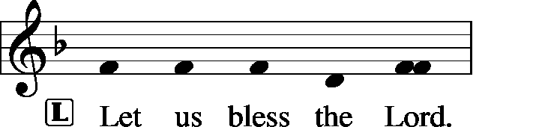

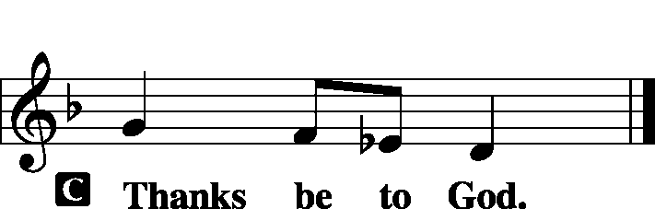

|  |  |
| --- | --- |
|  |  |
| BENEDICTION |  |

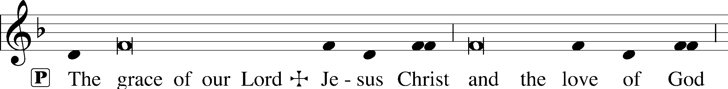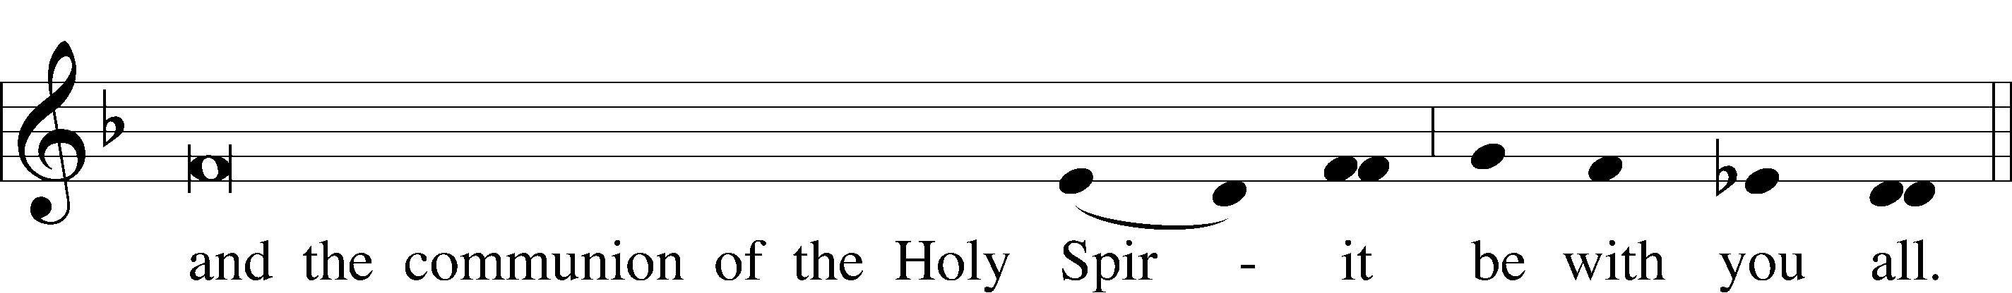

|  |  |  |  |  |  |  |
| --- | --- | --- | --- | --- | --- | --- |
|  | | |  | | |  |
| CLOSING HYMN | | *Oh, for a Thousand Tongues to Sing* | | | *LSB 528* | |
|  | |  | | |  | |
| SILENT PRAYER | | |  | | |  | |
|  | *Almighty and merciful God, I have again worshiped in Your presence and received both forgiveness for my many sins and the assurance of Your love in Jesus Christ. I thank You for this undeserved grace and ask You to keep me in faith until, with all Your saints, I inherit eternal salvation; through Jesus Christ, my Lord. Amen.* | | | | | | |
|  | | | | | | | |
| T T T | | | | | | | |
|  | | | | | | | |
| Pastor: The Rev. Barry Long | | | |  | | | |
| Elder: Phil King | | | | | | | |
| Organist: Carol Wessler | | | | | | | |
|  | | | | | | | |

Acknowledgments

Matins from Lutheran Service Book

Unless otherwise indicated, all scripture quotations are from *The Holy Bible, English Standard Version*, copyright © 2001 by Crossway Bibles, a division of Good News Publishers. Used by permission. All rights reserved.

Created by Lutheran Service Builder © 2006 Concordia Publishing House.