*Looking for extra help in focusing your thoughts for the Lord’s Supper? “Christian Questions with Their Answers” was prepared by Luther to address just that. They can be found in your hymnal on pages 329-330. Review them if you get to church early, or during the offering, or if you are waiting to be invited forward.*

|  |
| --- |
| Fourth Sunday after Pentecost |
| July 6, 2025 |
| Divine Service III/Holy Communion |
| LSB Page 184 |

|  |  |  |  |  |  |
| --- | --- | --- | --- | --- | --- |
| Prayer before Worship: | | | | | |
|  | *O Lord, my Creator, Redeemer, and Comforter, as I come to worship You in spirit and in truth, I humbly pray that You would open my heart to the preaching of Your Word so that I may repent of my sins, believe in Jesus Christ as my only Savior, and grow in grace and holiness. Hear me for the sake of His name. Amen.* | | | | |
|  |  | | | | |
| PRELUDE | | | | | |
|  | | | | | |
| RINGING BELL CALLS US TO WORSHIP | | | | | |
|  | | | | | |
| WELCOME | | | | | |
|  | | | | | |
| OPENING HYMN | | *This Is the Day the Lord Has Made* | | | LSB 903 |
|  | |  | |  | |
| CONFESSION AND ABSOLUTION | | | *Page 184 (left column)* | | |
| P: | In the name of the Father and of the T Son and of the Holy Spirit. | | | | |
| C: | Amen. | | | | |
| P: | Beloved in the Lord! Let us draw near with a true heart and confess our sins unto God our Father, beseeching Him in the name of our Lord Jesus Christ to grant us forgiveness.  Our help is in the name of the Lord, | | | | |
| C: | **Who made heaven and earth.** | | | | |
| P: | I said, I will confess my transgressions unto the Lord, | | | | |
| C: | **and You forgave the iniquity of my sin.** | | | | |
|  |  | | | | |
|  | *Silence for reflection on God's Word and for self-examination.* | | | | |
|  |  | | | | |
| P: | O almighty God, merciful Father, | | | | |
| C: | **I, a poor, miserable sinner, confess unto You all my sins and iniquities with which I have ever offended You and justly deserved Your temporal and eternal punishment. But I am heartily sorry for them and sincerely repent of them, and I pray You of Your boundless mercy and for the sake of the holy, innocent, bitter sufferings and death of Your beloved Son, Jesus Christ, to be gracious and merciful to me, a poor, sinful being.** | | | | |
|  |  | | | | |
| P: | Upon this your confession, I, by virtue of my office, as a called and ordained servant of the Word, announce the grace of God unto all of you, and in the stead and by the command of my Lord Jesus Christ I forgive you all your sins in the name of the Father and of the T Son and of the Holy Spirit. | | | | |
| C: | **Amen.** | | | | |
|  | | |  | | |
| INTROIT | | | Ps. 19:2, 4–6; antiphon: Ps. 19:1 | | |
|  | | |  | | |



The heavens declare the glo- **|** ry of God,**\***

and the sky above proclaims His **|** handiwork.

Day to day **|** pours out speech,**\***

and night to night reveals **|** knowledge.

Their measuring line goes out through all the earth, and their words to the end **|** of the world.**\***

In them He has set a tent **|** for the sun,

which comes out like a bridegroom leaving his **|** chamber,**\***

and, like a strong man, runs its **|** course with joy.

Its rising is from the end of the heavens, and its circuit to the **|** end of them,**\***

and there is nothing hidden **|** from its heat.

**Glory be to the Father and | to the Son\***

**and to the Holy | Spirit;**

**as it was in the be- | ginning,\***

**is now, and will be forever. | Amen.**

The heavens declare the glo- **|** ry of God,**\***

and the sky above proclaims His **|** handiwork.

|  |  |  |  |
| --- | --- | --- | --- |
|  | |  | |
| KYRIE | *Lord Have Mercy* | | *Page 186* |
|  |  | |  |

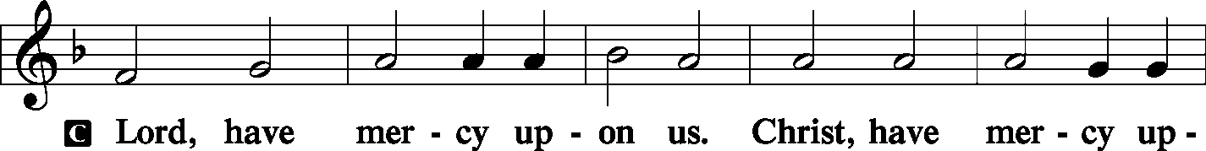

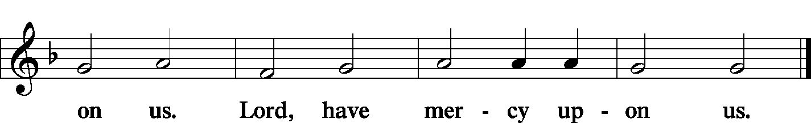

|  |  |  |
| --- | --- | --- |
| GLORIA IN EXCELSIS |  | *Page 187-89* |
|  |  |  |

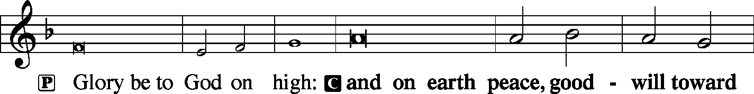

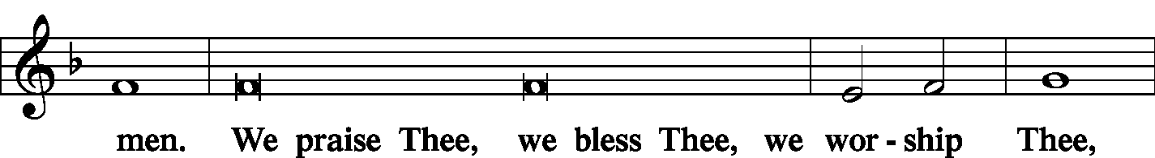

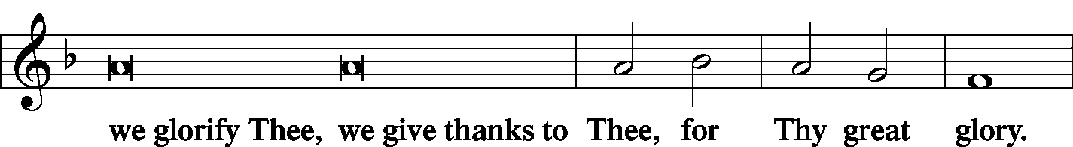

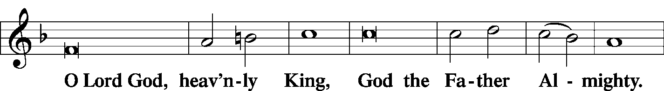

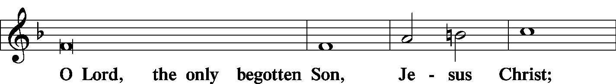

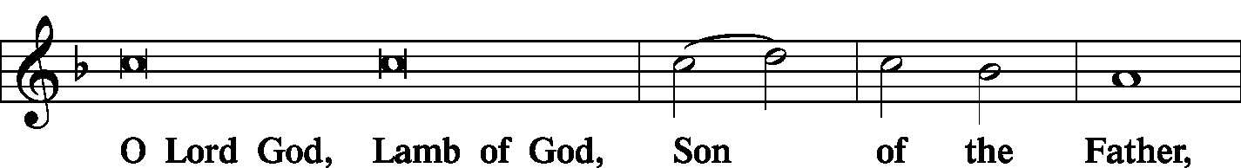

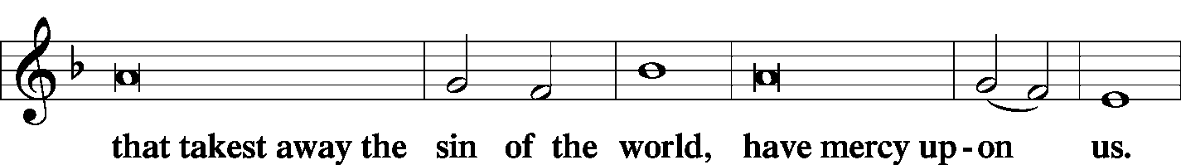

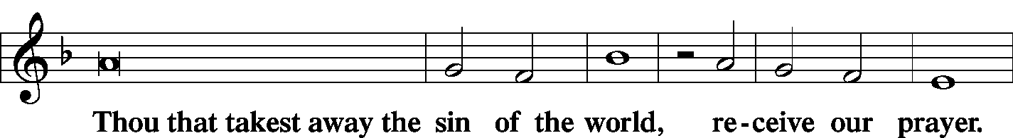

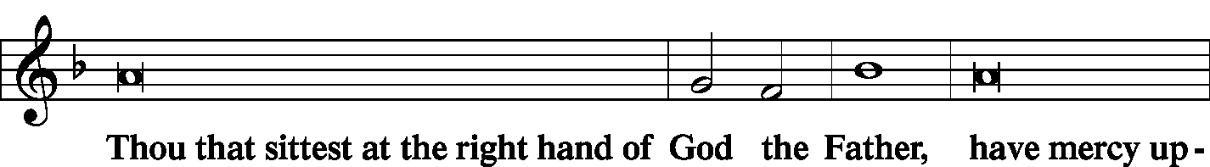

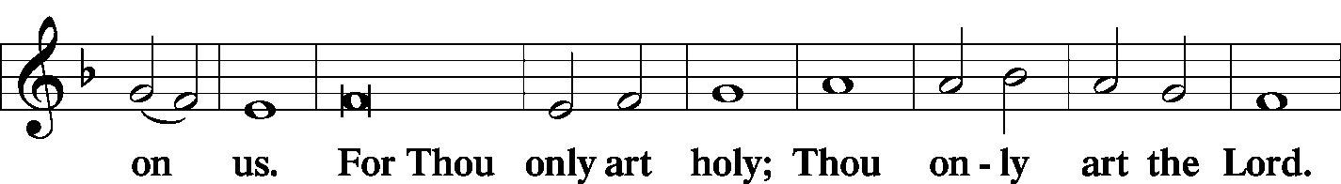

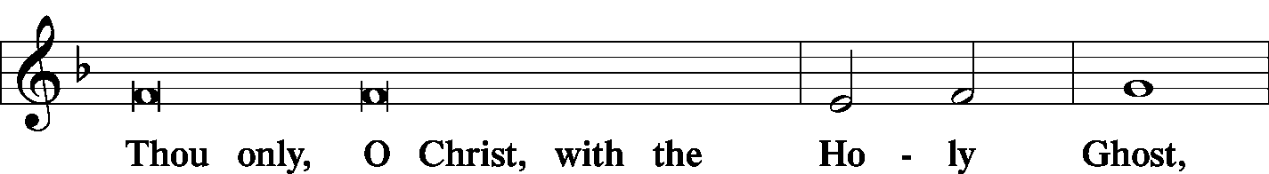

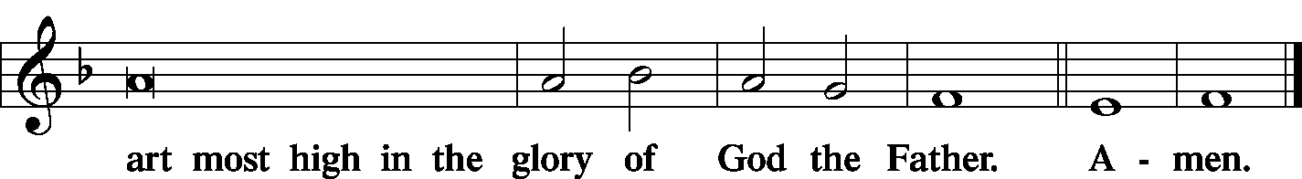

|  |  |  |  |  |
| --- | --- | --- | --- | --- |
|  | |  | |  |
| SALUTATION | |  | | *Page 189* |
| P: | The Lord be with you. | | |  |
| C: | And with thy spirit. | | |  |
|  |  | | |  |
| P: | Let us pray. | | |  |
|  | |  | |  |
| COLLECT OF THE DAY | |  | |  |
| C: | Almighty God, You have built Your Church on the foundation of the apostles and prophets with Christ Jesus Himself as the cornerstone. Continue to send Your messengers to preserve Your people in true peace that, by the preaching of Your Word, Your Church may be kept free from all harm and danger; through Jesus Christ, Your Son, our Lord, who lives and reigns with You and the Holy Spirit, one God, now and forever. Amen. | | | |
|  |  | | | |
|  | *Please be seated* | | | |
|  |  | | | |
| FIRST READING | | | Isaiah 66:10–14 | |

10“Rejoice with Jerusalem, and be glad for her, all you who love her; rejoice with her in joy, all you who mourn over her; 11that you may nurse and be satisfied from her consoling breast; that you may drink deeply with delight from her glorious abundance.” 12For thus says the Lord: “Behold, I will extend peace to her like a river, and the glory of the nations like an overflowing stream; and you shall nurse, you shall be carried upon her hip, and bounced upon her knees. 13As one whom his mother comforts, so I will comfort you; you shall be comforted in Jerusalem. 14You shall see, and your heart shall rejoice; your bones shall flourish like the grass; and the hand of the Lord shall be known to his servants, and he shall show his indignation against his enemies.”

|  |  |  |  |  |  |
| --- | --- | --- | --- | --- | --- |
|  | | | |  | |
| P: | This is the Word of the Lord. | | | | |
| C: | **Thanks be to God.** | | | | |
|  | | |  | |  |
| PSALM | | Psalm 66:1–7 | | |  |



Shout for joy to God, **|** all the earth;**\***

sing the glory of His Name; give to Him **|** glorious praise!

Say to God, “How awesome **|** are Your deeds!**\***

So great is Your power that Your enemies come cringing **|** to You.

All the earth worships You and sings prais- **|** es to You;**\***

they sing praises **|** to Your name.”

Come and see what **|** God has done:**\***

He is awesome in His deeds toward the chil- **|** dren of man.

He turned the sea into **|** dry land;**\***

they passed through the riv- **|** er on foot.

There did we rejoice in Him, Who rules by His might forever, Whose eyes keep watch on the **|** nations—**\***

let not the rebellious ex- **|** alt themselves.

**Glory be to the Father and | to the Son\***

**and to the Holy | Spirit;**

**as it was in the be- | ginning,\***

**is now, and will be forever. | Amen.**

|  |  |
| --- | --- |
|  |  |
| SECOND READING | Galatians 6:1–10, 14–18 |

1Brothers, if anyone is caught in any transgression, you who are spiritual should restore him in a spirit of gentleness. Keep watch on yourself, lest you too be tempted. 2Bear one another’s burdens, and so fulfill the law of Christ. 3For if anyone thinks he is something, when he is nothing, he deceives himself. 4But let each one test his own work, and then his reason to boast will be in himself alone and not in his neighbor. 5For each will have to bear his own load.

6One who is taught the word must share all good things with the one who teaches. 7Do not be deceived: God is not mocked, for whatever one sows, that will he also reap. 8For the one who sows to his own flesh will from the flesh reap corruption, but the one who sows to the Spirit will from the Spirit reap eternal life. 9And let us not grow weary of doing good, for in due season we will reap, if we do not give up. 10So then, as we have opportunity, let us do good to everyone, and especially to those who are of the household of faith.

14But far be it from me to boast except in the cross of our Lord Jesus Christ, by which the world has been crucified to me, and I to the world. 15For neither circumcision counts for anything, nor uncircumcision, but a new creation. 16And as for all who walk by this rule, peace and mercy be upon them, and upon the Israel of God.

17From now on let no one cause me trouble, for I bear on my body the marks of Jesus.

18The grace of our Lord Jesus Christ be with your spirit, brothers. Amen.

|  |  |  |
| --- | --- | --- |
| P: | This is the Word of the Lord. | |
| C: | **Thanks be to God.** | |
|  |  | |
|  | *Please stand* | |
|  |  | |
| ALLELUIA | |  |

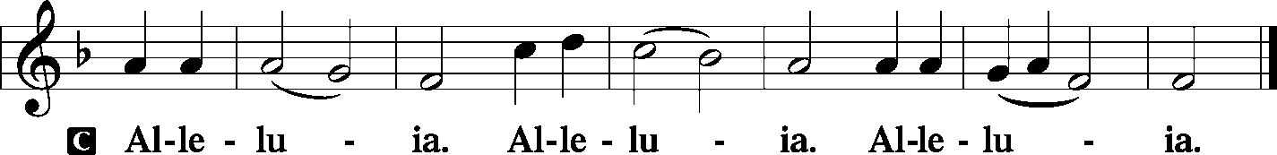

|  |  |  |
| --- | --- | --- |
|  | |  |
| HOLY GOSPEL | | Luke 10:1-20 |
| P: | The Holy Gospel according to St. Luke, the tenth chapter. | |
|  |  | |

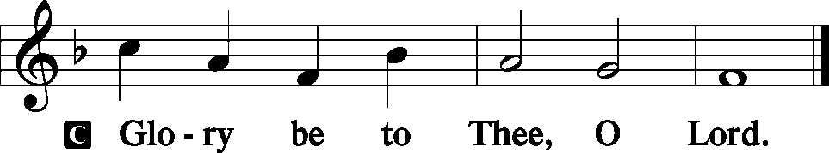

1After this the Lord appointed seventy-two others and sent them on ahead of Him, two by two, into every town and place where He himself was about to go. 2And He said to them, “The harvest is plentiful, but the laborers are few. Therefore pray earnestly to the Lord of the harvest to send out laborers into His harvest. 3Go your way; behold, I am sending you out as lambs in the midst of wolves. 4Carry no moneybag, no knapsack, no sandals, and greet no one on the road. 5Whatever house you enter, first say, ‘Peace be to this house!’ 6And if a son of peace is there, your peace will rest upon him. But if not, it will return to you. 7And remain in the same house, eating and drinking what they provide, for the laborer deserves his wages. Do not go from house to house. 8Whenever you enter a town and they receive you, eat what is set before you. 9Heal the sick in it and say to them, ‘The kingdom of God has come near to you.’ 10But whenever you enter a town and they do not receive you, go into its streets and say, 11‘Even the dust of your town that clings to our feet we wipe off against you. Nevertheless know this, that the kingdom of God has come near.’ 12I tell you, it will be more bearable on that day for Sodom than for that town.

13“Woe to you, Chorazin! Woe to you, Bethsaida! For if the mighty works done in you had been done in Tyre and Sidon, they would have repented long ago, sitting in sackcloth and ashes. 14But it will be more bearable in the judgment for Tyre and Sidon than for you. 15And you, Capernaum, will you be exalted to heaven? You shall be brought down to Hades. 16“The one who hears you hears Me, and the one who rejects you rejects Me, and the one who rejects Me rejects Him Who sent Me.”

17The seventy-two returned with joy, saying, “Lord, even the demons are subject to us in Your Name!” 18And He said to them, “I saw Satan fall like lightning from heaven. 19Behold, I have given you authority to tread on serpents and scorpions, and over all the power of the enemy, and nothing shall hurt you. 20Nevertheless, do not rejoice in this, that the spirits are subject to you, but rejoice that your names are written in heaven.”

|  |  |
| --- | --- |
|  |  |
| P: | This is the Gospel of our Lord. |
|  |  |

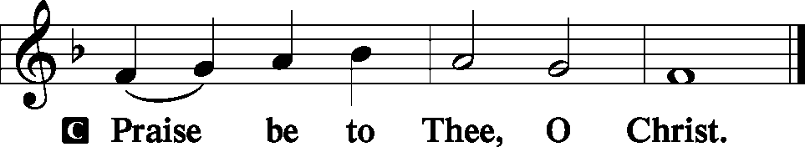

|  |  |  |  |  |  |
| --- | --- | --- | --- | --- | --- |
|  | | |  | | |
| NICENE CREED | | | *Page 191* | | |
| C: | I believe in one God, the Father Almighty, maker of heaven and earth and of all things visible and invisible.  And in one Lord Jesus Christ, the only-begotten Son of God, begotten of His Father before all worlds, God of God, Light of Light, very God of very God, begotten, not made, being of one substance with the Father, by Whom all things were made; Who for us men and for our salvation came down from heaven and was incarnate by the Holy Spirit of the virgin Mary and was made man; and was crucified also for us under Pontius Pilate. He suffered and was buried. And the third day He rose again according to the Scriptures and ascended into heaven and sits at the right hand of the Father. And He will come again with glory to judge both the living and the dead, Whose kingdom will have no end.  And I believe in the Holy Spirit, the Lord and giver of life, Who proceeds from the Father and the Son, Who with the Father and the Son together is worshiped and glorified, Who spoke by the prophets. And I believe in one holy Christian and apostolic Church, I acknowledge one Baptism for the remission of sins, and I look for the resurrection of the dead and the life **T** of the world to come. Amen. | | | | |
|  |  | | | | |
|  | *Please be seated.* | | | | |
|  |  | | | | |
| HYMN OF THE DAY | | *O Christ, Our True and Only Light* | | | LSB 839 |
|  | |  | | |  |
| SERMON | |  | |  | |
|  | |  | |  | |
|  | *Please stand.* | | |  | |
|  |  | | |  | |
| OFFERTORY | | *Create in Me* | | *Pages 192-193* | |
|  | |  | |  | |

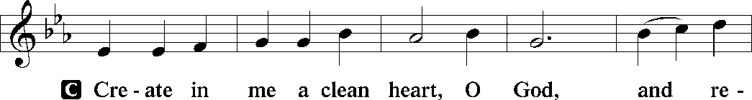

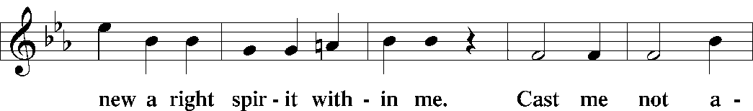

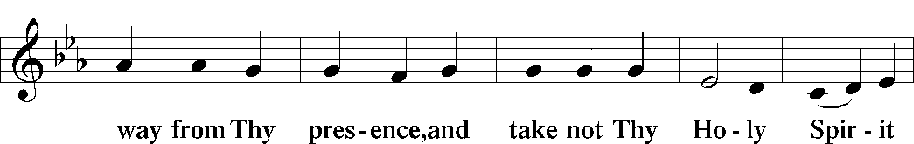

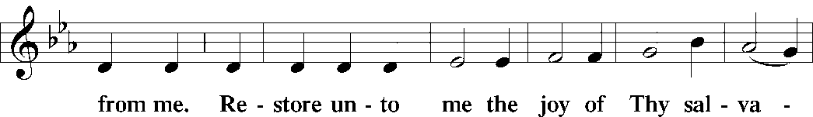

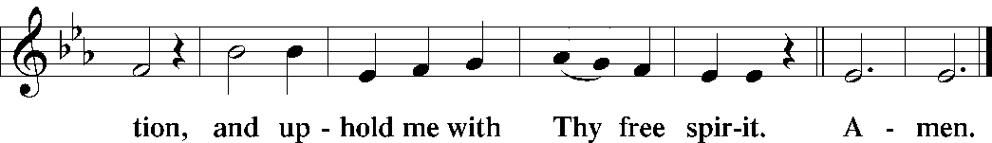

|  |  |  |
| --- | --- | --- |
|  |  | |
| PRAYER OF THE CHURCH | | |
|  | | |
| **HYMN** *Lamb of God LSB 550* | | |
|  | | |
| PREFACE | | *Page 194* |
|  | | |
| P: | The Lord be with you. | |
|  |  | |

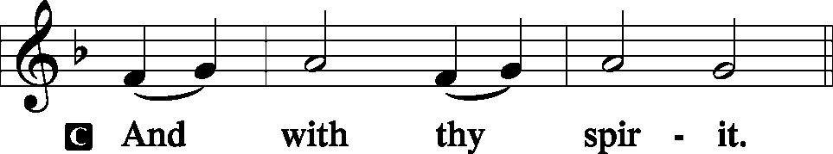

|  |  |
| --- | --- |
|  |  |
| P: | Lift up your hearts. |
|  |  |

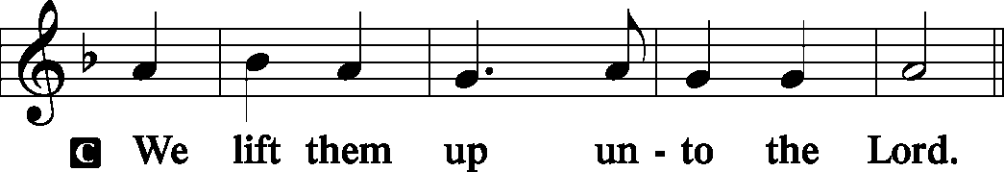

|  |  |
| --- | --- |
|  |  |
| P: | Let us give thanks unto the Lord, our God. |
|  |  |

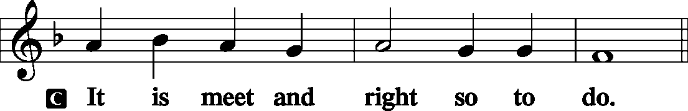

|  |  |  |  |  |
| --- | --- | --- | --- | --- |
|  | | | | |
| PROPER PREFACE | | | | |
| P: | It is truly meet, right, and salutary that we should at all times and in all places give thanks to You, holy Lord, almighty Father, everlasting God, through Jesus Christ, our Lord, who on this day overcame death and the grave and by His glorious resurrection opened to us the way of everlasting life. Therefore with angels and archangels and with all the company of heaven we laud and magnify Your glorious name, evermore praising You and singing: | | | |
|  |  | | | |
| SANCTUS | | *Holy, Holy, Holy* | | *Page 195* |
|  | | |  | |

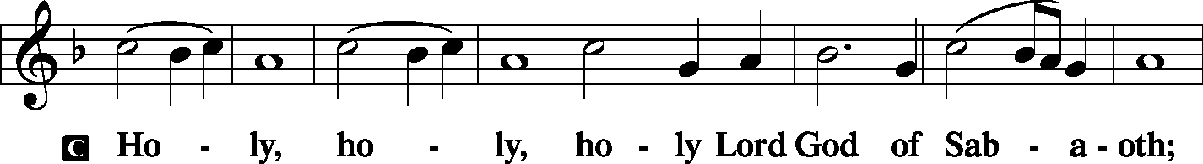

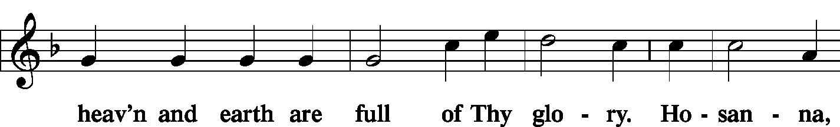

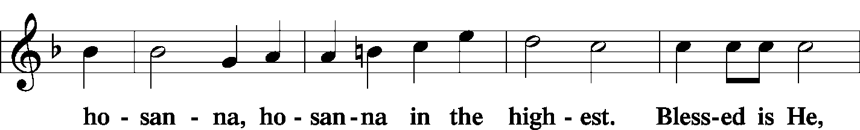

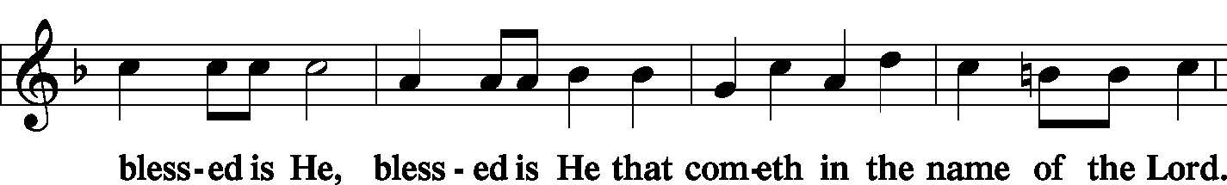

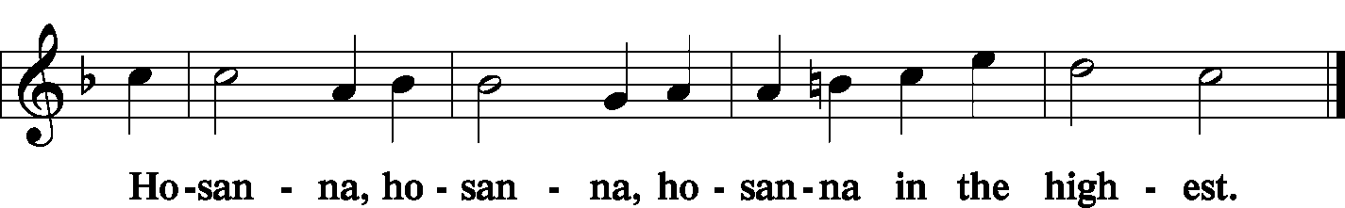

|  |  |  |  |  |
| --- | --- | --- | --- | --- |
|  | | |  | |
| LORD’S PRAYER | | | *Page 196* | |
| C: | Our Father Who art in heaven, hallowed be Thy name, Thy kingdom come, Thy will be done on earth as it is in heaven; give us this day our daily bread; and forgive us our trespasses as we forgive those who trespass against us; and lead us not into temptation, but deliver us from evil. For Thine is the kingdom and the power and the glory forever and ever. Amen. | | | |
|  | | |  | |
| WORDS OF OUR LORD | | | *Page 197* | |
| P: | Our Lord Jesus Christ, on the night when He was betrayed, took bread, and when He had given thanks, He broke it and gave it to the disciples and said: “Take, eat; this is My T body, which is given for you. This do in remembrance of Me.”  In the same way also He took the cup after supper, and when He had given thanks, He gave it to them, saying: “Drink of it, all of you; this cup is the new testament in My T blood, which is shed for you for the forgiveness of sins. This do, as often as you drink it, in remembrance of Me.” | | | |
|  |  | | | |
| PAX DOMINI | | *The Peace of the Lord* | | *Page 197* |
| P: | *The peace of the Lord be with you always.* | | |  |
|  |  | | |  |

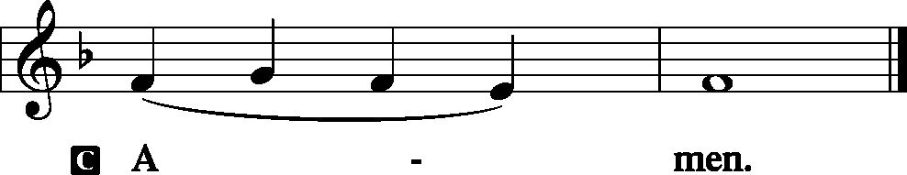

|  |  |  |  |
| --- | --- | --- | --- |
|  |  | |  |
|  | *Please be seated* | |  |
|  |  | |  |
| AGNUS DEI | | *Lamb of God* | *Page 198* |
|  | |  |  |



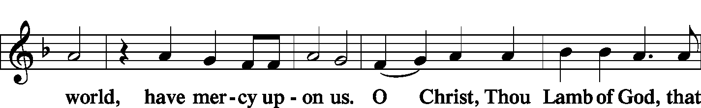

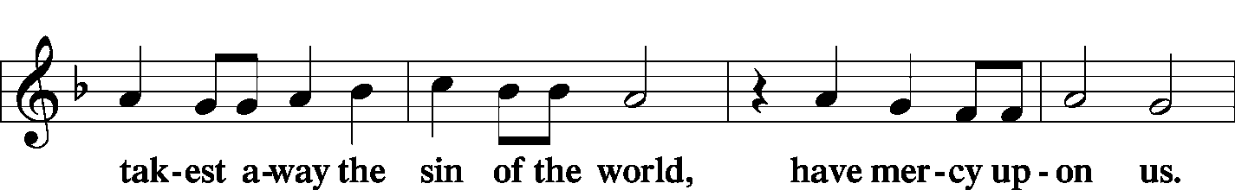

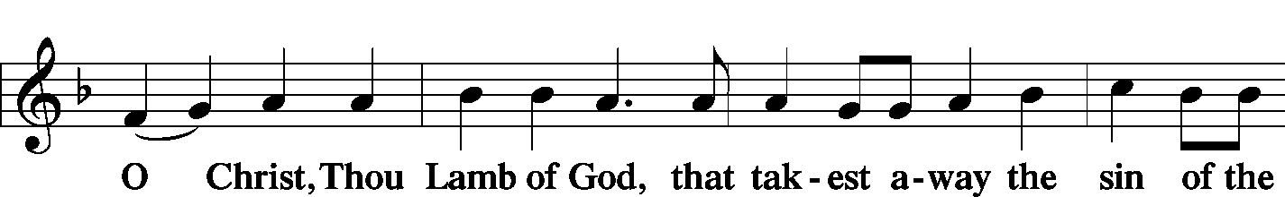



|  |  |  |  |  |  |
| --- | --- | --- | --- | --- | --- |
|  | | |  | |  |
|  | *Prayer before Communing: Dear Savior, at Your gracious invitation I come to Your table to eat and drink Your holy body and blood. Let me find favor in Your eyes to receive this holy Sacrament in faith for the salvation of my soul and to the glory of Your holy name; for You live and reign with the Father and the Holy Spirit, one God, now and forever. Amen.* | | | | |
|  |  | | | | |
|  | *Thanksgiving after Receiving the Sacrament: Almighty and everlasting God, I thank and praise You for feeding me the life-giving body and blood of Your beloved Son, Jesus Christ. Send Your Holy Spirit that, having with my mouth received the holy Sacrament, I may by faith obtain and eternally enjoy Your divine grace, the forgiveness of sins, unity with Christ, and life eternal; through Jesus Christ, my Lord. Amen.* | | | | |
|  |  | | | | |
| DISTRIBUTION | | | |  | |
|  | *LSB 636* | *Soul, Adorn Yourself with Gladness* | | | |
|  |  |  | | | |
|  | *LSB 617* | *O Lord, We Praise Thee* | | | |
|  |  |  | | | |
| POST-COMMUNION BLESSING | | | | | |
| P: | May the true Body of our Lord Jesus Christ, and His most precious Blood, strengthen you in true faith, granting you the forgiveness of sins, unto life everlasting. Depart in peace. | | | | |
| C: | Amen. | | | | |
|  |  | | | | |
| NUNC DIMITTIS | | *Lord, Now Lettest Thou Thy Servant*  *(Song of Simeon)* | | | *Pages 199-200* |
|  | |  | | |  |

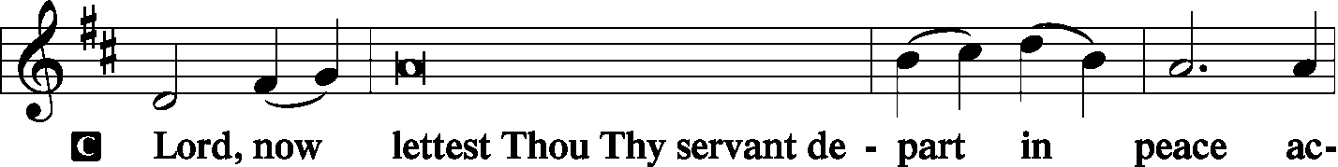

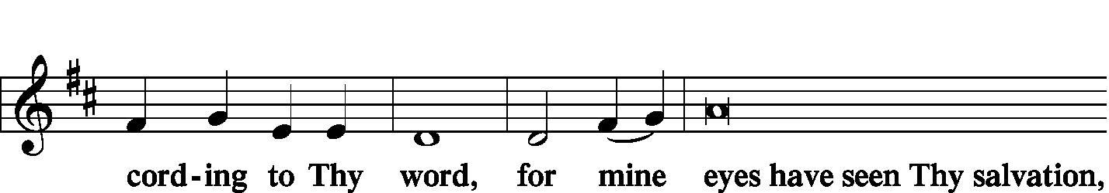

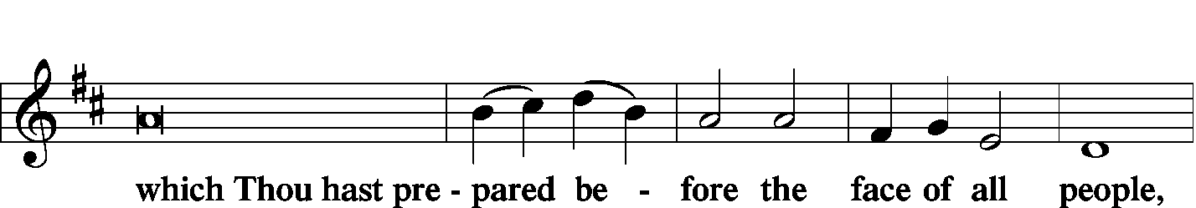

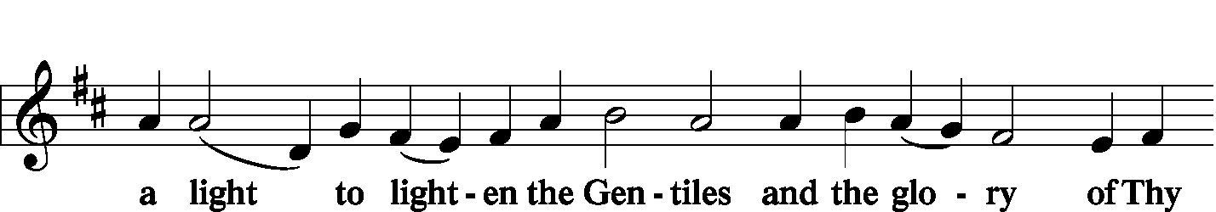

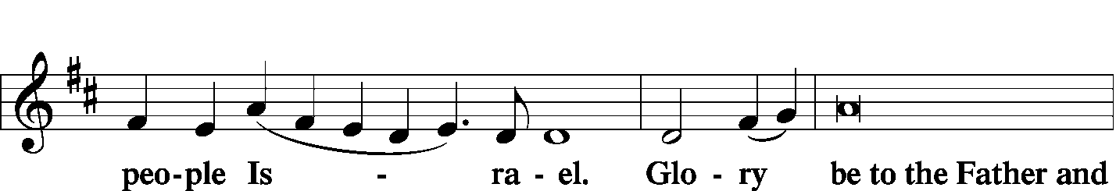

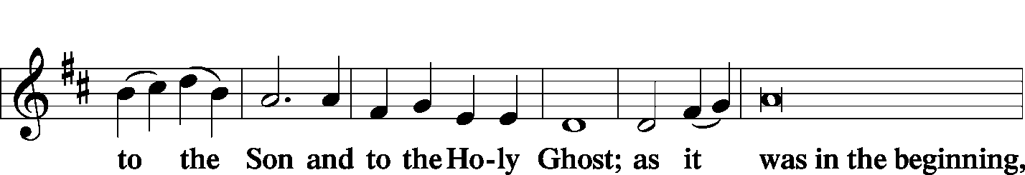

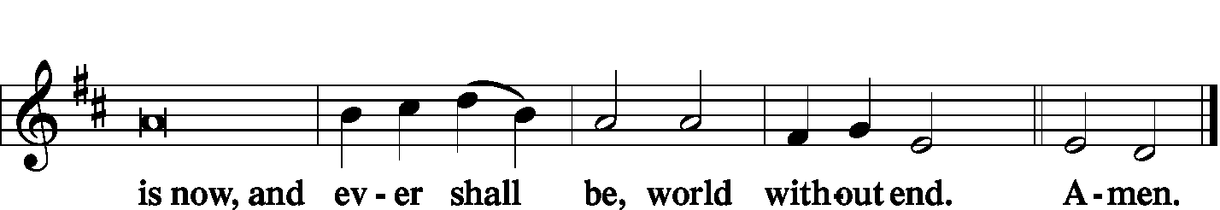

|  |  |  |  |
| --- | --- | --- | --- |
|  | |  |  |
| THANKSGIVING | |  | *Pages 200-01* |
| P: | O Give thanks unto the Lord, for He is good, | |  |
|  |  | |  |

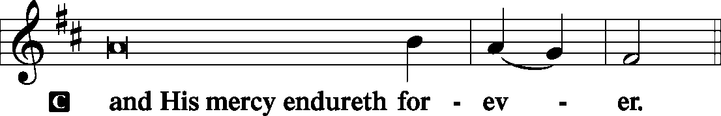

|  |  |
| --- | --- |
|  |  |
| P: | Let us pray.  We give thanks to You, almighty God, that You have refreshed us through this salutary gift, and we implore You that of Your mercy You would strengthen us through the same in faith toward You and in fervent love toward one another; through Jesus Christ, Your Son, our Lord, Who lives and reigns with You and the Holy Spirit, one God, now and forever. |
|  |  |



|  |  |  |  |
| --- | --- | --- | --- |
|  | |  |  |
| SALUTATION AND BENEDICAMUS | | | *Pages 201-02* |
| P: | The Lord be with you. | | |
|  |  | | |

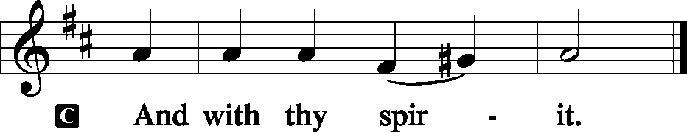

|  |  |
| --- | --- |
|  |  |
| P: | Bless we the Lord. |
|  |  |

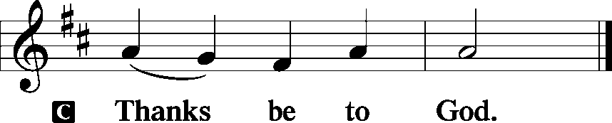

|  |  |  |
| --- | --- | --- |
|  | |  |
| BENEDICTION | | *Page 202* |
| P: | The Lord bless you and keep you.  The Lord make His face shine upon you and be gracious unto you.  The Lord lift up His countenance upon you and T give you peace. | |
|  |  | |

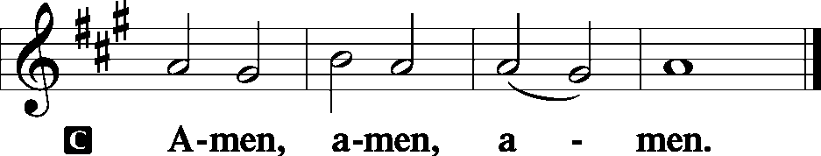

|  |  |  |  |  |
| --- | --- | --- | --- | --- |
|  | | | |  |
| CLOSING HYMN | | *Jesus Shall Reign* | | LSB 832 |
|  | |  | |  |
| SILENT PRAYER | |  | |  |
|  | *Almighty and merciful God, I have again worshiped in Your presence and received both forgiveness for my many sins and the assurance of Your love in Jesus Christ. I thank You for this undeserved grace and ask You to keep me in faith until, with all Your saints, I inherit eternal salvation; through Jesus Christ, my Lord. Amen.* | | | |
|  | |  | |  |
| ANNOUNCEMENTS | | |  |  |
|  | | |  |  |
| POSTLUDE | | |  |  |
|  | | |  |  |

T T T

Acknowledgments

Divine Service, Setting Three from Lutheran Service Book

Unless otherwise indicated, all scripture quotations are from *The Holy Bible, English Standard Version*, copyright © 2001 by Crossway Bibles, a division of Good News Publishers. Used by permission. All rights reserved.

Created by Lutheran Service Builder © 2006 Concordia Publishing House.

|  |  |  |
| --- | --- | --- |
| PASTOR | - | The Rev. Barry A. Long |
| ELDER | - | Dr. Joel Eckert |
| PIANIST | - | Nathan Anders |