|  |
| --- |
| Fifth Sunday after Pentecost |
| July 13, 2025 |
| + The Order of Matins + |
| Lutheran Service Book – Pages 219-228 |

|  |  |  |
| --- | --- | --- |
| Prayer Before Worship | |  |
|  | *O Lord, my Creator, Redeemer, and Comforter, as I come to worship You in spirit and in truth, I humbly pray that You would open my heart to the preaching of Your Word so that I may repent of my sins, believe in Jesus Christ as my only Savior, and grow in grace and holiness. Hear me for the sake of His name. Amen.* | |
|  |  | |
| PRELUDE | | |
|  | | |

|  |
| --- |
| RINGING BELL CALLS US TO WORSHIP |

|  |  |  |  |  |  |
| --- | --- | --- | --- | --- | --- |
|  | | |  | | |
| WELCOME | | |  | | |
|  | | |  | | |
| OPENING HYMN | | *LSB 845 Where Charity and Love Prevail* | | | |
|  | | | |  |
| CONFESSION AND DECLARATION OF FORGIVENESS | | | | *Page 151* |
| P: | Let us begin in the name of the Father and of the T Son and of the Holy Spirit. | | | |
| C: | Amen. | | | |
| P: | If we say we have no sin, we deceive ourselves, and the truth is not in us. | | | |
| C: | But if we confess our sins, God, Who is faithful and just, will forgive our sins and cleanse us from all unrighteousness. | | | |
|  |  | | | |
|  | *(Silence for reflection on God’s Word and for self-examination.)* | | | |
|  |  | | | |
| P: | Let us then confess our sins to God our Father. | | | |
| C: | **Most merciful God, we confess that we are by nature sinful and unclean. We have sinned against You in thought, word, and deed, by what we have done and by what we have left undone. We have not loved You with our whole heart; we have not loved our neighbors as ourselves. We justly deserve Your present and eternal punishment. For the sake of Your Son, Jesus Christ, have mercy on us. Forgive us, renew us, and lead us, so that we may delight in Your will and walk in Your ways to the glory of Your holy name. Amen.** | | | |

|  |  |
| --- | --- |
| P: | The Holy Scriptures assure us that Almighty God in His mercy has given His Son to die for us and for His sake forgives us all our sins. Let us go in peace. |
| C: | Amen. |
|  |  |
| L: | O Lord, open my lips,, |



|  |  |
| --- | --- |
|  |  |
| L: | Make haste, O God, to deliver me: |



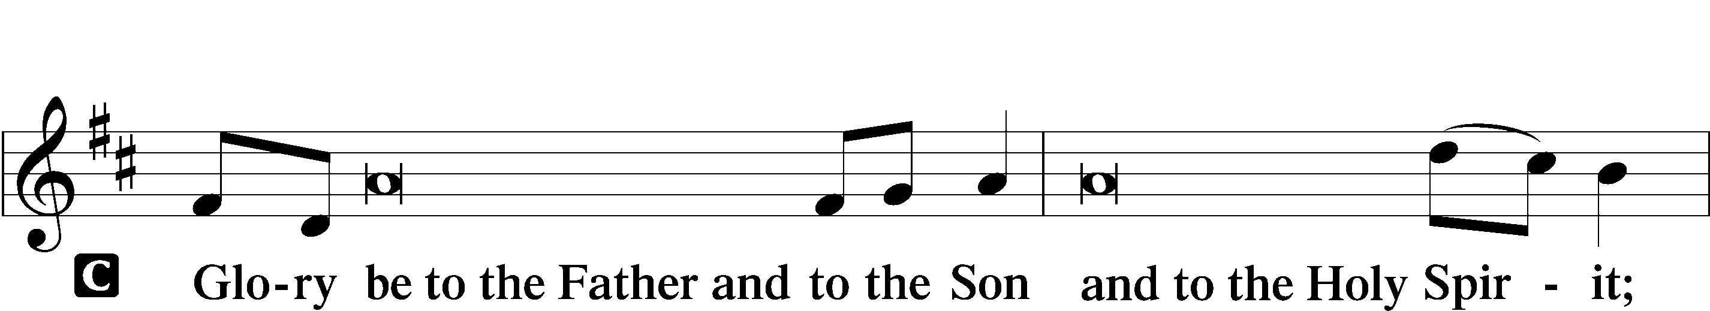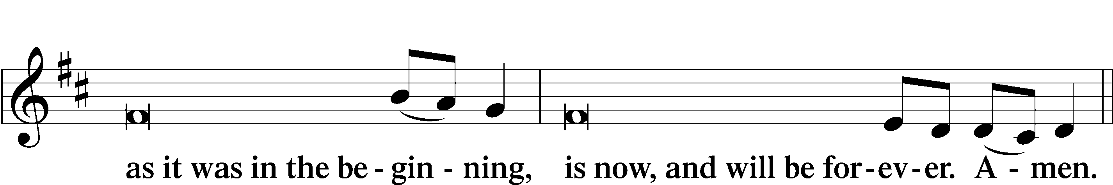

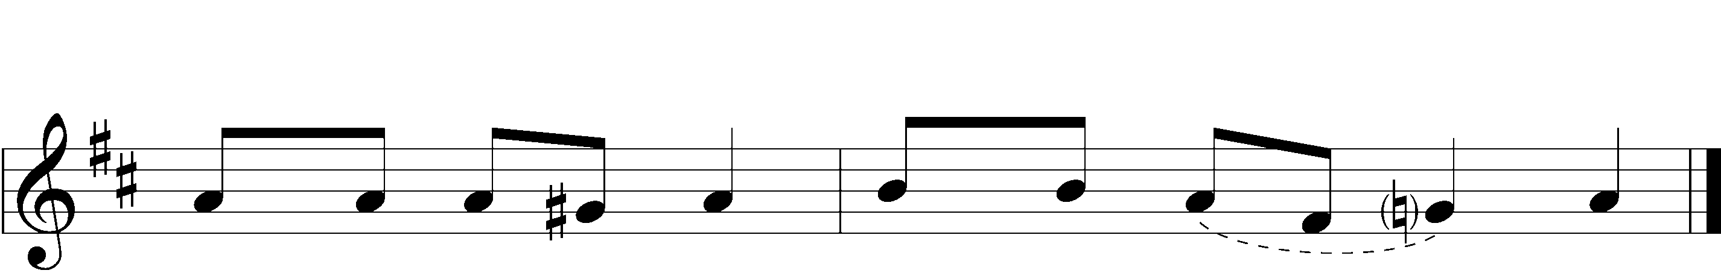



|  |  |  |  |
| --- | --- | --- | --- |
|  |  | | |
| PSALMODY | | Venite | *O Come, Let Us Sing* |
|  | Antiphon | | |
|  |  | | |
| L: | The Lord has gathered us in the true faith. | | |



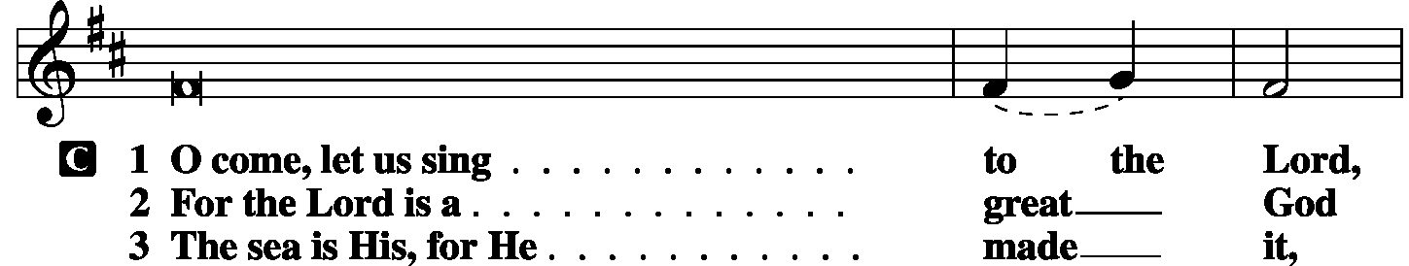

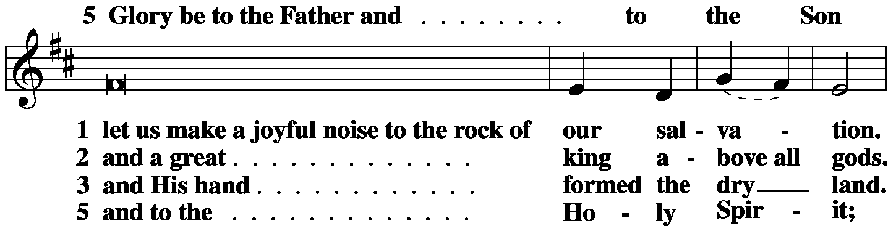

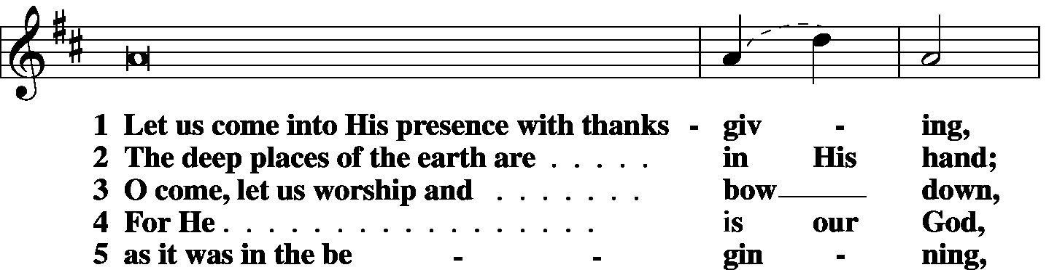

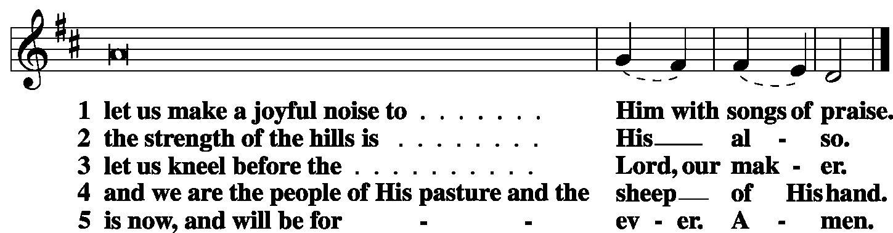

|  |  |
| --- | --- |
|  |  |
| L: | The Lord has gathered us in the true faith. |



|  |  |  |  |
| --- | --- | --- | --- |
|  |  |  |  |

|  |  |  |  |
| --- | --- | --- | --- |
|  | Second Psalm | Psalm 41 | *(Spoken responsively by verse)* |
|  |  |  | |

Blessèd is the one who considers the poor!

In the day of trouble the Lord delivers him;

the Lord protects him and keeps him alive;

he is called blesséd in the land;

you do not give him up to the will of his enemies.

The Lord sustains him on his sickbed;

in his illness You restore him to full health.

As for me, I said, “O Lord, be gracious to me;

heal me, for I have sinned against You!”

My enemies say of me in malice,

“When will he die and his name perish?”

And when one comes to see me, he utters empty words,

while his heart gathers iniquity;

when he goes out, he tells it abroad.

All who hate me whisper together about me;

they imagine the worst for me.

They say, “A deadly thing is poured out on him;

he will not rise again from where he lies.”

Even my close friend in whom I trusted,

who ate my bread, has lifted his heel against me.

But You, O Lord, be gracious to me,

and raise me up, that I may repay them!

By this I know that You delight in me:

my enemy will not shout in triumph over me.

But You have upheld me because of my integrity,

and set me in Your presence forever.

Blessèd be the Lord, the God of Israel,

from everlasting to everlasting! Amen and Amen.

Glory be to the Father and to the Son

and to the Holy Spirit;

as it was in the beginning,

is now, and will be forever. Amen.

|  |  |  |  |
| --- | --- | --- | --- |
|  |  | |  |
| OFFICE HYMN | LSB *870 Now That the Daylight Fills the Sky* | | |
|  |  | |  |
|  | |  | |

|  |  |
| --- | --- |
| FIRST LESSON | Leviticus 18:1-5, 19:9-18 |

18:1 The Lord spoke to Moses, saying, 2“Speak to the people of Israel and say to them, I am the Lord your God. 3You shall not do as they do in the land of Egypt, where you lived, and you shall not do as they do in the land of Canaan, to which I am bringing you. You shall not walk in their statutes.

4You shall follow my just decrees and keep my statutes and walk in them. I am the Lord your God. 5You shall therefore keep my statutes and my just decrees if a person does them, he shall live by them: I am the Lord.

19:9“When you reap the harvest of your land, you shall not reap your field right up to its edge, neither shall you gather the gleanings after your harvest. 10And you shall not strip your vineyard bare, neither shall you gather the fallen grapes of your vineyard. You shall leave them for the poor and for the sojourner: I am the Lord your God.

11“You shall not steal; you shall not deal falsely; you shall not lie to one another. 12You shall not swear by my name falsely, and so profane the name of your God: I am the Lord.

13“You shall not oppress your neighbor or rob him. The wages of a hired servant shall not remain with you all night until the morning. 14You shall not curse the deaf or put a stumbling block before the blind, but you shall fear your God: I am the Lord.

15“You shall do no injustice in court. You shall not be partial to the poor or defer to the great, but in righteousness shall you judge your neighbor. 16You shall not go around as a slanderer among your people, and you shall not stand up against the life of your neighbor: I am the Lord.

17“You shall not hate your brother in your heart, but you shall reason frankly with your neighbor, lest you incur sin because of him. 18You shall not take vengeance or bear a grudge against the sons of your own people, but you shall love your neighbor as yourself: I am the Lord.

|  |  |  |  |  |
| --- | --- | --- | --- | --- |
|  |  | |  | |
| L: | O Lord, have mercy on us. | | | |
| C: | **Thanks be to God.** | | | |
|  | |  | |  |
| EPISTLE LESSON | | Colossians 1:1-14 | | |

1Paul, an apostle of Christ Jesus by the will of God, and Timothy our brother,

2To the saints and faithful brothers in Christ at Colossae: Grace to you and peace from God our Father.

3We always thank God, the Father of our Lord Jesus Christ, when we pray for you, 4since we heard of your faith in Christ Jesus and of the love that you have for all the saints, 5because of the hope laid up for you in heaven. Of this you have heard before in the word of the truth, the gospel, 6which has come to you, as indeed in the whole world it is bearing fruit and growing—as it also does among you, since the day you heard it and understood the grace of God in truth, 7just as you learned it from Epaphras our beloved fellow servant. He is a faithful minister of Christ on your behalf 8and has made known to us your love in the Spirit.

9And so, from the day we heard, we have not ceased to pray for you, asking that you may be filled with the knowledge of His will in all spiritual wisdom and understanding, 10so as to walk in a manner worthy of the Lord, fully pleasing to Him, bearing fruit in every good work and increasing in the knowledge of God. 11May you be strengthened with all power, according to His glorious might, for all endurance and patience with joy, 12giving thanks to the Father, Who has qualified you to share in the inheritance of the saints in light. 13He has delivered us from the domain of darkness and transferred us to the kingdom of His beloved Son, 14in Whom we have redemption, the forgiveness of sins.

|  |  |  |  |
| --- | --- | --- | --- |
|  | |  | |
| L: | | O Lord, have mercy. | |
| C: | | **Thanks be to God.** | |
|  |  | |  |

|  |  |  |  |  |  |  |
| --- | --- | --- | --- | --- | --- | --- |
| GOSPEL VERSE | | | | | Luke 10:27 | |
| L: | Alleluia. You shall love the Lord your God with all your heart and with all your soul and with all your strength and with all your mind, | | | | | |
| C: | and your neighbor as yourself. Alleluia. | | | | |
|  |  | |  | | | |
| HOLY GOSPEL | | | | Luke 10:25-37 | |
| L: | | The Holy Gospel according to St. Luke, the tenth chapter. | | | |
| C: | | **Glory to You, O Lord.** | | | |
|  | |  | | | |

25And behold, a lawyer stood up to put Him to the test, saying, “Teacher, what shall I do to inherit eternal life?” 26He said to him, **“What is written in the Law? How do you read it?”** 27And he answered, “You shall love the Lord your God with all your heart and with all your soul and with all your strength and with all your mind, and your neighbor as yourself.” 28And He said to him, **“You have answered correctly; do this, and you will live.”**

29But he, desiring to justify himself, said to Jesus, “And who is my neighbor?” 30Jesus replied, **“A man was going down from Jerusalem to Jericho, and he fell among robbers, who stripped him and beat him and departed, leaving him half dead. 31Now by chance a priest was going down that road, and when he saw him he passed by on the other side. 32So likewise a Levite, when he came to the place and saw him, passed by on the other side. 33But a Samaritan, as he journeyed, came to where he was, and when he saw him, he had compassion. 34He went to him and bound up his wounds, pouring on oil and wine. Then he set him on his own animal and brought him to an inn and took care of him. 35And the next day he took out two denarii and gave them to the innkeeper, saying, ‘Take care of him, and whatever more you spend, I will repay you when I come back.’ 36Which of these three, do you think, proved to be a neighbor to the man who fell among the robbers?”** 37He said, “The one who showed him mercy.” And Jesus said to him, “**You go, and do likewise.”**

|  |  |  |  |  |  |
| --- | --- | --- | --- | --- | --- |
|  | |  | | | |
| L: | This is the Gospel of the Lord. | | |
| C: | **Praise to You, O Christ.** | | | |
|  | | |  | | |

|  |  |  |
| --- | --- | --- |
| RESPONSORY | |  |
| L: | Forever, O Lord, Your Word is firmly set in the heavens. | |

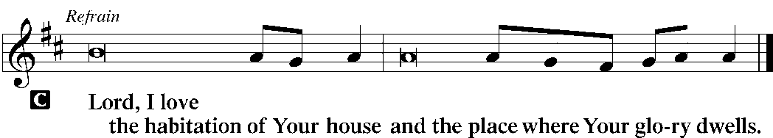

|  |  |
| --- | --- |
| L: | Blessed are those who hear the Word of God and keep it. |



|  |  |
| --- | --- |
| L: | Glory be to the Father and to the Son and to the Holy Spirit. |



|  |  |
| --- | --- |
|  |  |
| HYMN OF THE DAY | LSB *852 O God of Mercy, God of Might* |
|  | |
| SERMON | |
|  | |

|  |  |  |  |
| --- | --- | --- | --- |
| CANTICLE | **Te Deum** (*We Praise You, O God)* | | *LSB p. 223* |
|  |  |  | |

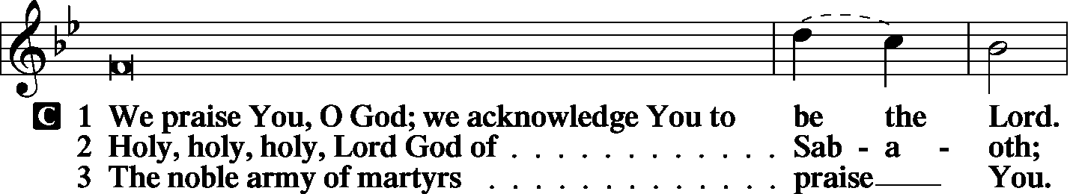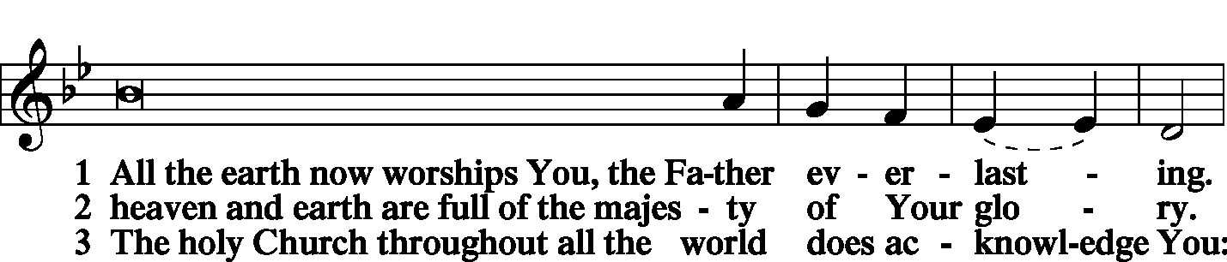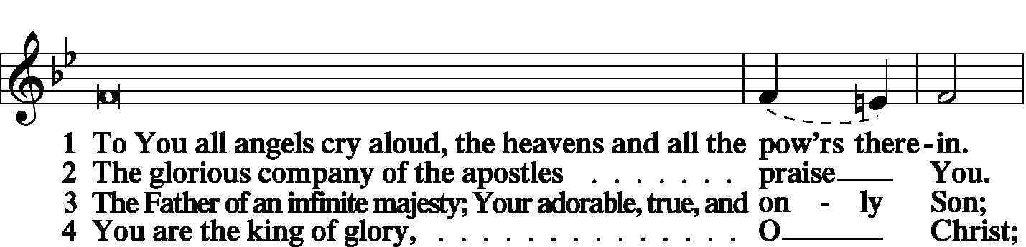

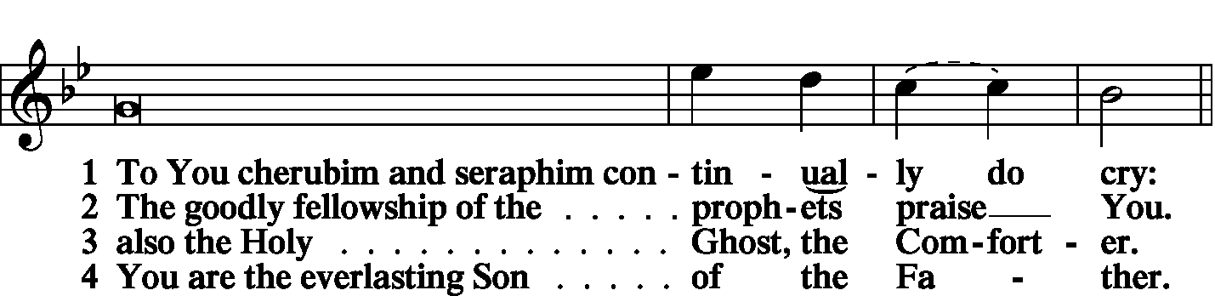

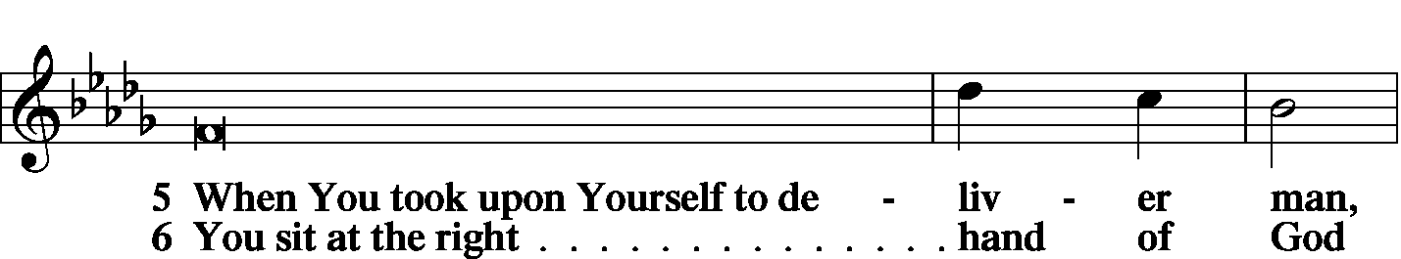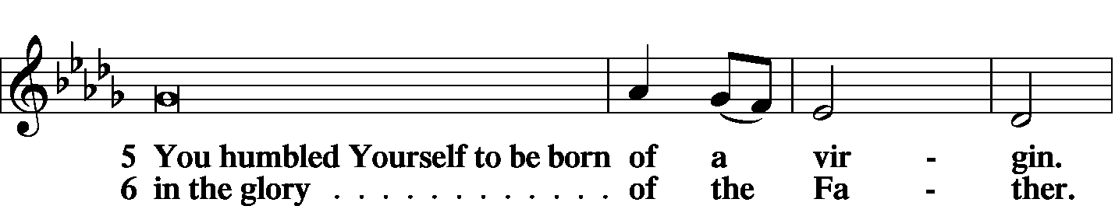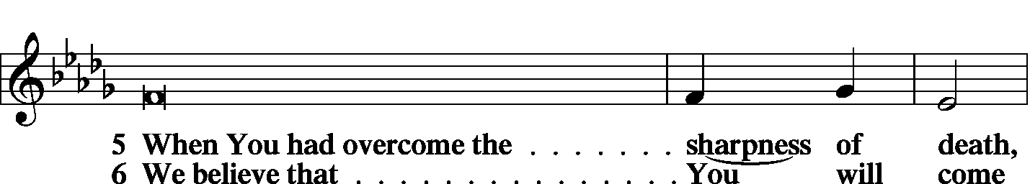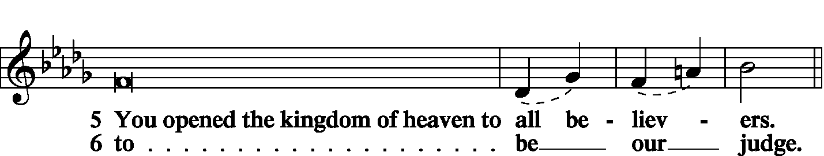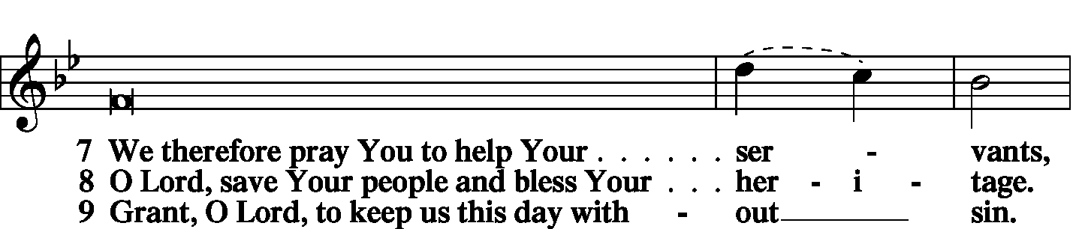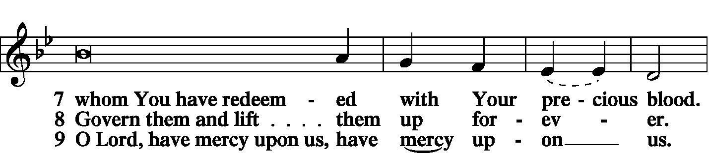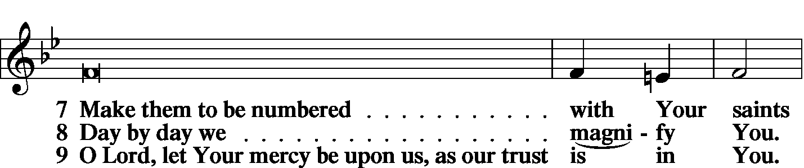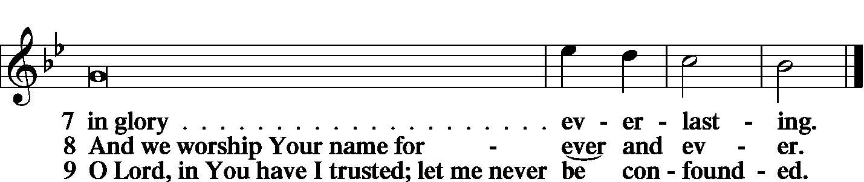

|  |  |  |
| --- | --- | --- |
|  | |  |
| PRAYER OF THE CHURCH | | |
|  | |  |
|  | Kyrie |  |

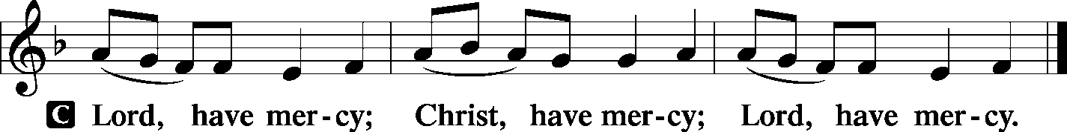

|  |  |
| --- | --- |
|  |  |
|  | Lord’s Prayer |
| C: | Our Father Who art in heaven, hallowed be Thy name, Thy kingdom come, Thy will be done on earth as it is in heaven; give us this day our daily bread; and forgive us our trespasses as we forgive those who trespass against us; and lead us not into temptation, but deliver us from evil. For Thine is the kingdom and the power and the glory forever and ever. Amen. |
|  |  |
| Collects | |
| L: | The Lord be with you. |

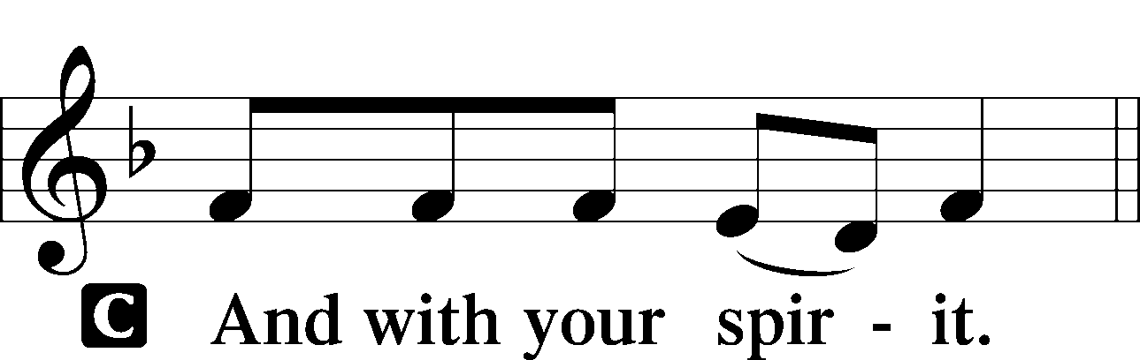

|  |  |
| --- | --- |
|  | Collect of the Day |
| L: | Lord Jesus Christ, in Your deep compassion You rescue us from whatever may hurt us. Teach us to love You above all things and to love our neighbors as ourselves. In Your Name we pray. |



|  |  |
| --- | --- |
|  | Collect for Matins |
| L: | Almighty God, heavenly Father, Your mercies are new to us every morning, and You abundantly provide for all our wants of body and soul. Give us we humbly pray, Your Holy Spirit that we may heartily acknowledge Your merciful goodness toward us, give thanks for all Your benefits, and cheerfully serve You. |



|  |  |  |
| --- | --- | --- |
|  | For Guidance in Our Calling | *LSB p. 311* |
| L: | Lord God, You have called Your servants to ventures of which we cannot see the ending, by paths as yet untrodden, through perils unknown. Give us faith to go out with good courage, not knowing where we go but only that Your hand is leading us and Your love supporting us; through Jesus Christ, our Lord. | |



|  |  |  |
| --- | --- | --- |
|  | For Responsible Citizenship | *LSB p.313* |
| L: | Lord, keep this nation under Your care. Bless the leaders of our land that we may be a people at peace among ourselves and a blessing to the other nations of the earth. Grant that we may choose trustworthy leaders, contribute to wise decisions for the general welfare, and serve You faithfully in our generation; through Jesus Christ, our Lord. | |



|  |  |
| --- | --- |
| L | May the Lord hear the prayers we name in our hearts....…… Lord, in Your mercy: |
| C: | Hear our prayer. |

|  |  |  |
| --- | --- | --- |
|  | Collect for Grace | *LSB p.228* |
| L: | O Lord, our heavenly Father, almighty and everlasting God, You have safely brought us to the beginning of this day. Defend us in the same with Your mighty power and grant that this day we fall into no sin, neither run into any kind of danger, but that all our doings, being ordered by Your governance, may be righteous in Your sight; through Jesus Christ, Your Son, our Lord, Who lives and reigns with You and the Holy Spirit, one God, now and forever. | |



|  |  |  |
| --- | --- | --- |
| BENEDICAMUS | | *LSB p. 227* |
| L: | Let us bless the Lord. | |

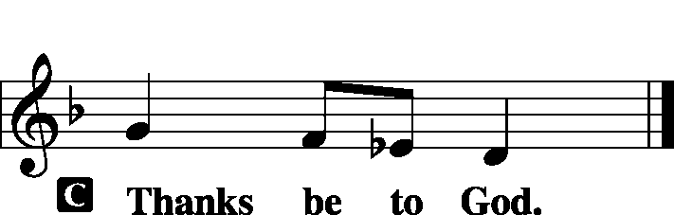

|  |  |  |
| --- | --- | --- |
|  | |  |
| BENEDICTION | |  |
| L: | The grace of our Lord T Jesus Christ and the love of God and the communion of the Holy Spirit be with us all. | |



|  |  |  |  |  |  |  |
| --- | --- | --- | --- | --- | --- | --- |
|  | | |  | |  | |
| CLOSING HYMN | | LSB *844 Lord of All Nations, Grant Me Grace* | | | | |
|  | |  | | | |  |
| SILENT PRAYER | | |  | |  | | |
|  | *Almighty and merciful God, I have again worshiped in Your presence and received both forgiveness for my many sins and the assurance of Your love in Jesus Christ. I thank You for this undeserved grace and ask You to keep me in faith until, with all Your saints, I inherit eternal salvation; through Jesus Christ, my Lord. Amen.* | | | | | | |
|  | | | | | | | |
| T T T | | | | | | | |
|  | | | | | | | |
| Worship Leader: Tom Brosowske | | | |  | | | |
| Elder: Tom Brosowske | | | | | | | |
| Organist: Carol Wessler | | | | | | | |
|  | | | | | | | |

Acknowledgments

Matins from Lutheran Service Book

Unless otherwise indicated, all scripture quotations are from *The Holy Bible, English Standard Version*, copyright © 2001 by Crossway Bibles, a division of Good News Publishers. Used by permission. All rights reserved.

Created by Lutheran Service Builder © 2006 Concordia Publishing House.