|  |
| --- |
| Sixth Sunday after Pentecost |
| July 20, 2025 |
| + The Order of Matins + |
| Lutheran Service Book – Pages 219-228 |

|  |  |  |
| --- | --- | --- |
| Prayer Before Worship | |  |
|  | *O Lord, my Creator, Redeemer, and Comforter, as I come to worship You in spirit and in truth, I humbly pray that You would open my heart to the preaching of Your Word so that I may repent of my sins, believe in Jesus Christ as my only Savior, and grow in grace and holiness. Hear me for the sake of His name. Amen.* | |
|  |  | |
| PRELUDE | | |
|  | | |

|  |
| --- |
| RINGING BELL CALLS US TO WORSHIP |

|  |  |  |  |  |  |
| --- | --- | --- | --- | --- | --- |
|  | | |  | | |
| WELCOME | | |  | | |
|  | | |  | | |
| OPENING HYMN | | *LSB 537 Beautiful Savior* | | | |
|  | | | |  |
| CONFESSION AND DECLARATION OF FORGIVENESS | | | | *Page 151* |
| P: | Let us begin in the name of the Father and of the T Son and of the Holy Spirit. | | | |
| C: | Amen. | | | |
| P: | If we say we have no sin, we deceive ourselves, and the truth is not in us. | | | |
| C: | But if we confess our sins, God, Who is faithful and just, will forgive our sins and cleanse us from all unrighteousness. | | | |
|  |  | | | |
|  | *(Silence for reflection on God’s Word and for self-examination.)* | | | |
|  |  | | | |
| P: | Let us then confess our sins to God our Father. | | | |
| C: | **Most merciful God, we confess that we are by nature sinful and unclean. We have sinned against You in thought, word, and deed, by what we have done and by what we have left undone. We have not loved You with our whole heart; we have not loved our neighbors as ourselves. We justly deserve Your present and eternal punishment. For the sake of Your Son, Jesus Christ, have mercy on us. Forgive us, renew us, and lead us, so that we may delight in Your will and walk in Your ways to the glory of Your holy name. Amen.** | | | |

|  |  |
| --- | --- |
| P: | The Holy Scriptures assure us that Almighty God in His mercy has given His Son to die for us and for His sake forgives us all our sins. Let us go in peace. |
| C: | Amen. |
|  |  |
| L: | O Lord, open my lips,, |



|  |  |
| --- | --- |
|  |  |
| L: | Make haste, O God, to deliver me: |



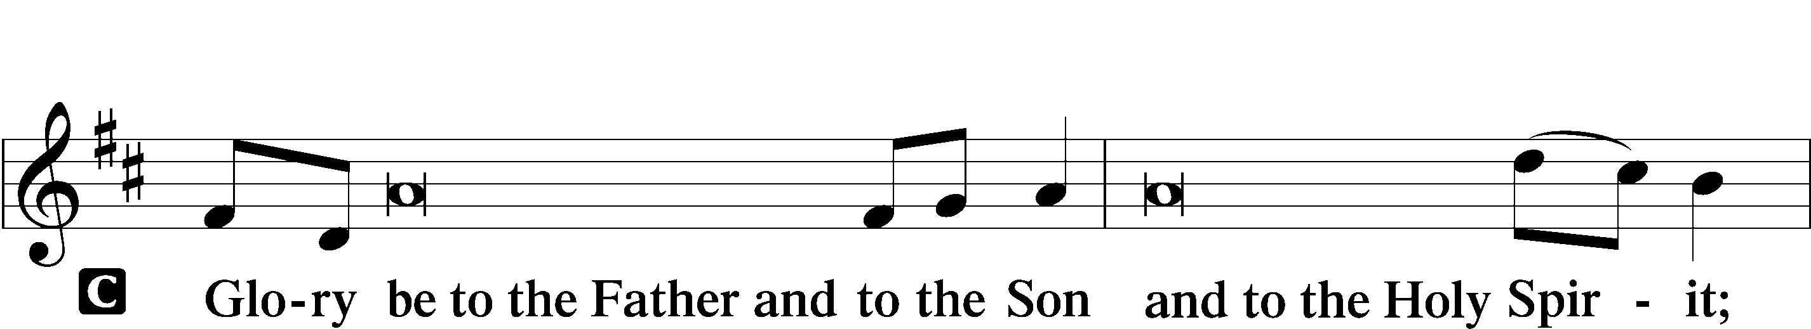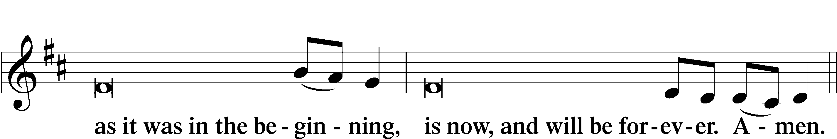

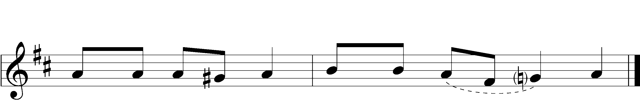



|  |  |  |  |
| --- | --- | --- | --- |
|  |  | | |
| PSALMODY | | Venite | *O Come, Let Us Sing* |
|  | Antiphon | | |
|  |  | | |
| L: | The Lord has gathered us in the true faith. | | |



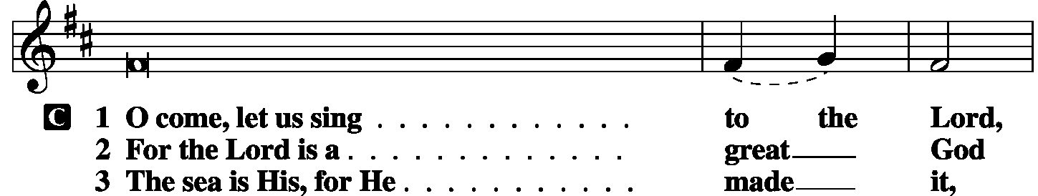

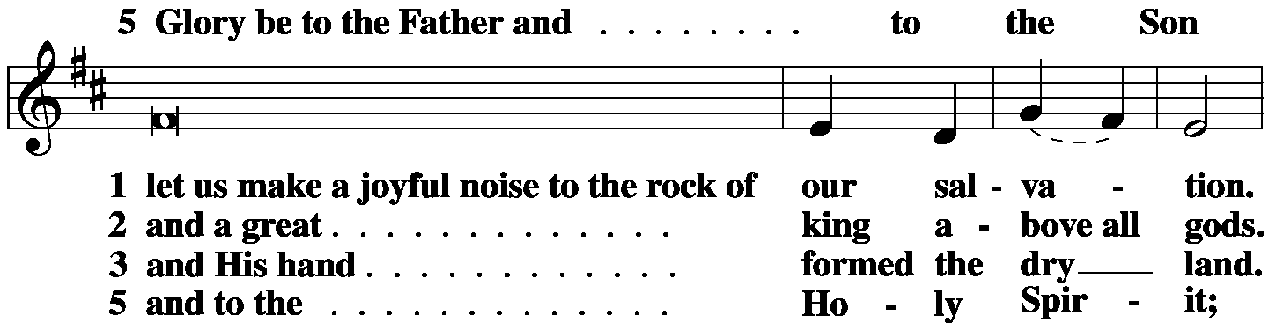

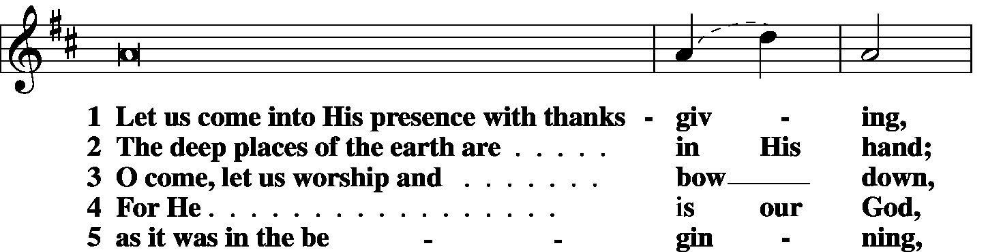

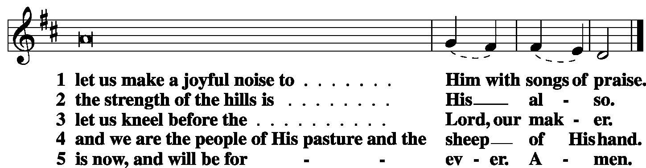

|  |  |
| --- | --- |
|  |  |
| L: | The Lord has gathered us in the true faith. |



|  |  |  |  |
| --- | --- | --- | --- |
|  |  |  |  |

|  |  |  |  |
| --- | --- | --- | --- |
|  | Second Psalm | Psalm 27 | *(Spoken responsively by verse)* |
|  |  |  | |

The Lord is my light and my salvation; whom shall I fear?

The Lord is the stronghold of my life; of whom shall I be afraid?

When evildoers assail me to eat up my flesh,

my adversaries and foes, it is they who stumble and fall.

Though an army encamp against me, my heart shall not fear;

though war arise against me, yet I will be confident.

One thing have I asked of the Lord, that will I seek after:

that I may dwell in the house of the Lord all the days of my life,

to gaze upon the beauty of the Lord and to inquire in His temple.

For He will hide me in His shelter in the day of trouble;

He will conceal me under the cover of His tent;

He will lift me high upon a rock.

And now my head shall be lifted up above my enemies all around me,

and will offer in his tent sacrifices with shouts of joy;

I will sing and make melody to the Lord.

Hear, O Lord, when I cry aloud;

be gracious to me and answer me!

You have said, “Seek My face.”

My heart says to You, “Your face, Lord, do I seek.”

Hide not Your face from me. Turn not your servant away in anger,

O You Who have been my help. Cast me not off; forsake me not,

O God of my salvation!

For my father and my mother have forsaken me,**\***

but the Lord will take me in.

Teach me Your way, O Lord,

and lead me on a level path because of my enemies.

Give me not up to the will of my adversaries;

for false witnesses have risen against me,

and they breathe out violence.

I believe that I shall look upon the goodness of the Lord

in the land of the living!

Wait for the Lord;

be strong, and let your heart take courage; wait for the Lord!

**Glory be to the Father and to the Son**

**and to the Holy Spirit;**

**as it was in the beginning,**

**is now, and will be forever. Amen.**

|  |  |  |  |
| --- | --- | --- | --- |
|  |  | |  |
| OFFICE HYMN | LSB *872 Come, Thou Bright and Morning Star* | | |
|  |  | |  |
|  | |  | |
| FIRST LESSON | | Genesis 18:1-14 | |

1 The Lord appeared to [Abraham] by the oaks of Mamre, as he sat at the door of his tent in the heat of the day.

2He lifted up his eyes and looked, and behold, three men were standing in front of him. When he saw them, he ran from the tent door to meet them and bowed himself to the earth 3and said, “O Lord, if I have found favor in your sight, do not pass by your servant. 4Let a little water be brought, and wash your feet, and rest yourselves under the tree, 5while I bring a morsel of bread, that you may refresh yourselves, and after that you may pass on—since you have come to your servant.” So they said, “Do as you have said.” 6And Abraham went quickly into the tent to Sarah and said, “Quick! Three seahs of fine flour! Knead it, and make cakes.” 7And Abraham ran to the herd and took a calf, tender and good, and gave it to a young man, who prepared it quickly. 8Then he took curds and milk and the calf that he had prepared, and set it before them. And he stood by them under the tree while they ate.

9They said to him, “Where is Sarah your wife?” And he said, “She is in the tent.” 10The Lord said, “I will surely return to you about this time next year, and Sarah your wife shall have a son.” And Sarah was listening at the tent door behind him. 11Now Abraham and Sarah were old, advanced in years. The way of women had ceased to be with Sarah. 12So Sarah laughed to herself, saying, “After I am worn out, and my lord is old, shall I have pleasure?” 13The Lord said to Abraham, “Why did Sarah laugh and say, ‘Shall I indeed bear a child, now that I am old?’ 14Is anything too hard for the Lord? At the appointed time I will return to you about this time next year, and Sarah shall have a son.”

|  |  |  |  |  |
| --- | --- | --- | --- | --- |
|  |  | |  | |
| L: | O Lord, have mercy on us. | | | |
| C: | **Thanks be to God.** | | | |
|  | |  | |  |
| EPISTLE LESSON | | Colossians 1:21-29 | | |

21 You, who once were alienated and hostile in mind, doing evil deeds, 22He has now reconciled in His body of flesh by His death, in order to present you holy and blameless and above reproach before Him, 23if indeed you continue in the faith, stable and steadfast, not shifting from the hope of the gospel that you heard, which has been proclaimed in all creation under heaven, and of which I, Paul, became a minister.

24Now I rejoice in my sufferings for your sake, and in my flesh I am filling up what is lacking in Christ’s afflictions for the sake of His body, that is, the church, 25of which I became a minister according to the stewardship from God that was given to me for you, to make the word of God fully known, 26the mystery hidden for ages and generations but now revealed to His saints. 27To them God chose to make known how great among the Gentiles are the riches of the glory of this mystery, which is Christ in you, the hope of glory. 28Him we proclaim, warning everyone and teaching everyone with all wisdom, that we may present everyone mature in Christ. 29For this I toil, struggling with all His energy that He powerfully works within me.

|  |  |  |  |  |  |  |  |  |
| --- | --- | --- | --- | --- | --- | --- | --- | --- |
|  | |  | | | | | | |
| L: | | O Lord, have mercy. | | | | | | |
| C: | | **Thanks be to God.** | | | | | | |
|  |  | | | | | |  | |
| GOSPEL VERSE | | | | | | Colossians 2:6b-7a | | |
| L: | | Alleluia. As you received Christ Jesus the Lord, so walk in Him, | | | | | | |
| C: | | rooted and built up in him. Alleluia. | | | | | |
|  | |  | |  | | | | |
| HOLY GOSPEL | | | | | Luke 10:38-42 | | |
| L: | | | The Holy Gospel according to St. Luke, the tenth chapter. | | | | |
| C: | | | **Glory to You, O Lord.** | | | | |
|  | | |  | | | | |

38Now as they went on their way, Jesus entered a village. And a woman named Martha welcomed Him into her house. 39And she had a sister called Mary, who sat at the Lord’s feet and listened to His teaching. 40But Martha was distracted with much serving. And she went up to Him and said, “Lord, do You not care that my sister has left me to serve alone? Tell her then to help me.” 41But the Lord answered her, **“Martha, Martha, you are anxious and troubled about many things, 42but one thing is necessary. Mary has chosen the good portion, which will not be taken away from her.”**

|  |  |  |  |  |  |
| --- | --- | --- | --- | --- | --- |
|  | |  | | | |
| L: | This is the Gospel of the Lord. | | |
| C: | **Praise to You, O Christ.** | | | |
|  | | |  | | |

|  |  |  |
| --- | --- | --- |
| RESPONSORY | |  |
| L: | Forever, O Lord, Your Word is firmly set in the heavens. | |

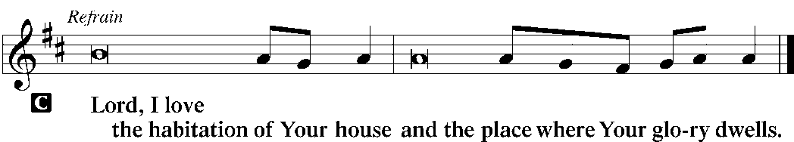

|  |  |
| --- | --- |
| L: | Blessed are those who hear the Word of God and keep it. |



|  |  |
| --- | --- |
| L: | Glory be to the Father and to the Son and to the Holy Spirit. |



|  |  |
| --- | --- |
|  |  |
| HYMN OF THE DAY | LSB *536 One Thing’s Needful* |
|  | |
| SERMON | |
|  | |

|  |  |  |  |
| --- | --- | --- | --- |
| CANTICLE | **Te Deum** (*We Praise You, O God)* | | *LSB p. 223* |
|  |  |  | |

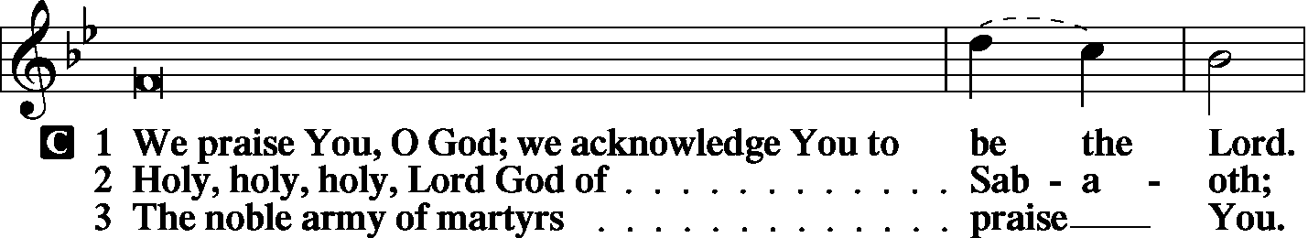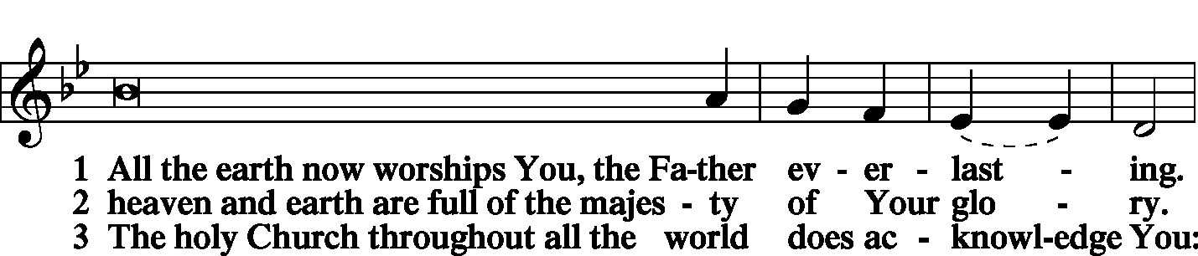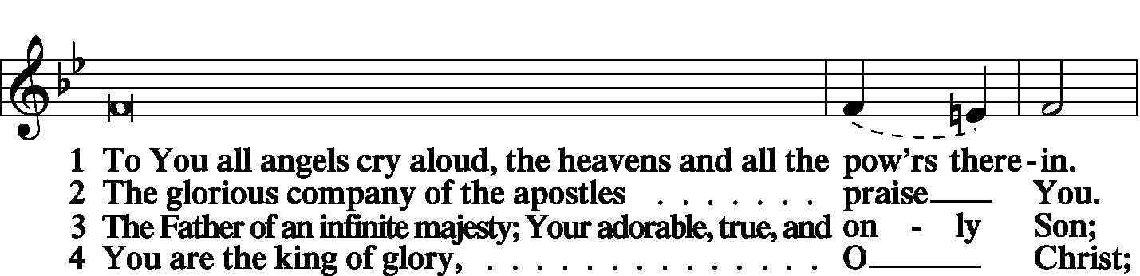

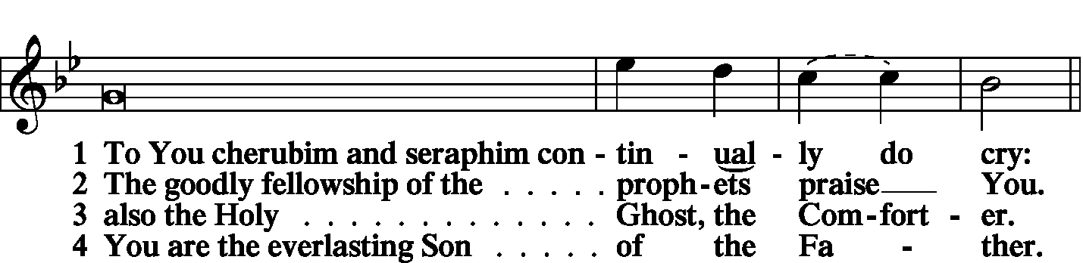

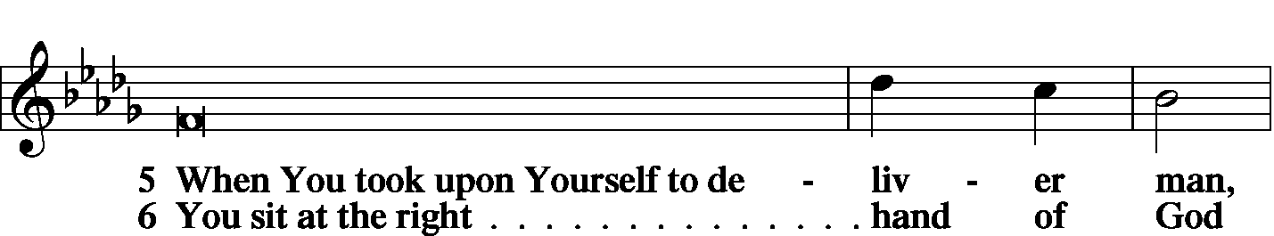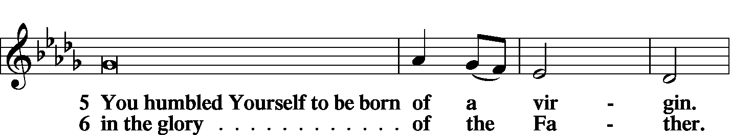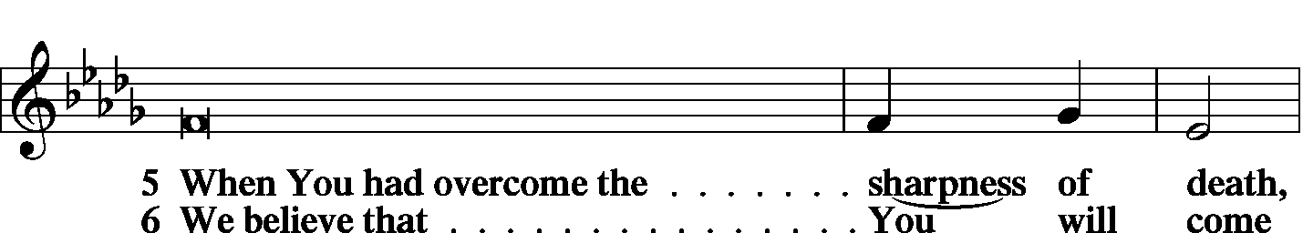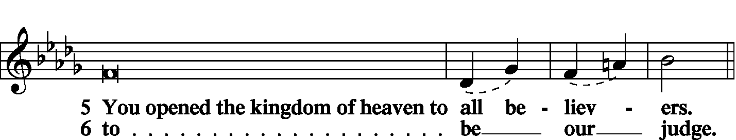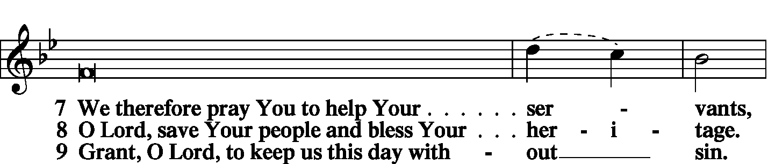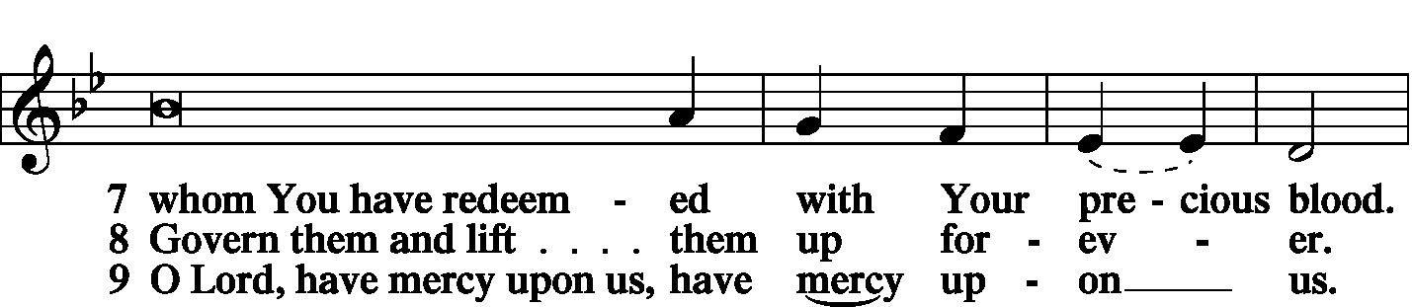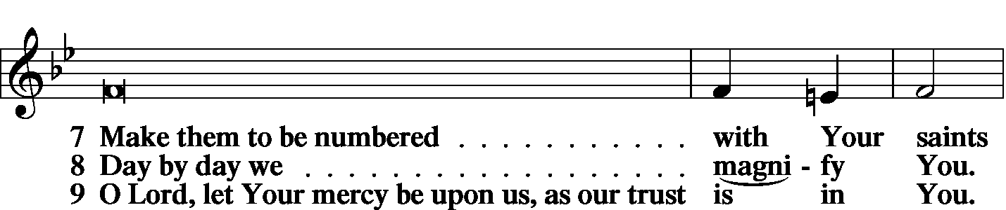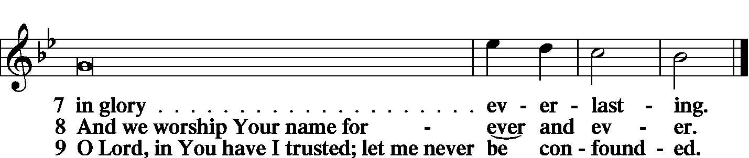

|  |  |  |
| --- | --- | --- |
|  | |  |
| PRAYER OF THE CHURCH | | |
|  | |  |
|  | Kyrie |  |

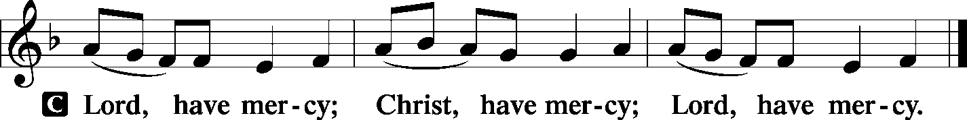

|  |  |
| --- | --- |
|  |  |
|  | Lord’s Prayer |
| C: | Our Father Who art in heaven, hallowed be Thy name, Thy kingdom come, Thy will be done on earth as it is in heaven; give us this day our daily bread; and forgive us our trespasses as we forgive those who trespass against us; and lead us not into temptation, but deliver us from evil. For Thine is the kingdom and the power and the glory forever and ever. Amen. |
|  |  |
| Collects | |
| L: | The Lord be with you. |

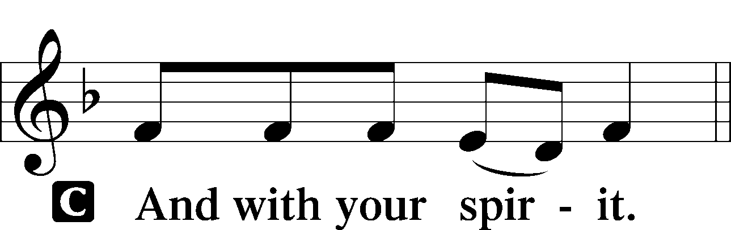

|  |  |
| --- | --- |
|  | Collect of the Day |
| L: | O Lord, grant us the Spirit to hear Your Word and know the one thing needful that by Your Word and Spirit we may live according to Your will; through Jesus Christ, our Lord. |



|  |  |
| --- | --- |
|  | Collect for Matins |
| L: | Almighty God, heavenly Father, Your mercies are new to us every morning, and You abundantly provide for all our wants of body and soul. Give us we humbly pray, Your Holy Spirit that we may heartily acknowledge Your merciful goodness toward us, give thanks for all Your benefits, and cheerfully serve You. |



|  |  |  |
| --- | --- | --- |
|  | For Guidance in Our Calling | *LSB p. 311* |
| L: | Lord God, You have called Your servants to ventures of which we cannot see the ending, by paths as yet untrodden, through perils unknown. Give us faith to go out with good courage, not knowing where we go but only that Your hand is leading us and Your love supporting us; through Jesus Christ, our Lord. | |



|  |  |  |
| --- | --- | --- |
|  | For Responsible Citizenship | *LSB p.313* |
| L: | Lord, keep this nation under Your care. Bless the leaders of our land that we may be a people at peace among ourselves and a blessing to the other nations of the earth. Grant that we may choose trustworthy leaders, contribute to wise decisions for the general welfare, and serve You faithfully in our generation; through Jesus Christ, our Lord. | |



|  |  |
| --- | --- |
| L | May the Lord hear the prayers we name in our hearts....…… Lord, in Your mercy: |
| C: | Hear our prayer. |

|  |  |  |
| --- | --- | --- |
|  | Collect for Grace | *LSB p.228* |
| L: | O Lord, our heavenly Father, almighty and everlasting God, You have safely brought us to the beginning of this day. Defend us in the same with Your mighty power and grant that this day we fall into no sin, neither run into any kind of danger, but that all our doings, being ordered by Your governance, may be righteous in Your sight; through Jesus Christ, Your Son, our Lord, Who lives and reigns with You and the Holy Spirit, one God, now and forever. | |



|  |  |  |
| --- | --- | --- |
| BENEDICAMUS | | *LSB p. 227* |
| L: | Let us bless the Lord. | |

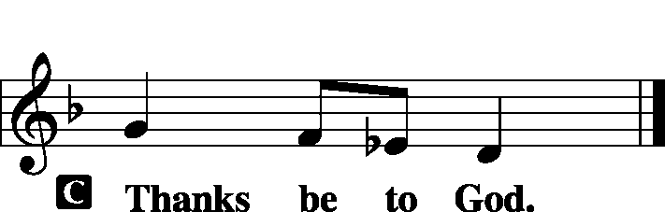

|  |  |  |
| --- | --- | --- |
|  | |  |
| BENEDICTION | |  |
| L: | The grace of our Lord T Jesus Christ and the love of God and the communion of the Holy Spirit be with us all. | |



|  |  |  |  |  |  |  |
| --- | --- | --- | --- | --- | --- | --- |
|  | | |  | |  | |
| CLOSING HYMN | | LSB 589 Speak, O Lord, Your Servant Listens | | | | |
|  | |  | | | |  |
| SILENT PRAYER | | |  | |  | | |
|  | *Almighty and merciful God, I have again worshiped in Your presence and received both forgiveness for my many sins and the assurance of Your love in Jesus Christ. I thank You for this undeserved grace and ask You to keep me in faith until, with all Your saints, I inherit eternal salvation; through Jesus Christ, my Lord. Amen.* | | | | | | |
|  | | | | | | | |
| T T T | | | | | | | |
|  | | | | | | | |
| Worship Leader: Tom Brosowske | | | |  | | | |
| Elder: Phil King | | | | | | | |
| Organist: Carol Wessler | | | | | | | |
|  | | | | | | | |

Acknowledgments

Matins from Lutheran Service Book

Unless otherwise indicated, all scripture quotations are from *The Holy Bible, English Standard Version*, copyright © 2001 by Crossway Bibles, a division of Good News Publishers. Used by permission. All rights reserved.

Created by Lutheran Service Builder © 2006 Concordia Publishing House.