|  |
| --- |
| The Seventh Sunday after Pentecost |
| July 27, 2025 |
| + The Order of Matins + |
| Lutheran Service Book – Pages 219-228 |

|  |  |  |
| --- | --- | --- |
| Prayer Before Worship | |  |
|  | *O Lord, my Creator, Redeemer, and Comforter, as I come to worship You in spirit and in truth, I humbly pray that You would open my heart to the preaching of Your Word so that I may repent of my sins, believe in Jesus Christ as my only Savior, and grow in grace and holiness. Hear me for the sake of His name. Amen.* | |
|  |  | |
| PRELUDE | | |
|  | | |

|  |
| --- |
| RINGING BELL CALLS US TO WORSHIP |

|  |  |  |  |  |  |  |
| --- | --- | --- | --- | --- | --- | --- |
|  | | | |  | | |
| WELCOME | | | |  | | |
|  | | | |  | | |
| OPENING HYMN | | *Praise. My Soul, the King of Heaven* | | | LSB 793 |
|  | |  | | |  |
| CONFESSION AND ABSOLUTION | | | *Page 151* | | |
| P: | In the name of the Father and of the T Son and of the Holy Spirit. | | | | |
| C: | Amen. | | | | |
| P: | If we say we have no sin, we deceive ourselves, and the truth is not in us. | | | | |
| C: | But if we confess our sins, God, Who is faithful and just, will forgive our sins and cleanse us from all unrighteousness. | | | | |
|  |  | | | | |
|  | *(Silence for reflection on God’s Word and for self-examination.)* | | | | |
|  |  | | | | |
| P: | Let us then confess our sins to God our Father. | | | | |
| C: | **Most merciful God, we confess that we are by nature sinful and unclean. We have sinned against You in thought, word, and deed, by what we have done and by what we have left undone. We have not loved You with our whole heart; we have not loved our neighbors as ourselves. We justly deserve Your present and eternal punishment. For the sake of Your Son, Jesus Christ, have mercy on us. Forgive us, renew us, and lead us, so that we may delight in Your will and walk in Your ways to the glory of Your holy name. Amen.** | | | | |
| P: | Almighty God in His mercy has given His Son to die for you and for His sake forgives you all your sins. As a called and ordained servant of Christ, and by His authority, I therefore forgive you all your sins in the name of the Father and of the T Son and of the Holy Spirit. | | | | |
| C: | Amen. | | | | |
|  |  | | | | |

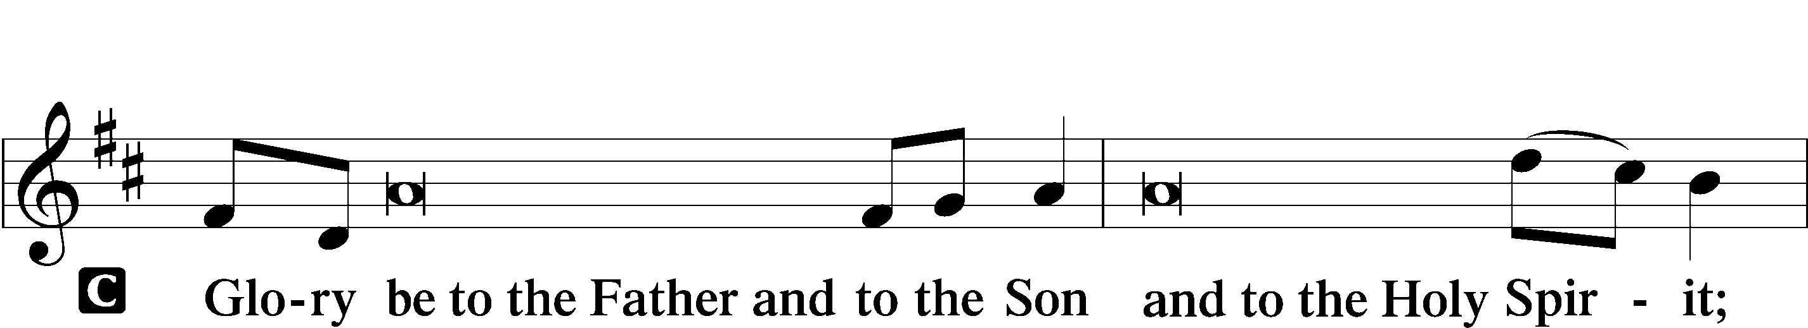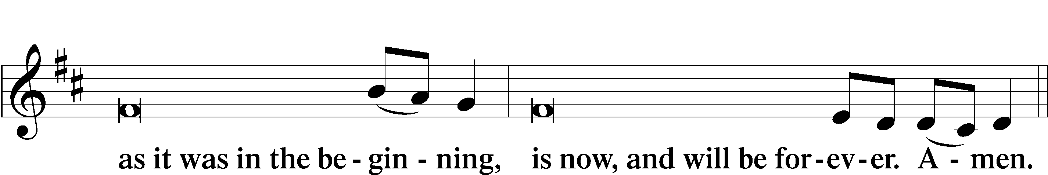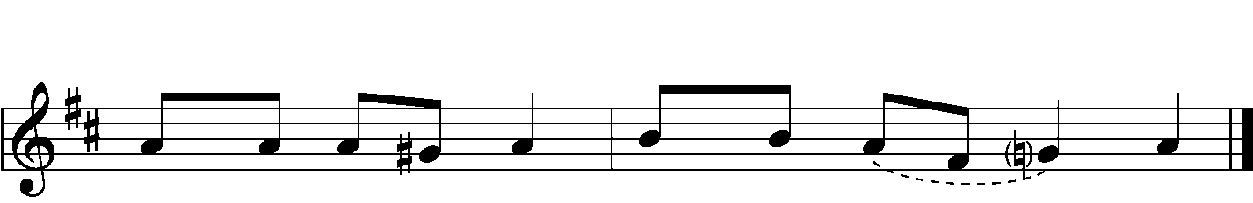

|  |  |  |  |
| --- | --- | --- | --- |
|  |  | | |
| PSALMODY | | Venite | *O Come, Let Us Sing* |
|  | Antiphon | | |
|  |  | | |

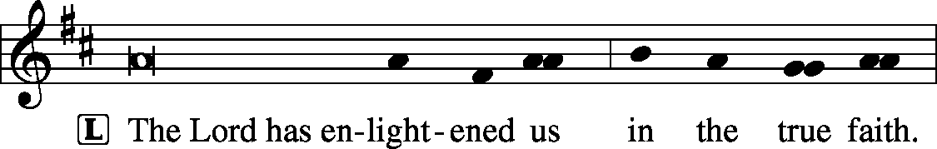



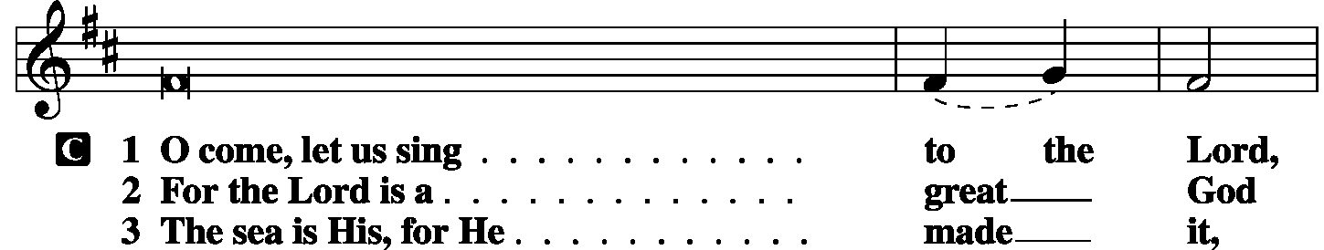

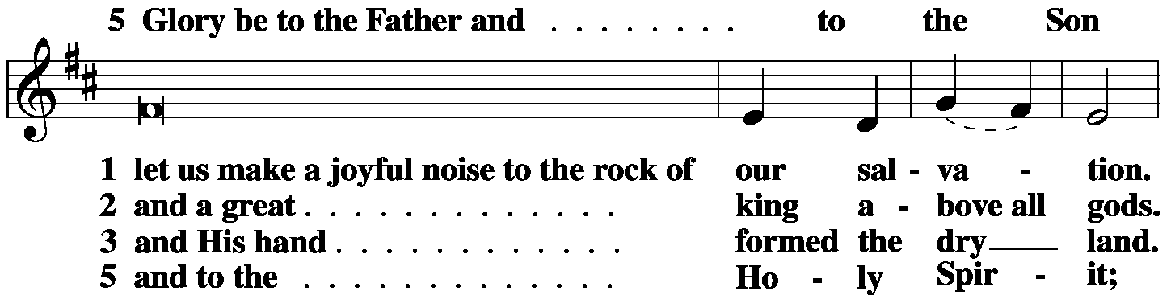

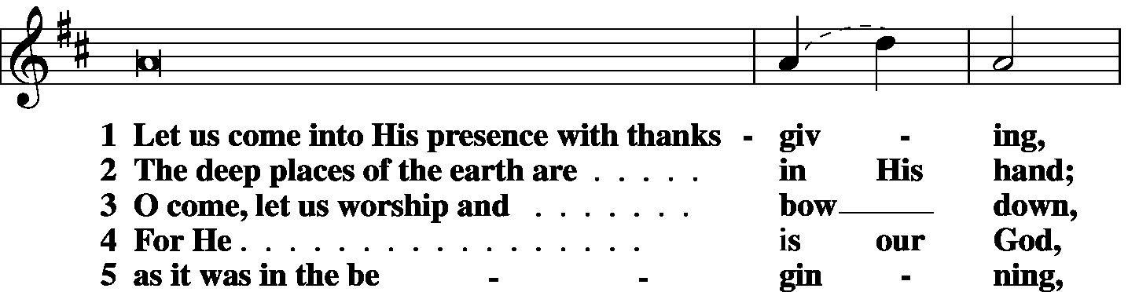

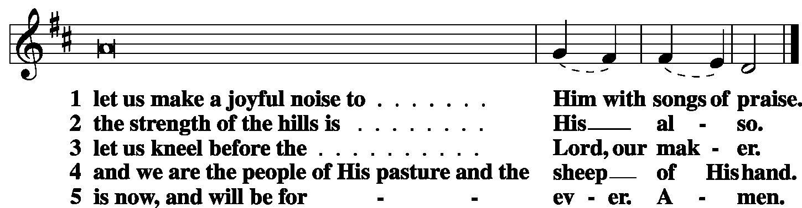





|  |  |  |  |
| --- | --- | --- | --- |
|  |  |  |  |
|  | Second Psalm | Psalm 138 | *(Sung responsively by verse)* |
|  |  |  | |



I give You thanks, O Lord, with **|** my whole heart;**\***

before the gods I **|** sing Your praise;

I bow down toward Your holy temple

and give thanks to Your Name for Your steadfast love and Your **|** faithfulness,**\***

for You have exalted above all things

Your Name **|** and Your Word.

On the day I called, You **|** answered me;**\***

my strength of soul **|** You increased.

All the kings of the earth shall give You thanks, **|** O Lord,**\***

for they have heard the words **|** of Your mouth,

and they shall sing of the ways **|** of the Lord,**\***

for great is the glory **|** of the Lord.

For though the Lord is high, He regards the **|** lowly,**\***

but the haughty He knows **|** from afar.

Though I walk in the midst of trouble, You pre- **|** serve my life;**\***

You stretch out Your hand against the wrath of my enemies,

and Your right hand de- **|** livers me.

The Lord will fulfill His pur- **|** pose for me;**\***

Your steadfast love, O Lord, endures forever.

Do not forsake the work **|** of Your hands.

Glory be to the Father and | to the Son*

and to the Holy | Spirit;

as it was in the be- | ginning,*

is now, and will be forever. | Amen.

|  |  |  |  |
| --- | --- | --- | --- |
|  |  | |  |
| OFFICE HYMN | *O Splendor of God's Glory Bright* | | LSB 874 |
|  |  | |  |
| THE GOSPEL FOR YOUNG FOLK | |  | | |
|  | |  | | |
| FIRST LESSON | | Genesis 18:17–33 | | |

17The Lord said, “Shall I hide from Abraham what I am about to do, 18seeing that Abraham shall surely become a great and mighty nation, and all the nations of the earth shall be blessed in him? 19For I have chosen him, that he may command his children and his household after him to keep the way of the Lord by doing righteousness and justice, so that the Lord may bring to Abraham what He has promised him.” 20Then the Lord said, “Because the outcry against Sodom and Gomorrah is great and their sin is very grave, 21I will go down to see whether they have done altogether according to the outcry that has come to me. And if not, I will know.”

22So the men turned from there and went toward Sodom, but Abraham still stood before the Lord. 23Then Abraham drew near and said, “Will You indeed sweep away the righteous with the wicked? 24Suppose there are fifty righteous within the city. Will You then sweep away the place and not spare it for the fifty righteous who are in it? 25Far be it from You to do such a thing, to put the righteous to death with the wicked, so that the righteous fare as the wicked! Far be that from you! Shall not the Judge of all the earth do what is just?” 26And the Lord said, “If I find at Sodom fifty righteous in the city, I will spare the whole place for their sake.”

27Abraham answered and said, “Behold, I have undertaken to speak to the Lord, I who am but dust and ashes. 28Suppose five of the fifty righteous are lacking. Will you destroy the whole city for lack of five?” And He said, “I will not destroy it if I find forty-five there.” 29Again he spoke to Him and said, “Suppose forty are found there.” He answered, “For the sake of forty I will not do it.” 30Then he said, “Oh let not the Lord be angry, and I will speak. Suppose thirty are found there.” He answered, “I will not do it, if I find thirty there.” 31He said, “Behold, I have undertaken to speak to the Lord. Suppose twenty are found there.” He answered, “For the sake of twenty I will not destroy it.” 32Then he said, “Oh let not the Lord be angry, and I will speak again but this once. Suppose ten are found there.” He answered, “For the sake of ten I will not destroy it.” 33And the Lord went His way, when He had finished speaking to Abraham, and Abraham returned to his place.

|  |  |  |
| --- | --- | --- |
|  |  | |
| P: | O Lord, have mercy on us. | |
| C: | **Thanks be to God.** | |
|  | |  |
| SECOND LESSON | | Colossians 2:6-19 |

6Therefore, as you received Christ Jesus the Lord, so walk in Him, 7rooted and built up in Him and established in the faith, just as you were taught, abounding in thanksgiving.

8See to it that no one takes you captive by philosophy and empty deceit, according to human tradition, according to the elemental spirits of the world, and not according to Christ. 9For in Him the whole fullness of deity dwells bodily, 10and you have been filled in Him, Who is the Head of all rule and authority. 11In Him also you were circumcised with a circumcision made without hands, by putting off the body of the flesh, by the circumcision of Christ, 12having been buried with Him in baptism, in which you were also raised with Him through faith in the powerful working of God, Who raised Him from the dead. 13And you, who were dead in your trespasses and the uncircumcision of your flesh, God made alive together with Him, having forgiven us all our trespasses, 14by canceling the record of debt that stood against us with its legal demands. This He set aside, nailing it to the cross. 15He disarmed the rulers and authorities and put them to open shame, by triumphing over them in Him.

16Therefore let no one pass judgment on you in questions of food and drink, or with regard to a festival or a new moon or a Sabbath. 17These are a shadow of the things to come, but the substance belongs to Christ. 18Let no one disqualify you, insisting on asceticism and worship of angels, going on in detail about visions, puffed up without reason by his sensuous mind, 19and not holding fast to the Head, from Whom the whole body, nourished and knit together through its joints and ligaments, grows with a growth that is from God.

|  |  |  |
| --- | --- | --- |
|  |  | |
| P: | O Lord, have mercy on us. | |
| C: | **Thanks be to God.** | |
|  | |  |
| GOSPEL VERSE | | Luke 11:9 |
| P: | Alleluia. I tell you, ask, and it will be given to you; seek, and you will find; | |
| C: | knock, and it will be opened to you. Alleluia. | |
|  |  | |
| HOLY GOSPEL | | Luke 11:1-13 |
| P: | The Holy Gospel according to St. Luke, the eleventh chapter. | |
| C: | **Glory to You, O Lord.** | |
|  |  | |

1Now Jesus was praying in a certain place, and when he finished, one of his disciples said to him, “Lord, teach us to pray, as John taught his disciples.” 2And He said to them, **“When you pray, say:**

**“Father, hallowed be Your Name.**

**Your kingdom come.**

**3Give us each day our daily bread,**

**4and forgive us our sins,**

**for we ourselves forgive everyone who is indebted to us.**

**And lead us not into temptation.”**

5And He said to them, **“Which of you who has a friend will go to him at midnight and say to him, ‘Friend, lend me three loaves, 6for a friend of mine has arrived on a journey, and I have nothing to set before him’; 7and he will answer from within, ‘Do not bother me; the door is now shut, and my children are with me in bed. I cannot get up and give you anything’? 8I tell you, though he will not get up and give him anything because he is his friend, yet because of his impudence he will rise and give him whatever he needs. 9And I tell you, ask, and it will be given to you; seek, and you will find; knock, and it will be opened to you. 10For everyone who asks receives, and the one who seeks finds, and to the one who knocks it will be opened. 11What father among you, if his son asks for a fish, will instead of a fish give him a serpent; 12or if he asks for an egg, will give him a scorpion? 13If you then, who are evil, know how to give good gifts to your children, how much more will the heavenly Father give the Holy Spirit to those who ask Him!”**

|  |  |  |
| --- | --- | --- |
|  |  | |
| P: | This is the Gospel of the Lord. | |
| C: | **Praise to You, O Christ.** | |
|  | |  |
| RESPONSORY | |  |
|  |  | |

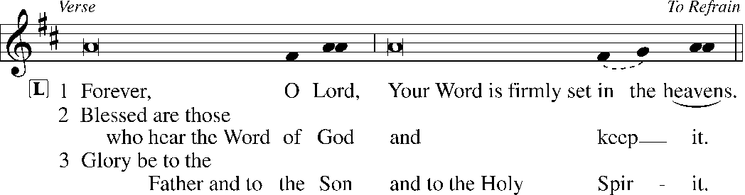

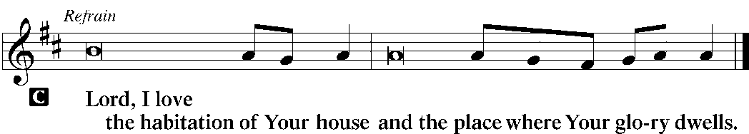

|  |  |  |  |  |  |
| --- | --- | --- | --- | --- | --- |
|  | |  | |  | |
| HYMN OF THE DAY | | *Hear Us, Father, When We Pray* | | LSB 773 | |
|  | | | | | |
| SERMON | | | | | |
|  | | | | | |
| CANTICLE | Te Deum | | *LSB p. 223* | |
|  |  | |  | |

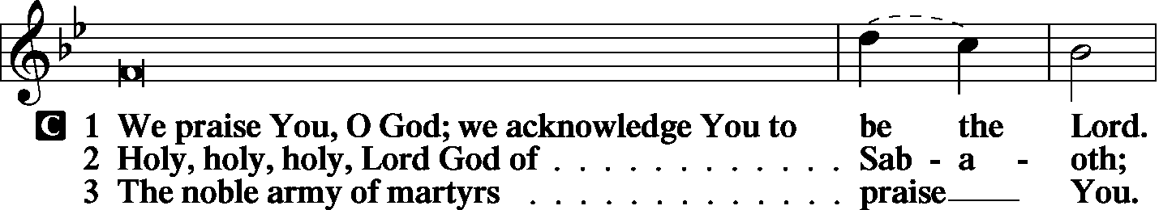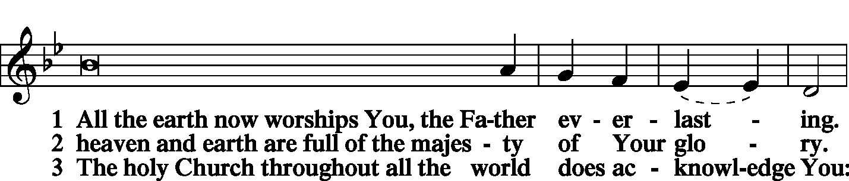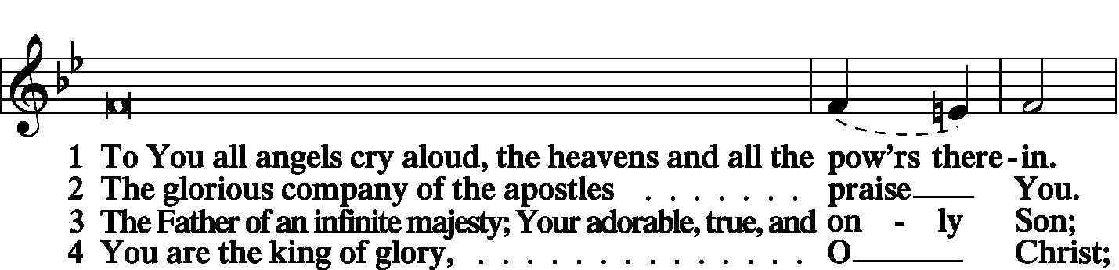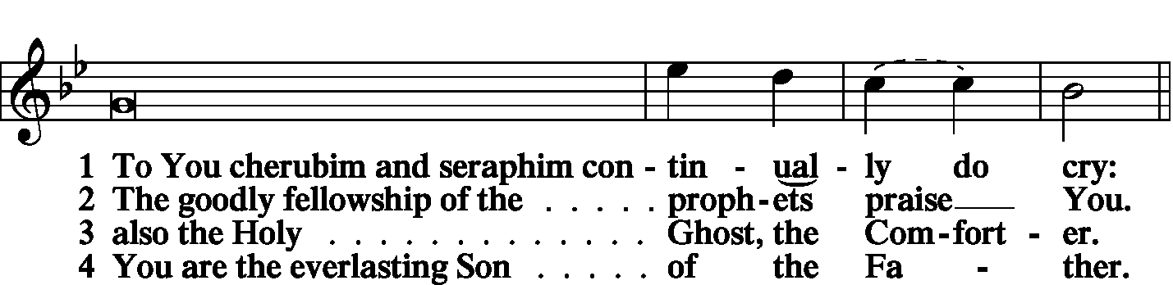

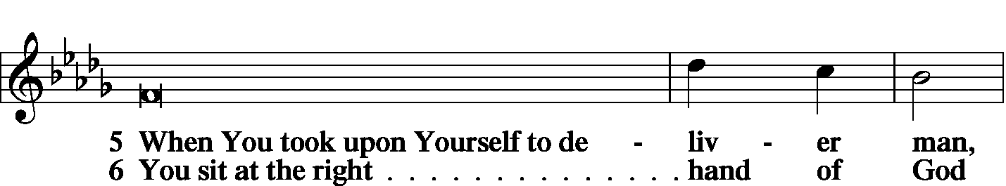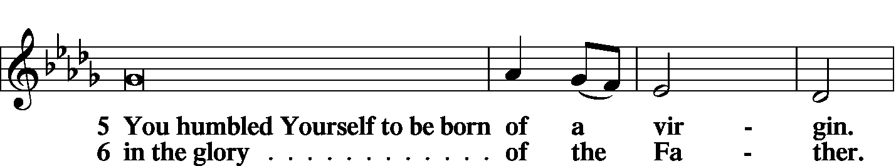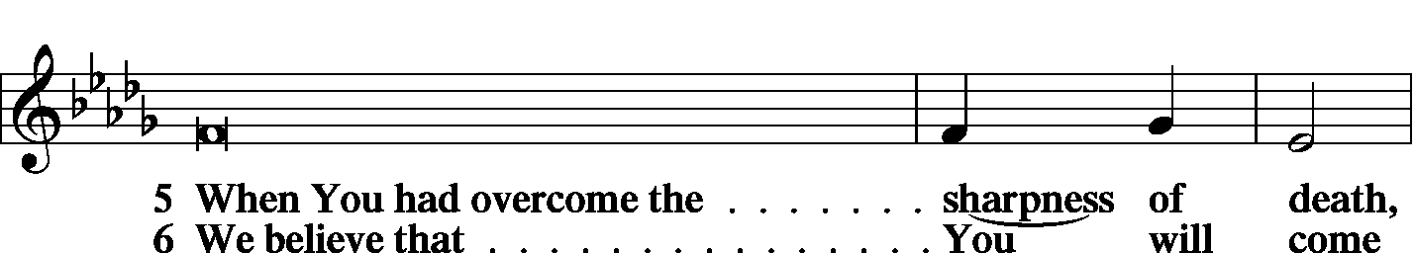

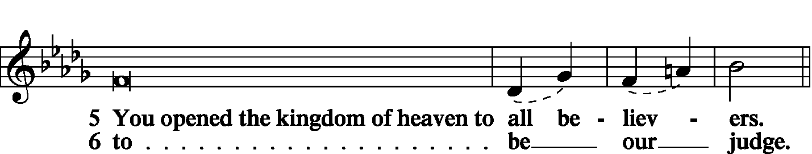

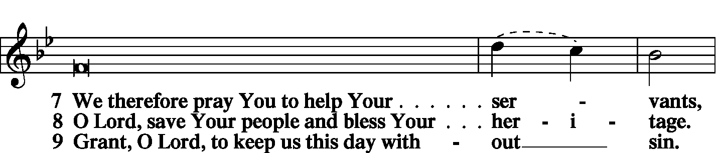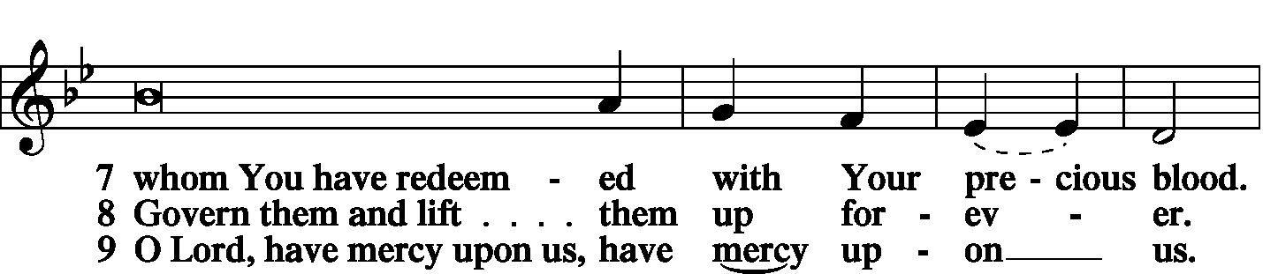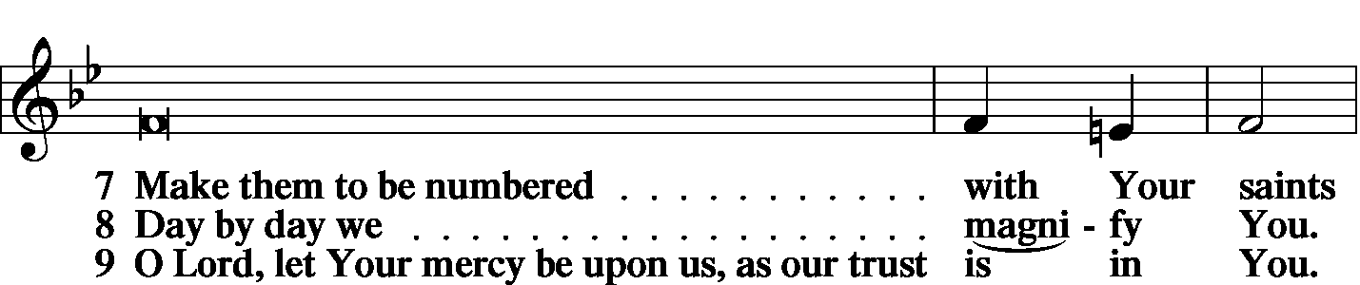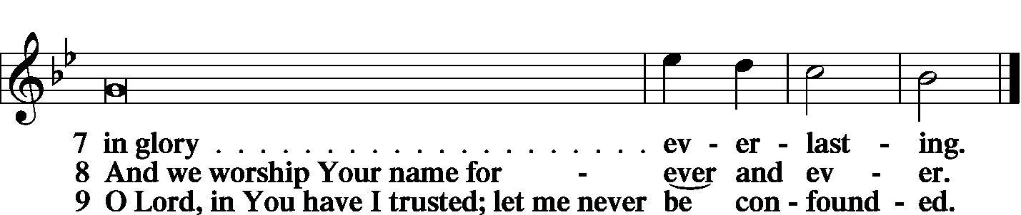

|  |  |
| --- | --- |
|  |  |
| PRAYER OF THE CHURCH | *LSB p. 227* |
|  |  |
| KYRIE |  |

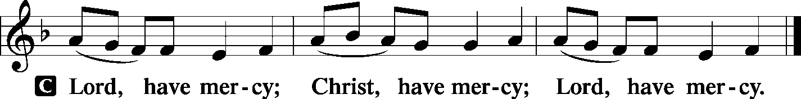

|  |  |  |
| --- | --- | --- |
|  |  | |
| LORD’S PRAYER | | |
| C: | Our Father Who art in heaven, hallowed be Thy name, Thy kingdom come, Thy will be done on earth as it is in heaven; give us this day our daily bread; and forgive us our trespasses as we forgive those who trespass against us; and lead us not into temptation, but deliver us from evil. For Thine is the kingdom and the power and the glory forever and ever. Amen. | |
|  |  | |
| COLLECTS | |  |
|  | |  |

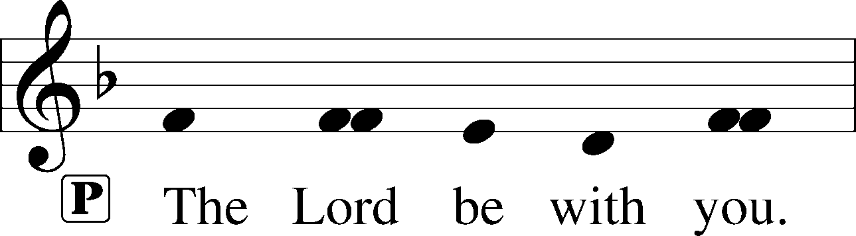

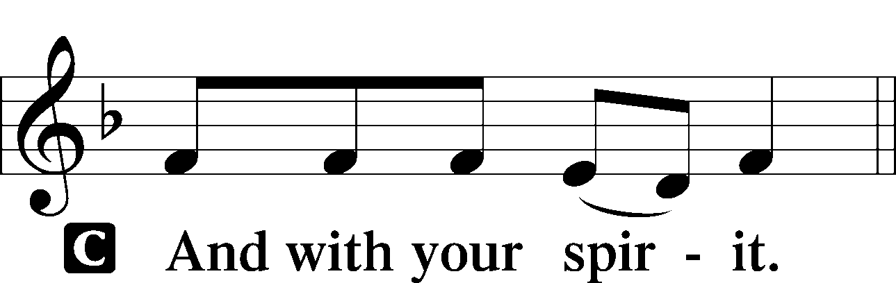

|  |  |
| --- | --- |
|  | |
| Collect of the Day | |
| P: | O Lord, let Your merciful ears be attentive to the prayers of Your servants, and by Your Word and Spirit teach us how to pray that our petitions may be pleasing before You; through Jesus Christ, Your Son, our Lord. |



|  |  |
| --- | --- |
| Collect for Matins | |
| P: | Almighty God, heavenly Father, Your mercies are new to us every morning, and You abundantly provide for all our wants of body and soul. Give us we humbly pray, Your Holy Spirit that we may heartily acknowledge Your merciful goodness toward us, give thanks for all Your benefits, and cheerfully serve You. |



|  |  |  |
| --- | --- | --- |
| For Guidance in Our Calling | | *LSB p. 311* |
| P: | Lord God, You have called Your servants to ventures of which we cannot see the ending, by paths as yet untrodden, through perils unknown. Give us faith to go out with good courage, not knowing where we go but only that Your hand is leading us and Your love supporting us; through Jesus Christ, our Lord. | |



|  |  |  |
| --- | --- | --- |
| For Responsible Citizenship | | *LSB p.313* |
| P: | Lord, keep this nation under Your care. Bless the leaders of our land that we may be a people at peace among ourselves and a blessing to the other nations of the earth. Grant that we may choose trustworthy leaders, contribute to wise decisions for the general welfare, and serve You faithfully in our generation; through Jesus Christ, our Lord. | |



|  |  |  |
| --- | --- | --- |
| Collect for Grace | | *LSB p.228* |
| P: | O Lord, our heavenly Father, almighty and everlasting God, You have safely brought us to the beginning of this day. Defend us in the same with Your mighty power and grant that this day we fall into no sin, neither run into any kind of danger, but that all our doings, being ordered by Your governance, may be righteous in Your sight; through Jesus Christ, Your Son, our Lord, Who lives and reigns with You and the Holy Spirit, one God, now and forever. | |



|  |  |  |
| --- | --- | --- |
| BENEDICAMUS | | *LSB p. 227* |
|  |  | |

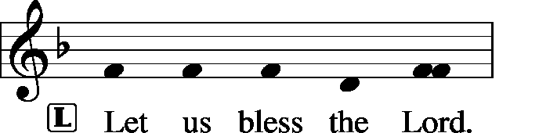

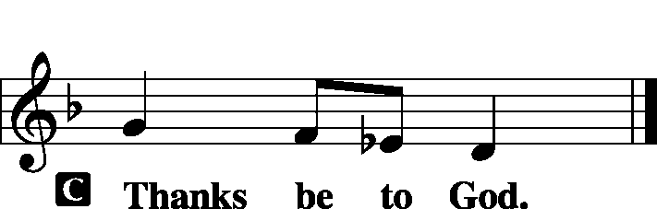

|  |  |  |
| --- | --- | --- |
|  | |  |
| BENEDICTION | |  |
|  |  | |

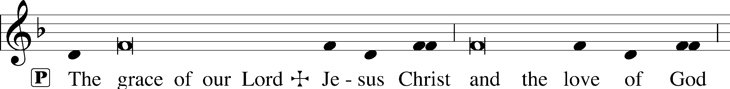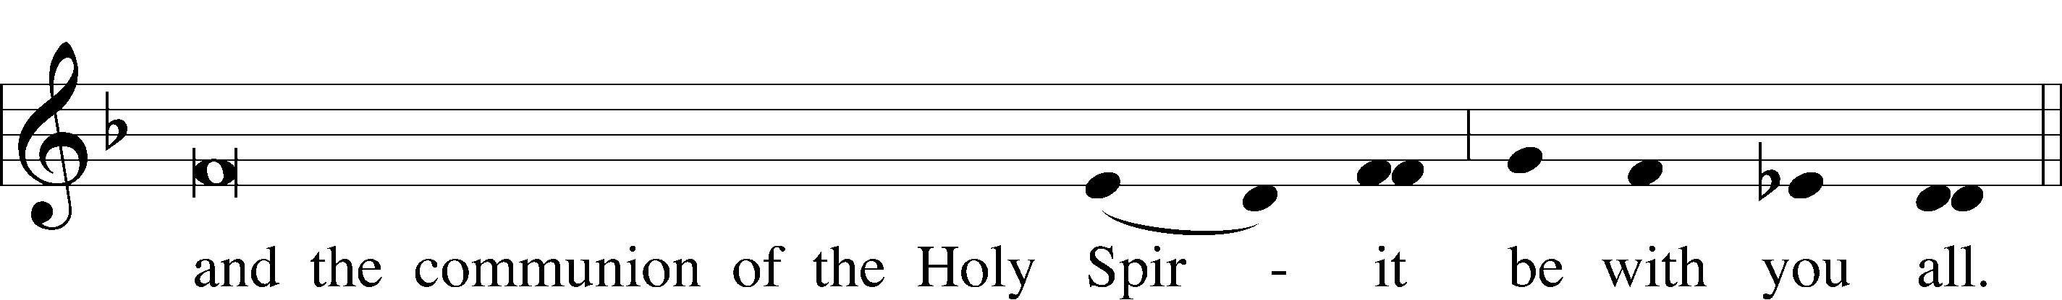

|  |  |  |  |  |  |  |
| --- | --- | --- | --- | --- | --- | --- |
|  | | |  | | |  |
| CLOSING HYMN | | *Praise the Almighty* | | | LSB 797 | |
|  | |  | | |  | |
| SILENT PRAYER | | |  | | |  | |
|  | *Almighty and merciful God, I have again worshiped in Your presence and received both forgiveness for my many sins and the assurance of Your love in Jesus Christ. I thank You for this undeserved grace and ask You to keep me in faith until, with all Your saints, I inherit eternal salvation; through Jesus Christ, my Lord. Amen.* | | | | | | |
|  | | | | | | | |
| T T T | | | | | | | |
|  | | | | | | | |
| Pastor: The Rev. Barry Long | | | |  | | | |
| Elder: Gary Beenders | | | | | | | |
| Organist: Carol Wessler | | | | | | | |
|  | | | | | | | |

Acknowledgments

Matins from Lutheran Service Book

Unless otherwise indicated, all scripture quotations are from *The Holy Bible, English Standard Version*, copyright © 2001 by Crossway Bibles, a division of Good News Publishers. Used by permission. All rights reserved.

Created by Lutheran Service Builder © 2006 Concordia Publishing House.