*Looking for extra help in focusing your thoughts for the Lord’s Supper? “Christian Questions with Their Answers” was prepared by Luther to address just that. They can be found in your hymnal on pages 329-330. Review them if you get to church early, or during the offering, or if you are waiting to be invited forward.*

|  |
| --- |
| Eighth Sunday after Pentecost |
| August 3, 2025 |
| Divine Service III/Holy Communion |
| LSB Page 184 |

|  |  |  |  |  |  |
| --- | --- | --- | --- | --- | --- |
| Prayer before Worship: | | | | | |
|  | *O Lord, my Creator, Redeemer, and Comforter, as I come to worship You in spirit and in truth, I humbly pray that You would open my heart to the preaching of Your Word so that I may repent of my sins, believe in Jesus Christ as my only Savior, and grow in grace and holiness. Hear me for the sake of His name. Amen.* | | | | |
|  |  | | | | |
| PRELUDE | | | | | |
|  | | | | | |
| RINGING BELL CALLS US TO WORSHIP | | | | | |
|  | | | | | |
| WELCOME | | | | | |
|  | | | | | |
| OPENING HYMN | | *Christ Is Made the Sure Foundation* | | | LSB 909 |
|  | |  | |  | |
| CONFESSION AND ABSOLUTION | | | *Page 184 (left column)* | | |
| P: | In the name of the Father and of the T Son and of the Holy Spirit. | | | | |
| C: | Amen. | | | | |
| P: | Beloved in the Lord! Let us draw near with a true heart and confess our sins unto God our Father, beseeching Him in the name of our Lord Jesus Christ to grant us forgiveness.  Our help is in the name of the Lord, | | | | |
| C: | **Who made heaven and earth.** | | | | |
| P: | I said, I will confess my transgressions unto the Lord, | | | | |
| C: | **and You forgave the iniquity of my sin.** | | | | |
|  |  | | | | |
|  | *Silence for reflection on God's Word and for self-examination.* | | | | |
|  |  | | | | |
| P: | O almighty God, merciful Father, | | | | |
| C: | **I, a poor, miserable sinner, confess unto You all my sins and iniquities with which I have ever offended You and justly deserved Your temporal and eternal punishment. But I am heartily sorry for them and sincerely repent of them, and I pray You of Your boundless mercy and for the sake of the holy, innocent, bitter sufferings and death of Your beloved Son, Jesus Christ, to be gracious and merciful to me, a poor, sinful being.** | | | | |
|  |  | | | | |
| P: | Upon this your confession, I, by virtue of my office, as a called and ordained servant of the Word, announce the grace of God unto all of you, and in the stead and by the command of my Lord Jesus Christ I forgive you all your sins in the name of the Father and of the T Son and of the Holy Spirit. | | | | |
| C: | **Amen.** | | | | |
|  | | |  | | |
| INTROIT | | | Ps. 49:7–8, 13–14a, 15; antiphon: Ps. 49:1–2 | | |
|  | | |  | | |



Hear this, all **|** peoples!**\***

Give ear, all inhabitants **|** of the world,

both **|** low and high,**\***

rich and poor to- **|** gether!

Truly no man can ransom an- **|** other,**\***

or give to God the price **|** of his life,

for the ransom of their life is **|** costly**\***

and can nev- **|** er suffice.

This is the path of those who have foolish **|** confidence;**\***

yet after them people approve **|** of their boasts.

Like sheep they are appointed **|** for Sheol;**\***

death shall be their **|** shepherd.

But God will ransom my soul from the power **|** of Sheol,**\***

for He will re- **|** ceive me.

**Glory be to the Father and | to the Son\***

**and to the Holy | Spirit;**

**as it was in the be- | ginning,\***

**is now, and will be forever. | Amen.**

Hear this, all **|** peoples!**\***

Give ear, all inhabitants **|** of the world,

both **|** low and high,**\***

rich and poor to- **|** gether!

|  |  |  |  |
| --- | --- | --- | --- |
|  | |  | |
| KYRIE | *Lord Have Mercy* | | *Page 186* |
|  |  | |  |

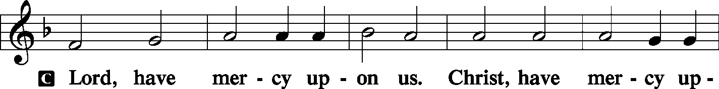

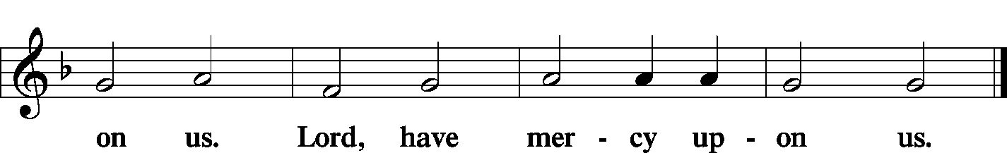

|  |  |  |
| --- | --- | --- |
| GLORIA IN EXCELSIS |  | *Page 187-89* |
|  |  |  |

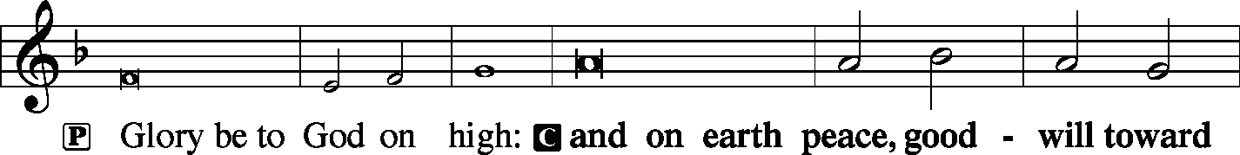

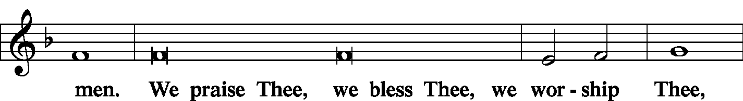

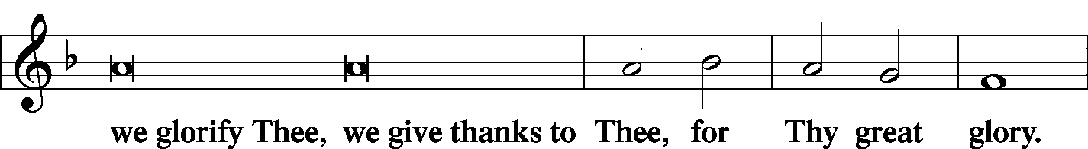

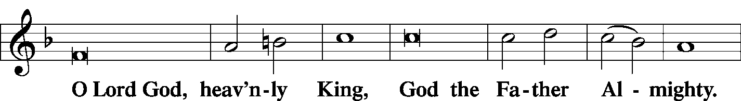

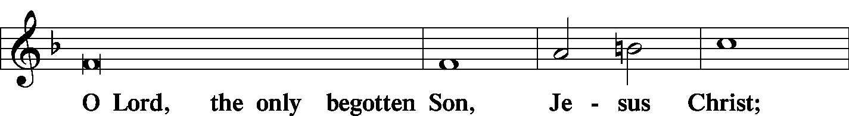

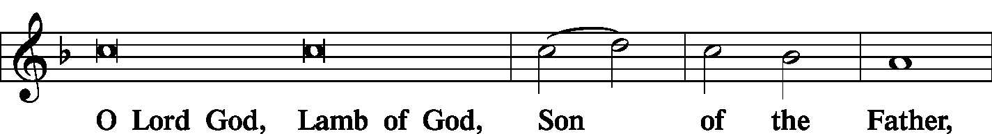

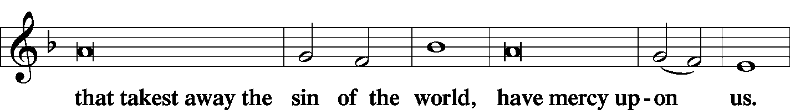

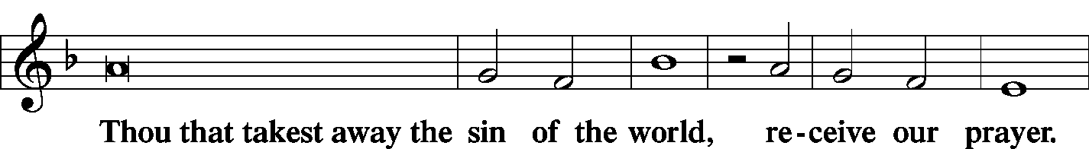

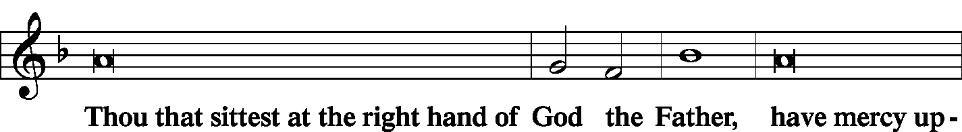

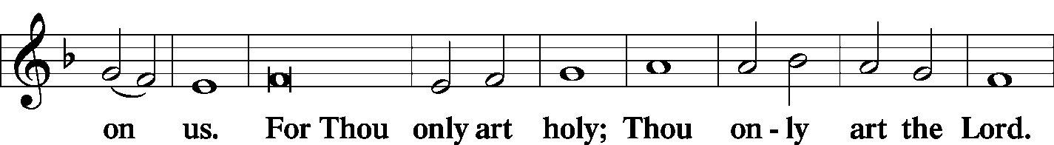

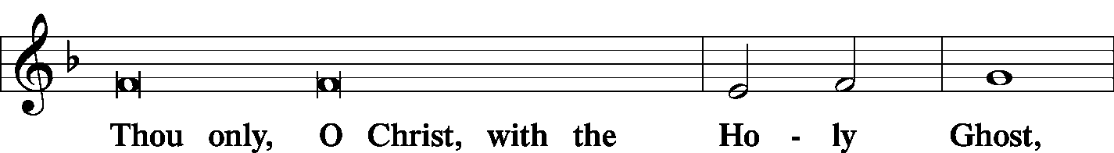

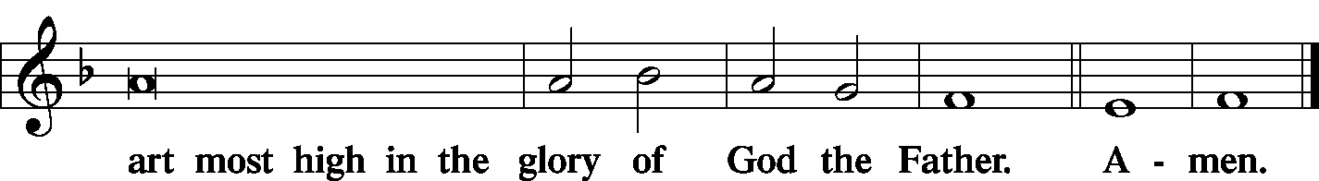

|  |  |  |  |  |  |
| --- | --- | --- | --- | --- | --- |
|  |  |  | | | |
| SALUTATION |  | *Page 189* | | | |
|  | | |  |  | | |
|  | | |  |  | | |
|  | | |  |  | | |
|  |  |  | | | |
| COLLECT OF THE DAY |  |  | | | |
|  | | |  | | |
| C: **O LORD, GRANT US WISDOM TO RECOGNIZE THE TREASURES YOU HAVE STORED UP FOR US IN HEAVEN, THAT WE MAY NEVER DESPAIR BUT ALWAYS REJOICE AND BE THANKFUL FOR THE RICHES OF YOUR GRACE; THROUGH JESUS CHRIST, YOUR SON, OUR LORD, WHO LIVES AND REIGNS WITH YOU AND THE HOLY SPIRIT, ONE GOD, NOW AND FOREVER. AMEN**  *Please be seated* | | |  | | |
|  | | |  | | |
| GOSPEL FOR YOUNG FOLK | | | | | GOSPEL FOR YOUNG FOLK |
|  | | | | |  |
| FIRST READING Ecclesiastes 1:2, 12–14; 2:18–26 | | | | | Isaiah 66:10–14 |

1:2Vanity of vanities, says the Preacher, vanity of vanities! All is vanity.

12I the Preacher have been king over Israel in Jerusalem. 13And I applied my heart to seek and to search out by wisdom all that is done under heaven. It is an unhappy business that God has given to the children of man to be busy with. 14I have seen everything that is done under the sun, and behold, all is vanity and a striving after wind.

2:18I hated all my toil in which I toil under the sun, seeing that I must leave it to the man who will come after me, 19and who knows whether he will be wise or a fool? Yet he will be master of all for which I toiled and used my wisdom under the sun. This also is vanity. 20So I turned about and gave my heart up to despair over all the toil of my labors under the sun, 21because sometimes a person who has toiled with wisdom and knowledge and skill must leave everything to be enjoyed by someone who did not toil for it. This also is vanity and a great evil. 22What has a man from all the toil and striving of heart with which he toils beneath the sun? 23For all his days are full of sorrow, and his work is a vexation. Even in the night his heart does not rest. This also is vanity.

24There is nothing better for a person than that he should eat and drink and find enjoyment in his toil. This also, I saw, is from the hand of God, 25for apart from Him who can eat or who can have enjoyment?

26For to the one who pleases Him God has given wisdom and knowledge and joy, but to the sinner He has given the business of gathering and collecting, only to give to one who pleases God. This also is vanity and a striving after wind.

|  |  |  |  |  |  |
| --- | --- | --- | --- | --- | --- |
|  | | | |  | |
| P: | This is the Word of the Lord. | | | | |
| C: | **Thanks be to God.** | | | | |
|  | | |  | |  |
| PSALM | | Psalm 100 | | |  |



Make a joyful noise to the Lord, **|** all the earth!**\***

Serve the Lord with gladness! Come into His presence with **|** singing!

Know that the Lord, **|** He is God!**\***

It is He Who made us, and we are His;

we are His people, and the sheep of His **|** pasture.

Enter His gates with thanksgiving, and His **|** courts with praise!**\***

Give thanks to Him; **|** bless His Name!

For the Lord is good; His steadfast love endures for- **|** ever,**\***

and His faithfulness to all gener- **|** ations.

**Glory be to the Father and | to the Son\***

**and to the Holy | Spirit;**

**as it was in the be- | ginning,\***

**is now, and will be forever. | Amen.**

|  |  |
| --- | --- |
|  |  |
| SECOND READING | Colossians 3:1–11 |

1If then you have been raised with Christ, seek the things that are above, where Christ is, seated at the right hand of God. 2Set your minds on things that are above, not on things that are on earth. 3For you have died, and your life is hidden with Christ in God. 4When Christ Who is your life appears, then you also will appear with Him in glory.

5Put to death therefore what is earthly in you: sexual immorality, impurity, passion, evil desire, and covetousness, which is idolatry. 6On account of these the wrath of God is coming. 7In these you too once walked, when you were living in them. 8But now you must put them all away: anger, wrath, malice, slander, and obscene talk from your mouth. 9Do not lie to one another, seeing that you have put off the old self with its practices 10and have put on the new self, which is being renewed in knowledge after the image of its creator. 11Here there is not Greek and Jew, circumcised and uncircumcised, barbarian, Scythian, slave, free; but Christ is all, and in all.

|  |  |  |
| --- | --- | --- |
| P: | This is the Word of the Lord. | |
| C: | **Thanks be to God.** | |
|  |  | |
|  | *Please stand* | |
|  |  | |
| ALLELUIA | |  |

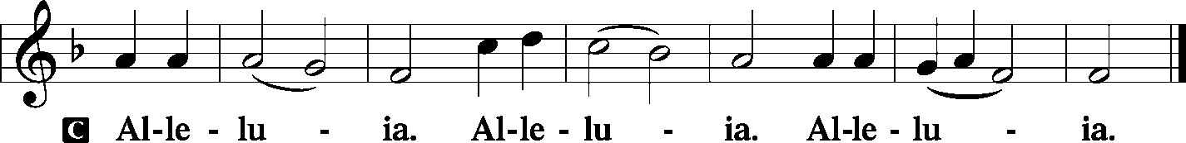

|  |  |  |
| --- | --- | --- |
|  | |  |
| HOLY GOSPEL | | Luke 12:13–21 |
| P: | The Holy Gospel according to St. Luke, the twelfth chapter. | |
|  |  | |

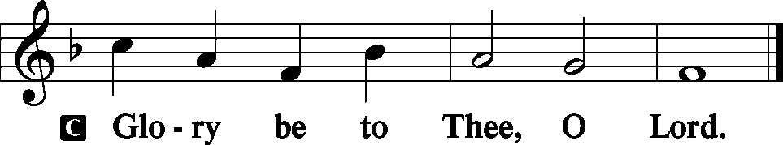

13Someone in the crowd said to [Jesus], “Teacher, tell my brother to divide the inheritance with me.”

14But He said to him, **“Man, who made Me a judge or arbitrator over you?**” 15And He said to them, **“Take care, and be on your guard against all covetousness, for one’s life does not consist in the abundance of his possessions.”** 16And He told them a parable, saying, **“The land of a rich man produced plentifully, 17and he thought to himself, ‘What shall I do, for I have nowhere to store my crops?’ 18And he said, ‘I will do this: I will tear down my barns and build larger ones, and there I will store all my grain and my goods. 19And I will say to my soul, Soul, you have ample goods laid up for many years; relax, eat, drink, be merry.’ 20But God said to him, ‘Fool! This night your soul is required of you, and the things you have prepared, whose will they be?’ 21So is the one who lays up treasure for himself and is not rich toward God.”**

|  |  |
| --- | --- |
|  |  |
| P: | This is the Gospel of our Lord. |
|  |  |

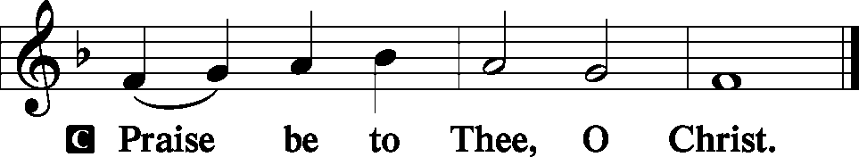

|  |  |  |  |  |  |
| --- | --- | --- | --- | --- | --- |
|  | | |  | | |
| NICENE CREED | | | *Page 191* | | |
| C: | I believe in one God, the Father Almighty, maker of heaven and earth and of all things visible and invisible.  And in one Lord Jesus Christ, the only-begotten Son of God, begotten of His Father before all worlds, God of God, Light of Light, very God of very God, begotten, not made, being of one substance with the Father, by Whom all things were made; Who for us men and for our salvation came down from heaven and was incarnate by the Holy Spirit of the virgin Mary and was made man; and was crucified also for us under Pontius Pilate. He suffered and was buried. And the third day He rose again according to the Scriptures and ascended into heaven and sits at the right hand of the Father. And He will come again with glory to judge both the living and the dead, Whose kingdom will have no end.  And I believe in the Holy Spirit, the Lord and giver of life, Who proceeds from the Father and the Son, Who with the Father and the Son together is worshiped and glorified, Who spoke by the prophets. And I believe in one holy Christian and apostolic Church, I acknowledge one Baptism for the remission of sins, and I look for the resurrection of the dead and the life **T** of the world to come. Amen. | | | | |
|  |  | | | | |
|  | *Please be seated.* | | | | |
|  |  | | | | |
| HYMN OF THE DAY | | *Gracious God, You Send Great Blessings* | | | LSB 782 |
|  | |  | | |  |
| SERMON | |  | |  | |
|  | |  | |  | |
|  | *Please stand.* | | |  | |
|  |  | | |  | |
| OFFERTORY | | *Create in Me* | | *Pages 192-193* | |
|  | |  | |  | |

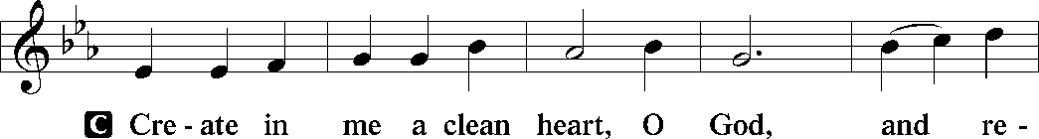

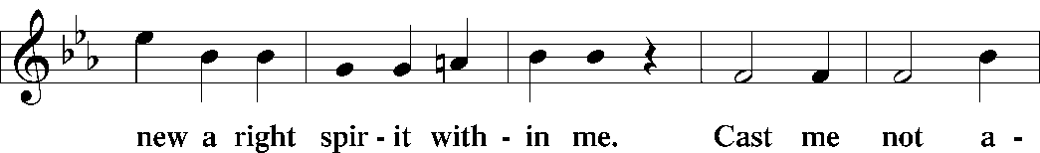

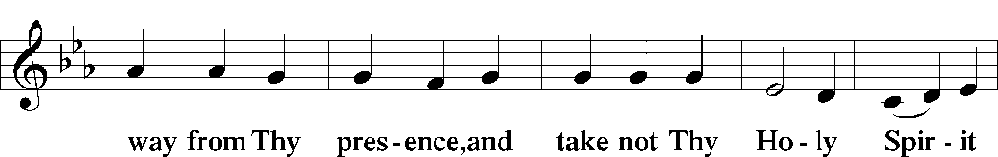

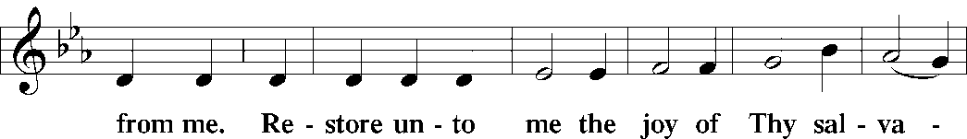

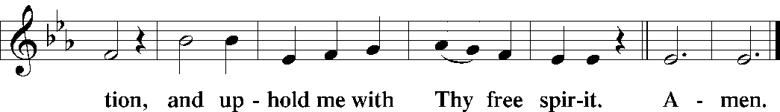

|  |  |  |
| --- | --- | --- |
|  |  | |
| PRAYER OF THE CHURCH | | |
|  | | |
| **HYMN** *Lamb of God LSB 550* | | |
|  | | |
| PREFACE | | *Page 194* |
|  | | |
| P: | The Lord be with you. | |
|  |  | |

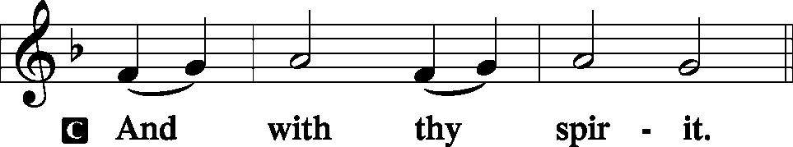

|  |  |
| --- | --- |
|  |  |
| P: | Lift up your hearts. |
|  |  |

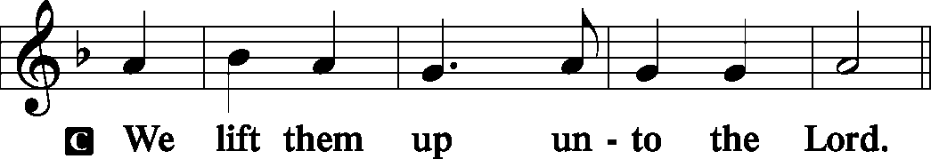

|  |  |
| --- | --- |
|  |  |
| P: | Let us give thanks unto the Lord, our God. |
|  |  |

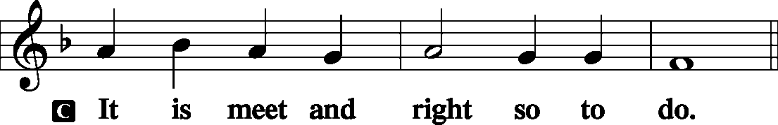

|  |  |  |  |  |
| --- | --- | --- | --- | --- |
|  | | | | |
| PROPER PREFACE | | | | |
| P: | It is truly good, right, and salutary that we should at all times and in all places give thanks to You, holy Lord, almighty Father, everlasting God, through Jesus Christ, our Lord, Who, having created all things, took on human flesh and was born of the virgin Mary. For our sake He died on the cross and rose from the dead to put an end to death, thus fulfilling Your will and gaining for You a holy people. Therefore with angels and archangels and with all the company of heaven we laud and magnify Your glorious name, evermore praising You and singing: | | | |
|  |  | | | |
| SANCTUS | | *Holy, Holy, Holy* | | *Page 195* |
|  | | |  | |

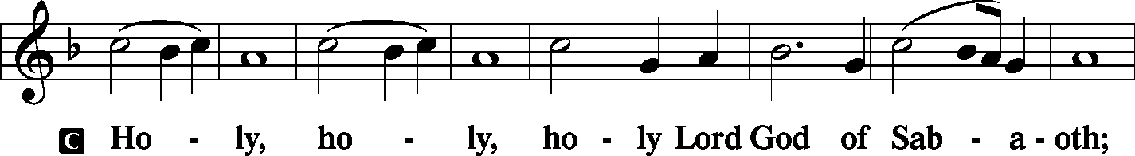

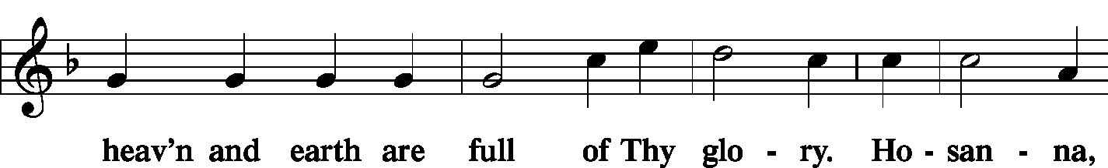

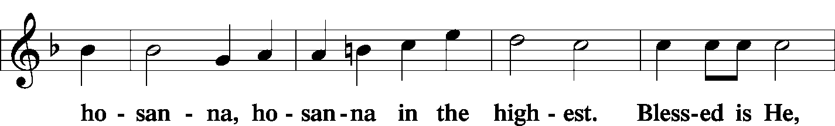

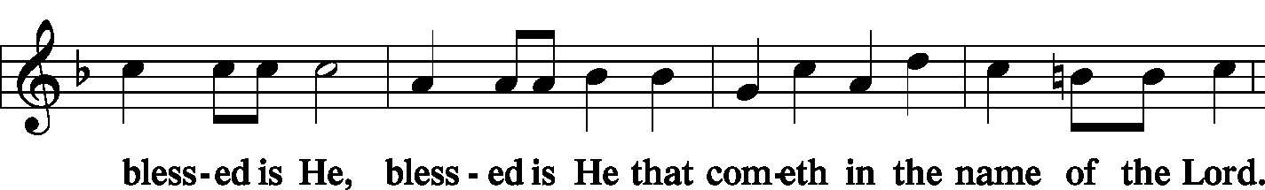

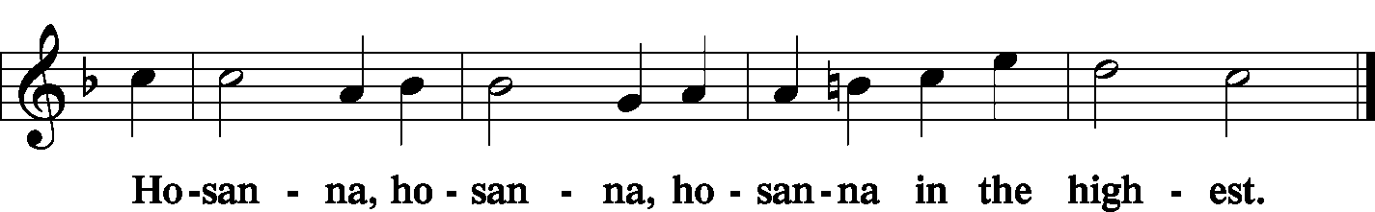

|  |  |  |  |  |
| --- | --- | --- | --- | --- |
|  | | |  | |
| LORD’S PRAYER | | | *Page 196* | |
| C: | Our Father Who art in heaven, hallowed be Thy name, Thy kingdom come, Thy will be done on earth as it is in heaven; give us this day our daily bread; and forgive us our trespasses as we forgive those who trespass against us; and lead us not into temptation, but deliver us from evil. For Thine is the kingdom and the power and the glory forever and ever. Amen. | | | |
|  | | |  | |
| WORDS OF OUR LORD | | | *Page 197* | |
| P: | Our Lord Jesus Christ, on the night when He was betrayed, took bread, and when He had given thanks, He broke it and gave it to the disciples and said: “Take, eat; this is My T body, which is given for you. This do in remembrance of Me.”  In the same way also He took the cup after supper, and when He had given thanks, He gave it to them, saying: “Drink of it, all of you; this cup is the new testament in My T blood, which is shed for you for the forgiveness of sins. This do, as often as you drink it, in remembrance of Me.” | | | |
|  |  | | | |
| PAX DOMINI | | *The Peace of the Lord* | | *Page 197* |
| P: | The peace of the Lord be with you always. | | |  |
|  |  | | |  |

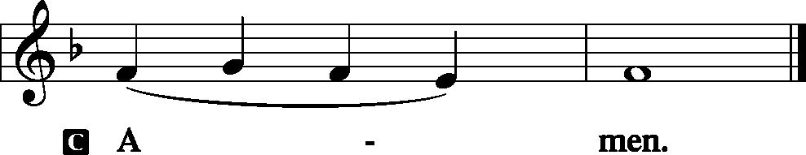

|  |  |  |  |
| --- | --- | --- | --- |
|  |  | |  |
|  | *Please be seated* | |  |
|  |  | |  |
| AGNUS DEI | | *Lamb of God* | *Page 198* |
|  | |  |  |

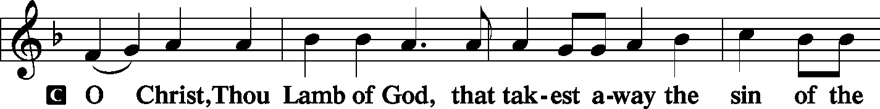

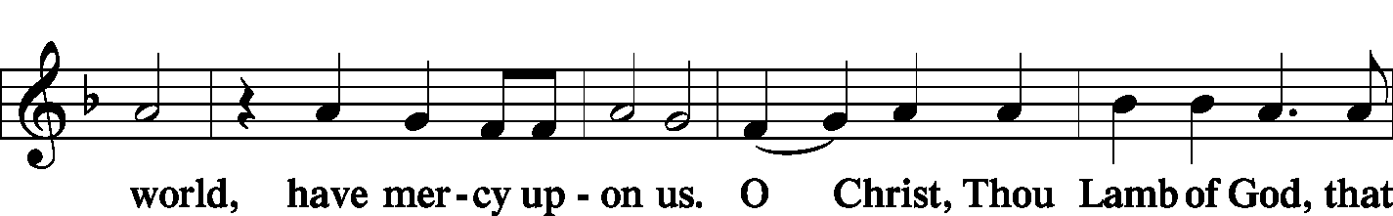

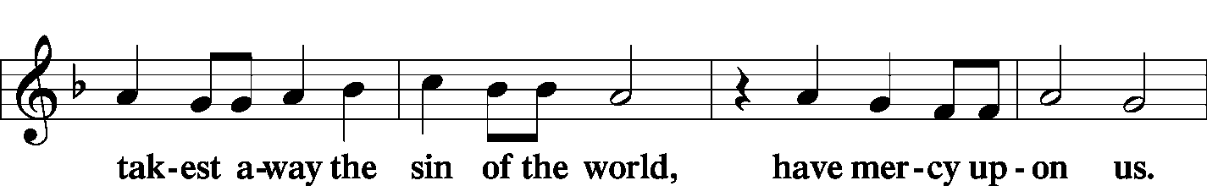

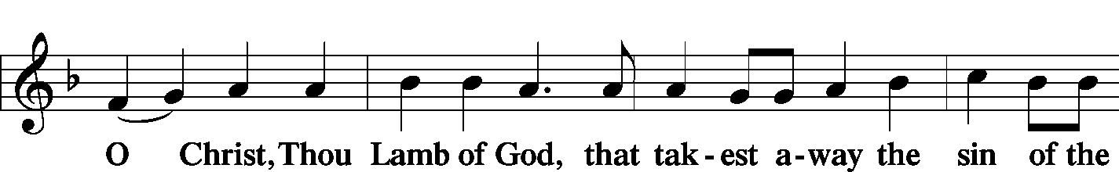

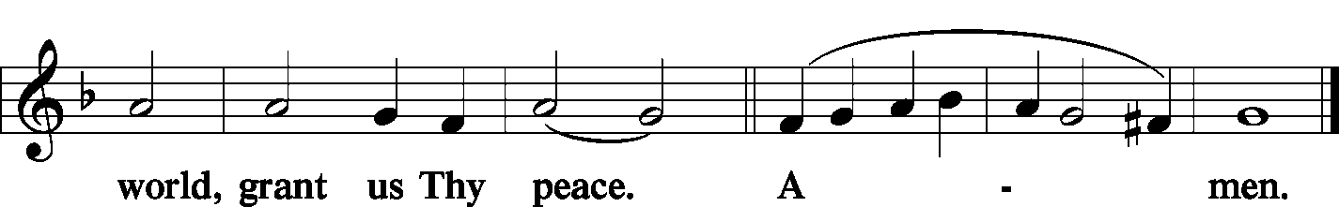

|  |  |  |  |  |  |
| --- | --- | --- | --- | --- | --- |
|  | | |  | |  |
|  | *Prayer before Communing: Dear Savior, at Your gracious invitation I come to Your table to eat and drink Your holy body and blood. Let me find favor in Your eyes to receive this holy Sacrament in faith for the salvation of my soul and to the glory of Your holy name; for You live and reign with the Father and the Holy Spirit, one God, now and forever. Amen.* | | | | |
|  |  | | | | |
|  | *Thanksgiving after Receiving the Sacrament: Almighty and everlasting God, I thank and praise You for feeding me the life-giving body and blood of Your beloved Son, Jesus Christ. Send Your Holy Spirit that, having with my mouth received the holy Sacrament, I may by faith obtain and eternally enjoy Your divine grace, the forgiveness of sins, unity with Christ, and life eternal; through Jesus Christ, my Lord. Amen.* | | | | |
|  |  | | | | |
| DISTRIBUTION | | | |  | |
|  | *LSB 62*2 | *Lord Jesus Christ, You Have Prepared* | | | |
|  |  |  | | | |
|  | *LSB 730* | *What Is the World to Me* | | | |
|  |  |  | | | |
| POST-COMMUNION BLESSING | | | | | |
| P: | May the true Body of our Lord Jesus Christ, and His most precious Blood, strengthen you in true faith, granting you the forgiveness of sins, unto life everlasting. Depart in peace. | | | | |
| C: | Amen. | | | | |
|  |  | | | | |
| NUNC DIMITTIS | | *Lord, Now Lettest Thou Thy Servant*  *(Song of Simeon)* | | | *Pages 199-200* |
|  | |  | | |  |

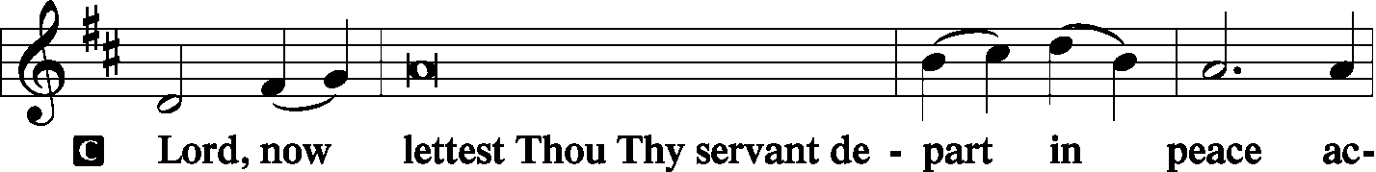

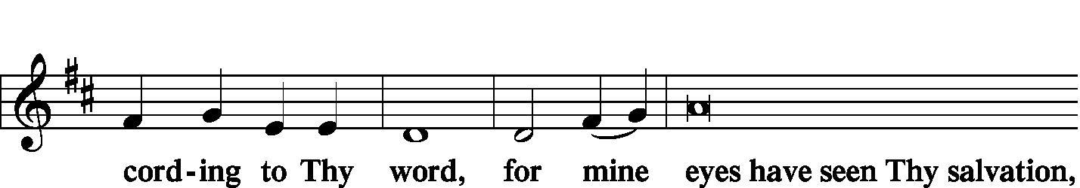

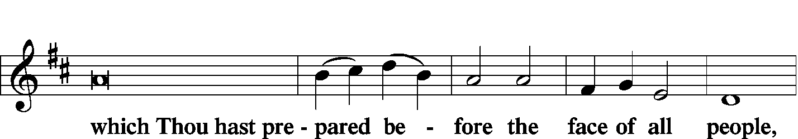

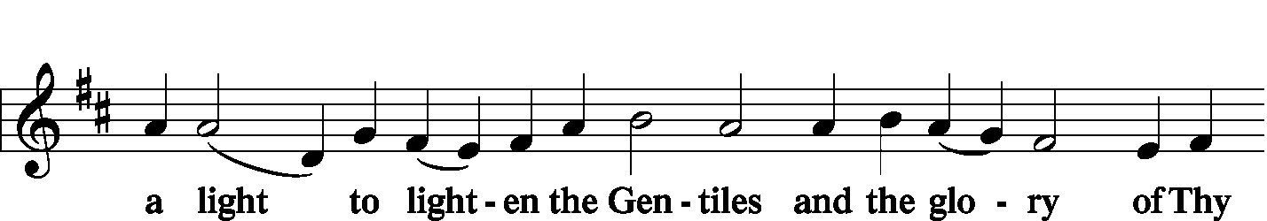

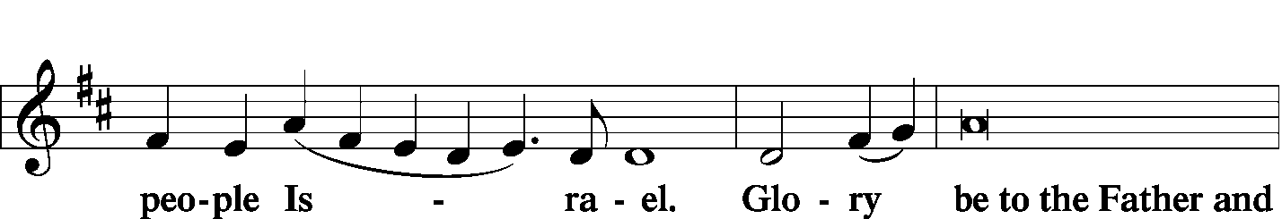

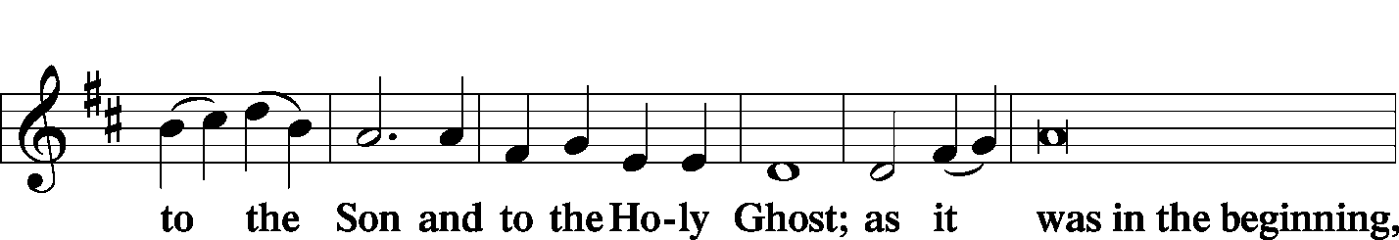

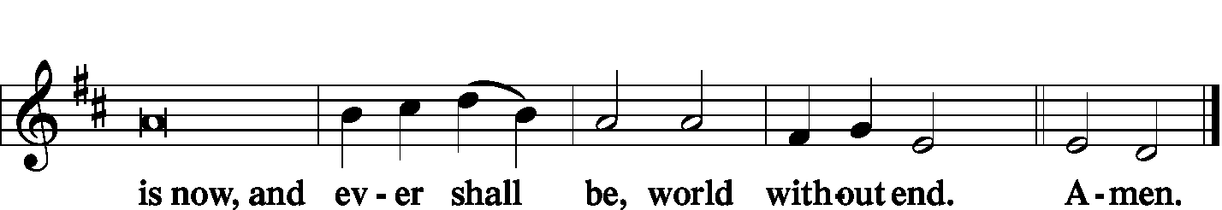

|  |  |  |  |
| --- | --- | --- | --- |
|  | |  |  |
| THANKSGIVING | |  | *Pages 200-01* |
| P: | O Give thanks unto the Lord, for He is good, | |  |
|  |  | |  |

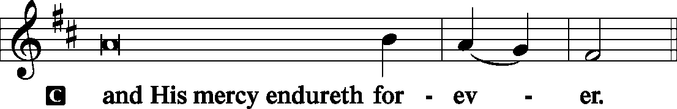

|  |  |
| --- | --- |
|  |  |
| P: | Let us pray.  We give thanks to You, almighty God, that You have refreshed us through this salutary gift, and we implore You that of Your mercy You would strengthen us through the same in faith toward You and in fervent love toward one another; through Jesus Christ, Your Son, our Lord, Who lives and reigns with You and the Holy Spirit, one God, now and forever. |
|  |  |



|  |  |  |  |
| --- | --- | --- | --- |
|  | |  |  |
| SALUTATION AND BENEDICAMUS | | | *Pages 201-02* |
| P: | The Lord be with you. | | |
|  |  | | |

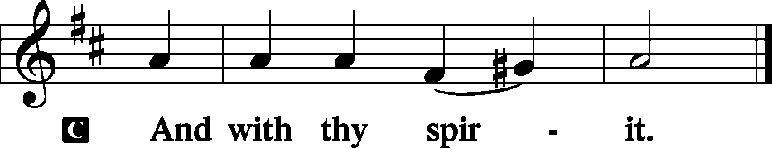

|  |  |
| --- | --- |
|  |  |
| P: | Bless we the Lord. |
|  |  |

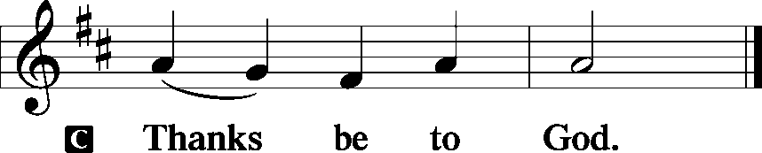

|  |  |  |
| --- | --- | --- |
|  | |  |
| BENEDICTION | | *Page 202* |
| P: | The Lord bless you and keep you.  The Lord make His face shine upon you and be gracious unto you.  The Lord lift up His countenance upon you and T give you peace. | |
|  |  | |

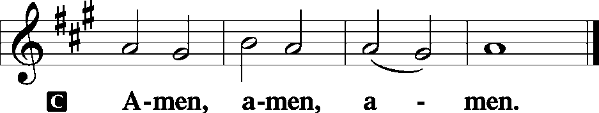

|  |  |  |  |  |
| --- | --- | --- | --- | --- |
|  | | | |  |
| CLOSING HYMN | | *O Holy Spirit, Grant Us Grace* | | LSB 693 |
|  | |  | |  |
| SILENT PRAYER | |  | |  |
|  | *Almighty and merciful God, I have again worshiped in Your presence and received both forgiveness for my many sins and the assurance of Your love in Jesus Christ. I thank You for this undeserved grace and ask You to keep me in faith until, with all Your saints, I inherit eternal salvation; through Jesus Christ, my Lord. Amen.* | | | |
|  | |  | |  |
| ANNOUNCEMENTS | | |  |  |
|  | | |  |  |
| POSTLUDE | | |  |  |
|  | | |  |  |

T T T

Acknowledgments

Divine Service, Setting Three from Lutheran Service Book

Unless otherwise indicated, all scripture quotations are from *The Holy Bible, English Standard Version*, copyright © 2001 by Crossway Bibles, a division of Good News Publishers. Used by permission. All rights reserved.

Created by Lutheran Service Builder © 2006 Concordia Publishing House.

|  |  |  |
| --- | --- | --- |
| PASTOR | - | The Rev. Barry A. Long |
| ELDER | - | Daniel Keehner |
| ORGANIST | - | Carol Wessler |