|  |
| --- |
| The Ninth Sunday after Pentecost |
| August 10, 2025 |
| + The Order of Matins + |
| Lutheran Service Book – Pages 219-228 |

|  |  |  |
| --- | --- | --- |
| Prayer Before Worship | |  |
|  | *O Lord, my Creator, Redeemer, and Comforter, as I come to worship You in spirit and in truth, I humbly pray that You would open my heart to the preaching of Your Word so that I may repent of my sins, believe in Jesus Christ as my only Savior, and grow in grace and holiness. Hear me for the sake of His name. Amen.* | |
|  |  | |
| PRELUDE | | |
|  | | |

|  |
| --- |
| RINGING BELL CALLS US TO WORSHIP |

|  |  |  |  |  |  |  |
| --- | --- | --- | --- | --- | --- | --- |
|  | | | |  | | |
| WELCOME | | | |  | | |
|  | | | |  | | |
| OPENING HYMN | | *Rejoice, O Pilgrim Throng* | | | LSB 813 |
|  | |  | | |  |
| CONFESSION AND ABSOLUTION | | | *Page 151* | | |
| P: | In the name of the Father and of the T Son and of the Holy Spirit. | | | | |
| C: | Amen. | | | | |
| P: | If we say we have no sin, we deceive ourselves, and the truth is not in us. | | | | |
| C: | But if we confess our sins, God, Who is faithful and just, will forgive our sins and cleanse us from all unrighteousness. | | | | |
|  |  | | | | |
|  | *(Silence for reflection on God’s Word and for self-examination.)* | | | | |
|  |  | | | | |
| P: | Let us then confess our sins to God our Father. | | | | |
| C: | **Most merciful God, we confess that we are by nature sinful and unclean. We have sinned against You in thought, word, and deed, by what we have done and by what we have left undone. We have not loved You with our whole heart; we have not loved our neighbors as ourselves. We justly deserve Your present and eternal punishment. For the sake of Your Son, Jesus Christ, have mercy on us. Forgive us, renew us, and lead us, so that we may delight in Your will and walk in Your ways to the glory of Your holy name. Amen.** | | | | |
| P: | Almighty God in His mercy has given His Son to die for you and for His sake forgives you all your sins. As a called and ordained servant of Christ, and by His authority, I therefore forgive you all your sins in the name of the Father and of the T Son and of the Holy Spirit. | | | | |
| C: | Amen. | | | | |
|  |  | | | | |

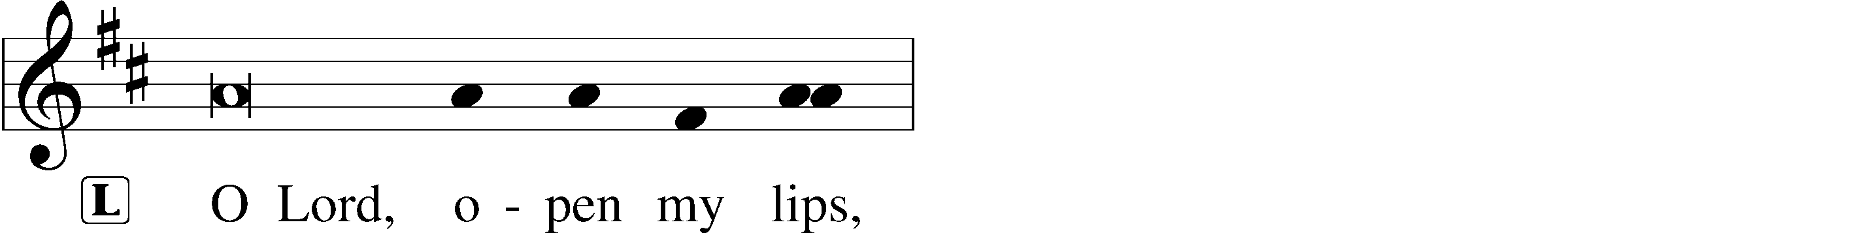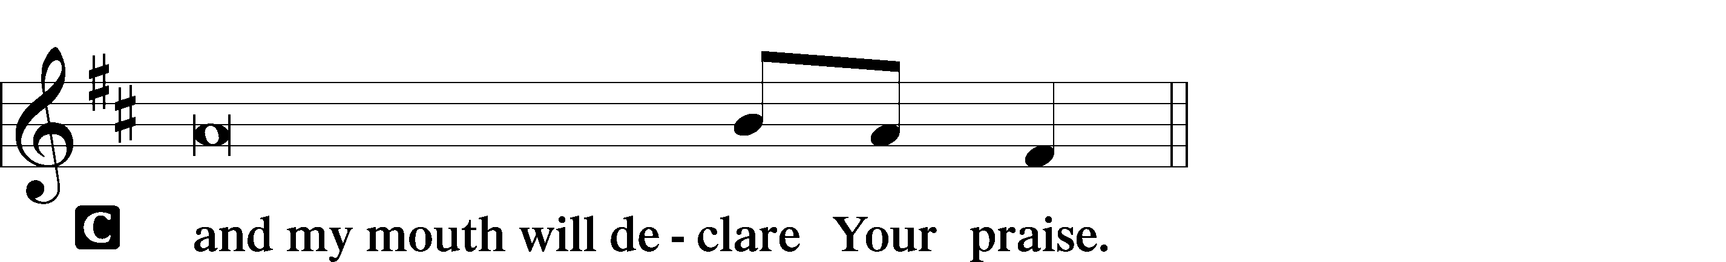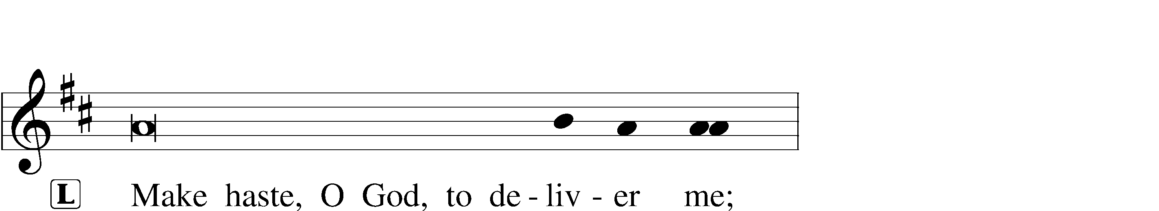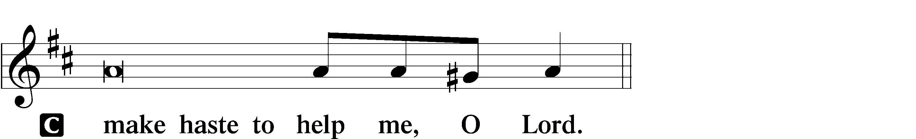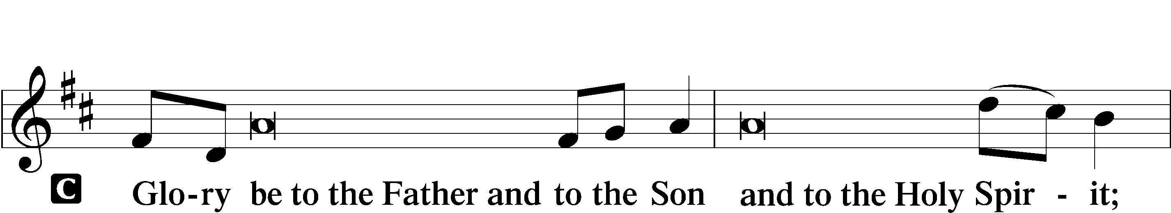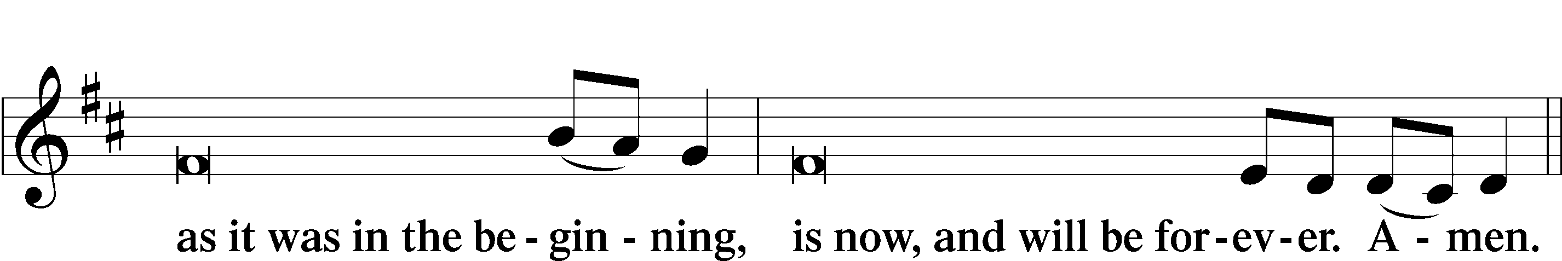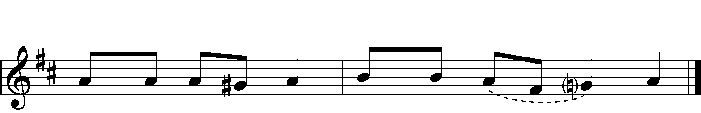

|  |  |  |  |
| --- | --- | --- | --- |
|  |  | | |
| PSALMODY | | Venite | *O Come, Let Us Sing* |
|  | Antiphon | | |
|  |  | | |

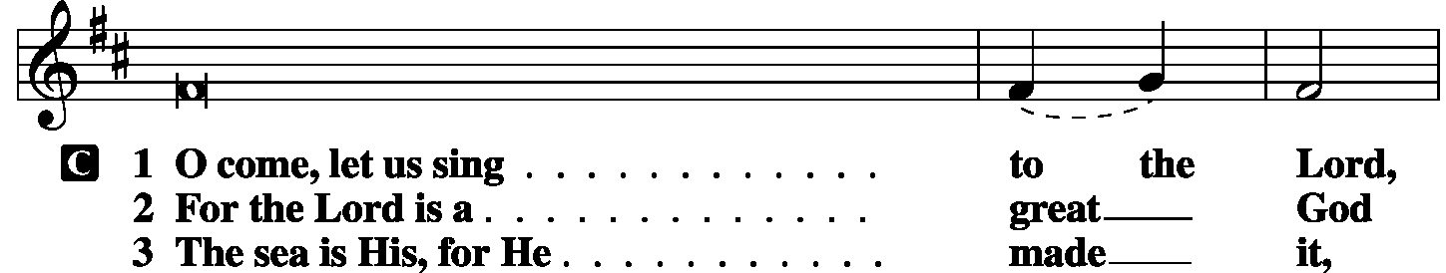

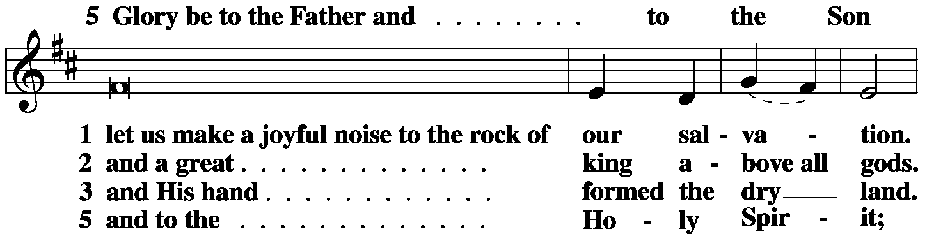

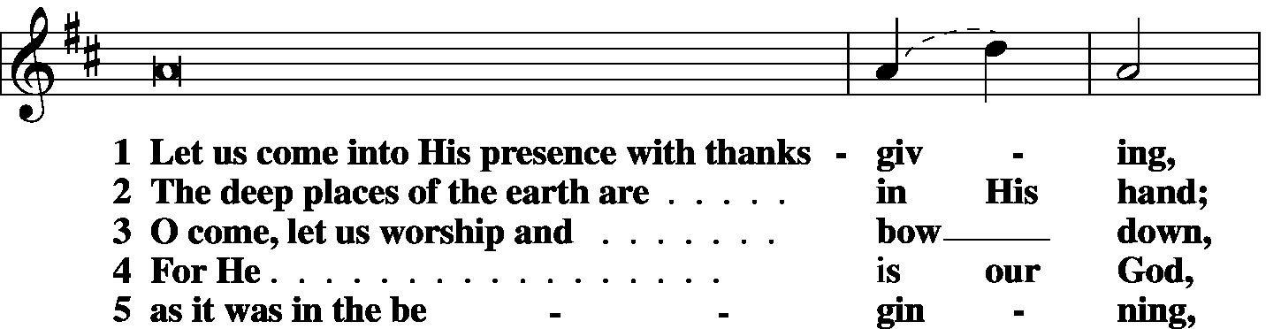

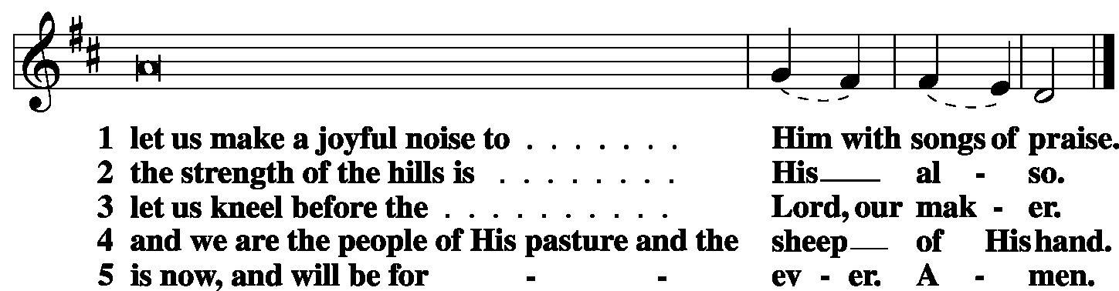

|  |  |  |  |
| --- | --- | --- | --- |
|  |  |  |  |

|  |  |  |  |
| --- | --- | --- | --- |
|  | Second Psalm | Psalm 33:12-22 | *(Sung responsively by verse)* |
|  |  |  | |

Blessèd is the nation whose God **|** is the Lord,**\***

the people whom He has chosen as His **|** heritage!

The Lord looks down from **|** heaven;**\***

He sees all the chil- **|** dren of man;

from where He sits enthroned He **|** looks out**\***

on all the inhabitants **|** of the earth,

He Who fashions the hearts **|** of them all**\***

and observes **|** all their deeds.

The king is not saved by his great **|** army;**\***

a warrior is not delivered by his **|** great strength.

The war horse is a false hope for sal- **|** vation,**\***

and by its great might it cannot **|** rescue.

Behold, the eye of the Lord is on those who **|** fear Him,**\***

on those who hope in His **|** steadfast love,

that He may deliver their **|** soul from death**\***

and keep them alive in **|** famine.

Our soul waits **|** for the Lord;**\***

He is our help **|** and our shield.

For our heart is **|** glad in Him,**\***

because we trust in His **|** holy Name.

Let Your steadfast love, O Lord, be up- **|** on us,**\***

even as we **|** hope in You.

**Glory be to the Father and | to the Son\***

**and to the Holy | Spirit;**

**as it was in the be- | ginning,\***

**is now, and will be forever. | Amen.**

|  |  |  |  |
| --- | --- | --- | --- |
|  |  | |  |
| OFFICE HYMN | *Christ Whose Glory Fills the Skies* | | LSB 873 |
|  |  | |  |
| THE GOSPEL FOR YOUNG FOLK | |  | | |
|  | |  | | |

|  |  |
| --- | --- |
| FIRST LESSON | Genesis 15:1-6 |

1After these things the word of the Lord came to Abram in a vision: “Fear not, Abram, I am your shield; your reward shall be very great.” 2But Abram said, “O Lord God, what will You give me, for I continue childless, and the heir of my house is Eliezer of Damascus?” 3And Abram said, “Behold, you have given me no offspring, and a member of my household will be my heir.” 4And behold, the Word of the Lord came to him: “This man shall not be your heir; your very own son shall be your heir.” 5And He brought him outside and said, “Look toward heaven, and number the stars, if you are able to number them.” Then He said to him, “So shall your offspring be.” 6And he believed the Lord, and He counted it to him as righteousness.

|  |  |  |
| --- | --- | --- |
|  |  | |
| P: | O Lord, have mercy on us. | |
| C: | **Thanks be to God.** | |
|  | |  |
| SECOND LESSON | | Hebrews 11:1-16 |

1Now faith is the assurance of things hoped for, the conviction of things not seen. 2For by it the people of old received their commendation. 3By faith we understand that the universe was created by the Word of God, so that what is seen was not made out of things that are visible.

4By faith Abel offered to God a more acceptable sacrifice than Cain, through which he was commended as righteous, God commending him by accepting his gifts. And through his faith, though he died, he still speaks. 5By faith Enoch was taken up so that he should not see death, and he was not found, because God had taken him. Now before he was taken he was commended as having pleased God. 6And without faith it is impossible to please Him, for whoever would draw near to God must believe that He exists and that He rewards those who seek Him. 7By faith Noah, being warned by God concerning events as yet unseen, in reverent fear constructed an ark for the saving of his household. By this he condemned the world and became an heir of the righteousness that comes by faith.

8By faith Abraham obeyed when he was called to go out to a place that he was to receive as an inheritance. And he went out, not knowing where he was going. 9By faith he went to live in the land of promise, as in a foreign land, living in tents with Isaac and Jacob, heirs with him of the same promise. 10For he was looking forward to the city that has foundations, whose designer and builder is God. 11By faith Sarah herself received power to conceive, even when she was past the age, since she considered Him faithful Who had promised. 12Therefore from one man, and him as good as dead, were born descendants as many as the stars of heaven and as many as the innumerable grains of sand by the seashore.

13These all died in faith, not having received the things promised, but having seen them and greeted them from afar, and having acknowledged that they were strangers and exiles on the earth. 14For people who speak thus make it clear that they are seeking a homeland. 15If they had been thinking of that land from which they had gone out, they would have had opportunity to return. 16But as it is, they desire a better country, that is, a heavenly one. Therefore God is not ashamed to be called their God, for He has prepared for them a city.

|  |  |  |
| --- | --- | --- |
|  |  | |
| P: | O Lord, have mercy on us. | |
| C: | **Thanks be to God.** | |
|  | |  |
| GOSPEL VERSE | | Luke 12:32 |
| P: | Alleluia. Fear not, little flock | |
| C: | for it is your Father’s good pleasure to give you the kingdom. Alleluia. | |
|  |  | |
| HOLY GOSPEL | | Luke 12:22-40 |
| P: | The Holy Gospel according to St. Luke, the twelfth chapter. | |
| C: | **Glory to You, O Lord.** | |
|  |  | |

22And He said to His disciples, **“Therefore I tell you, do not be anxious about your life, what you will eat, nor about your body, what you will put on. 23For life is more than food, and the body more than clothing. 24Consider the ravens: they neither sow nor reap, they have neither storehouse nor barn, and yet God feeds them. Of how much more value are you than the birds! 25And which of you by being anxious can add a single hour to his span of life? 26If then you are not able to do as small a thing as that, why are you anxious about the rest? 27Consider the lilies, how they grow: they neither toil nor spin, yet I tell you, even Solomon in all his glory was not arrayed like one of these. 28But if God so clothes the grass, which is alive in the field today, and tomorrow is thrown into the oven, how much more will He clothe you, O you of little faith! 29And do not seek what you are to eat and what you are to drink, nor be worried. 30For all the nations of the world seek after these things, and your Father knows that you need them. 31Instead, seek His kingdom, and these things will be added to you.**

**32“Fear not, little flock, for it is your Father’s good pleasure to give you the kingdom. 33Sell your possessions, and give to the needy. Provide yourselves with moneybags that do not grow old, with a treasure in the heavens that does not fail, where no thief approaches and no moth destroys. 34For where your treasure is, there will your heart be also.**

35[Jesus said:] **“Stay dressed for action and keep your lamps burning, 36and be like men who are waiting for their master to come home from the wedding feast, so that they may open the door to him at once when he comes and knocks. 37Blessed are those servants whom the master finds awake when he comes. Truly, I say to you, he will dress himself for service and have them recline at table, and he will come and serve them. 38If he comes in the second watch, or in the third, and finds them awake, blessed are those servants! 39But know this, that if the master of the house had known at what hour the thief was coming, he would not have left his house to be broken into. 40You also must be ready, for the Son of Man is coming at an hour you do not expect.”**

|  |  |  |
| --- | --- | --- |
|  |  | |
| P: | This is the Gospel of the Lord. | |
| C: | **Praise to You, O Christ.** | |
|  | |  |
| RESPONSORY | |  |
|  |  | |

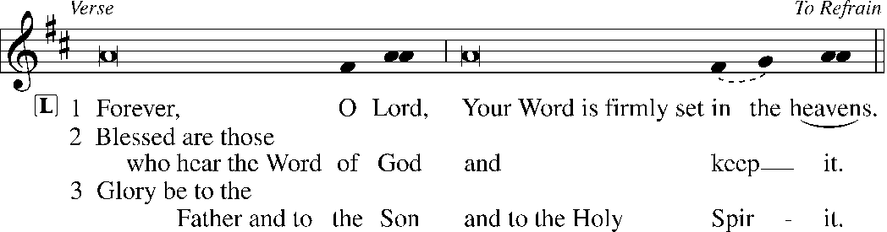

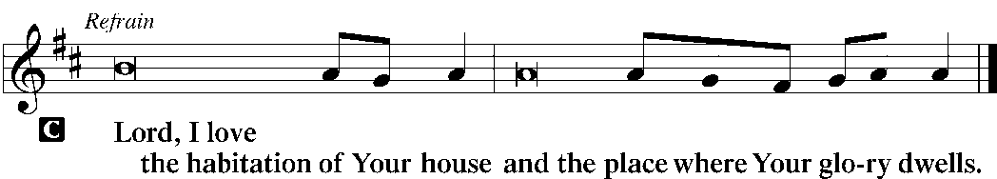

|  |  |  |  |  |  |
| --- | --- | --- | --- | --- | --- |
|  | |  | |  | |
| HYMN OF THE DAY | | *Have No Fear, Little Flock* | | LSB 735 | |
|  | | | | | |
| SERMON | | | | | |
|  | | | | | |
| CANTICLE | Te Deum | | *LSB p. 223* | |
|  |  | |  | |

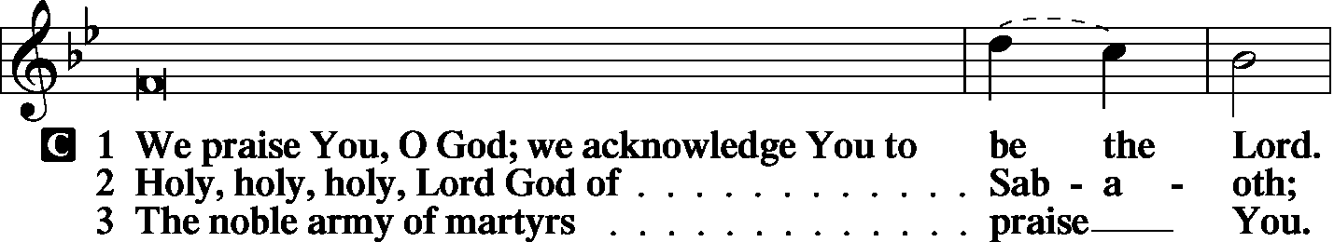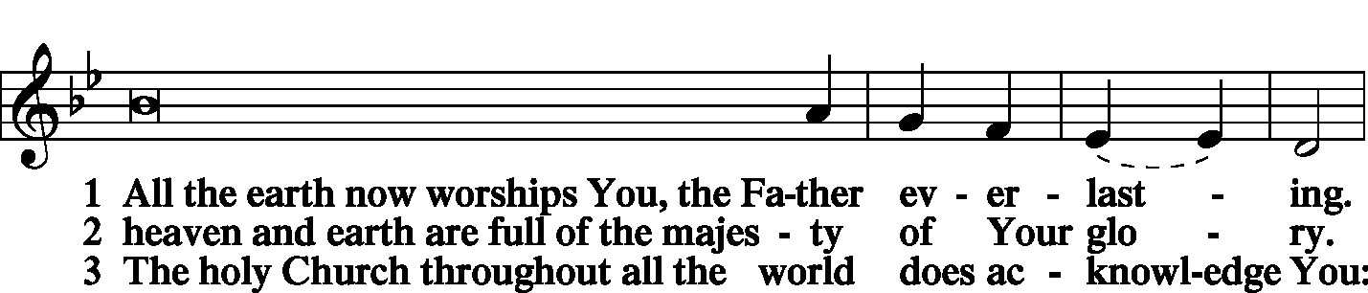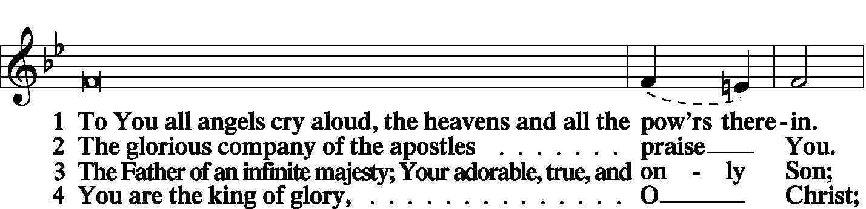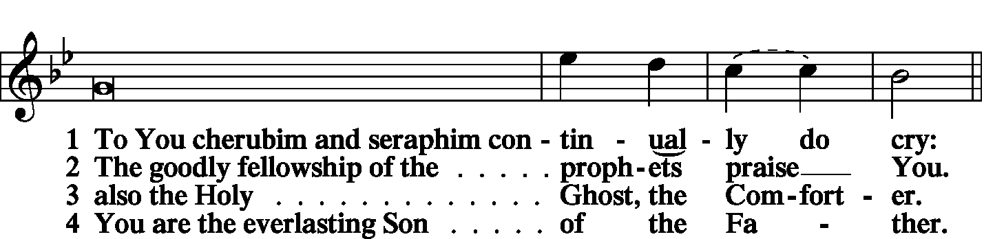

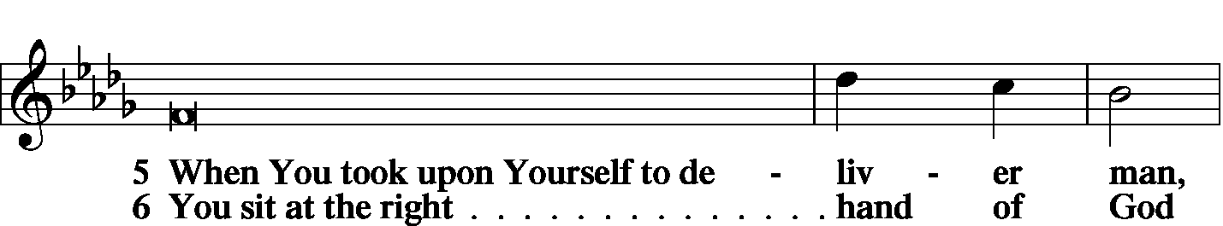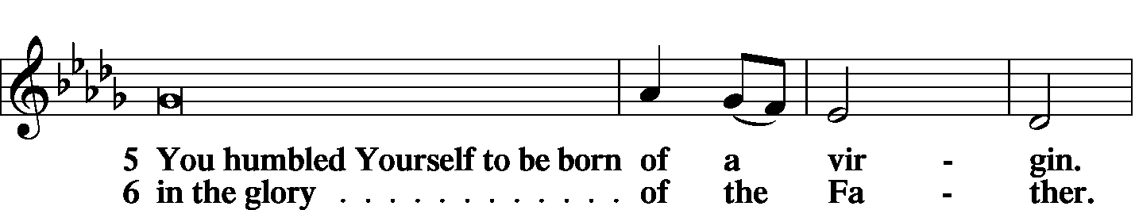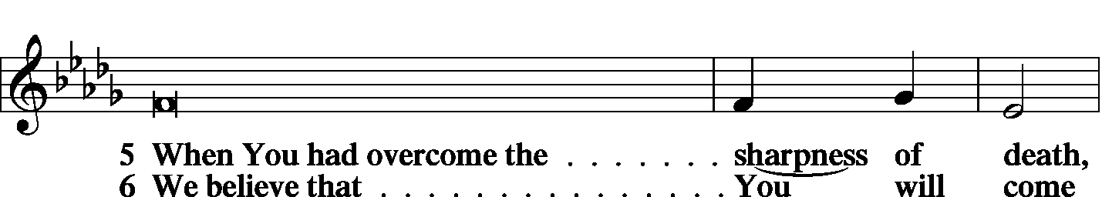

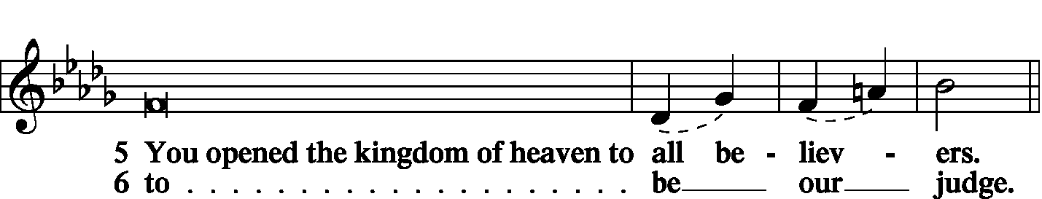

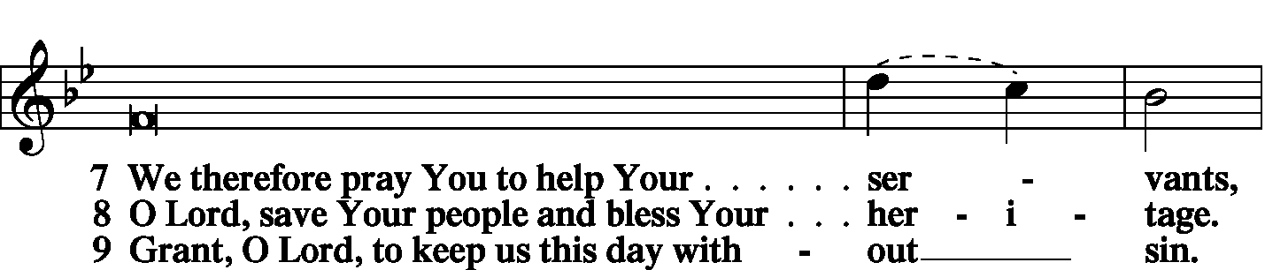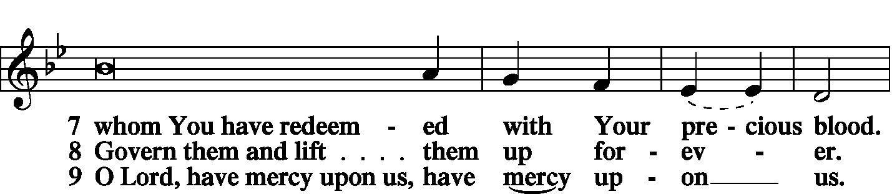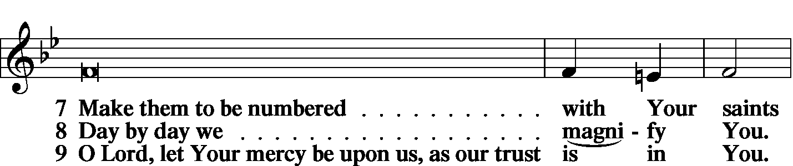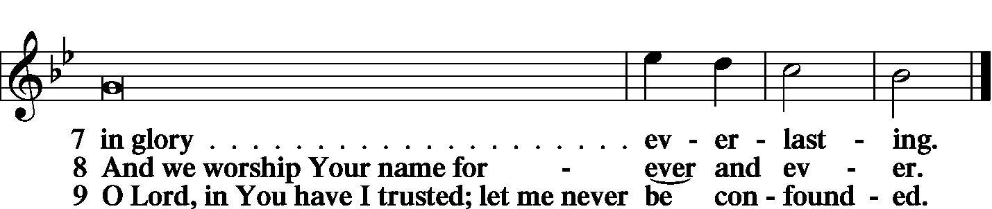

|  |  |
| --- | --- |
|  |  |
| PRAYER OF THE CHURCH | *LSB p. 227* |
|  |  |
| KYRIE |  |

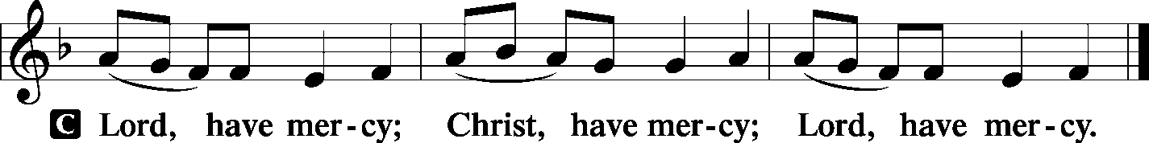

|  |  |
| --- | --- |
|  |  |
| LORD’S PRAYER | |
| C: | Our Father Who art in heaven, hallowed be Thy name, Thy kingdom come, Thy will be done on earth as it is in heaven; give us this day our daily bread; and forgive us our trespasses as we forgive those who trespass against us; and lead us not into temptation, but deliver us from evil. For Thine is the kingdom and the power and the glory forever and ever. Amen. |
|  |  |

|  |  |
| --- | --- |
| COLLECTS |  |
|  |  |

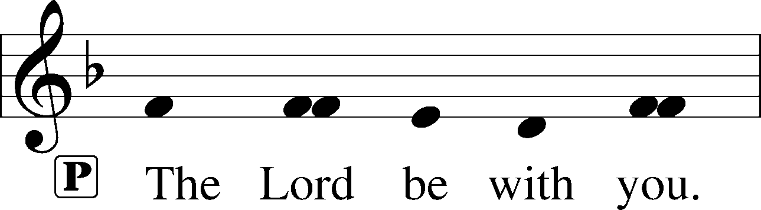

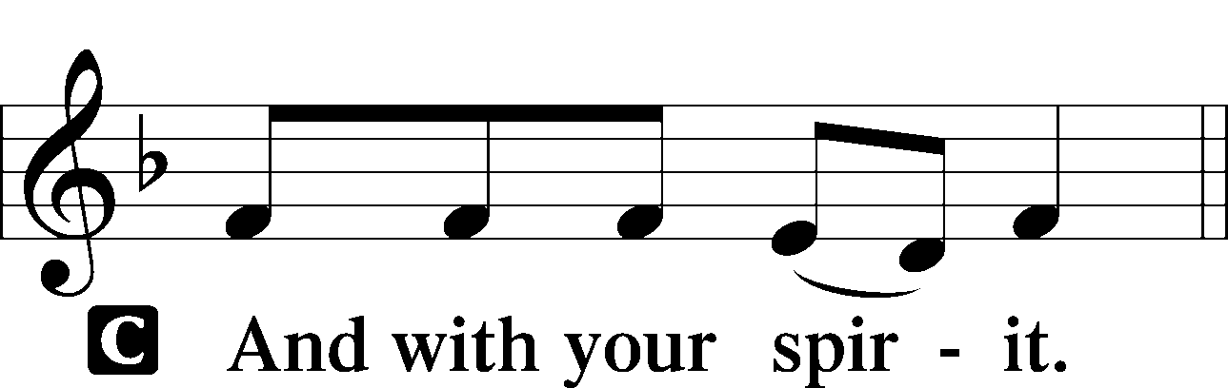

|  |  |
| --- | --- |
|  | |
| Collect of the Day | |
| P: | Almighty and merciful God, it is by Your grace that we live as Your people who offer acceptable service. Grant that we may walk by faith, and not by sight, in the way that leads to eternal life; through Jesus Christ, Your Son, our Lord. |



|  |  |
| --- | --- |
| Collect for Matins | |
| P: | Almighty God, heavenly Father, Your mercies are new to us every morning, and You abundantly provide for all our wants of body and soul. Give us we humbly pray, Your Holy Spirit that we may heartily acknowledge Your merciful goodness toward us, give thanks for all Your benefits, and cheerfully serve You. |



|  |  |  |
| --- | --- | --- |
| For Guidance in Our Calling | | *LSB p. 311* |
| P: | Lord God, You have called Your servants to ventures of which we cannot see the ending, by paths as yet untrodden, through perils unknown. Give us faith to go out with good courage, not knowing where we go but only that Your hand is leading us and Your love supporting us; through Jesus Christ, our Lord. | |



|  |  |  |
| --- | --- | --- |
| For Responsible Citizenship | | *LSB p.313* |
| P: | Lord, keep this nation under Your care. Bless the leaders of our land that we may be a people at peace among ourselves and a blessing to the other nations of the earth. Grant that we may choose trustworthy leaders, contribute to wise decisions for the general welfare, and serve You faithfully in our generation; through Jesus Christ, our Lord. | |



|  |  |
| --- | --- |
| A Prayer for Students and Families for Another Academic Year | |
| P: | Gracious Father in heaven, we thank You for the work You are doing in the lives of our families and children through the various forms of education they receive. We pray that You would use the education of this new academic year to build up our families and young people in the knowledge and skills that will allow them to serve their families, community, and church. We ask this in the name of Jesus Christ. |

|  |  |  |
| --- | --- | --- |
| Collect for Grace | | *LSB p.228* |
| P: | O Lord, our heavenly Father, almighty and everlasting God, You have safely brought us to the beginning of this day. Defend us in the same with Your mighty power and grant that this day we fall into no sin, neither run into any kind of danger, but that all our doings, being ordered by Your governance, may be righteous in Your sight; through Jesus Christ, Your Son, our Lord, Who lives and reigns with You and the Holy Spirit, one God, now and forever. | |



|  |  |  |
| --- | --- | --- |
| BENEDICAMUS | | *LSB p. 227* |
|  |  | |

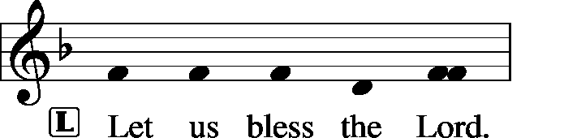

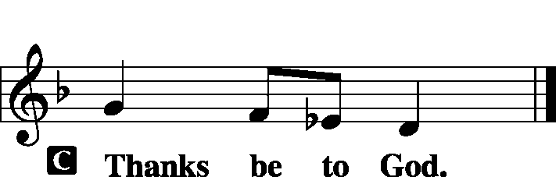

|  |  |  |
| --- | --- | --- |
| BENEDICTION | |  |
|  |  | |

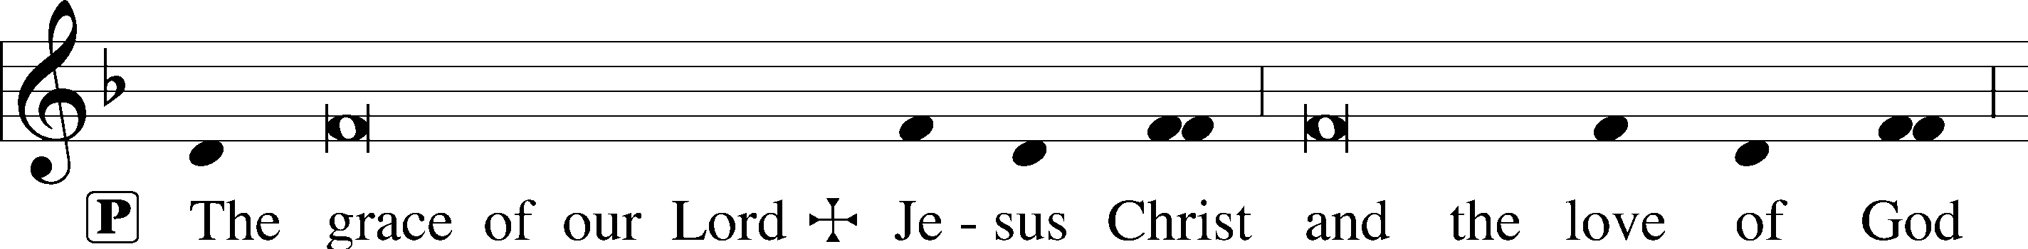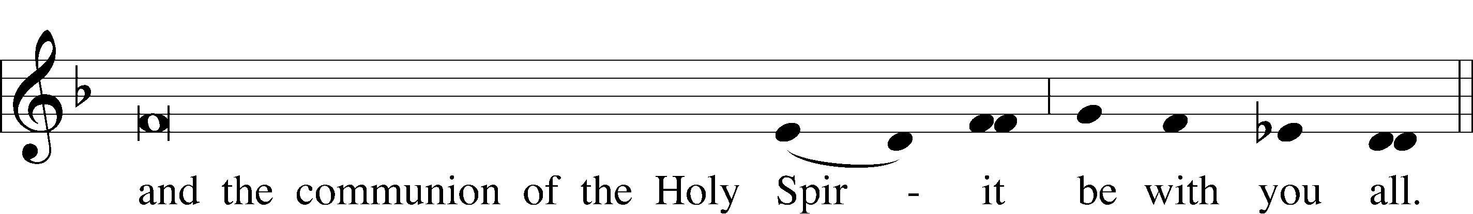

|  |  |  |  |  |  |  |
| --- | --- | --- | --- | --- | --- | --- |
|  | | |  | | |  |
| CLOSING HYMN | | *Great Is Thy Faithfulness* | | | LSB 809 | |
|  | |  | | |  | |
| SILENT PRAYER | | |  | | |  | |
|  | *Almighty and merciful God, I have again worshiped in Your presence and received both forgiveness for my many sins and the assurance of Your love in Jesus Christ. I thank You for this undeserved grace and ask You to keep me in faith until, with all Your saints, I inherit eternal salvation; through Jesus Christ, my Lord. Amen.* | | | | | | |
|  | | | | | | | |
| T T T | | | | | | | |
|  | | | | | | | |
| Pastor: The Rev. Barry Long | | | |  | | | |
| Elder: Dr. Joel Eckert | | | | | | | |
| Organist: Carol Wessler | | | | | | | |
|  | | | | | | | |

Acknowledgments

Matins from Lutheran Service Book

Unless otherwise indicated, all scripture quotations are from *The Holy Bible, English Standard Version*, copyright © 2001 by Crossway Bibles, a division of Good News Publishers. Used by permission. All rights reserved.

Created by Lutheran Service Builder © 2006 Concordia Publishing House.