|  |
| --- |
| Tenth Sunday after Pentecost |
| August 17, 2025 |
| Divine Service I/Holy Communion |
| LSB Page 151 |

REGISTRATION FOR HOLY COMMUNION

Members of Mt. Calvary and visitors, who are confirmed members in good standing of congregations of the Lutheran Church-Missouri Synod, are asked to announce attendance at Holy Communion by means of the registration cards in the pews. Non-member visitors and guests, who may desire to attend Holy Communion, are asked to speak in person with the pastor before doing so. Those who desire a blessing, but choose not to commune, may come forward and simply cross their hands over their chest.

In accord with Holy Scripture, our church teaches that Holy Communion is open only to those who: (1) have been baptized in the name of the Triune God; Matt. 28:19, Acts 2:41-42; (2) are able to examine themselves both as to what this meal is and also its purpose; 1 Cor. 11:26-30; (3) have confessed and repented of their sins; 1 John 1:8-2:3; (4) believe that in, with, and under the bread and wine all communicants receive the true body and blood of our Lord Jesus Christ for the forgiveness of sins: 1 Cor. 11:23-27, 1 Cor. 10:16, Matt. 26:26-28; and who (5) are united in belief in the same teaching: 1 Cor. 10:17, Rom. 16:18, 2 John 10-11, Matt. 28:20, Heb. 13:9.

*Looking for extra help in focusing your thoughts for the Lord’s Supper? “Christian Questions with Their Answers” was prepared by Luther to address just that. They can be found in your hymnal on pages 329-330. Review them if you get to church early, or if you are waiting to be invited forward.*

|  |  |  |  |  |
| --- | --- | --- | --- | --- |
|  | | | | |
| *Prayer Before Worship: O Lord, my Creator, Redeemer, and Comforter, as I come to worship You in spirit and in truth, I humbly pray that You would open my heart to the preaching of Your Word so that I may repent of my sins, believe in Jesus Christ as my only Savior, and grow in grace and holiness. Hear me for the sake of His name. Amen.* | | | | |
|  |  | | | |
| PRELUDE | |  | |  |
|  | | |  | |
| RINGING BELL CALLS US TO WORSHIP | | |  | |
|  | | |  | |
| WELCOME | | |  | |
|  | | |  | |

|  |  |  |  |  |
| --- | --- | --- | --- | --- |
| OPENING HYMN | | *LSB 578 Thy Strong Word* | | |
|  | |  | |  |
| CONFESSION AND ABSOLUTION | | | *Page 151* | |
| P: | In the name of the Father and of the T Son and of the Holy Spirit. | | | |
| C: | Amen. | | | |
| P: | If we say we have no sin, we deceive ourselves, and the truth is not in us. | | | |
| C: | But if we confess our sins, God, Who is faithful and just, will forgive our sins and cleanse us from all unrighteousness. | | | |
|  |  | | | |
|  | *(Silence for reflection on God’s Word and for self-examination.)* | | | |
|  |  | | | |
| P: | Let us then confess our sins to God our Father. | | | |
| C: | **Most merciful God, we confess that we are by nature sinful and unclean. We have sinned against You in thought, word, and deed, by what we have done and by what we have left undone. We have not loved You with our whole heart; we have not loved our neighbors as ourselves. We justly deserve Your present and eternal punishment. For the sake of Your Son, Jesus Christ, have mercy on us. Forgive us, renew us, and lead us, so that we may delight in Your will and walk in Your ways to the glory of Your holy name. Amen.** | | | |
| P: | Almighty God in His mercy has given His Son to die for you and for His sake forgives you all your sins. As a called and ordained servant of Christ, and by His authority, I therefore forgive you all your sins in the name of the Father and of the T Son and of the Holy Spirit. | | | |
| C: | Amen. | | | |
|  | | |
| INTROIT | | | *Psalm 55:1, 12–14, 16; antiphon: v. 22* | |
|  | | |  | |

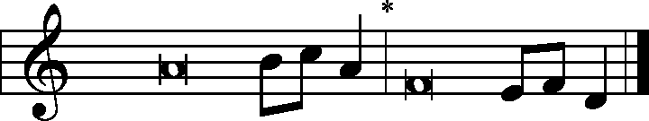

Cast your burden on the Lord, and he will sus- | tain you;*

he will never permit the righteous to | be moved.  
Give ear to my prayer, | O God,*

and hide not yourself from my plea for | mercy!  
For it is not an enemy who taunts me—then I could | bear it;*

it is not an adversary who deals insolently with me—then I could | hide from him.

But it is you, a man, my | equal,*

my companion, my fa- | miliar friend.  
We used to take sweet counsel to- | gether;*

within God’s house we walked | in the throng.  
But I | call to God,*

and the Lord will | save me.  
**Glory be to the Father and | to the Son**\*

**and to the Holy | Spirit;**  
**as it was in the be- | ginning,**\*

**is now, and will be forever. | Amen.**  
Cast your burden on the Lord, and he will sus- | tain you;*

he will never permit the righteous to | be moved.

|  |  |
| --- | --- |
| KYRIE | Pages 152-53 |
|  |  |

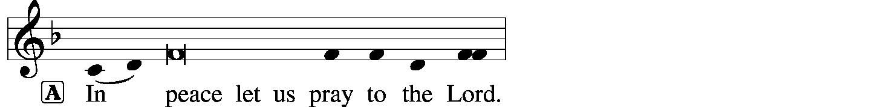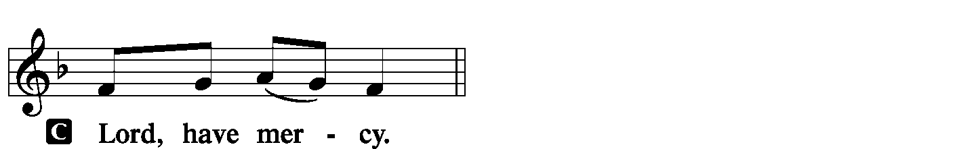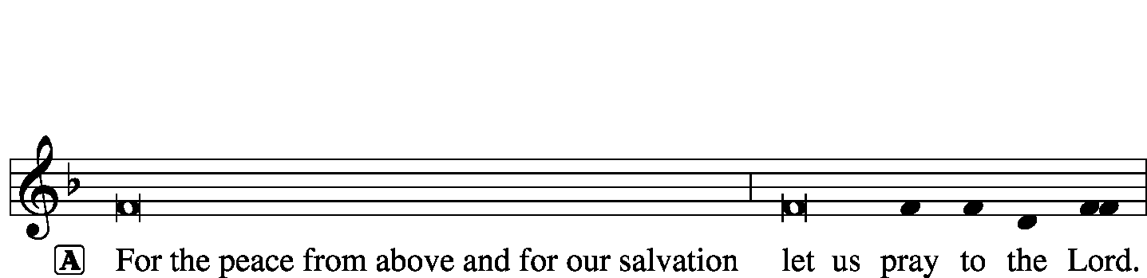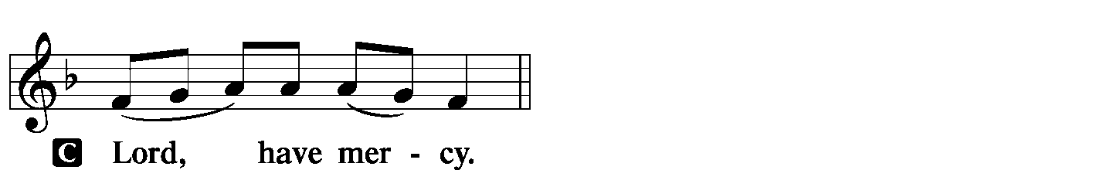

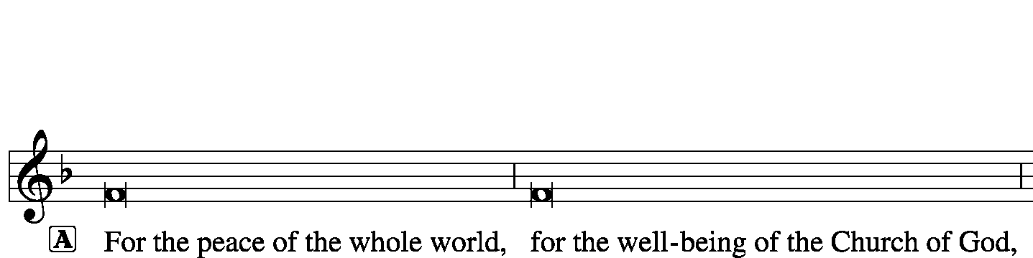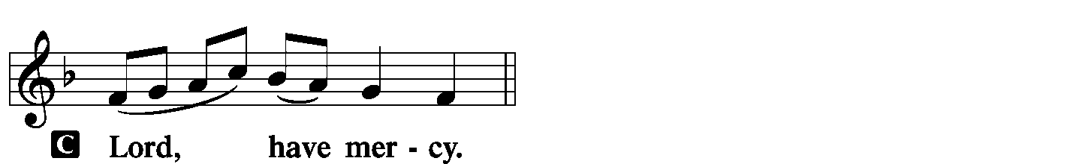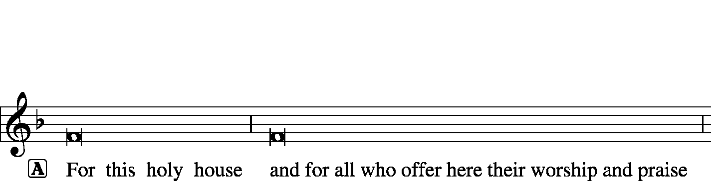



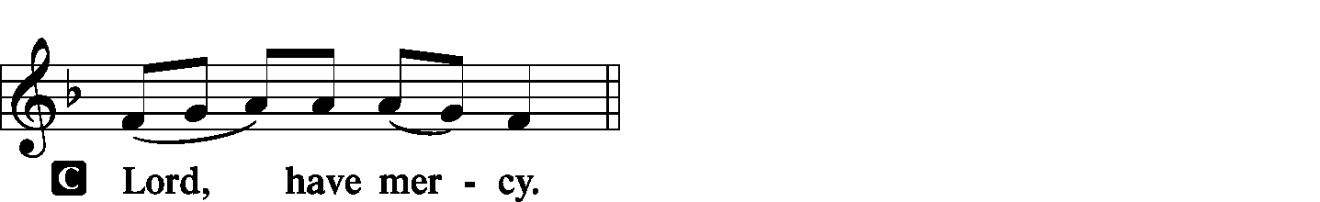

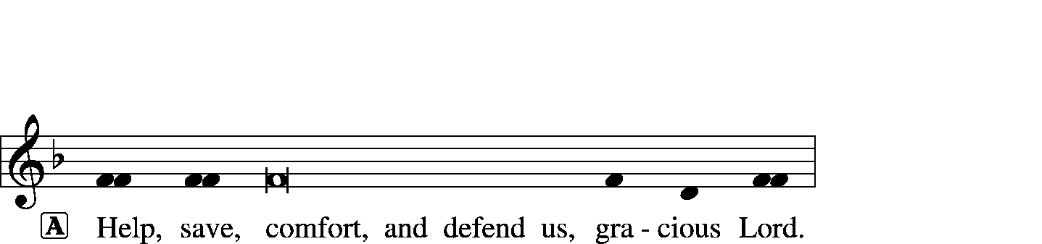



|  |  |  |  |
| --- | --- | --- | --- |
|  |  | | |
| HYMN OF PRAISE | | *Gloria in Excelsis* | Page 154 |
|  | |  |  |

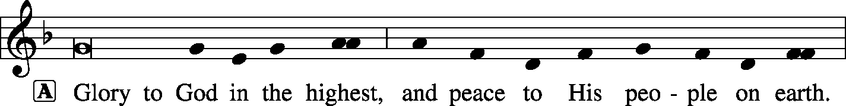

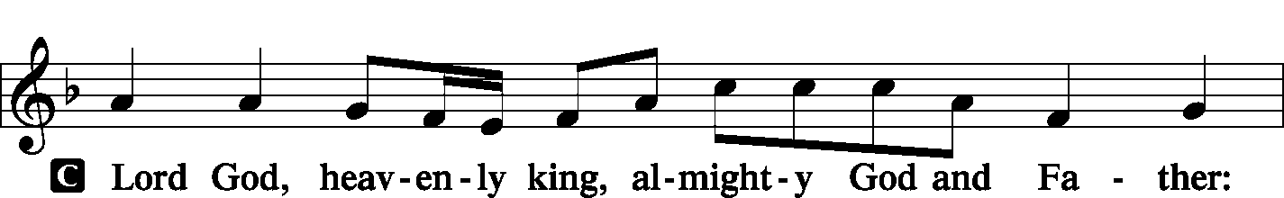

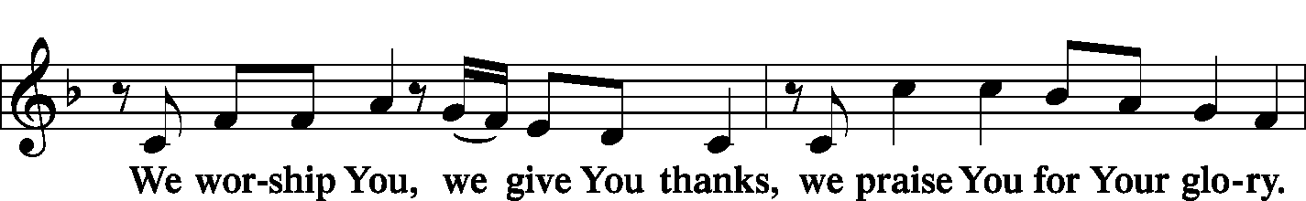

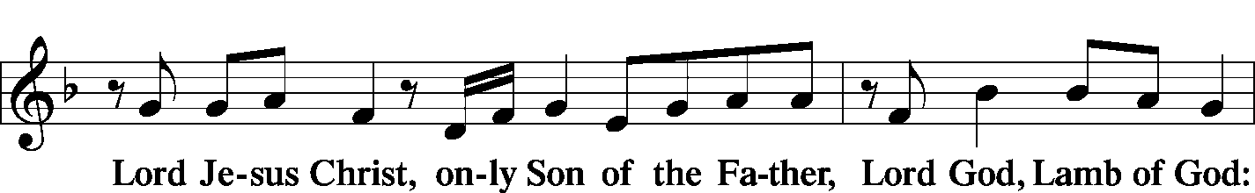

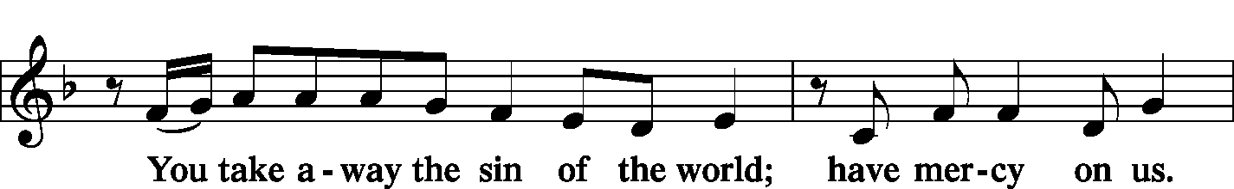

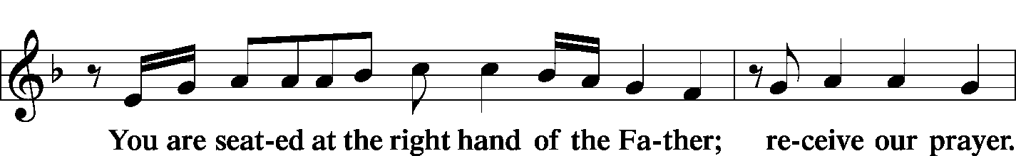

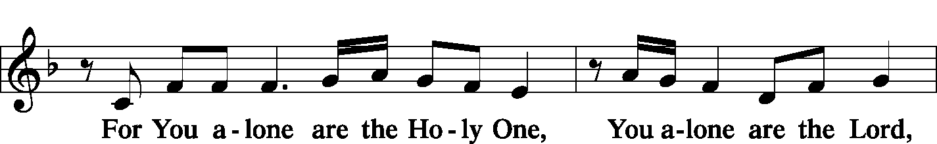

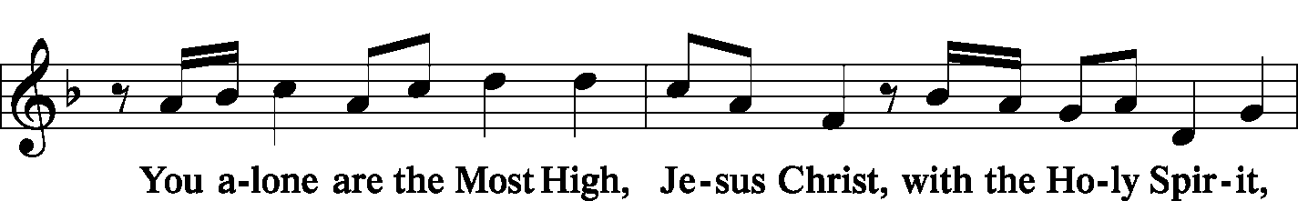

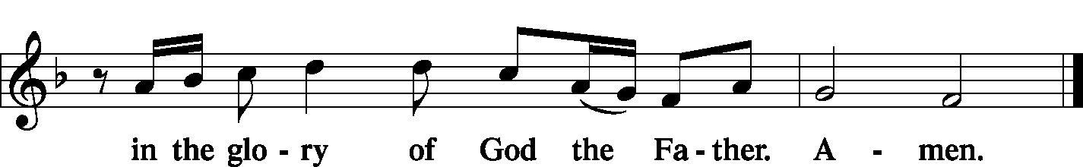

|  |  |  |
| --- | --- | --- |
|  |  | |
| SALUTATION | | *Page 156* |

|  |  |
| --- | --- |
|  |  |

|  |  |  |
| --- | --- | --- |
| COLLECT OF THE DAY | |  |
| P: | Let us pray. | |
| C: | Merciful Lord, cleanse and defend Your Church by the sacrifice of Christ. United with Him in Holy Baptism, give us grace to receive with thanksgiving the fruits of His redeeming work and daily follow in His way; through the same Jesus Christ, Your Son, our Lord, Who lives and reigns with You and the Holy Spirit, one God, now and forever. **Amen.** | |
|  | |  |
| THE GOSPEL FOR YOUNGER FOLK | |  |
|  | |  |
| FIRST READING | | *Jeremiah 23:16–29* |

16Thus says the Lord of hosts: “Do not listen to the words of the prophets who prophesy to you, filling you with vain hopes. They speak visions of their own minds, not from the mouth of the Lord. 17They say continually to those who despise the Word of the Lord, ‘It shall be well with you’; and to everyone who stubbornly follows his own heart, they say, ‘No disaster shall come upon you.’”

18For who among them has stood in the council of the Lord  
 to see and to hear His Word,  
 or who has paid attention to His Word and listened?  
19Behold, the storm of the Lord!  
 Wrath has gone forth,  
a whirling tempest;  
 it will burst upon the head of the wicked.  
20The anger of the Lord will not turn back  
 until He has executed and accomplished  
 the intents of His heart.  
In the latter days you will understand it clearly.

21“I did not send the prophets,  
 yet they ran;  
I did not speak to them,  
 yet they prophesied.  
22But if they had stood in My council,  
 then they would have proclaimed My words to My people,  
and they would have turned them from their evil way,  
 and from the evil of their deeds.

23“Am I a God at hand, declares the Lord, and not a God afar off? 24Can a man hide himself in secret places so that I cannot see him? declares the Lord. Do I not fill heaven and earth? declares the Lord. 25I have heard what the prophets have said who prophesy lies in My Name, saying, ‘I have dreamed, I have dreamed!’ 26How long shall there be lies in the heart of the prophets who prophesy lies, and who prophesy the deceit of their own heart, 27who think to make My people forget My Name by their dreams that they tell one another, even as their fathers forgot My Name for Baal? 28Let the prophet who has a dream tell the dream, but let him who has My Word speak my word faithfully. What has straw in common with wheat? declares the Lord. 29Is not My Word like fire, declares the Lord, and like a hammer that breaks the rock in pieces?”

|  |  |  |  |
| --- | --- | --- | --- |
|  |  | | |
| P: | This is the word of the Lord. | | |
| C: | Thanks be to God. | | |
|  |  | | |
| PSALM | | Psalm 119:81-88 | *(Sung responsively by verse)* |
|  | |  |  |

My soul longs for Your sal- | vation;*  
 I hope | in Your Word.  
My eyes long for Your | promise;*  
 I ask, “When will You | comfort me?”  
For I have become like a wineskin | in the smoke,*  
 yet I have not forgotten Your | statutes.  
How long must Your ser- | vant endure?*  
 When will You judge those who perse- | cute me?  
The insolent have dug pit- | falls for me;*  
 they do not live according | to Your law.  
All Your command- | ments are sure;*  
 they persecute me with falsehood; | help me!  
They have almost made an end of me | on earth,*  
 but I have not forsaken Your | precepts.  
In Your steadfast love | give me life,*  
 that I may keep the testimonies | of Your mouth.

**Glory be to the Father and | to the Son\***

**and to the Holy | Spirit;**

**as it was in the be- | ginning,\***

**is now, and will be forever. | Amen.**

|  |  |  |  |
| --- | --- | --- | --- |
|  |  |  | |
| SECOND READING | | | *Hebrews 11:17—12:3* |

17By faith Abraham, when he was tested, offered up Isaac, and he who had received the promises was in the act of offering up his only son, 18of whom it was said, “Through Isaac shall your offspring be named.” 19He considered that God was able even to raise him from the dead, from which, figuratively speaking, he did receive him back. 20By faith Isaac invoked future blessings on Jacob and Esau. 21By faith Jacob, when dying, blessed each of the sons of Joseph, bowing in worship over the head of his staff. 22By faith Joseph, at the end of his life, made mention of the exodus of the Israelites and gave directions concerning his bones.

23By faith Moses, when he was born, was hidden for three months by his parents, because they saw that the child was beautiful, and they were not afraid of the king’s edict. 24By faith Moses, when he was grown up, refused to be called the son of Pharaoh’s daughter, 25choosing rather to be mistreated with the people of God than to enjoy the fleeting pleasures of sin. 26He considered the reproach of Christ greater wealth than the treasures of Egypt, for he was looking to the reward. 27By faith he left Egypt, not being afraid of the anger of the king, for he endured as seeing him who is invisible. 28By faith he kept the Passover and sprinkled the blood, so that the Destroyer of the firstborn might not touch them.

29By faith the people crossed the Red Sea as if on dry land, but the Egyptians, when they attempted to do the same, were drowned. 30By faith the walls of Jericho fell down after they had been encircled for seven days. 31By faith Rahab the prostitute did not perish with those who were disobedient, because she had given a friendly welcome to the spies.

32And what more shall I say? For time would fail me to tell of Gideon, Barak, Samson, Jephthah, of David and Samuel and the prophets— 33who through faith conquered kingdoms, enforced justice, obtained promises, stopped the mouths of lions, 34quenched the power of fire, escaped the edge of the sword, were made strong out of weakness, became mighty in war, put foreign armies to flight. 35Women received back their dead by resurrection. Some were tortured, refusing to accept release, so that they might rise again to a better life. 36Others suffered mocking and flogging, and even chains and imprisonment. 37They were stoned, they were sawn in two, they were killed with the sword. They went about in skins of sheep and goats, destitute, afflicted, mistreated— 38of whom the world was not worthy—wandering about in deserts and mountains, and in dens and caves of the earth.

39And all these, though commended through their faith, did not receive what was promised, 40since God had provided something better for us, that apart from us they should not be made perfect.

12:1Therefore, since we are surrounded by so great a cloud of witnesses, let us also lay aside every weight, and sin which clings so closely, and let us run with endurance the race that is set before us, 2looking to Jesus, the founder and perfecter of our faith, who for the joy that was set before him endured the cross, despising the shame, and is seated at the right hand of the throne of God.

3Consider him who endured from sinners such hostility against himself, so that you may not grow weary or fainthearted.

|  |  |
| --- | --- |
|  |  |
| P: | This is the word of the Lord. |
| C: | Thanks be to God. |
|  |  |

|  |  |
| --- | --- |
| GOSPEL VERSE | *Page 156* |

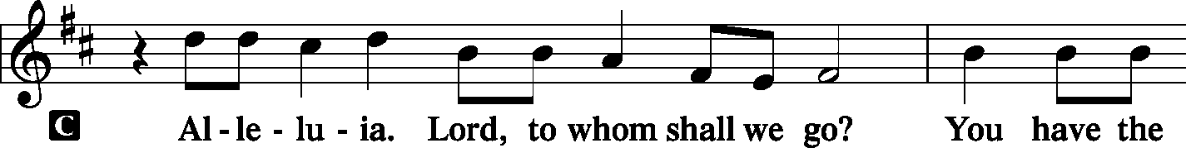

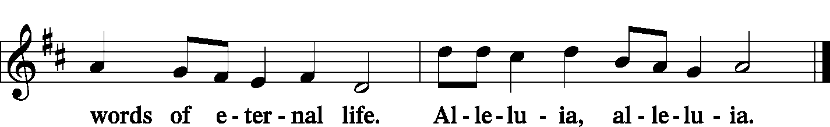

|  |  |  |
| --- | --- | --- |
|  | |  |
| INTRODUCTION | |  |
| P: | The Holy Gospel according to St. Luke, the twelfth chapter. | |
|  |  | |

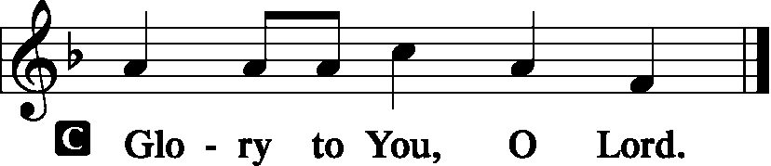

|  |  |
| --- | --- |
|  |  |
| GOSPEL LESSON | *Luke 12:49–56* |

49[Jesus said:] “I came to cast fire on the earth, and would that it were already kindled! 50I have a baptism to be baptized with, and how great is My distress until it is accomplished! 51Do you think that I have come to give peace on earth? No, I tell you, but rather division. 52For from now on in one house there will be five divided, three against two and two against three. 53They will be divided, father against son and son against father, mother against daughter and daughter against mother, mother-in-law against her daughter-in-law and daughter-in-law against mother-in-law.”

54He also said to the crowds, “When you see a cloud rising in the west, you say at once, ‘A shower is coming.’ And so it happens. 55And when you see the south wind blowing, you say, ‘There will be scorching heat,’ and it happens. 56You hypocrites! You know how to interpret the appearance of earth and sky, but why do you not know how to interpret the present time?”

|  |  |
| --- | --- |
|  |  |
| P: | This is the Gospel of the Lord. |
|  |  |

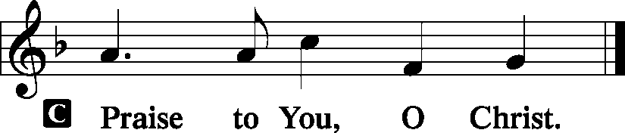

|  |  |  |
| --- | --- | --- |
|  |  |  |
| HYMN OF THE DAY | *LSB 733 O God, Our Help in Ages Past* | |
|  |  |  |
| SERMON |  |  |
|  | | |

|  |  |  |  |  |  |  |
| --- | --- | --- | --- | --- | --- | --- |
| NICENE CREED | | | *Page 158* | | | |
| C: | I believe in one God, the Father Almighty, maker of heaven and earth and of all things visible and invisible.  And in one Lord Jesus Christ, the only-begotten Son of God, begotten of His Father before all worlds, God of God, Light of Light, very God of very God, begotten, not made, being of one substance with the Father, by Whom all things were made; Who for us men and for our salvation came down from heaven and was incarnate by the Holy Spirit of the virgin Mary and was made man; and was crucified also for us under Pontius Pilate. He suffered and was buried. And the third day He rose again according to the Scriptures and ascended into heaven and sits at the right hand of the Father. And He will come again with glory to judge both the living and the dead, Whose kingdom will have no end.  And I believe in the Holy Spirit, the Lord and giver of life, Who proceeds from the Father and the Son, Who with the Father and the Son together is worshiped and glorified, Who spoke by the prophets. And I believe in one holy Christian and apostolic Church, I acknowledge one Baptism for the remission of sins, and I look for the resurrection of the dead and the life **T** of the world to come. Amen. | | | | | |
|  |  | | | | | |
| PRAYER OF THE CHURCH | | | | *Page 159* | | |
|  | | | |  | | |
| OFFERTORY | | *What Shall I Render to the Lord*  Psalm 116 | | | | *Pages 159-60* |
|  | |  | | |  | |

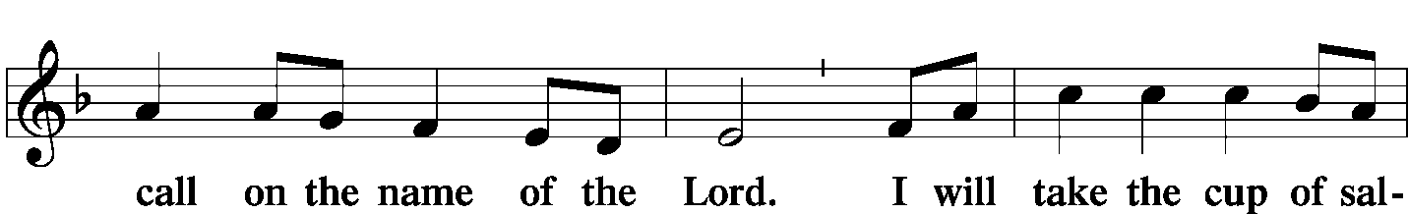

|  |  |  |  |  |  |
| --- | --- | --- | --- | --- | --- |
|  |  | | | |  |
| Hymn | | *LSB 550 Lamb of God* | | | |
|  | |  | |  | |
| PREFACE | | | Page 160 | | |
|  | | |  | | |

|  |  |  |
| --- | --- | --- |
|  | |  |
| PROPER PREFACE | |  |
| P: | It is truly good, right, and salutary that we should at all times and in all places give thanks to You, holy Lord, almighty Father, everlasting God, through Jesus Christ, our Lord, Who, having created all things, took on human flesh and was born of the virgin Mary. For our sake He died on the cross and rose from the dead to put an end to death, thus fulfilling Your will and gaining for You a holy people. Therefore with angels and archangels and with all the company of heaven we laud and magnify Your glorious name, evermore praising You and singing: | |

|  |  |  |
| --- | --- | --- |
| SANCTUS | *Holy, Holy, Holy Lord* | *Page 161* |
|  |  |  |

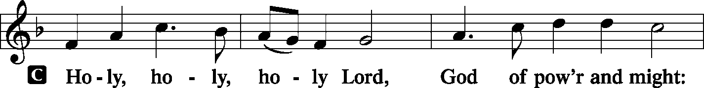

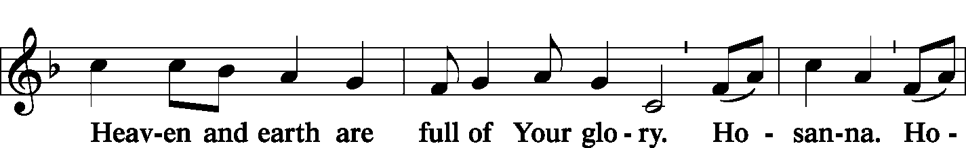

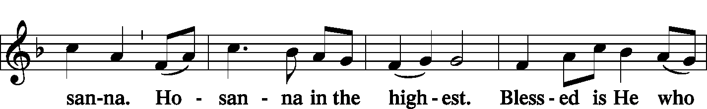

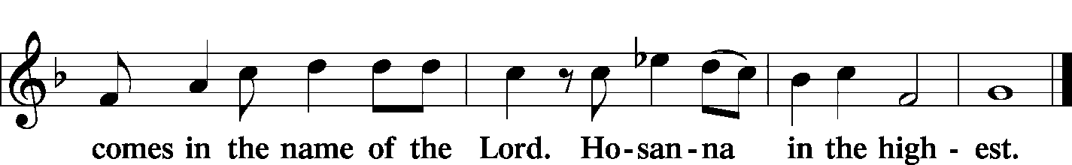

|  |  |  |  |  |  |  |  |  |  |  |  |
| --- | --- | --- | --- | --- | --- | --- | --- | --- | --- | --- | --- |
|  | | | |  | | | | |  | | |
| PRAYER OF THANKSGIVING | | | | | | | |  | *Page 161* | | |
| P: | Blessed are You, Lord of heaven and earth, for You have had mercy on those whom You created and sent Your only-begotten Son into our flesh to bear our sin and be our Savior. With repentant joy we receive the salvation accomplished for us by the all-availing sacrifice of His body and His blood on the cross.  Gathered in the name and the remembrance of Jesus, we beg You, O Lord, to forgive, renew, and strengthen us with Your Word and Spirit. Grant us faithfully to eat His body and drink His blood as He bids us do in His own testament. Gather us together, we pray, from the ends of the earth to celebrate with all the faithful the marriage feast of the Lamb in His kingdom, which has no end. Graciously receive our prayers; deliver and preserve us. To You alone, O Father, be all glory, honor, and worship, with the Son and the Holy Spirit, one God, now and forever. | | | | | | | | | | |
| C: | Amen. | | | | | | | | | | |
|  | | | | | | |  | | | | |
| LORD’S PRAYER | | | | | | | Page 162, Right Column | | | | |
| P: | | | Lord, remember us in Your kingdom and teach us to pray: | | | | | | | | |
| C: | | | Our Father Who art in heaven, hallowed be Thy name, Thy kingdom come, Thy will be done on earth as it is in heaven; give us this day our daily bread; and forgive us our trespasses as we forgive those who trespass against us; and lead us not into temptation, but deliver us from evil. For Thine is the kingdom and the power and the glory forever and ever. Amen. | | | | | | | | |
|  | | | | | |  | | | | | |
| WORDS OF OUR LORD | | | | | | *(Words of Institution)* | | | | | |
| P: | | Our Lord Jesus Christ, on the night when He was betrayed, took bread, and when He had given thanks, He broke it and gave it to the disciples and said: “Take, eat; this is My T body, which is given for you. This do in remembrance of Me.”  In the same way also He took the cup after supper, and when He had given thanks, He gave it to them, saying: “Drink of it, all of you; this cup is the new testament in My T blood, which is shed for you for the forgiveness of sins. This do, as often as you drink it, in remembrance of Me.” | | | | | | | | | |
|  | | | | |  | | | | |  | |
| PAX DOMINI | | | | | *The Peace of the Lord* | | | | | | *Page 163* |
|  | | | | |  | | | | |  | |

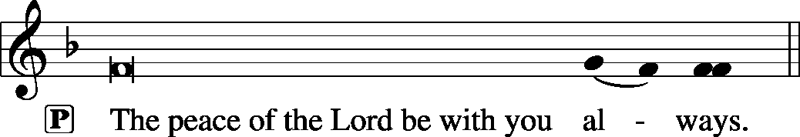



|  |  |  |
| --- | --- | --- |
|  |  |  |

|  |  |  |
| --- | --- | --- |
| AGNUS DEI | *Lamb of God* | *Page 163* |

|  |  |  |  |  |  |
| --- | --- | --- | --- | --- | --- |
|  | | |  | |  |
|  | *Prayer before Communing: Dear Savior, at Your gracious invitation I come to Your table to eat and drink Your holy body and blood. Let me find favor in Your eyes to receive this holy Sacrament in faith for the salvation of my soul and to the glory of Your holy name; for You live and reign with the Father and the Holy Spirit, one God, now and forever. Amen.* | | | | |
|  |  | | | | |
|  | *Thanksgiving after Receiving the Sacrament: Almighty and everlasting God, I thank and praise You for feeding me the life-giving body and blood of Your beloved Son, Jesus Christ. Send Your Holy Spirit that, having with my mouth received the holy Sacrament, I may by faith obtain and eternally enjoy Your divine grace, the forgiveness of sins, unity with Christ, and life eternal; through Jesus Christ, my Lord. Amen.* | | | | |
|  |  | | | | |
| DISTRIBUTION | | | |  | |
|  | *LSB 633* | *At the Lamb’s High Feast We Sing* | | | |
|  | *LSB 661* | *The Son of God Goes Forth to War* | | | |
|  |  |  | | | |
| POST-COMMUNION BLESSING | | | | | |
| P: | May the true Body of our Lord Jesus Christ, and His most precious Blood, strengthen you in true faith, granting you the forgiveness of sins, unto life everlasting. Depart in Peace. | | | | |
| C: | Amen. | | | | |
|  |  | | | | |

|  |  |  |
| --- | --- | --- |
| POST-COMMUNION CANTICLE | *Nunc Dimittis – Song of Simeon*  *Lord, Now You Let Your Servant* | Page 165 |
|  |  |  |

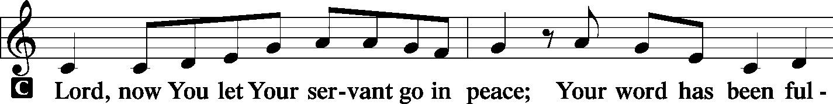

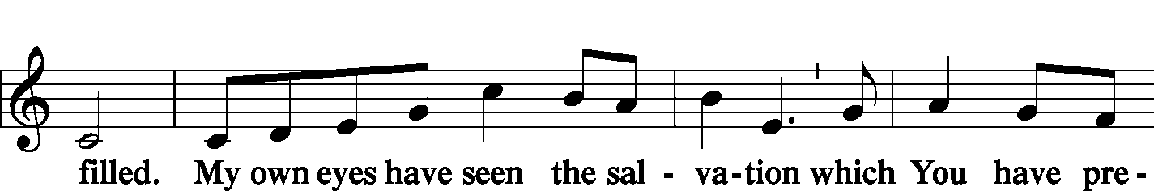

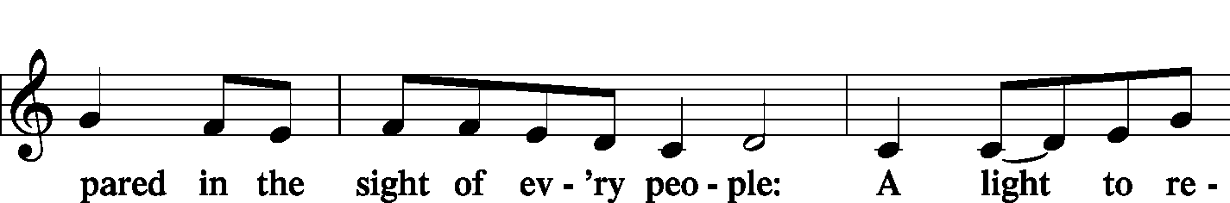

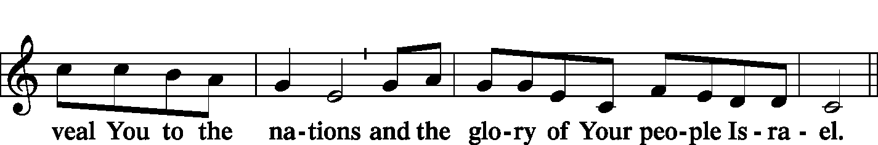

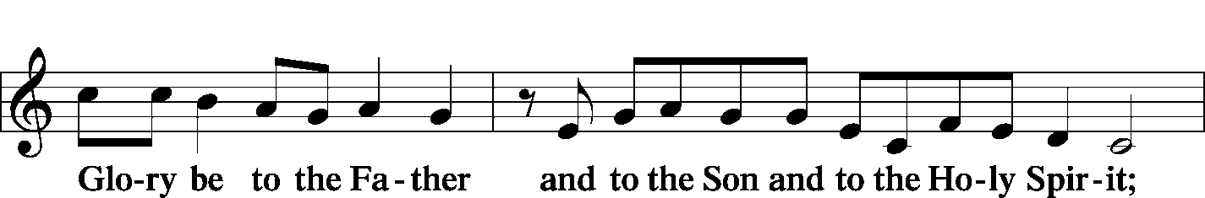

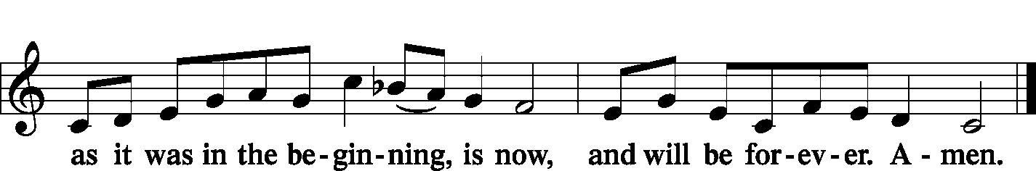

|  |  |  |  |
| --- | --- | --- | --- |
| POST-COMMUNION COLLECT | |  | Page 166 |
| P: | Let us pray.  We give thanks to You, almighty God, that You have refreshed us through this salutary gift, and we implore You that of Your mercy You would strengthen us through the same in faith toward You and in fervent love toward one another; through Jesus Christ, Your Son, our Lord, Who lives and reigns with You and the Holy Spirit, one God, now and forever. | | |
| C: | **Amen.** | |
|  |  | |

|  |  |  |
| --- | --- | --- |
| BENEDICTION |  | Page 166 |
|  |  |  |

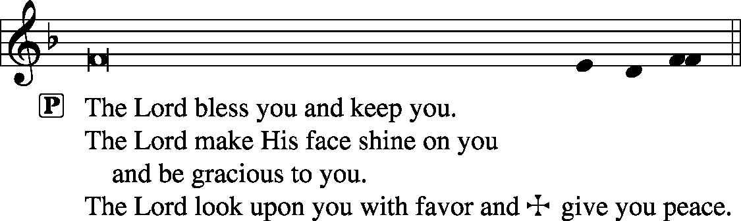



|  |  |  |  |  |  |
| --- | --- | --- | --- | --- | --- |
|  | | |  | |  |
| CLOSING HYMN | | *LSB 664 Fight the Good Fight* | | | |
|  | |  | |  | |
| SILENT PRAYER | |  | |  | |
|  | *Almighty and merciful God, I have again worshiped in Your presence and received both forgiveness for my many sins and the assurance of Your love in Jesus Christ. I thank You for this undeserved grace and ask You to keep me in faith until, with all Your saints, I inherit eternal salvation; through Jesus Christ, my Lord. Amen.* | | | | |
|  |  | | | | |
| ANNOUNCEMENTS | | | | | |
|  | | | | | |
| POSTLUDE | | | | | |

T T T

Acknowledgments

Divine Service, Setting One from Lutheran Service Book

Unless otherwise indicated, all scripture quotations are from *The Holy Bible, English Standard Version*, copyright © 2001 by Crossway Bibles, a division of Good News Publishers. Used by permission. All rights reserved.

Created by Lutheran Service Builder © 2006 Concordia Publishing House.

|  |  |  |
| --- | --- | --- |
| PASTOR |  | The Rev. Barry Long |
| ELDER | - | Tom Brosowske |
| ORGANIST |  | Carol Wessler |