|  |
| --- |
| The Festival of St. Bartholomew, Apostle |
| The Eleventh Sunday after Pentecost |
| August 24, 2025 |
| + The Order of Matins + |
| Lutheran Service Book – Pages 219-228 |

|  |  |  |
| --- | --- | --- |
| Prayer Before Worship | |  |
|  | *O Lord, my Creator, Redeemer, and Comforter, as I come to worship You in spirit and in truth, I humbly pray that You would open my heart to the preaching of Your Word so that I may repent of my sins, believe in Jesus Christ as my only Savior, and grow in grace and holiness. Hear me for the sake of His name. Amen.* | |
|  |  | |
| PRELUDE | | |
|  | | |

|  |
| --- |
| RINGING BELL CALLS US TO WORSHIP |

|  |  |  |  |  |  |  |
| --- | --- | --- | --- | --- | --- | --- |
|  | | | |  | | |
| WELCOME | | | |  | | |
|  | | | |  | | |
| OPENING HYMN | | *LSB 810* O God of God, O Light of Light | | | |
|  | |  | | |  |
| CONFESSION AND ABSOLUTION | | | *Page 151* | | |
| P: | In the name of the Father and of the T Son and of the Holy Spirit. | | | | |
| C: | Amen. | | | | |
| P: | If we say we have no sin, we deceive ourselves, and the truth is not in us. | | | | |
| C: | But if we confess our sins, God, Who is faithful and just, will forgive our sins and cleanse us from all unrighteousness. | | | | |
|  |  | | | | |
|  | *(Silence for reflection on God’s Word and for self-examination.)* | | | | |
|  |  | | | | |
| P: | Let us then confess our sins to God our Father. | | | | |
| C: | **Most merciful God, we confess that we are by nature sinful and unclean. We have sinned against You in thought, word, and deed, by what we have done and by what we have left undone. We have not loved You with our whole heart; we have not loved our neighbors as ourselves. We justly deserve Your present and eternal punishment. For the sake of Your Son, Jesus Christ, have mercy on us. Forgive us, renew us, and lead us, so that we may delight in Your will and walk in Your ways to the glory of Your holy name. Amen.** | | | | |

|  |  |
| --- | --- |
| P: | Almighty God in His mercy has given His Son to die for you and for His sake forgives you all your sins. As a called and ordained servant of Christ, and by His authority, I therefore forgive you all your sins in the name of the Father and of the T Son and of the Holy Spirit. |
| C: | Amen. |
|  |  |

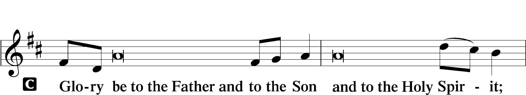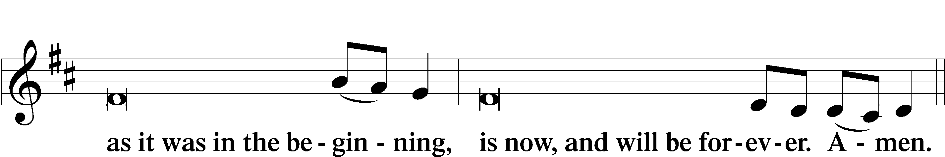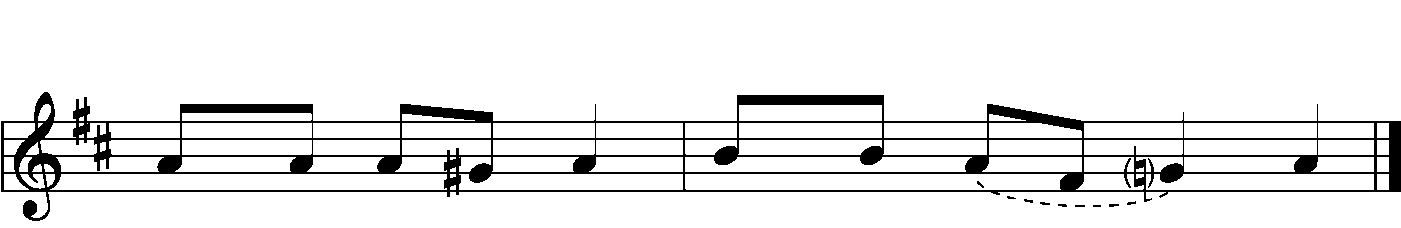

|  |  |
| --- | --- |
|  |  |

|  |  |  |  |
| --- | --- | --- | --- |
| PSALMODY | | Venite | *O Come, Let Us Sing* |
|  | Antiphon | | |
|  |  | | |

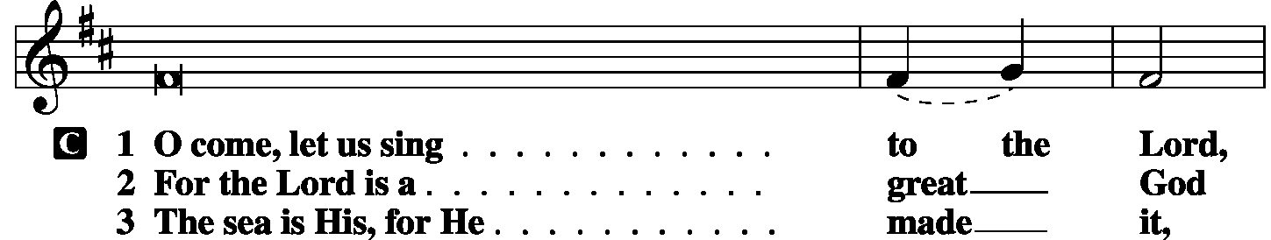

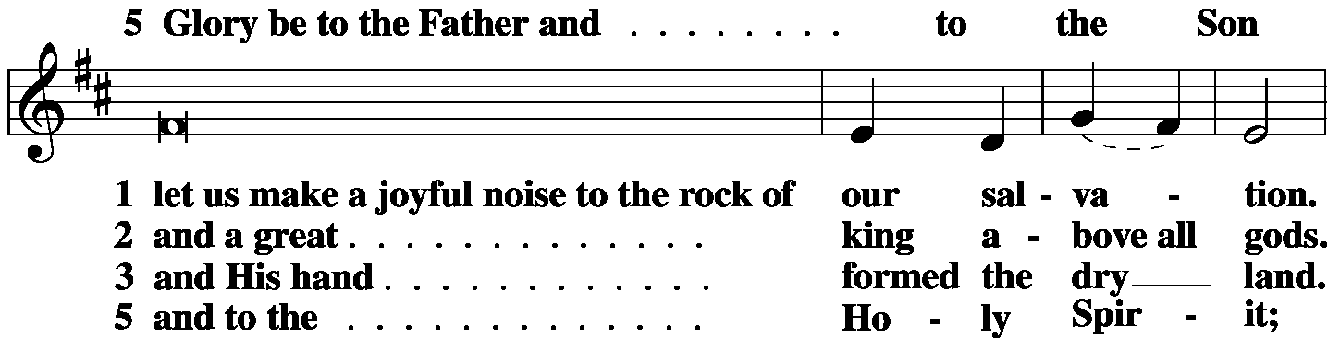

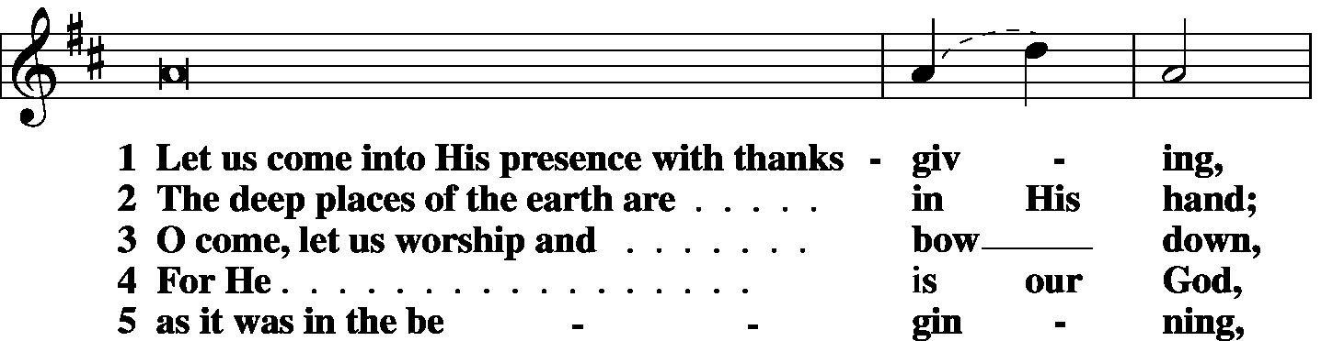

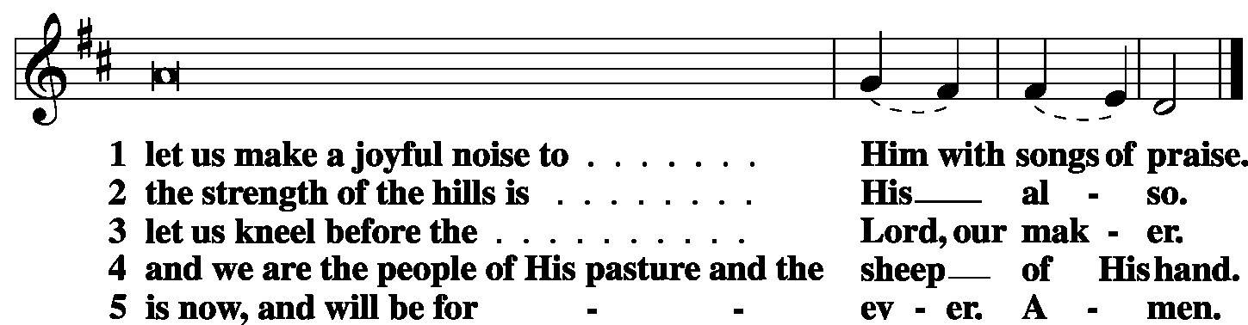

|  |  |  |  |
| --- | --- | --- | --- |
|  |  |  |  |
|  | Second Psalm | Psalm 121 | *(Sung responsively by verse)* |
|  |  |  | |

I lift up my eyes | to the hills.*

From where does my | help come?  
**My help comes | from the Lord,\***

**who made | heaven and earth.**

He will not let your | foot be moved;*

he who keeps you will not | slumber.  
**Behold, he who keeps | Israel*  
 will neither slum- | ber nor sleep.**

The Lord is your | keeper;*

the Lord is your shade on your | right hand. **The sun shall not strike | you by day,\***

**nor the | moon by night.**

The Lord will keep you from all | evil;*  
 he will | keep your life.  
**The Lord will keep your going out and your | coming in*  
 from this time forth and for- | evermore.**

**Glory be to the Father and | to the Son\***

**and to the Holy | Spirit;**

**as it was in the be- | ginning,\***

**is now, and will be forever. | Amen.**

|  |  |  |  |
| --- | --- | --- | --- |
|  |  | |  |
| OFFICE HYMN | LSB 518, vv. 1, 23, 3 | | |
|  |  | |  |
| THE GOSPEL FOR YOUNG FOLK | |  | | |
|  | |  | | |

|  |  |
| --- | --- |
| FIRST LESSON | *Proverbs 3:1–8* |

1My son, do not forget my teaching,  
 but let your heart keep my commandments,  
2for length of days and years of life  
 and peace they will add to you.  
3Let not steadfast love and faithfulness forsake you;  
 bind them around your neck;  
 write them on the tablet of your heart.  
4So you will find favor and good success  
 in the sight of God and man.  
5Trust in the Lord with all your heart,  
 and do not lean on your own understanding.  
6In all your ways acknowledge Him,  
 and He will make straight your paths.  
7Be not wise in your own eyes;  
 fear the Lord, and turn away from evil.  
8It will be healing to your flesh  
 and refreshment to your bones.

|  |  |  |
| --- | --- | --- |
|  |  | |
| P: | O Lord, have mercy on us. | |
| C: | **Thanks be to God.** | |
|  | |  |
| SECOND LESSON | | *2 Corinthians 4:7–10* |

7But we have this treasure in jars of clay, to show that the surpassing power belongs to God and not to us 8We are afflicted in every way, but not crushed; perplexed, but not driven to despair; 9persecuted, but not forsaken; struck down, but not destroyed; 10always carrying in the body the death of Jesus, so that the life of Jesus may also be manifested in our bodies.

|  |  |  |
| --- | --- | --- |
|  |  | |
| P: | O Lord, have mercy on us. | |
| C: | **Thanks be to God.** | |
|  | |  |
| GOSPEL VERSE | | *Luke 22:26b, 27d* |
| P: | Alleluia. Let the greatest among you become as the youngest, and the leader as one who serves. | |
| C: | But I am among you as the one who serves. Alleluia | |
|  |  | |

|  |  |  |
| --- | --- | --- |
| HOLY GOSPEL | | *John 1:43-51* |
| P: | The Holy Gospel according to St. John, the first chapter. | |
| C: | **Glory to You, O Lord.** | |
|  |  | |

43The next day Jesus decided to go to Galilee. He found Philip and said to him, **“Follow me.”** 44Now Philip was from Bethsaida, the city of Andrew and Peter. 45Philip found Nathanael and said to him, “We have found Him of Whom Moses in the Law and also the prophets wrote, Jesus of Nazareth, the son of Joseph.” 46Nathanael said to him, “Can anything good come out of Nazareth?” Philip said to him, “Come and see.” 47Jesus saw Nathanael coming toward Him and said of him, **“Behold, an Israelite indeed, in whom there is no deceit!”** 48Nathanael said to Him, “How do you know me?” Jesus answered him, **“Before Philip called you, when you were under the fig tree, I saw you.”** 49Nathanael answered him, “Rabbi, You are the Son of God! You are the King of Israel!” 50Jesus answered him, **“Because I said to you, ‘I saw you under the fig tree,’ do you believe? You will see greater things than these.”** 51And He said to him, **“Truly, truly, I say to you, you will see heaven opened, and the angels of God ascending and descending on the Son of Man.”**

|  |  |  |
| --- | --- | --- |
|  |  | |
| P: | This is the Gospel of the Lord. | |
| C: | **Praise to You, O Christ.** | |
|  | |  |
| RESPONSORY | |  |
|  |  | |

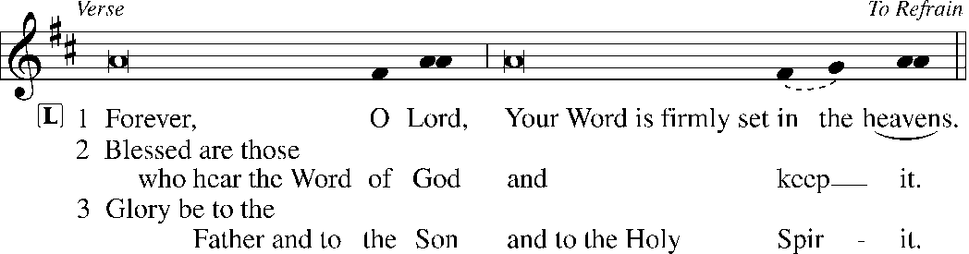

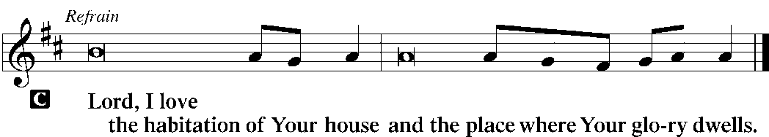

|  |  |  |
| --- | --- | --- |
|  |  |  |
| HYMN OF THE DAY | LSB 840 Christ High-Ascended, Now in Glory Seated | |
|  | | |
| SERMON | | |
|  | | |

|  |  |  |
| --- | --- | --- |
| CANTICLE | Te Deum | *LSB p. 223* |
|  |  |  |

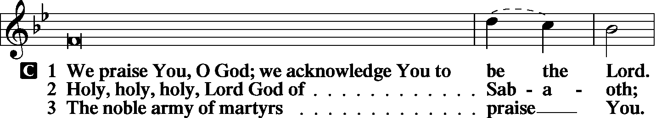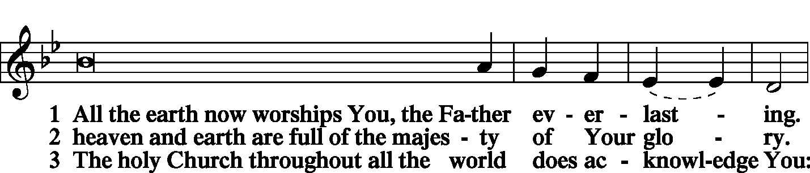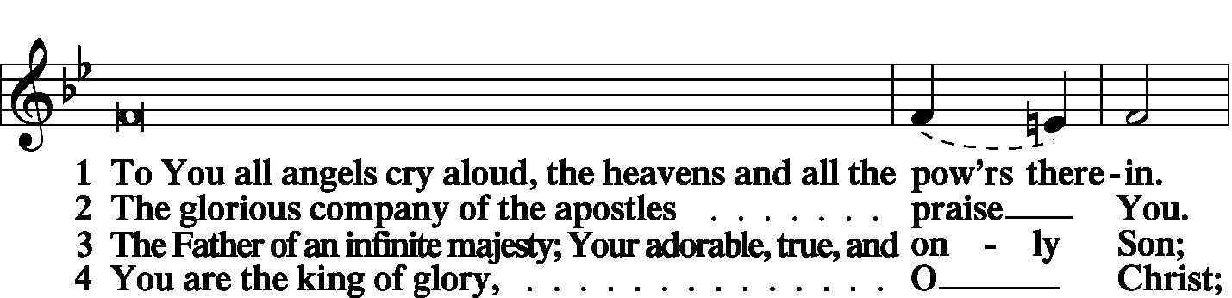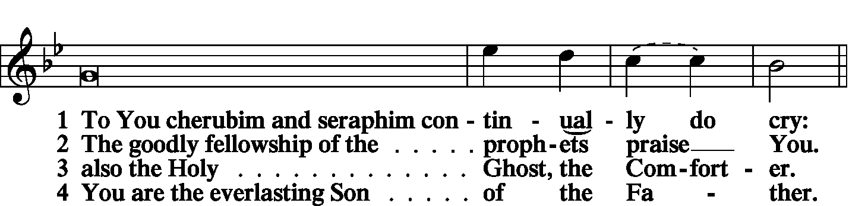

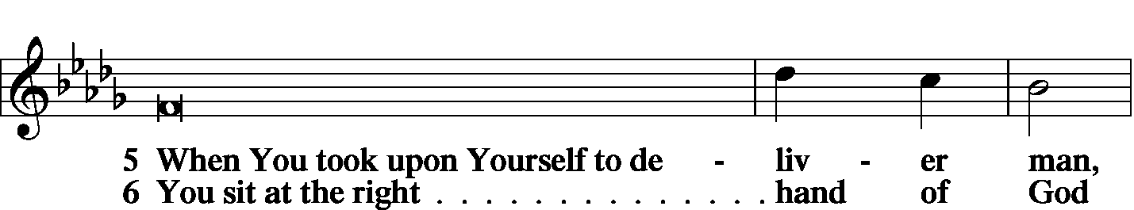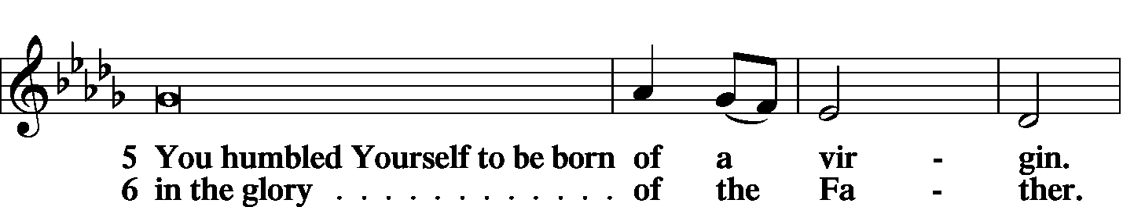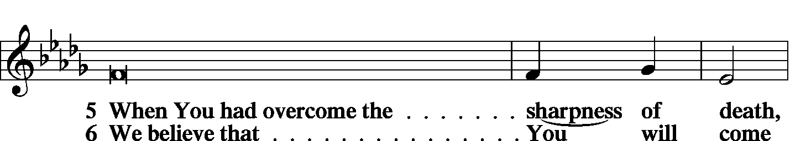

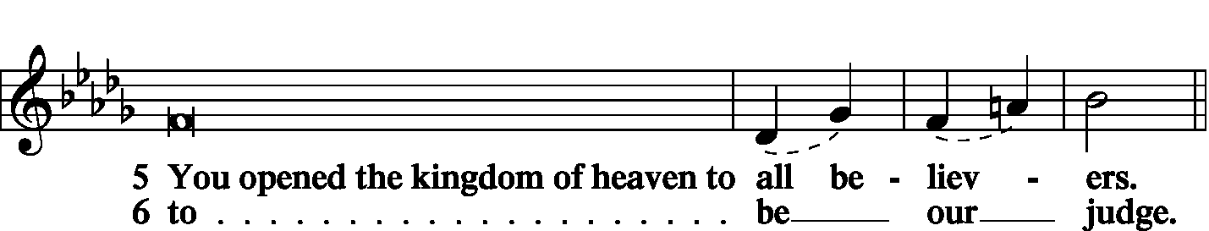

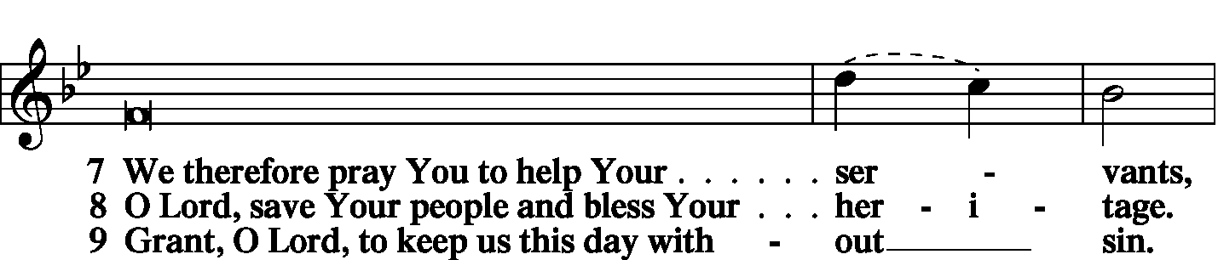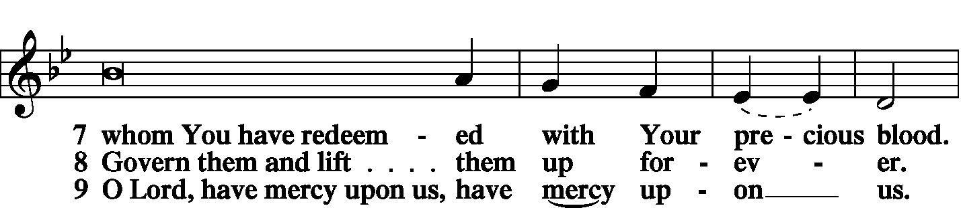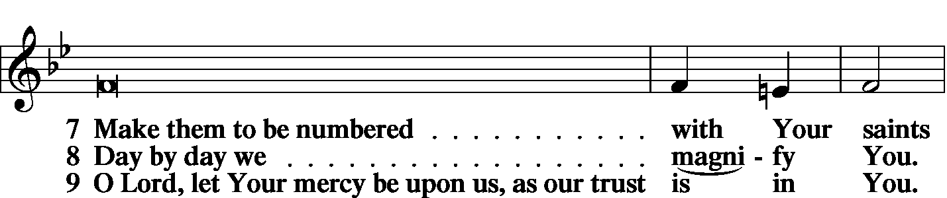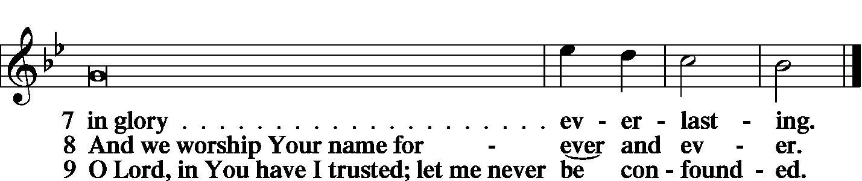

|  |  |
| --- | --- |
|  |  |
| PRAYER OF THE CHURCH | *LSB p. 227* |
|  |  |
| KYRIE |  |

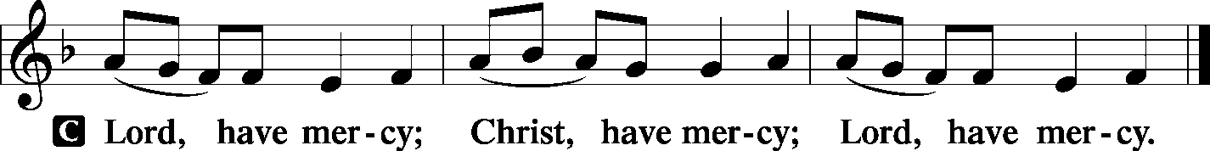

|  |  |
| --- | --- |
|  |  |

|  |  |  |
| --- | --- | --- |
| LORD’S PRAYER | | |
| C: | Our Father Who art in heaven, hallowed be Thy name, Thy kingdom come, Thy will be done on earth as it is in heaven; give us this day our daily bread; and forgive us our trespasses as we forgive those who trespass against us; and lead us not into temptation, but deliver us from evil. For Thine is the kingdom and the power and the glory forever and ever. Amen. | |
|  |  | |
| COLLECTS | |  |
|  | |  |

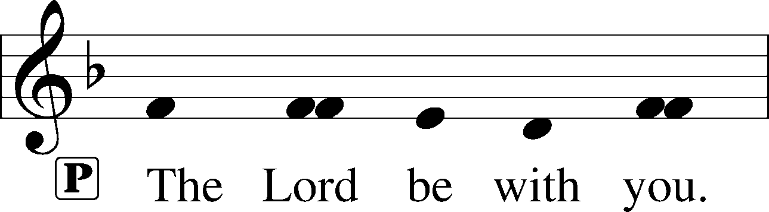

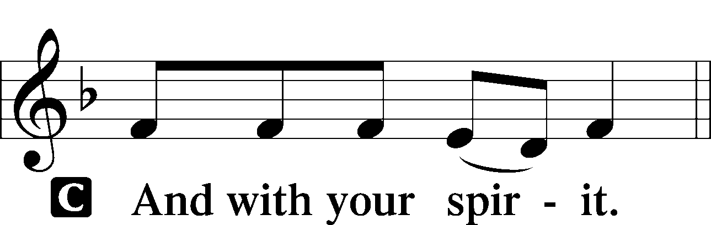

|  |  |
| --- | --- |
|  | |
| Collect of the Day | |
| P: | Almighty God, Your Son, Jesus Christ, chose Bartholomew to be an apostle to preach the blessed Gospel. Grant that Your Church may love what he believed and preach what he taught; through Jesus Christ, our Lord, |



|  |  |
| --- | --- |
|  | |
| Collect for Matins | |
| P: | Almighty God, heavenly Father, Your mercies are new to us every morning, and You abundantly provide for all our wants of body and soul. Give us we humbly pray, Your Holy Spirit that we may heartily acknowledge Your merciful goodness toward us, give thanks for all Your benefits, and cheerfully serve You. |



|  |  |  |
| --- | --- | --- |
| For Guidance in Our Calling | | *LSB p. 311* |
| P: | Lord God, You have called Your servants to ventures of which we cannot see the ending, by paths as yet untrodden, through perils unknown. Give us faith to go out with good courage, not knowing where we go but only that Your hand is leading us and Your love supporting us; through Jesus Christ, our Lord. | |



|  |  |  |
| --- | --- | --- |
|  | |  |
| For Responsible Citizenship | | *LSB p.313* |
| P: | Lord, keep this nation under Your care. Bless the leaders of our land that we may be a people at peace among ourselves and a blessing to the other nations of the earth. Grant that we may choose trustworthy leaders, contribute to wise decisions for the general welfare, and serve You faithfully in our generation; through Jesus Christ, our Lord. | |



|  |  |  |
| --- | --- | --- |
|  | |  |
| Collect for Grace | | *LSB p.228* |
| P: | O Lord, our heavenly Father, almighty and everlasting God, You have safely brought us to the beginning of this day. Defend us in the same with Your mighty power and grant that this day we fall into no sin, neither run into any kind of danger, but that all our doings, being ordered by Your governance, may be righteous in Your sight; through Jesus Christ, Your Son, our Lord, Who lives and reigns with You and the Holy Spirit, one God, now and forever. | |



|  |  |  |
| --- | --- | --- |
| BENEDICAMUS | | *LSB p. 227* |
|  |  | |

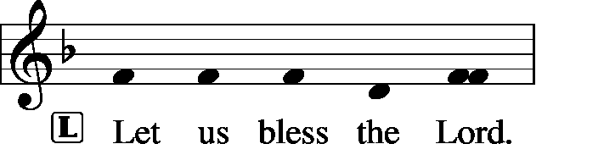

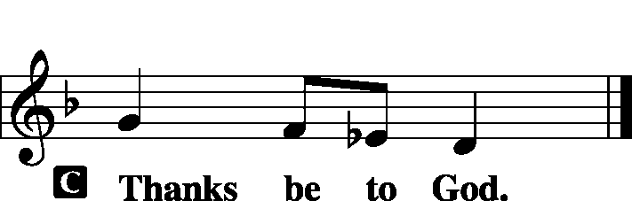

|  |  |  |
| --- | --- | --- |
|  | |  |
| BENEDICTION | |  |
|  |  | |

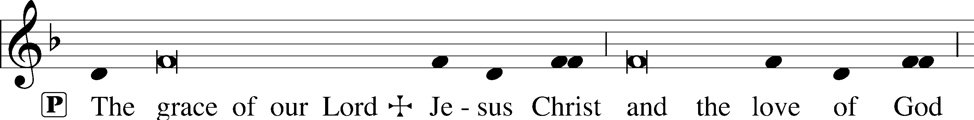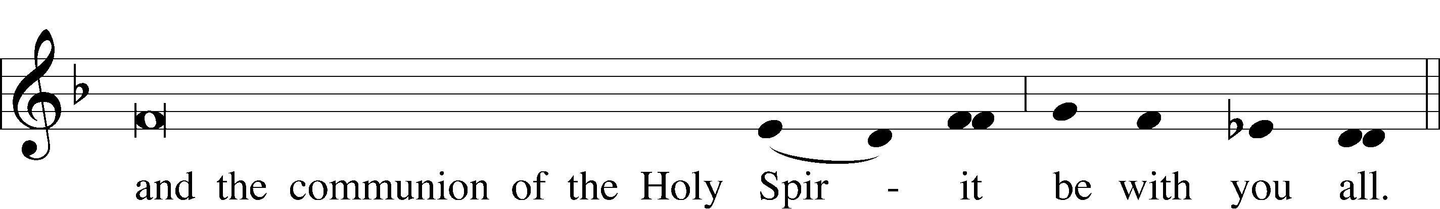

|  |  |  |  |  |  |  |
| --- | --- | --- | --- | --- | --- | --- |
|  | | |  | | |  |
| CLOSING HYMN | | LSB 830 Spread the Reign of God the Lord | | | | |
|  | |  | | |  | |
| SILENT PRAYER | | |  | | |  | |
|  | *Almighty and merciful God, I have again worshiped in Your presence and received both forgiveness for my many sins and the assurance of Your love in Jesus Christ. I thank You for this undeserved grace and ask You to keep me in faith until, with all Your saints, I inherit eternal salvation; through Jesus Christ, my Lord. Amen.* | | | | | | |
|  | | | | | | | |
| T T T | | | | | | | |
|  | | | | | | | |
| Pastor: The Rev. Barry Long | | | |  | | | |
| Elder: Phil KIng | | | | | | | |
| Organist: Carol Wessler | | | | | | | |
|  | | | | | | | |

Acknowledgments

Matins from Lutheran Service Book

Unless otherwise indicated, all scripture quotations are from *The Holy Bible, English Standard Version*, copyright © 2001 by Crossway Bibles, a division of Good News Publishers. Used by permission. All rights reserved.

Created by Lutheran Service Builder © 2006 Concordia Publishing House.