|  |
| --- |
| Twelfth Sunday after Pentecost |
| August 31, 2025 |
| + The Order of Matins + |
| Lutheran Service Book – Pages 219-228 |

|  |  |  |
| --- | --- | --- |
| Prayer Before Worship | |  |
|  | *O Lord, my Creator, Redeemer, and Comforter, as I come to worship You in spirit and in truth, I humbly pray that You would open my heart to the preaching of Your Word so that I may repent of my sins, believe in Jesus Christ as my only Savior, and grow in grace and holiness. Hear me for the sake of His name. Amen.* | |
|  |  | |
| PRELUDE | | |
|  | | |

|  |
| --- |
| RINGING BELL CALLS US TO WORSHIP |

|  |  |  |  |  |  |
| --- | --- | --- | --- | --- | --- |
|  | | |  | | |
| WELCOME | | |  | | |
|  | | |  | | |
| OPENING HYMN | | *LSB 907 God Himself Is Present* | | | |
|  | | | |  |
| CONFESSION AND DECLARATION OF FORGIVENESS | | | | *Page 151* |
| P: | Let us begin in the name of the Father and of the T Son and of the Holy Spirit. | | | |
| C: | Amen. | | | |
| P: | If we say we have no sin, we deceive ourselves, and the truth is not in us. | | | |
| C: | But if we confess our sins, God, Who is faithful and just, will forgive our sins and cleanse us from all unrighteousness. | | | |
|  |  | | | |
|  | *(Silence for reflection on God’s Word and for self-examination.)* | | | |
|  |  | | | |
| P: | Let us then confess our sins to God our Father. | | | |
| C: | **Most merciful God, we confess that we are by nature sinful and unclean. We have sinned against You in thought, word, and deed, by what we have done and by what we have left undone. We have not loved You with our whole heart; we have not loved our neighbors as ourselves. We justly deserve Your present and eternal punishment. For the sake of Your Son, Jesus Christ, have mercy on us. Forgive us, renew us, and lead us, so that we may delight in Your will and walk in Your ways to the glory of Your holy name. Amen.** | | | |

|  |  |
| --- | --- |
| P: | The Holy Scriptures assure us that Almighty God in His mercy has given His Son to die for us and for His sake forgives us all our sins. Let us go in peace. |
| C: | Amen. |
|  |  |
| L: | O Lord, open my lips,, |

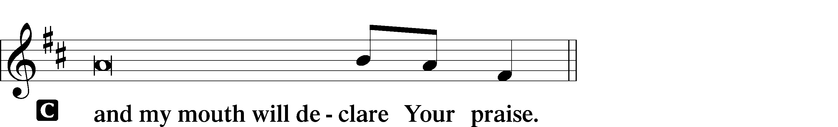

|  |  |
| --- | --- |
|  |  |
| L: | Make haste, O God, to deliver me: |

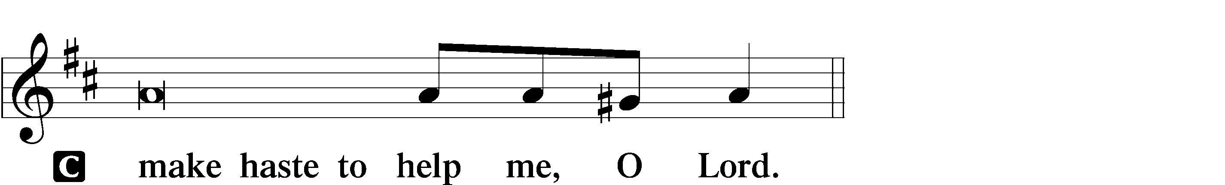

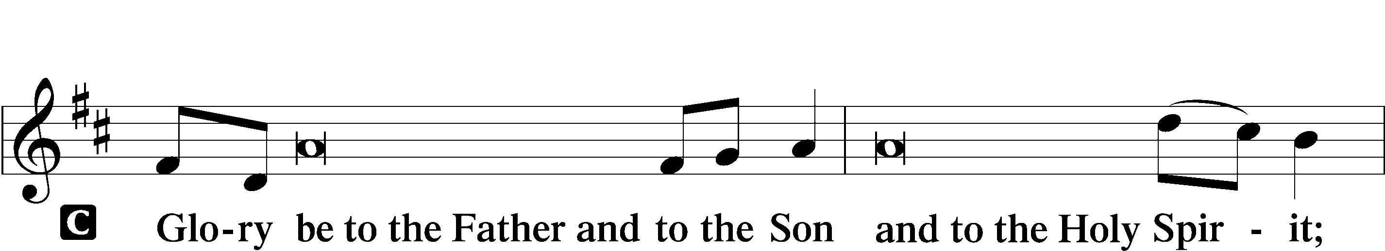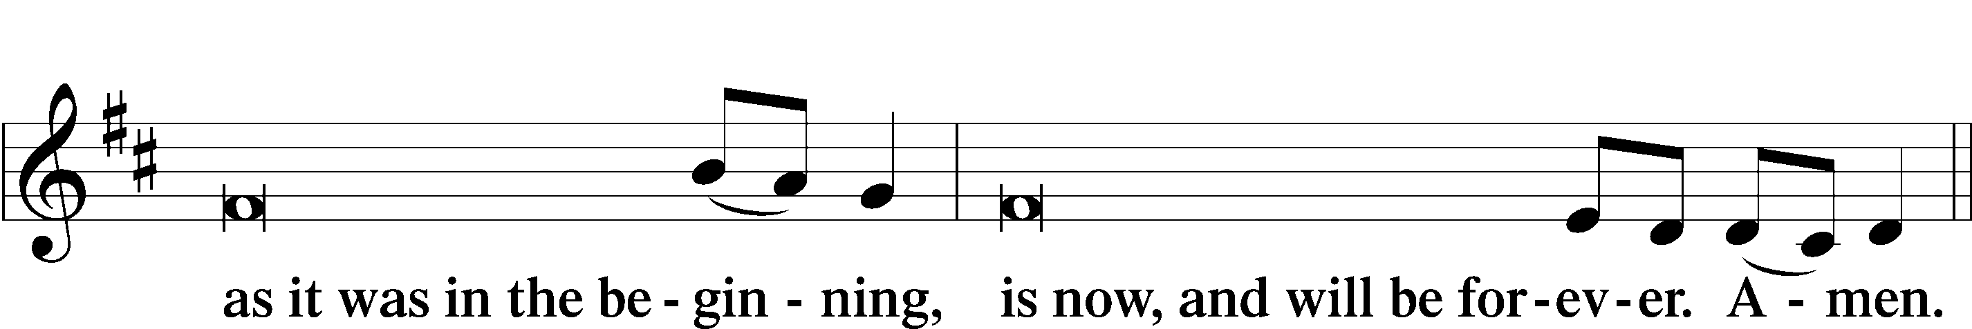

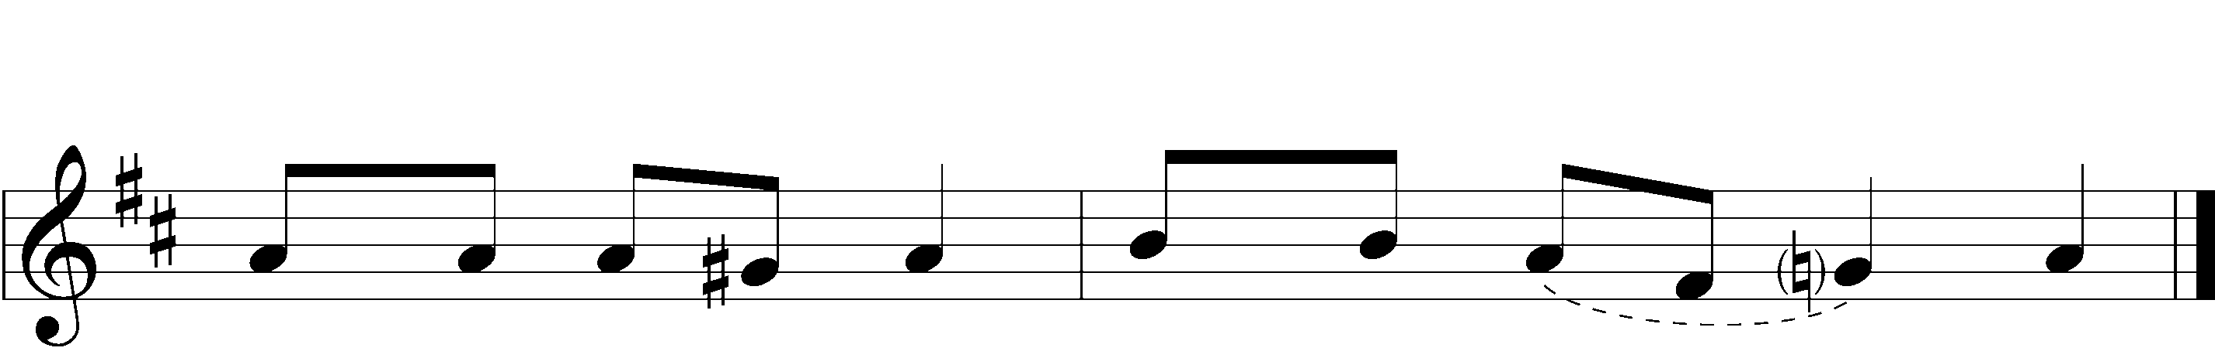



|  |  |  |  |
| --- | --- | --- | --- |
|  |  | | |
| PSALMODY | | Venite | *O Come, Let Us Sing* |
|  | Antiphon | | |
|  |  | | |
| L: | The Lord has sanctified us in the true faith. | | |



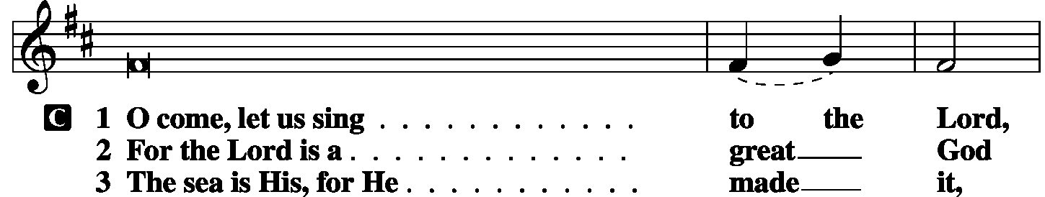

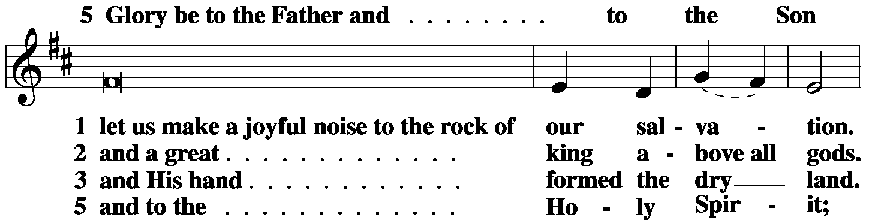

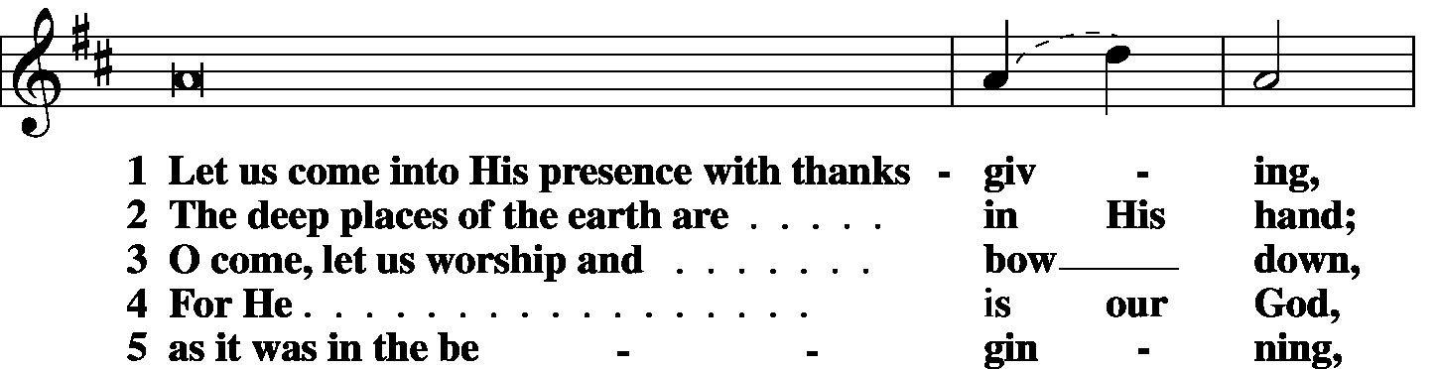

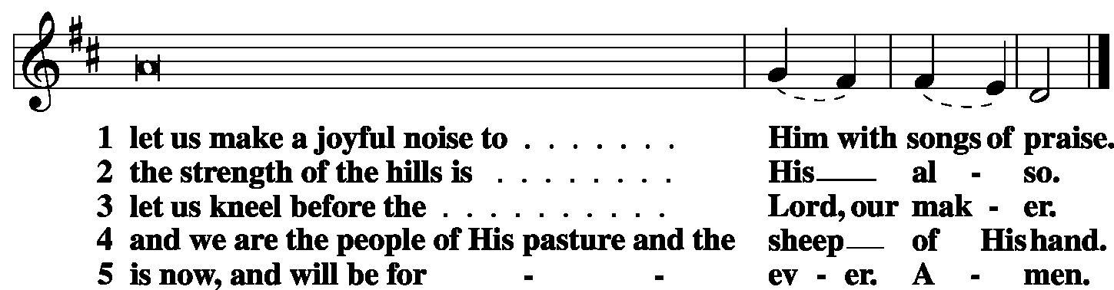

|  |  |
| --- | --- |
|  |  |
| L: | The Lord has sanctified us in the true faith. |



|  |  |  |  |
| --- | --- | --- | --- |
|  |  |  |  |

|  |  |  |  |
| --- | --- | --- | --- |
|  | Second Psalm | Psalm *131* | *(Spoken responsively by verse)* |
|  |  |  | |

O Lord, my heart is not lifted up; my eyes are not raised too high;  
I do not occupy myself with things too great and too marvelous for me.

But I have calmed and quieted my soul, like a weaned child with its mother;

like a weaned child is my soul within me.

O Israel, hope in the Lord

from this time forth and forevermore.

**Glory be to the Father and to the Son**

**and to the Holy Spirit;**

**as it was in the beginning,**

**is now, and will be forever. Amen.**

|  |  |  |  |
| --- | --- | --- | --- |
|  |  | |  |
| OFFICE HYMN | LSB *872 Come, Thou Bright and Morning Star* | | |
|  |  | |  |
|  | |  | |
| FIRST LESSON | | *Proverbs 25:2–10* | |

2It is the glory of God to conceal things,  
 but the glory of kings is to search things out.  
3As the heavens for height, and the earth for depth,  
 so the heart of kings is unsearchable.  
4Take away the dross from the silver,  
 and the smith has material for a vessel;  
5take away the wicked from the presence of the king,  
 and his throne will be established in righteousness.  
6Do not put yourself forward in the king’s presence  
 or stand in the place of the great,  
7for it is better to be told, “Come up here,”  
 than to be put lower in the presence of a noble.  
What your eyes have seen  
 8do not hastily bring into court,  
for what will you do in the end,  
 when your neighbor puts you to shame?  
9Argue your case with your neighbor himself,  
 and do not reveal another’s secret,  
10lest he who hears you bring shame upon you,  
 and your ill repute have no end.

|  |  |  |  |
| --- | --- | --- | --- |
|  |  | |  |
| L: | O Lord, have mercy on us. | | |
| C: | **Thanks be to God.** | | |
| EPISTLE LESSON | | *Hebrews 13:1–17* | |

1Let brotherly love continue. 2Do not neglect to show hospitality to strangers, for thereby some have entertained angels unawares. 3Remember those who are in prison, as though in prison with them, and those who are mistreated, since you also are in the body. 4Let marriage be held in honor among all, and let the marriage bed be undefiled, for God will judge the sexually immoral and adulterous. 5Keep your life free from love of money, and be content with what you have, for He has said, “I will never leave you nor forsake you.” 6So we can confidently say,

“The Lord is my helper;  
 I will not fear;

what can man do to me?”

7Remember your leaders, those who spoke to you the word of God. Consider the outcome of their way of life, and imitate their faith. 8Jesus Christ is the same yesterday and today and forever. 9Do not be led away by diverse and strange teachings, for it is good for the heart to be strengthened by grace, not by foods, which have not benefited those devoted to them. 10We have an altar from which those who serve the tent have no right to eat. 11For the bodies of those animals whose blood is brought into the holy places by the high priest as a sacrifice for sin are burned outside the camp. 12So Jesus also suffered outside the gate in order to sanctify the people through His own blood. 13Therefore let us go to Him outside the camp and bear the reproach He endured. 14For here we have no lasting city, but we seek the city that is to come. 15Through Him then let us continually offer up a sacrifice of praise to God, that is, the fruit of lips that acknowledge His Name. 16Do not neglect to do good and to share what you have, for such sacrifices are pleasing to God.

17Obey your leaders and submit to them, for they are keeping watch over your souls, as those who will have to give an account. Let them do this with joy and not with groaning, for that would be of no advantage to you.

|  |  |  |  |  |  |  |  |  |
| --- | --- | --- | --- | --- | --- | --- | --- | --- |
|  | |  | | | | | | |
| L: | | O Lord, have mercy. | | | | | | |
| C: | | **Thanks be to God.** | | | | | | |
|  |  | | | | | |  | |
| GOSPEL VERSE | | | | | | *Luke 14:11* | | |
| L: | | Alleluia. Everyone who exalts himself will be humbled, | | | | | | |
| C: | | and he who humbles himself will be exalted. Alleluia. | | | | | |
|  | |  | |  | | | | |
| HOLY GOSPEL | | | | | *Luke 14:1-14* | | |
| L: | | | The Holy Gospel according to St. Luke, the fourteenth chapter. | | | | |
| C: | | | **Glory to You, O Lord.** | | | | |
|  | | |  | | | | |
|  | | |  | | | | |

1One Sabbath, when [Jesus] went to dine at the house of a ruler of the Pharisees, they were watching Him carefully. 2And behold, there was a man before Him who had dropsy. 3And Jesus responded to the lawyers and Pharisees, saying, **“Is it lawful to heal on the Sabbath, or not?”** 4But they remained silent. Then He took him and healed him and sent him away. 5And He said to them, **“Which of you, having a son or an ox that has fallen into a well on a Sabbath day, will not immediately pull him out?”** 6And they could not reply to these things.

7Now He told a parable to those who were invited, when He noticed how they chose the places of honor, saying to them, **8“When you are invited by someone to a wedding feast, do not sit down in a place of honor, lest someone more distinguished than you be invited by him, 9and he who invited you both will come and say to you, ‘Give your place to this person,’ and then you will begin with shame to take the lowest place. 10But when you are invited, go and sit in the lowest place, so that when your host comes he may say to you, ‘Friend, move up higher.’ Then you will be honored in the presence of all who sit at table with you. 11For everyone who exalts himself will be humbled, and he who humbles himself will be exalted.”**

12He said also to the man who had invited Him**, “When you give a dinner or a banquet, do not invite your friends or your brothers or your relatives or rich neighbors, lest they also invite you in return and you be repaid. 13But when you give a feast, invite the poor, the crippled, the lame, the blind, 14and you will be blessed, because they cannot repay you. You will be repaid at the resurrection of the just.”**

|  |  |  |  |  |  |
| --- | --- | --- | --- | --- | --- |
|  | |  | | | |
| L: | This is the Gospel of the Lord. | | |
| C: | **Praise to You, O Christ.** | | | |
|  | | |  | | |
| RESPONSORY | | |  | | |
| L: | Forever, O Lord, Your Word is firmly set in the heavens. | | | | |

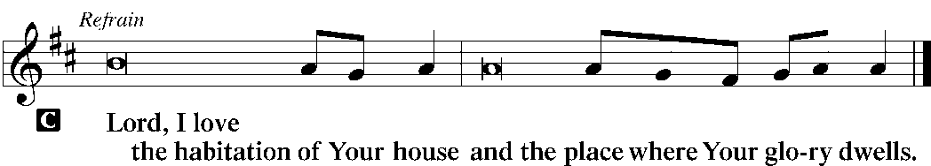

|  |  |
| --- | --- |
| L: | Blessed are those who hear the Word of God and keep it. |



|  |  |
| --- | --- |
| L: | Glory be to the Father and to the Son and to the Holy Spirit. |



|  |  |  |  |  |  |
| --- | --- | --- | --- | --- | --- |
|  | |  | | | |
| HYMN OF THE DAY | | *LSB 700* Love Divine, All Loves Excelling | | | |
|  | | | | | |
| SERMON | | | | | |
|  | | | | | |
| CANTICLE | **Te Deum** (*We Praise You, O God)* | | | *LSB p. 223* |
|  |  | |  | |

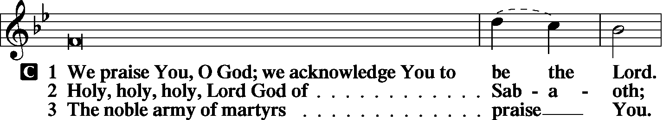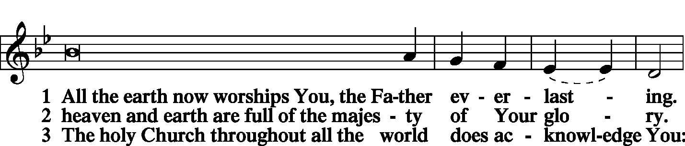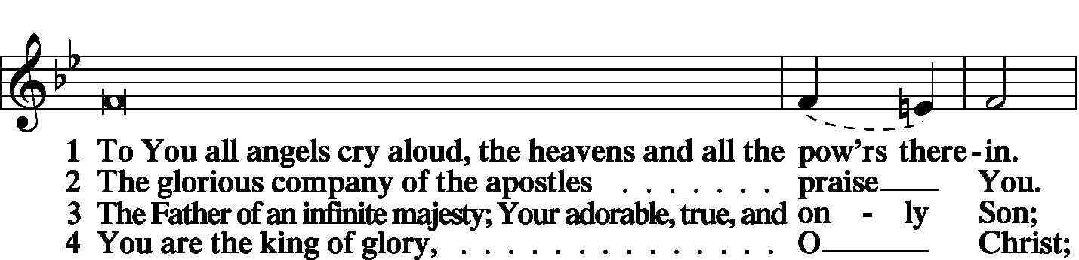

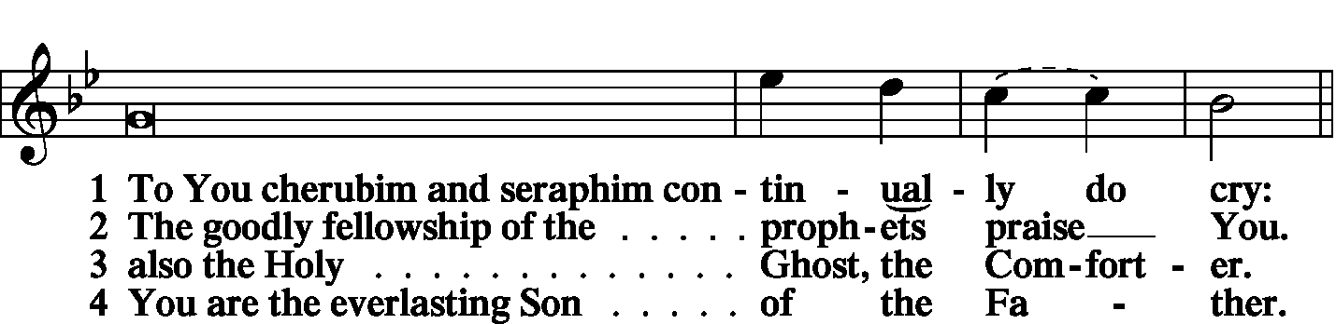

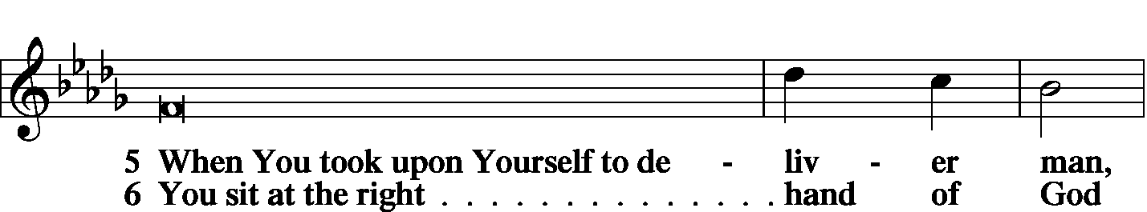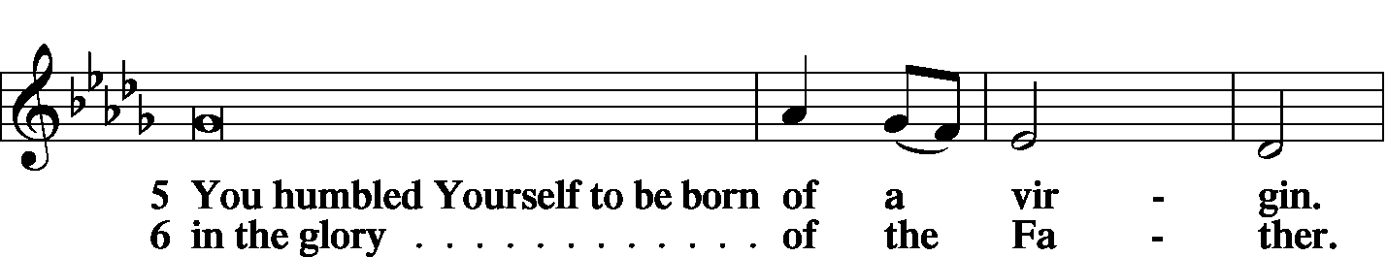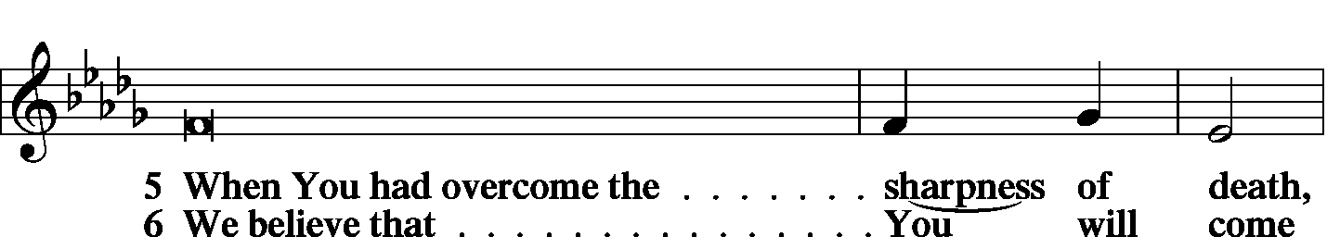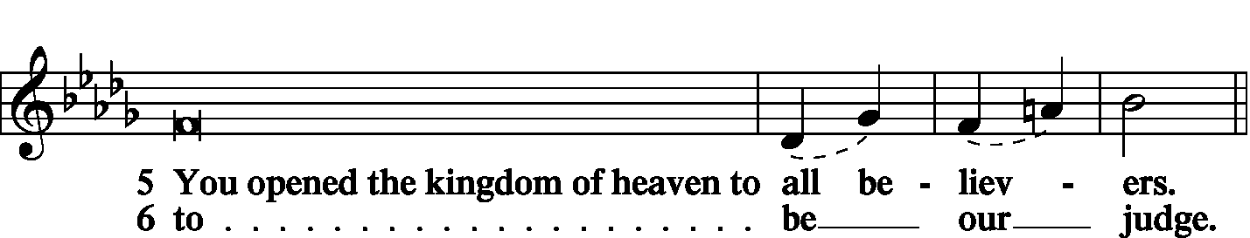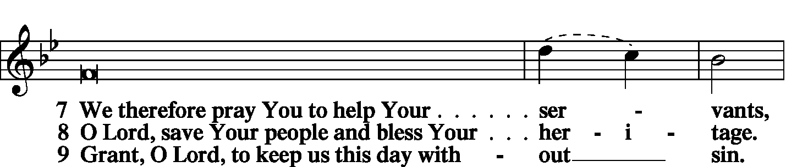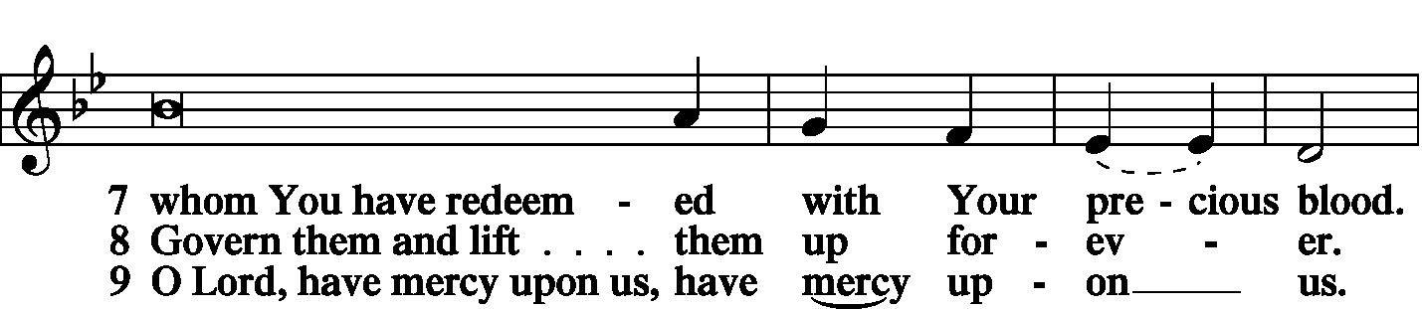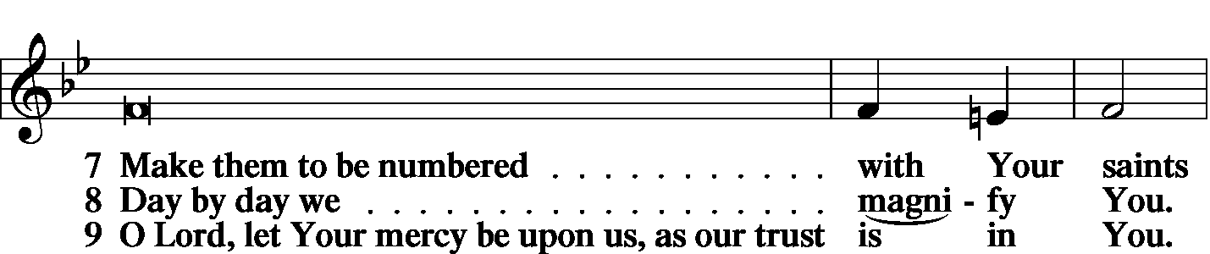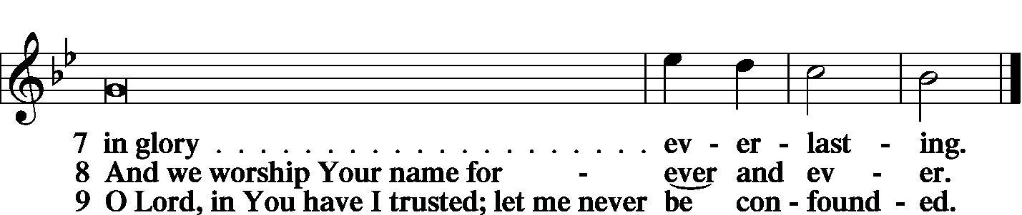

|  |  |  |
| --- | --- | --- |
|  | |  |
| PRAYER OF THE CHURCH | | |
|  | |  |
|  | Kyrie |  |

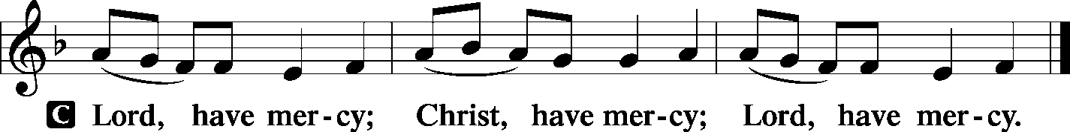

|  |  |
| --- | --- |
|  |  |
|  | Lord’s Prayer |
| C: | Our Father Who art in heaven, hallowed be Thy name, Thy kingdom come, Thy will be done on earth as it is in heaven; give us this day our daily bread; and forgive us our trespasses as we forgive those who trespass against us; and lead us not into temptation, but deliver us from evil. For Thine is the kingdom and the power and the glory forever and ever. Amen. |
|  |  |
| Collects | |
| L: | The Lord be with you. |

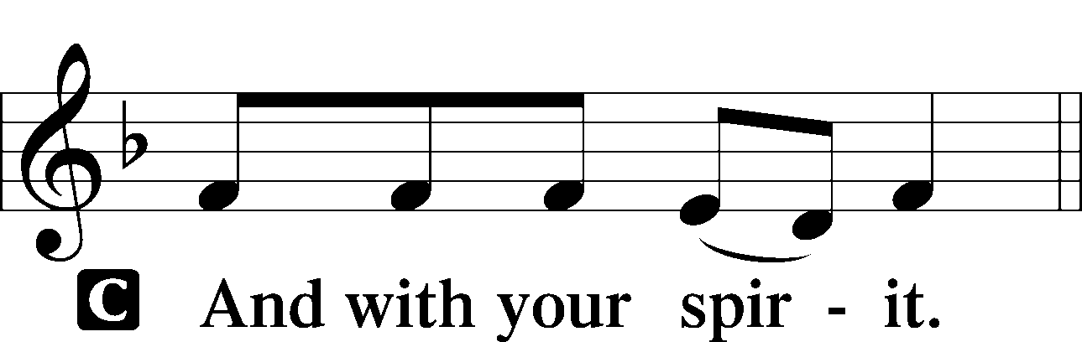

|  |  |
| --- | --- |
|  | Collect of the Day |
| L: | O Lord of grace and mercy, teach us by Your Holy Spirit to follow the example of Your Son in true humility, that we may withstand the temptations of the devil and with pure hearts and minds avoid ungodly pride; through the same Jesus Christ, our Lord. |



|  |  |
| --- | --- |
|  | Collect for Matins |
| L: | Almighty God, heavenly Father, Your mercies are new to us every morning, and You abundantly provide for all our wants of body and soul. Give us we humbly pray, Your Holy Spirit that we may heartily acknowledge Your merciful goodness toward us, give thanks for all Your benefits, and cheerfully serve You. |



|  |  |  |
| --- | --- | --- |
|  |  |  |
|  | For Guidance in Our Calling | *LSB p. 311* |
| L: | Lord God, You have called Your servants to ventures of which we cannot see the ending, by paths as yet untrodden, through perils unknown. Give us faith to go out with good courage, not knowing where we go but only that Your hand is leading us and Your love supporting us; through Jesus Christ, our Lord. | |



|  |  |  |
| --- | --- | --- |
|  |  |  |
|  | For Responsible Citizenship | *LSB p.313* |
| L: | Lord, keep this nation under Your care. Bless the leaders of our land that we may be a people at peace among ourselves and a blessing to the other nations of the earth. Grant that we may choose trustworthy leaders, contribute to wise decisions for the general welfare, and serve You faithfully in our generation; through Jesus Christ, our Lord. | |



|  |  |
| --- | --- |
| L | May the Lord hear the prayers we name in our hearts....…… Lord, in Your mercy: |
| C: | Hear our prayer. |

|  |  |  |
| --- | --- | --- |
|  | Collect for Grace | *LSB p.228* |
| L: | O Lord, our heavenly Father, almighty and everlasting God, You have safely brought us to the beginning of this day. Defend us in the same with Your mighty power and grant that this day we fall into no sin, neither run into any kind of danger, but that all our doings, being ordered by Your governance, may be righteous in Your sight; through Jesus Christ, Your Son, our Lord, Who lives and reigns with You and the Holy Spirit, one God, now and forever. | |



|  |  |  |
| --- | --- | --- |
|  | |  |
| BENEDICAMUS | | *LSB p. 227* |
| L: | Let us bless the Lord. | |

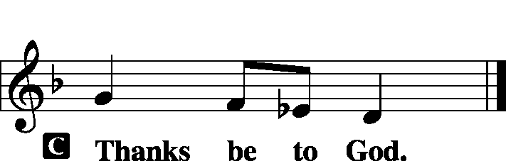

|  |  |  |
| --- | --- | --- |
|  | |  |
| BENEDICTION | |  |
| L: | The grace of our Lord T Jesus Christ and the love of God and the communion of the Holy Spirit be with us all. | |



|  |  |  |  |  |  |  |
| --- | --- | --- | --- | --- | --- | --- |
|  | | |  | |  | |
| CLOSING HYMN | | LSB 685 Let Us Ever Walk with Jesus | | | | |
|  | |  | | | |  |
| SILENT PRAYER | | |  | |  | | |
|  | *Almighty and merciful God, I have again worshiped in Your presence and received both forgiveness for my many sins and the assurance of Your love in Jesus Christ. I thank You for this undeserved grace and ask You to keep me in faith until, with all Your saints, I inherit eternal salvation; through Jesus Christ, my Lord. Amen.* | | | | | | |
|  | | | | | | | |
| T T T | | | | | | | |
|  | | | | | | | |
| Worship Leader: Phil King | | | |  | | | |
| Elder: Daniel Keehner | | | | | | | |
| Organist: Carol Wessler | | | | | | | |
|  | | | | | | | |

Acknowledgments

Matins from Lutheran Service Book

Unless otherwise indicated, all scripture quotations are from *The Holy Bible, English Standard Version*, copyright © 2001 by Crossway Bibles, a division of Good News Publishers. Used by permission. All rights reserved.

Created by Lutheran Service Builder © 2006 Concordia Publishing House.

**BIBLE STUDY TODAY** – – David Heien will lead class today & on next Sunday, September 7. Today, he'll recount the ministry of the prophet Elisha with particular attention to the healing of Naaman. On the 7th, he'll guide you through the end of Solomon's reign, and the troubles that lead to the kingdom breaking into the North and the South. on the 14th, Pr. Schurb (from the District Office) will lead the class, topic to be determined.