|  |
| --- |
| Thirteenth Sunday after Pentecost |
| September 7, 2025 |
| + The Order of Matins + |
| Lutheran Service Book – Pages 219-228 |

|  |  |  |
| --- | --- | --- |
| Prayer Before Worship | |  |
|  | *O Lord, my Creator, Redeemer, and Comforter, as I come to worship You in spirit and in truth, I humbly pray that You would open my heart to the preaching of Your Word so that I may repent of my sins, believe in Jesus Christ as my only Savior, and grow in grace and holiness. Hear me for the sake of His name. Amen.* | |
|  |  | |
| PRELUDE | | |
|  | | |

|  |
| --- |
| RINGING BELL CALLS US TO WORSHIP |

|  |  |  |  |  |  |
| --- | --- | --- | --- | --- | --- |
|  | | |  | | |
| WELCOME | | |  | | |
|  | | |  | | |
| OPENING HYMN | | *LSB 660 Stand Up, Stand Up for Jesus* | | | |
|  | | | |  |
| CONFESSION AND DECLARATION OF FORGIVENESS | | | | *Page 151* |
| P: | Let us begin in the name of the Father and of the T Son and of the Holy Spirit. | | | |
| C: | Amen. | | | |
| P: | If we say we have no sin, we deceive ourselves, and the truth is not in us. | | | |
| C: | But if we confess our sins, God, Who is faithful and just, will forgive our sins and cleanse us from all unrighteousness. | | | |
|  |  | | | |
|  | *(Silence for reflection on God’s Word and for self-examination.)* | | | |
|  |  | | | |
| P: | Let us then confess our sins to God our Father. | | | |
| C: | **Most merciful God, we confess that we are by nature sinful and unclean. We have sinned against You in thought, word, and deed, by what we have done and by what we have left undone. We have not loved You with our whole heart; we have not loved our neighbors as ourselves. We justly deserve Your present and eternal punishment. For the sake of Your Son, Jesus Christ, have mercy on us. Forgive us, renew us, and lead us, so that we may delight in Your will and walk in Your ways to the glory of Your holy name. Amen.** | | | |

|  |  |
| --- | --- |
| P: | The Holy Scriptures assure us that Almighty God in His mercy has given His Son to die for us and for His sake forgives us all our sins. Let us go in peace. |
| C: | Amen. |
|  |  |
| L: | O Lord, open my lips,, |



|  |  |
| --- | --- |
|  |  |
| L: | Make haste, O God, to deliver me: |



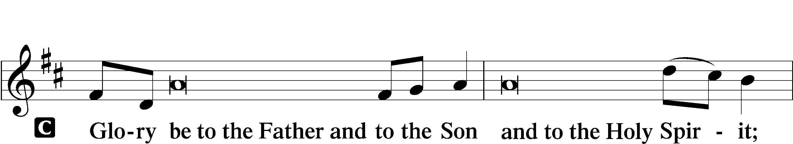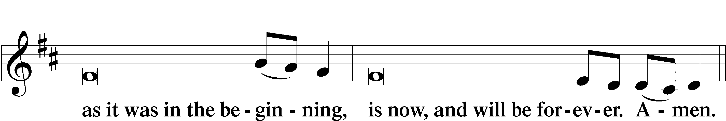

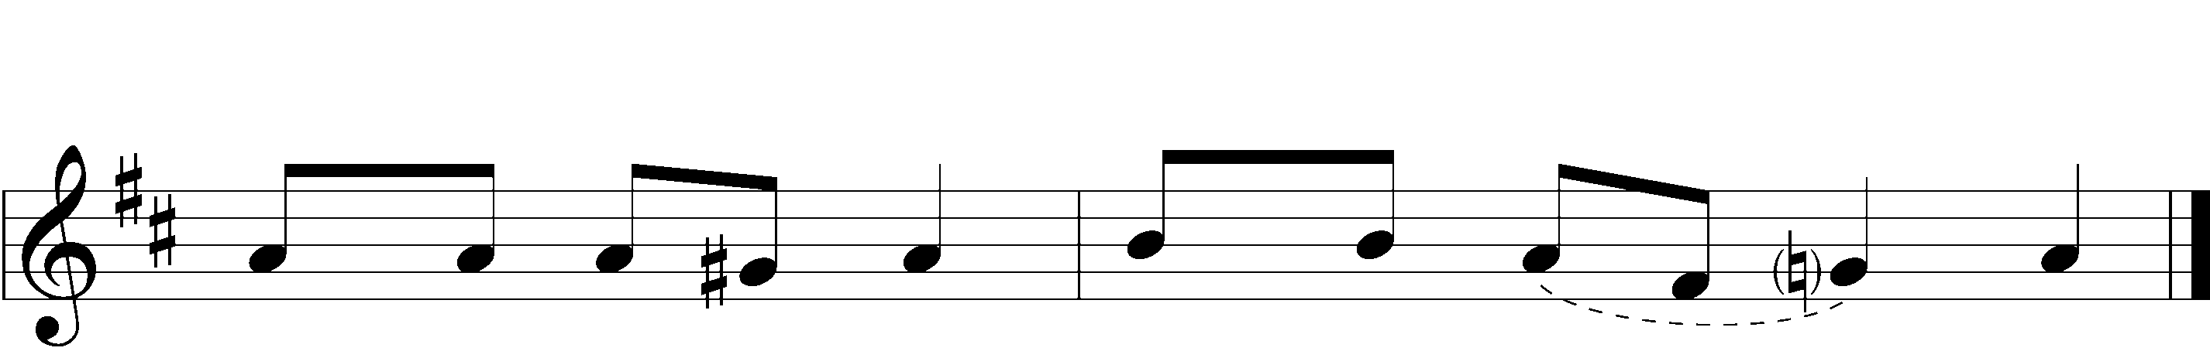



|  |  |  |  |
| --- | --- | --- | --- |
|  |  | | |
| PSALMODY | | Venite | *O Come, Let Us Sing* |
|  | Antiphon | | |
|  |  | | |
| L: | The Lord has sanctified us in the true faith. | | |



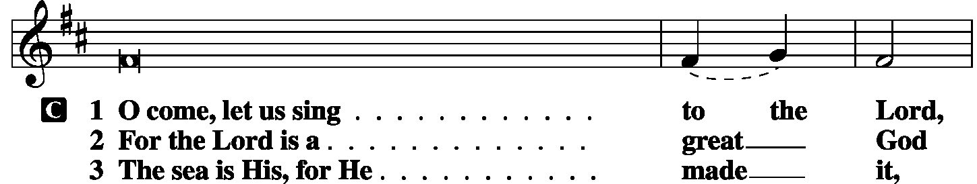

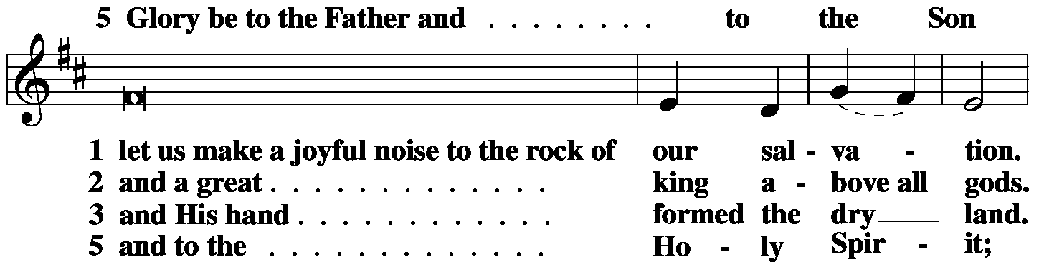

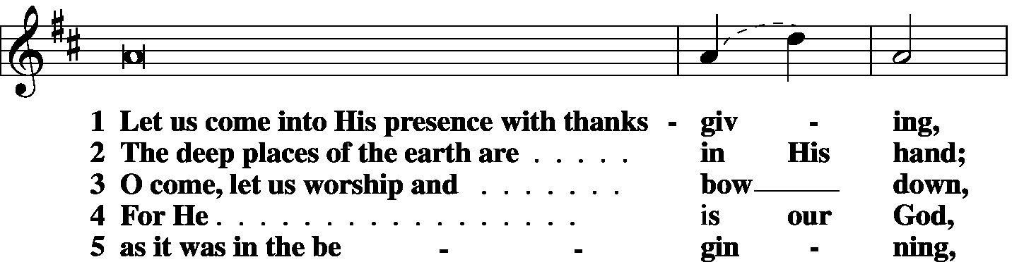

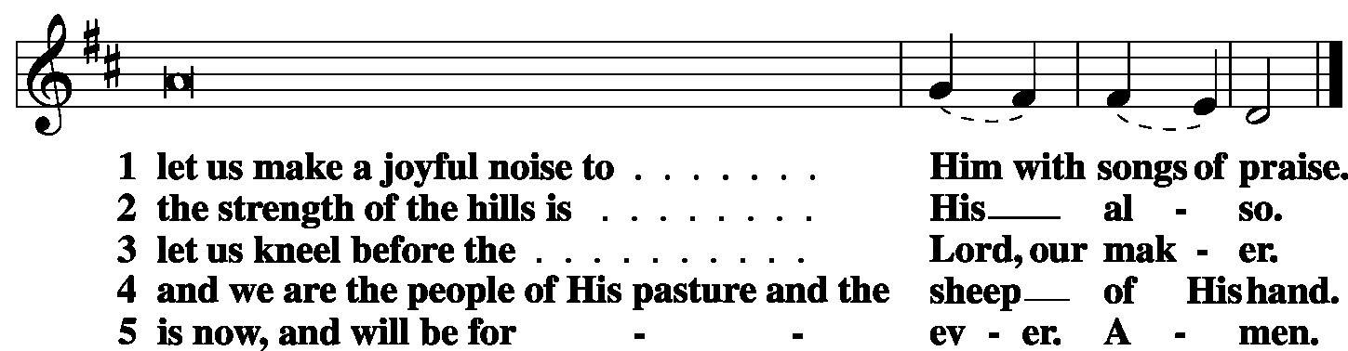

|  |  |
| --- | --- |
|  |  |
| L: | The Lord has sanctified us in the true faith. |



|  |  |  |  |
| --- | --- | --- | --- |
|  |  |  |  |

|  |  |  |  |
| --- | --- | --- | --- |
|  | Second Psalm | Psalm *1* | *(Spoken responsively by verse)* |
|  |  |  | |

Blessèd is the man who walks not in the counsel of the wicked,

nor stands in the way of sinners, nor sits in the seat of scoffers;

but his delight is in the law of the *Lord*,  
 and on His law he meditates day and night.

He is like a tree planted by streams of water that yields its fruit in its season, and its leaf does not wither.

In all that he does, he prospers.

The wicked are not so,

but are like chaff that the wind drives away.

Therefore the wicked will not stand in the judgment,  
 nor sinners in the congregation of the righteous;

for the *Lord* knows the way of the righteous,  
 but the way of the wicked will perish.

**Glory be to the Father and to the Son**

**and to the Holy Spirit;**

**as it was in the beginning,**

**is now, and will be forever. Amen.**

|  |  |  |  |
| --- | --- | --- | --- |
|  |  | |  |
| OFFICE HYMN | LSB 876 O Blessed, Holy Trinity | | |
|  | |  | |
| FIRST LESSON | | Deuteronomy 30:15-20 | |

15“See, I have set before you today life and good, death and evil. 16If you obey the commandments of the Lord your God that I command you today, by loving the Lord your God, by walking in His ways, and by keeping His commandments and His statutes and His rules, then you shall live and multiply, and the Lord your God will bless you in the land that you are entering to take possession of it. 17But if your heart turns away, and you will not hear, but are drawn away to worship other gods and serve them, 18I declare to you today, that you shall surely perish. You shall not live long in the land that you are going over the Jordan to enter and possess. 19I call heaven and earth to witness against you today, that I have set before you life and death, blessing and curse. Therefore choose life, that you and your offspring may live, 20loving the Lord your God, obeying His voice and holding fast to Him, for He is your life and length of days, that you may dwell in the land that the Lord swore to your fathers, to Abraham, to Isaac, and to Jacob, to give them.”

|  |  |  |
| --- | --- | --- |
|  |  |  |
| L: | O Lord, have mercy on us. | |
| C: | **Thanks be to God.** | |

|  |  |
| --- | --- |
| CHORAL VOLUNTARY | *Concordia K – 5th Grades* |
| *I Will Call Upon the Lord/This is My Commandment* | |
|  |  |
| EPISTLE LESSON | *Philemon 1-21* |

1Paul, a prisoner for Christ Jesus, and Timothy our brother,

To Philemon our beloved fellow worker 2and Apphia our sister and Archippus our fellow soldier, and the church in your house:

3Grace to you and peace from God our Father and the Lord Jesus Christ.

4I thank my God always when I remember you in my prayers, 5because I hear of your love and of the faith that you have toward the Lord Jesus and all the saints, 6and I pray that the sharing of your faith may become effective for the full knowledge of every good thing that is in us for the sake of Christ. 7For I have derived much joy and comfort from your love, my brother, because the hearts of the saints have been refreshed through you.

8Accordingly, though I am bold enough in Christ to command you to do what is required, 9yet for love’s sake I prefer to appeal to you—I, Paul, an old man and now a prisoner also for Christ Jesus— 10I appeal to you for my child, Onesimus, whose father I became in my imprisonment. 11(Formerly he was useless to you, but now he is indeed useful to you and to me.) 12I am sending him back to you, sending my very heart. 13I would have been glad to keep him with me, in order that he might serve me on your behalf during my imprisonment for the gospel, 14but I preferred to do nothing without your consent in order that your goodness might not be by compulsion but of your own free will. 15For this perhaps is why he was parted from you for a while, that you might have him back forever, 16no longer as a slave but more than a slave, as a beloved brother—especially to me, but how much more to you, both in the flesh and in the Lord.

17So if you consider me your partner, receive him as you would receive me. 18If he has wronged you at all, or owes you anything, charge that to my account. 19I, Paul, write this with my own hand: I will repay it—to say nothing of your owing me even your own self. 20Yes, brother, I want some benefit from you in the Lord. Refresh my heart in Christ.

21Confident of your obedience, I write to you, knowing that you will do even more than I say.

|  |  |  |  |  |  |  |
| --- | --- | --- | --- | --- | --- | --- |
|  | |  | | | | |
| L: | | O Lord, have mercy. | | | | |
| C: | | **Thanks be to God.** | | | | |
|  |  | | | |
| GOSPEL VERSE | | | | *Galatians 6:14* | | |
| L: | | Alleluia. Far be it from me to boast except in the cross of our Lord Jesus Christ, | | | | |
| C: | | by which the world has been crucified to me, and I to the world. Alleluia. | | | |
|  | |  |  | | | |

|  |  |  |  |
| --- | --- | --- | --- |
| HOLY GOSPEL | | *Luke 14:25-35* | |
| L: | The Holy Gospel according to St. Luke, the fourteenth chapter. | | |
| C: | **Glory to You, O Lord.** | | |
|  | | |  | |  |

25Now great crowds accompanied [Jesus], and He turned and said to them, **26“If anyone comes to Me and does not hate his own father and mother and wife and children and brothers and sisters, yes, and even his own life, he cannot be My disciple. 27Whoever does not bear his own cross and come after Me cannot be My disciple. 28For which of you, desiring to build a tower, does not first sit down and count the cost, whether he has enough to complete it? 29Otherwise, when he has laid a foundation and is not able to finish, all who see it begin to mock him, 30saying, ‘This man began to build and was not able to finish.’ 31Or what king, going out to encounter another king in war, will not sit down first and deliberate whether he is able with ten thousand to meet him who comes against him with twenty thousand? 32And if not, while the other is yet a great way off, he sends a delegation and asks for terms of peace. 33So therefore, any one of you who does not renounce all that he has cannot be My disciple.**

**34“Salt is good, but if salt has lost its taste, how shall its saltiness be restored? 35It is of no use either for the soil or for the manure pile. It is thrown away. He who has ears to hear, let him hear.”**

|  |  |  |  |  |  |
| --- | --- | --- | --- | --- | --- |
|  | |  | | | |
| L: | This is the Gospel of the Lord. | | |
| C: | **Praise to You, O Christ.** | | | |
|  | | |  | | |
| RESPONSORY | | |  | | |
| L: | Forever, O Lord, Your Word is firmly set in the heavens. | | | | |

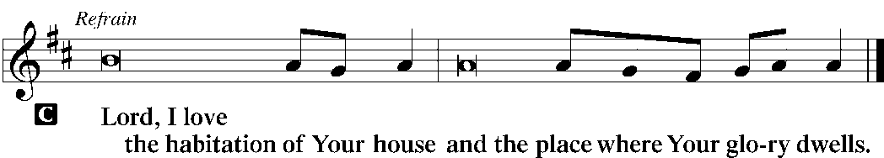

|  |  |
| --- | --- |
| L: | Blessed are those who hear the Word of God and keep it. |



|  |  |
| --- | --- |
| L: | Glory be to the Father and to the Son and to the Holy Spirit. |



|  |  |  |  |  |  |
| --- | --- | --- | --- | --- | --- |
|  | |  | | | |
| HYMN OF THE DAY | | *LSB* *713 From God Can Nothing Move Me* | | | |
|  | | | | | |
| SERMON | | | | | |
|  | | | | | |
| CANTICLE | **Te Deum** (*We Praise You, O God)* | | | *LSB p. 223* |
|  |  | |  | |

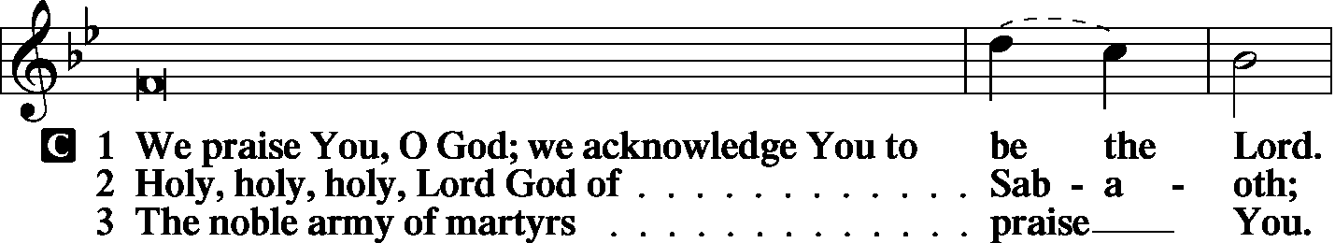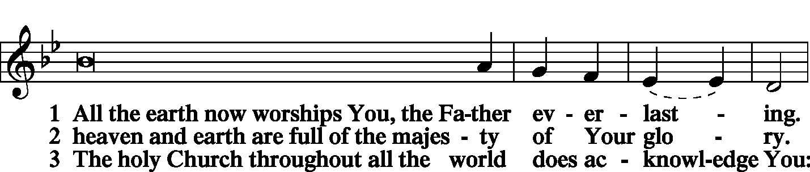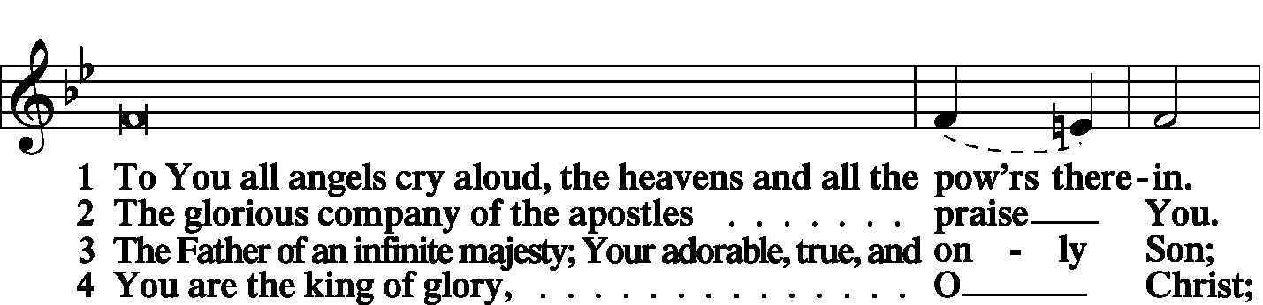

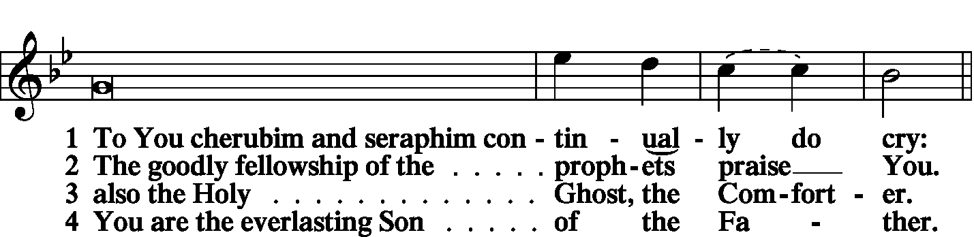

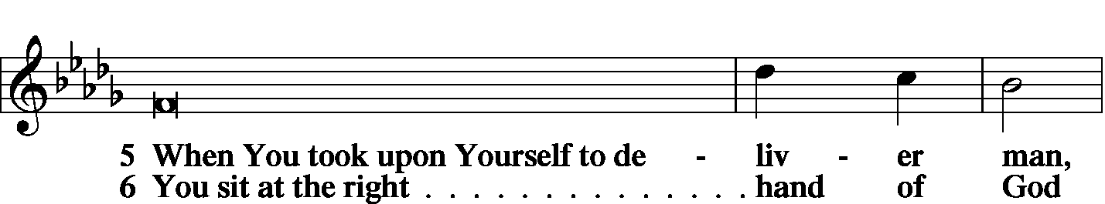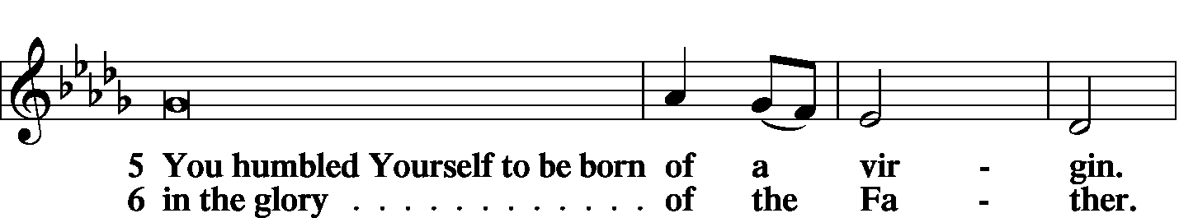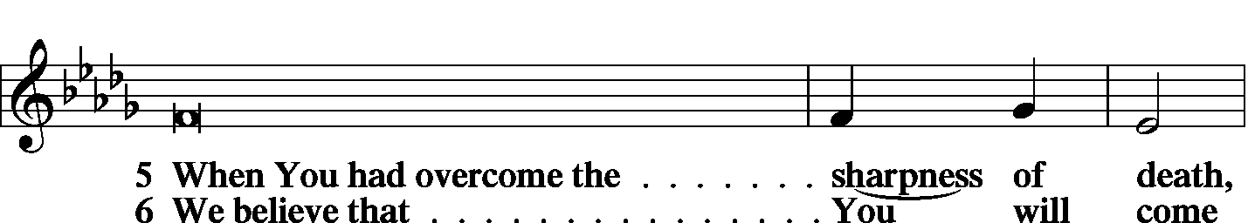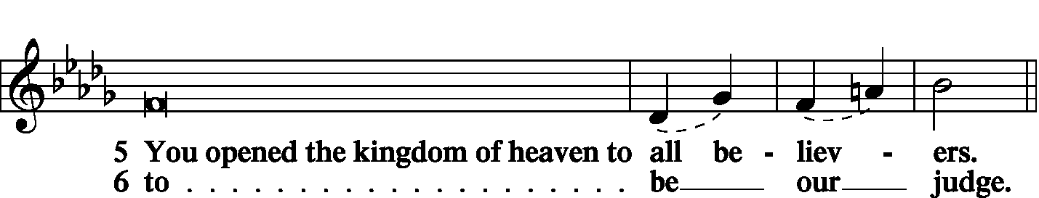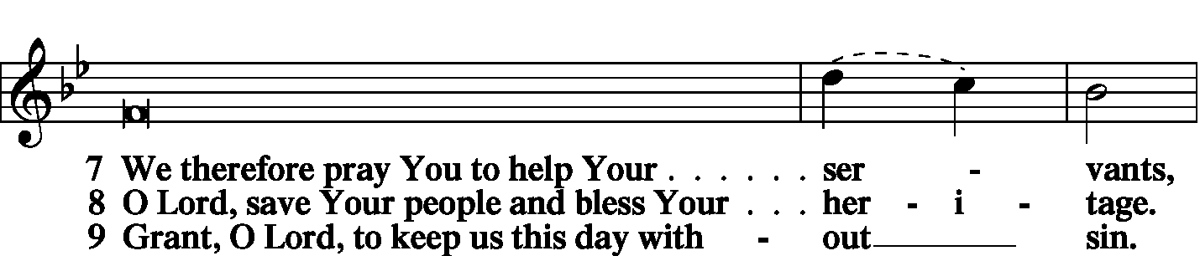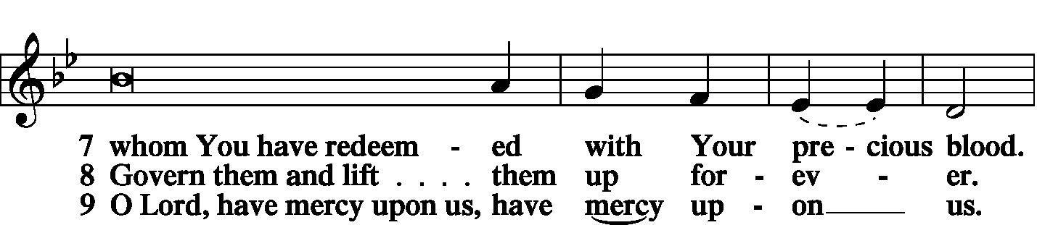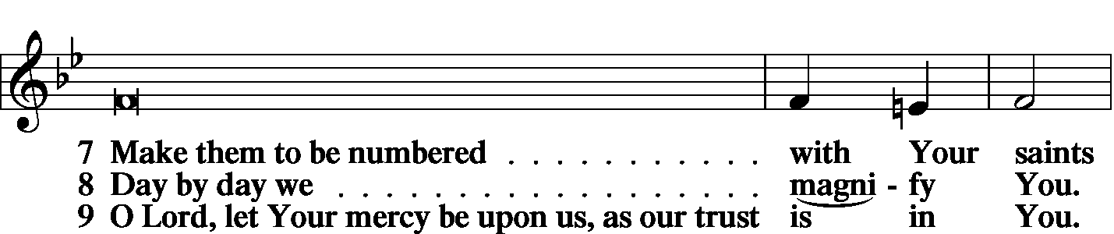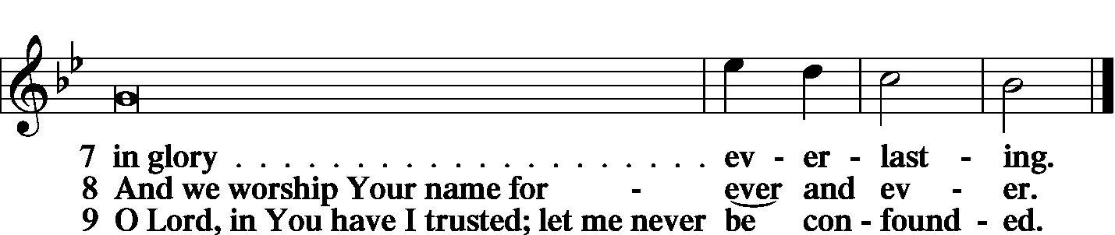

|  |  |  |
| --- | --- | --- |
|  | |  |
| PRAYER OF THE CHURCH | | |
|  | |  |
|  | Kyrie |  |

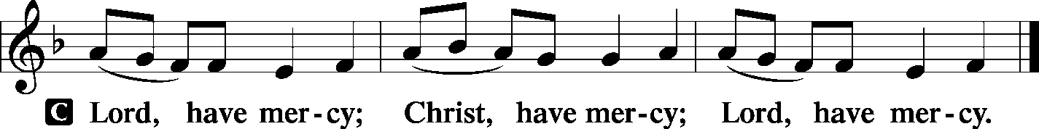

|  |  |
| --- | --- |
|  |  |
| Lord’s Prayer | |
| C: | Our Father Who art in heaven, hallowed be Thy name, Thy kingdom come, Thy will be done on earth as it is in heaven; give us this day our daily bread; and forgive us our trespasses as we forgive those who trespass against us; and lead us not into temptation, but deliver us from evil. For Thine is the kingdom and the power and the glory forever and ever. Amen. |
|  |  |
| Collects | |
| L: | The Lord be with you. |

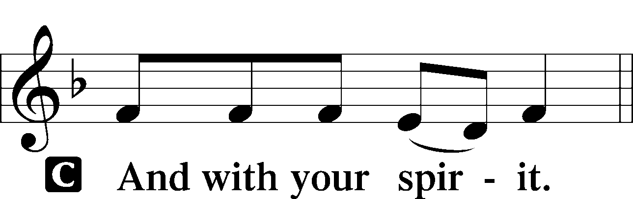

|  |  |
| --- | --- |
|  | Collect of the Day |
| L: | O merciful Lord, You did not spare Your only Son but delivered Him up for us all. Grant us courage and strength to take up the cross and follow Him, through Jesus Christ, Our Lord. |



|  |  |
| --- | --- |
|  | Collect for Matins |
| L: | Almighty God, heavenly Father, Your mercies are new to us every morning, and You abundantly provide for all our wants of body and soul. Give us we humbly pray, Your Holy Spirit that we may heartily acknowledge Your merciful goodness toward us, give thanks for all Your benefits, and cheerfully serve You. |



|  |  |  |
| --- | --- | --- |
|  |  |  |
|  | For Guidance in Our Calling | *LSB p. 311* |
| L: | Lord God, You have called Your servants to ventures of which we cannot see the ending, by paths as yet untrodden, through perils unknown. Give us faith to go out with good courage, not knowing where we go but only that Your hand is leading us and Your love supporting us; through Jesus Christ, our Lord. | |



|  |  |  |
| --- | --- | --- |
|  |  |  |
|  | For Responsible Citizenship | *LSB p.313* |
| L: | Lord, keep this nation under Your care. Bless the leaders of our land that we may be a people at peace among ourselves and a blessing to the other nations of the earth. Grant that we may choose trustworthy leaders, contribute to wise decisions for the general welfare, and serve You faithfully in our generation; through Jesus Christ, our Lord. | |



|  |  |
| --- | --- |
| L | May the Lord hear the prayers we name in our hearts....…… Lord, in Your mercy: |
| C: | Hear our prayer. |

|  |  |  |
| --- | --- | --- |
|  | Collect for Grace | *LSB p.228* |
| L: | O Lord, our heavenly Father, almighty and everlasting God, You have safely brought us to the beginning of this day. Defend us in the same with Your mighty power and grant that this day we fall into no sin, neither run into any kind of danger, but that all our doings, being ordered by Your governance, may be righteous in Your sight; through Jesus Christ, Your Son, our Lord, Who lives and reigns with You and the Holy Spirit, one God, now and forever. | |



|  |  |
| --- | --- |
|  |  |

|  |  |  |
| --- | --- | --- |
| BENEDICAMUS | | *LSB p. 227* |
| L: | Let us bless the Lord. | |

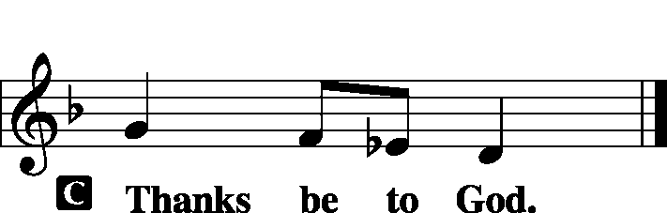

|  |  |  |
| --- | --- | --- |
|  | |  |
| BENEDICTION | |  |
| L: | The grace of our Lord T Jesus Christ and the love of God and the communion of the Holy Spirit be with us all. | |



|  |  |  |  |  |  |
| --- | --- | --- | --- | --- | --- |
|  | | |  |  | |
| CLOSING HYMN | | LSB 688 Come Follow Me, the Savior Spake | | | |
|  | |  | | |  |
| SILENT PRAYER | | |  |  | | |
|  | *Almighty and merciful God, I have again worshiped in Your presence and received both forgiveness for my many sins and the assurance of Your love in Jesus Christ. I thank You for this undeserved grace and ask You to keep me in faith until, with all Your saints, I inherit eternal salvation; through Jesus Christ, my Lord. Amen.* | | | | | |
|  | | | | | | |
| T T T | | | | | | |
|  | | | | | | |
| Worship Leaders: Daniel Keehnerand Gary Beenders | | | | | | |
| Elder: Dr. Joel Eckert | | | | | | |
| Organist: Carol Wessler | | | | | | |
|  | | | | | | |

Acknowledgments

Matins from Lutheran Service Book

Unless otherwise indicated, all scripture quotations are from *The Holy Bible, English Standard Version*, copyright © 2001 by Crossway Bibles, a division of Good News Publishers. Used by permission. All rights reserved.

Created by Lutheran Service Builder © 2006 Concordia Publishing House.

**BIBLE STUDY TODAY** – – David Heien will lead class today as he guides us through the end of Solomon's reign, and the troubles that lead to the kingdom breaking into the North and the South. On the 14th, Pr. Schurb (from the District Office) will discuss Paul's First Missionary Journey and the District's plans on evangelism during the Adult Class.