|  |
| --- |
| Fourteenth Sunday after Pentecost |
| September 14, 2025 |
| + The Order of Matins + |
| Lutheran Service Book – Pages 219-228 |

|  |  |  |
| --- | --- | --- |
| Prayer Before Worship | |  |
|  | *O Lord, my Creator, Redeemer, and Comforter, as I come to worship You in spirit and in truth, I humbly pray that You would open my heart to the preaching of Your Word so that I may repent of my sins, believe in Jesus Christ as my only Savior, and grow in grace and holiness. Hear me for the sake of His name. Amen.* | |
|  |  | |
| PRELUDE | | |
|  | | |

|  |
| --- |
| RINGING BELL CALLS US TO WORSHIP |

|  |  |  |  |  |  |
| --- | --- | --- | --- | --- | --- |
|  | | |  | | |
| WELCOME | | |  | | |
|  | | |  | | |
| OPENING HYMN | | *LSB 915 Today Your Mercy Calls Us* | | | |
|  | | | |  |
| CONFESSION AND DECLARATION OF FORGIVENESS | | | | *Page 151* |
| P: | Let us begin in the name of the Father and of the T Son and of the Holy Spirit. | | | |
| C: | Amen. | | | |
| P: | If we say we have no sin, we deceive ourselves, and the truth is not in us. | | | |
| C: | But if we confess our sins, God, Who is faithful and just, will forgive our sins and cleanse us from all unrighteousness. | | | |
|  |  | | | |
|  | *(Silence for reflection on God’s Word and for self-examination.)* | | | |
|  |  | | | |
| P: | Let us then confess our sins to God our Father. | | | |
| C: | **Most merciful God, we confess that we are by nature sinful and unclean. We have sinned against You in thought, word, and deed, by what we have done and by what we have left undone. We have not loved You with our whole heart; we have not loved our neighbors as ourselves. We justly deserve Your present and eternal punishment. For the sake of Your Son, Jesus Christ, have mercy on us. Forgive us, renew us, and lead us, so that we may delight in Your will and walk in Your ways to the glory of Your holy name. Amen.** | | | |
| P: | Almighty God in His mercy has given His Son to die for you and for His sake forgives you all your sins. As a called and ordained servant of Christ, and by His authority, I therefore forgive you all your sins in the name of the Father and of the T Son and of the Holy Spirit. | | | |
| C: | Amen. | | | |
| P: | O Lord, open my lips,, | | | |



|  |  |
| --- | --- |
|  |  |
| P: | Make haste, O God, to deliver me: |



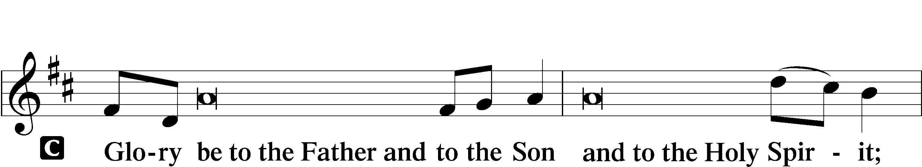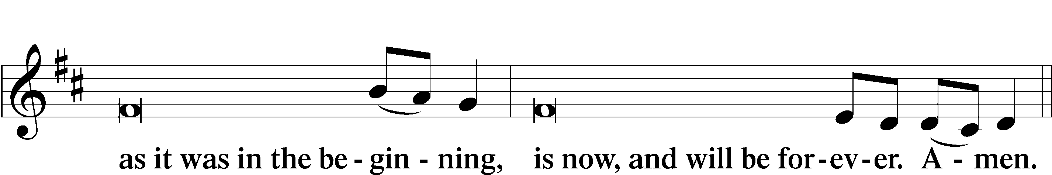

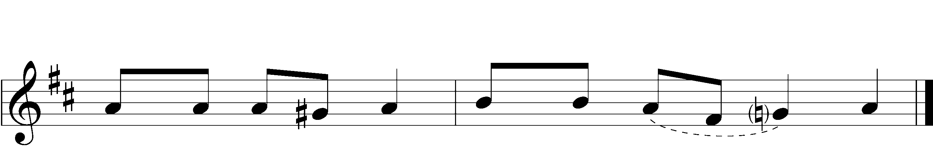



|  |  |  |  |
| --- | --- | --- | --- |
|  |  | | |
| PSALMODY | | Venite | *O Come, Let Us Sing* |
|  | Antiphon | | |
|  |  | | |
| P: | The Lord has sanctified us in the true faith. | | |



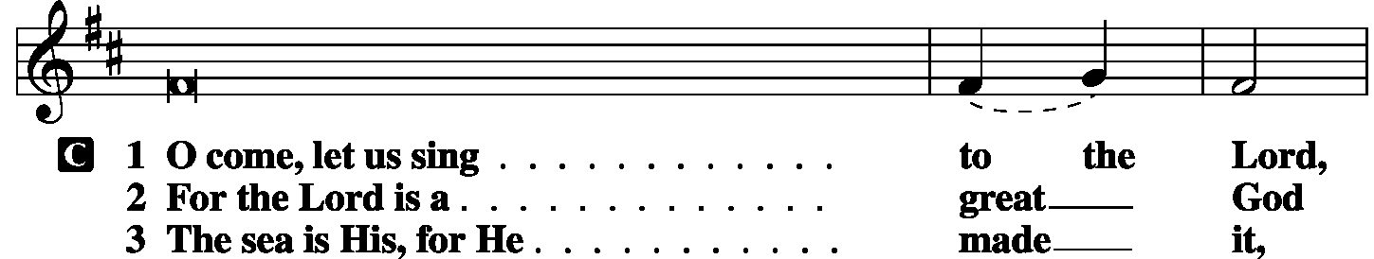

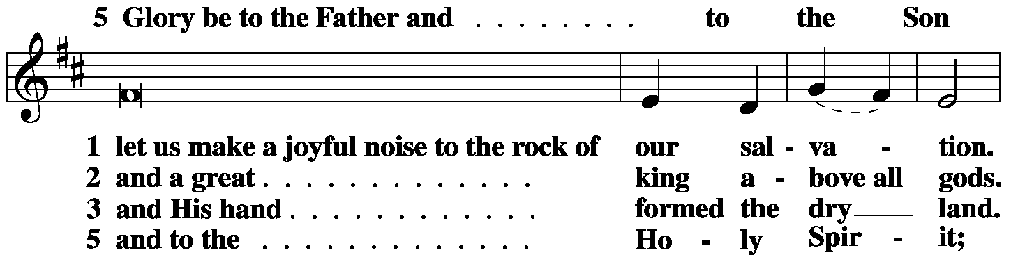

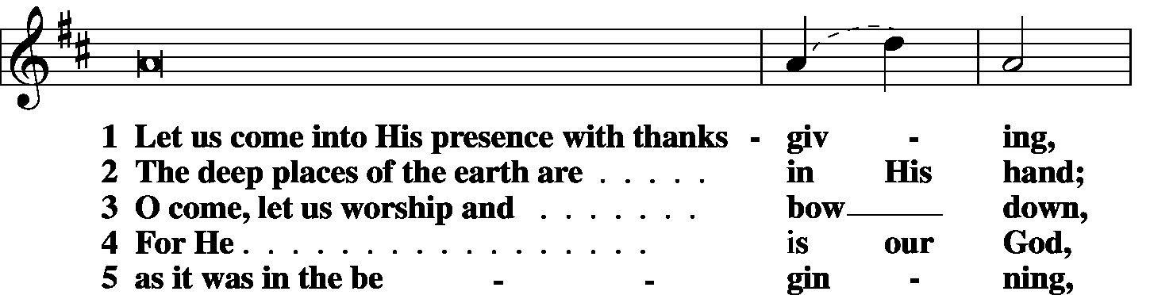

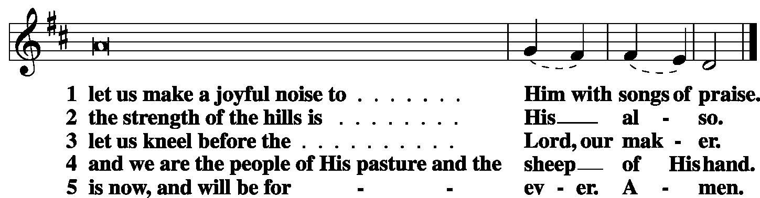

|  |  |
| --- | --- |
|  |  |
| P: | The Lord has sanctified us in the true faith. |



|  |  |  |  |
| --- | --- | --- | --- |
|  |  |  |  |

|  |  |  |  |
| --- | --- | --- | --- |
|  | Second Psalm | Psalm 119:169-176 | *(Spoken responsively by verse)* |
|  |  |  | |

Let my cry come before You, O Lord;  
 give me understanding according to Your Word!  
Let my plea come before You;  
 deliver me according to Your Word.  
My lips will pour forth praise,  
 for You teach me Your statutes.  
My tongue will sing of Your Word,  
 for all Your commandments are right.  
Let Your hand be ready to help me,  
 for I have chosen Your precepts.  
I long for Your salvation, O *Lord*,  
 and Your law is my delight.  
Let my soul live and praise You,  
 and let Your just decrees help me.  
I have gone astray like a lost sheep; seek Your servant,  
 for I do not forget Your commandments.

**Glory be to the Father and to the Son**

**and to the Holy Spirit;**

**as it was in the beginning,**

**is now, and will be forever. Amen.**

|  |  |  |  |
| --- | --- | --- | --- |
|  |  | |  |
| OFFICE HYMN | LSB 873 Christ Whose Glory Fills the Skies | | |
|  |  | |  |
| FIRST LESSON | | Ezekiel 34:11–24 | |

11For thus says the Lord God: “Behold, I, I Myself will search for My sheep and will seek them out. 12As a shepherd seeks out his flock when he is among his sheep that have been scattered, so will I seek out My sheep, and I will rescue them from all places where they have been scattered on a day of clouds and thick darkness. 13And I will bring them out from the peoples and gather them from the countries, and will bring them into their own land. And I will feed them on the mountains of Israel, by the ravines, and in all the inhabited places of the country. 14I will feed them with good pasture, and on the mountain heights of Israel shall be their grazing land. There they shall lie down in good grazing land, and on rich pasture they shall feed on the mountains of Israel. 15I Myself will be the shepherd of My sheep, and I Myself will make them lie down, declares the Lord God. 16I will seek the lost, and I will bring back the strayed, and I will bind up the injured, and I will strengthen the weak, and the fat and the strong I will destroy. I will feed them in justice.

17As for you, My flock, thus says the Lord God: Behold, I judge between sheep and sheep, between rams and male goats. 18Is it not enough for you to feed on the good pasture, that you must tread down with your feet the rest of your pasture; and to drink of clear water, that you must muddy the rest of the water with your feet? 19And must My sheep eat what you have trodden with your feet, and drink what you have muddied with your feet?

20Therefore, thus says the Lord God to them: Behold, I, I Myself will judge between the fat sheep and the lean sheep. 21Because you push with side and shoulder, and thrust at all the weak with your horns, till you have scattered them abroad, 22I will rescue My flock; they shall no longer be a prey. And I will judge between sheep and sheep. 23And I will set up over them one shepherd, My servant David, and he shall feed them: he shall feed them and be their shepherd. 24And I, the Lord, will be their God, and My servant David shall be prince among them. I am the Lord; I have spoken.”

|  |  |  |  |
| --- | --- | --- | --- |
|  |  | |  |
| P: | O Lord, have mercy on us. | | |
| C: | **Thanks be to God.** | | |
|  | |  | |
| EPISTLE LESSON | | *1Timothy 1:5-17* | |

5The aim of our charge is love that issues from a pure heart and a good conscience and a sincere faith. 6Certain persons, by swerving from these, have wandered away into vain discussion, 7desiring to be teachers of the law, without understanding either what they are saying or the things about which they make confident assertions.

8Now we know that the law is good, if one uses it lawfully, 9understanding this, that the law is not laid down for the just but for the lawless and disobedient, for the ungodly and sinners, for the unholy and profane, for those who strike their fathers and mothers, for murderers, 10the sexually immoral, men who practice homosexuality, enslavers, liars, perjurers, and whatever else is contrary to sound doctrine, 11in accordance with the glorious gospel of the blessed God with which I have been entrusted.

12I thank Him Who has given me strength, Christ Jesus our Lord, because He judged me faithful, appointing me to His service, 13though formerly I was a blasphemer, persecutor, and insolent opponent. But I received mercy because I had acted ignorantly in unbelief, 14and the grace of our Lord overflowed for me with the faith and love that are in Christ Jesus. 15The saying is trustworthy and deserving of full acceptance, that Christ Jesus came into the world to save sinners, of whom I am the foremost. 16But I received mercy for this reason, that in me, as the foremost, Jesus Christ might display His perfect patience as an example to those who were to believe in Him for eternal life. 17To the King of ages, immortal, invisible, the only God, be honor and glory forever and ever. Amen.

|  |  |  |  |  |  |  |  |  |
| --- | --- | --- | --- | --- | --- | --- | --- | --- |
|  | |  | | | | | | |
| P: | | O Lord, have mercy. | | | | | | |
| C: | | **Thanks be to God.** | | | | | | |
|  |  | | | | | |  | |
| GOSPEL VERSE | | | | | | *Luke 15:10* | | |
| P: | | Alleluia. I tell you, there is joy before the angels of God | | | | | | |
| C: | | over one sinner who repents. Alleluia. | | | | | |
|  | |  | |  | | | | |
| HOLY GOSPEL | | | | | *Luke 15:1-10* | | |
| P: | | | The Holy Gospel according to St. Luke, the fifteenth chapter. | | | | |
| C: | | | **Glory to You, O Lord.** | | | | |

1Now the tax collectors and sinners were all drawing near to hear [Jesus]. 2And the Pharisees and the scribes grumbled, saying, “This man receives sinners and eats with them.”

3So He told them this parable: **4“What man of you, having a hundred sheep, if he has lost one of them, does not leave the ninety-nine in the open country, and go after the one that is lost, until he finds it? 5And when he has found it, he lays it on his shoulders, rejoicing. 6And when he comes home, he calls together his friends and his neighbors, saying to them, ‘Rejoice with me, for I have found my sheep that was lost. 7Just so, I tell you, there will be more joy in heaven over one sinner who repents than over ninety-nine righteous persons who need no repentance.**

**8“Or what woman, having ten silver coins, if she loses one coin, does not light a lamp and sweep the house and seek diligently until she finds it? 9And when she has found it, she calls together her friends and neighbors, saying, ‘Rejoice with me, for I have found the coin that I had lost.’ 10Just so, I tell you, there is joy before the angels of God over one sinner who repents.”**

|  |  |  |  |  |  |
| --- | --- | --- | --- | --- | --- |
|  | |  | | | |
| P: | This is the Gospel of the Lord. | | |
| C: | **Praise to You, O Christ.** | | | |
|  | | |  | | |
| RESPONSORY | | |  | | |
| P: | Forever, O Lord, Your Word is firmly set in the heavens. | | | | |

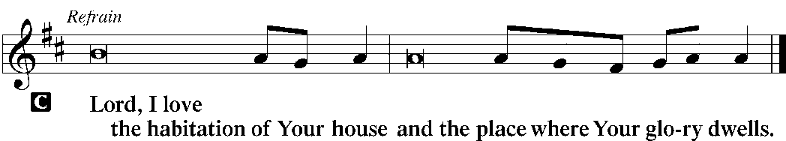

|  |  |
| --- | --- |
| P: | Blessed are those who hear the Word of God and keep it. |



|  |  |
| --- | --- |
| P: | Glory be to the Father and to the Son and to the Holy Spirit. |



|  |  |  |  |  |  |
| --- | --- | --- | --- | --- | --- |
| HYMN OF THE DAY | | *LSB 611 Chief of Sinners Though I Be* | | | |
|  | | | | | |
| SERMON | | | | | |
|  | | | | | |
| CANTICLE | **Te Deum** (*We Praise You, O God)* | | | *LSB p. 223* |
|  |  | |  | |

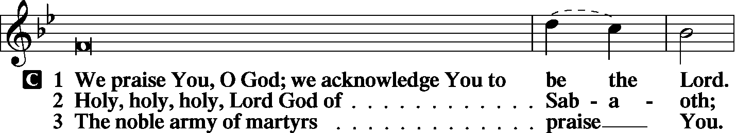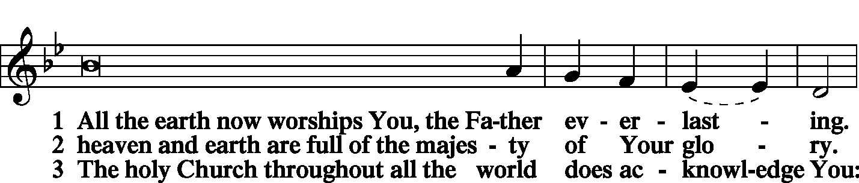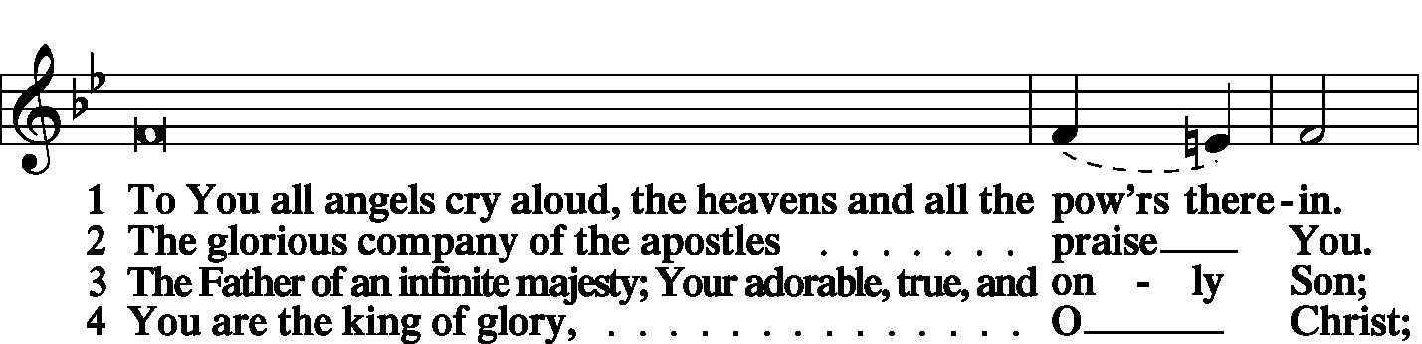

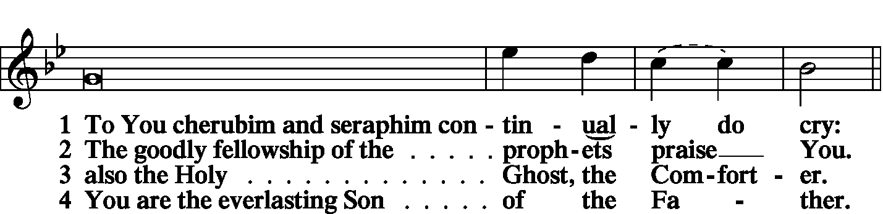

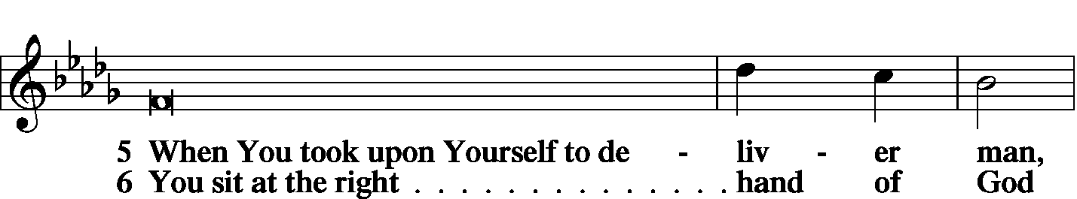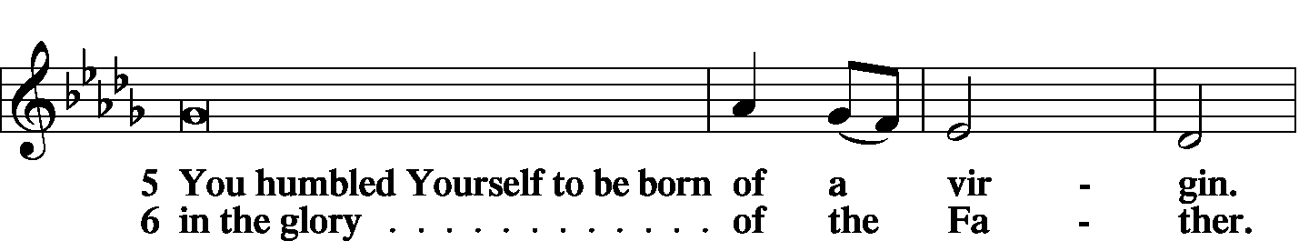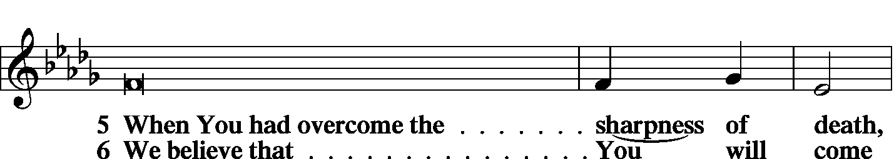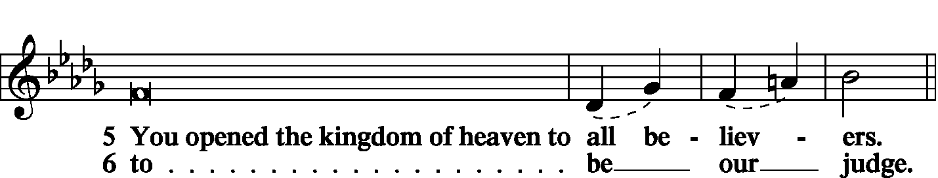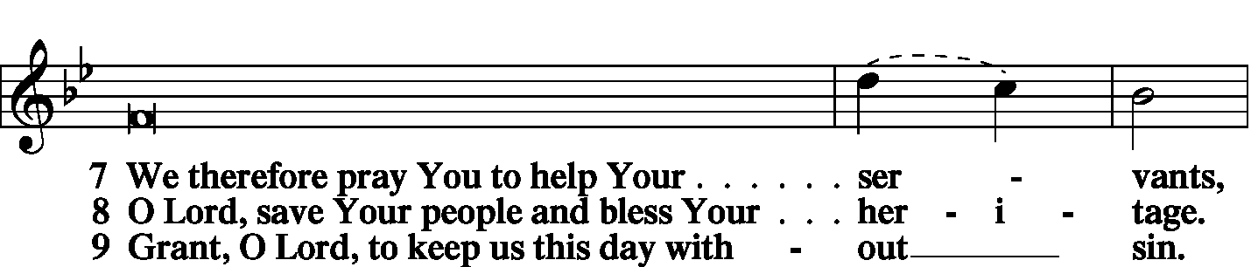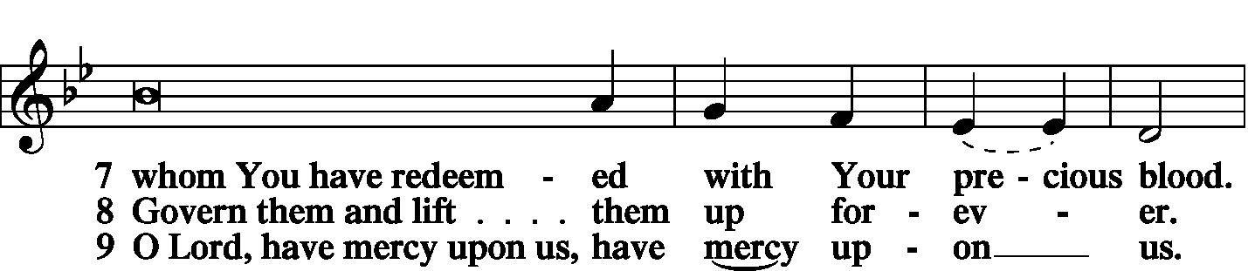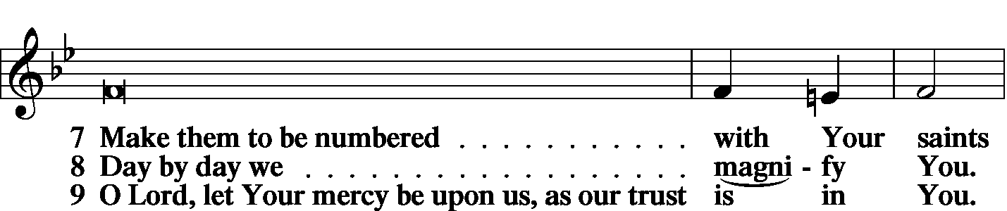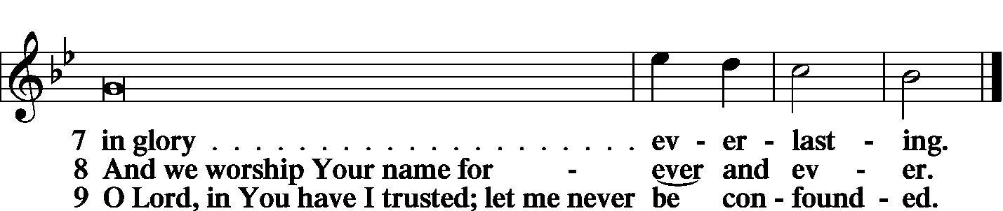

|  |  |  |
| --- | --- | --- |
|  | |  |
| PRAYER OF THE CHURCH | | |
|  | |  |
|  | Kyrie |  |

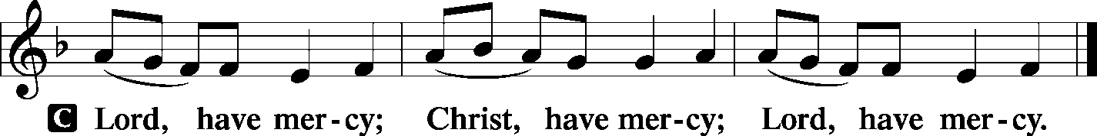

|  |  |
| --- | --- |
|  |  |
| Lord’s Prayer | |
| C: | Our Father Who art in heaven, hallowed be Thy name, Thy kingdom come, Thy will be done on earth as it is in heaven; give us this day our daily bread; and forgive us our trespasses as we forgive those who trespass against us; and lead us not into temptation, but deliver us from evil. For Thine is the kingdom and the power and the glory forever and ever. Amen. |
|  |  |
| Collects | |
| P: | The Lord be with you. |

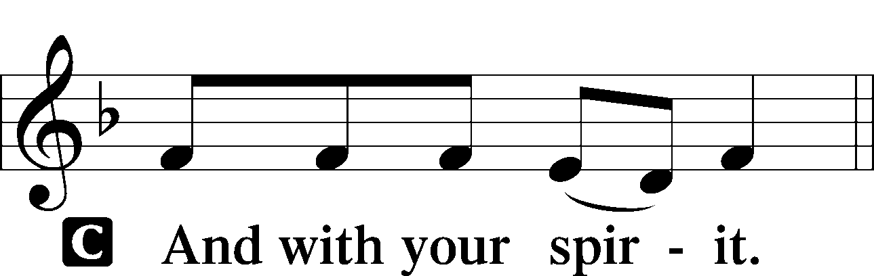

|  |  |
| --- | --- |
|  | Collect of the Day |
| P: | Lord Jesus, You are the Good Shepherd, without Whom nothing is secure. Rescue and preserve us that we may not be lost forever but follow You, rejoicing in the way that leads to eternal life; through Jesus Christ, our Lord. |



|  |  |
| --- | --- |
|  | Collect for Holy Cross |
| P: | Merciful God, Your Son, Jesus Christ, was lifted high upon the cross that He might bear the sins of the world and draw all people to Himself. Grant that we who glory in His death for our redemption may faithfully heed His call to bear the cross and follow Him, through Jesus Christ our Lord.. |
|  |  |

|  |  |
| --- | --- |
|  |  |
|  | Collect for Matins |
| P: | Almighty God, heavenly Father, Your mercies are new to us every morning, and You abundantly provide for all our wants of body and soul. Give us we humbly pray, Your Holy Spirit that we may heartily acknowledge Your merciful goodness toward us, give thanks for all Your benefits, and cheerfully serve You. |



|  |  |  |
| --- | --- | --- |
|  |  |  |
|  | For Guidance in Our Calling | *LSB p. 311* |
| P: | Lord God, You have called Your servants to ventures of which we cannot see the ending, by paths as yet untrodden, through perils unknown. Give us faith to go out with good courage, not knowing where we go but only that Your hand is leading us and Your love supporting us; through Jesus Christ, our Lord. | |



|  |  |  |
| --- | --- | --- |
|  |  |  |
|  | For Responsible Citizenship | *LSB p.313* |
| P: | Lord, keep this nation under Your care. Bless the leaders of our land that we may be a people at peace among ourselves and a blessing to the other nations of the earth. Grant that we may choose trustworthy leaders, contribute to wise decisions for the general welfare, and serve You faithfully in our generation; through Jesus Christ, our Lord. | |



|  |  |  |
| --- | --- | --- |
| P: | May the Lord hear the prayers we name in our hearts....…… Lord, in Your mercy: | |
| C: | Hear our prayer. | |
|  |  |  |
|  | Collect for Grace | *LSB p.228* |
| P: | O Lord, our heavenly Father, almighty and everlasting God, You have safely brought us to the beginning of this day. Defend us in the same with Your mighty power and grant that this day we fall into no sin, neither run into any kind of danger, but that all our doings, being ordered by Your governance, may be righteous in Your sight; through Jesus Christ, Your Son, our Lord, Who lives and reigns with You and the Holy Spirit, one God, now and forever. | |



|  |  |  |
| --- | --- | --- |
|  | |  |
| BENEDICAMUS | | *LSB p. 227* |
| L: | Let us bless the Lord. | |

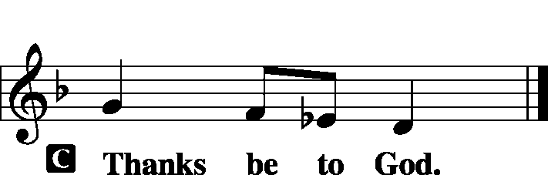

|  |  |  |
| --- | --- | --- |
|  | |  |
| BENEDICTION | |  |
| P: | The grace of our Lord T Jesus Christ and the love of God and the communion of the Holy Spirit be with us all. | |



|  |  |  |  |  |  |
| --- | --- | --- | --- | --- | --- |
|  | | |  |  | |
| CLOSING HYMN | | LSB 580 The Gospel Shows the Father’s Grace | | | |
|  | |  | | |  |
| SILENT PRAYER | | |  |  | | |
|  | *Almighty and merciful God, I have again worshiped in Your presence and received both forgiveness for my many sins and the assurance of Your love in Jesus Christ. I thank You for this undeserved grace and ask You to keep me in faith until, with all Your saints, I inherit eternal salvation; through Jesus Christ, my Lord. Amen.* | | | | | |
|  | | | | | | |
| T T T | | | | | | |
|  | | | | | | |

|  |
| --- |
| **Pastor**: The Rev. Dr. Ken Schurb -- Director of Evangelism & Missions, Stewardship and Human Care for the Central Illinois District of the LCMS. |
| Elder: Dr. Joel Eckert |
| Organist: Carol Wessler |
|  |

Acknowledgments

Matins from Lutheran Service Book

Unless otherwise indicated, all scripture quotations are from *The Holy Bible, English Standard Version*, copyright © 2001 by Crossway Bibles, a division of Good News Publishers. Used by permission. All rights reserved.

Created by Lutheran Service Builder © 2006 Concordia Publishing House.

**BIBLE STUDY TODAY** – Pr. Schurb will discuss Paul's First Missionary Journey and the District's plans on evangelism during the Adult Class.

We thank him for leading our Worship Services today, and for his message during the Bible Study Hour.