|  |
| --- |
| St. Matthew, Apostle and Evangelist |
| Fifteenth Sunday after Pentecost |
| September 21, 2025, 2025 |
| Divine Service I/Holy Communion |
| LSB Page 151 |

REGISTRATION FOR HOLY COMMUNION

Members of Mt. Calvary and visitors, who are confirmed members in good standing of congregations of the Lutheran Church-Missouri Synod, are asked to announce attendance at Holy Communion by means of the registration cards in the pews. Non-member visitors and guests, who may desire to attend Holy Communion, are asked to speak in person with the pastor before doing so. Those who desire a blessing, but choose not to commune, may come forward and simply cross their hands over their chest.

In accord with Holy Scripture, our church teaches that Holy Communion is open only to those who: (1) have been baptized in the name of the Triune God; Matt. 28:19, Acts 2:41-42; (2) are able to examine themselves both as to what this meal is and also its purpose; 1 Cor. 11:26-30; (3) have confessed and repented of their sins; 1 John 1:8-2:3; (4) believe that in, with, and under the bread and wine all communicants receive the true body and blood of our Lord Jesus Christ for the forgiveness of sins: 1 Cor. 11:23-27, 1 Cor. 10:16, Matt. 26:26-28; and who (5) are united in belief in the same teaching: 1 Cor. 10:17, Rom. 16:18, 2 John 10-11, Matt. 28:20, Heb. 13:9.

*Looking for extra help in focusing your thoughts for the Lord’s Supper? “Christian Questions with Their Answers” was prepared by Luther to address just that. They can be found in your hymnal on pages 329-330. Review them if you get to church early, or if you are waiting to be invited forward.*

|  |  |  |  |  |
| --- | --- | --- | --- | --- |
|  | | | | |
| *Prayer Before Worship: O Lord, my Creator, Redeemer, and Comforter, as I come to worship You in spirit and in truth, I humbly pray that You would open my heart to the preaching of Your Word so that I may repent of my sins, believe in Jesus Christ as my only Savior, and grow in grace and holiness. Hear me for the sake of His name. Amen.* | | | | |
|  |  | | | |
| PRELUDE | |  | |  |
|  | | |  | |
| RINGING BELL CALLS US TO WORSHIP | | |  | |
|  | | |  | |
| WELCOME | | |  | |
|  | | |  | |

|  |  |  |  |  |
| --- | --- | --- | --- | --- |
| OPENING HYMN | | *LSB 518 vv, 1, 25, 3 By All Your Saints in Warfare* | | |
|  | |  | |  |
| CONFESSION AND ABSOLUTION | | | *Page 151* | |
| P: | In the name of the Father and of the T Son and of the Holy Spirit. | | | |
| C: | Amen. | | | |
| P: | If we say we have no sin, we deceive ourselves, and the truth is not in us. | | | |
| C: | But if we confess our sins, God, Who is faithful and just, will forgive our sins and cleanse us from all unrighteousness. | | | |
|  |  | | | |
|  | *(Silence for reflection on God’s Word and for self-examination.)* | | | |
|  |  | | | |
| P: | Let us then confess our sins to God our Father. | | | |
| C: | **Most merciful God, we confess that we are by nature sinful and unclean. We have sinned against You in thought, word, and deed, by what we have done and by what we have left undone. We have not loved You with our whole heart; we have not loved our neighbors as ourselves. We justly deserve Your present and eternal punishment. For the sake of Your Son, Jesus Christ, have mercy on us. Forgive us, renew us, and lead us, so that we may delight in Your will and walk in Your ways to the glory of Your holy name. Amen.** | | | |
| P: | Almighty God in His mercy has given His Son to die for you and for His sake forgives you all your sins. As a called and ordained servant of Christ, and by His authority, I therefore forgive you all your sins in the name of the Father and of the T Son and of the Holy Spirit. | | | |
| C: | Amen. | | | |
|  | | |
| INTROIT | | | *Psalm 92:1–5; antiphon: Matthew 9:13b, c* | |
|  | | |  | |

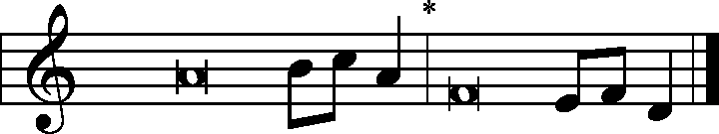

I desire mercy, and not | sacrifice.*  
 For I came not to call the righteous, but | sinners.  
It is good to give thanks | to the Lord,*  
 to sing praises to Your name, | O Most High;  
to declare Your steadfast love in the | morning,*  
 and Your faithful- | ness by night,  
to the music of the lute | and the harp,*  
 to the melody | of the lyre.  
For You, O Lord, have made me glad | by Your work;*  
 at the works of Your hands I | sing for joy.  
How great are Your works, | O Lord!*  
 Your thoughts are | very deep!  
**Glory be to the Father and | to the Son**\*  
 **and to the Holy | Spirit;**  
**as it was in the be- | ginning,**\*  
 **is now, and will be forever. | Amen.**  
I desire mercy, and not | sacrifice.*  
 For I came not to call the righteous, but | sinners.

|  |  |
| --- | --- |
|  |  |
| KYRIE | Pages 152-53 |
|  |  |

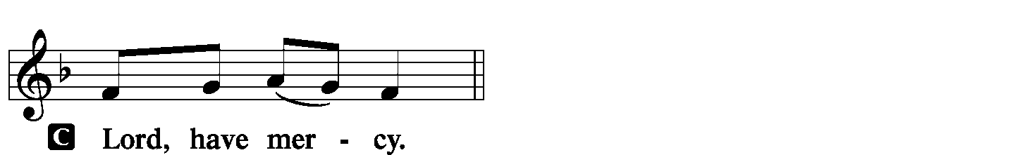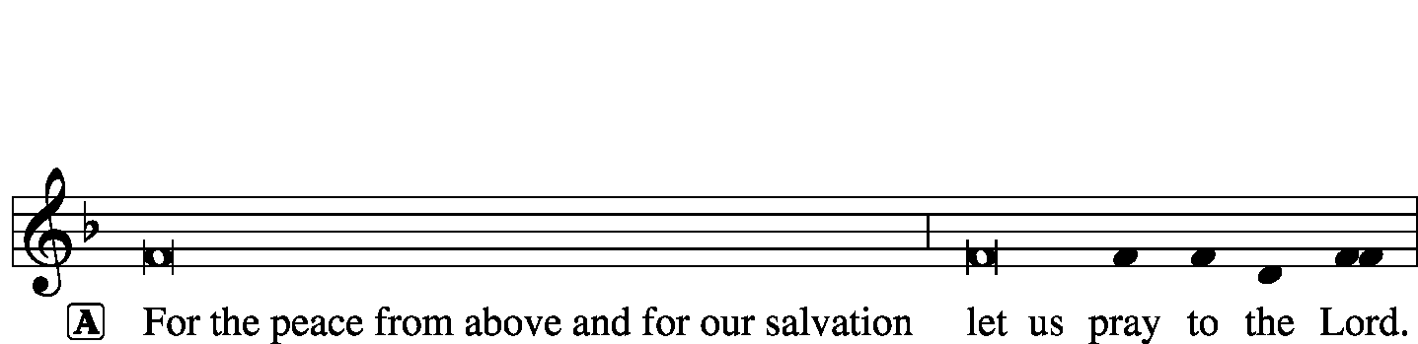

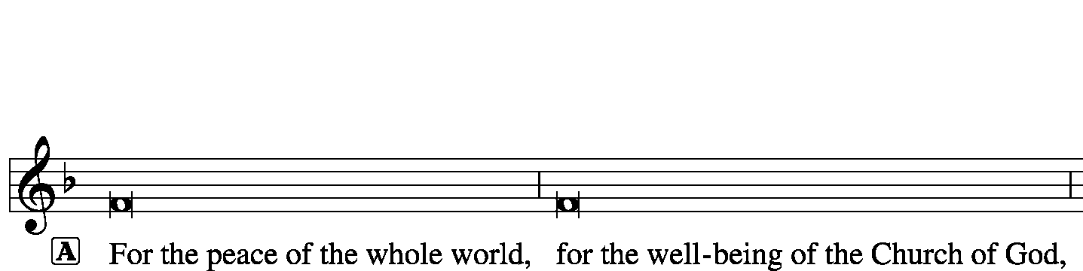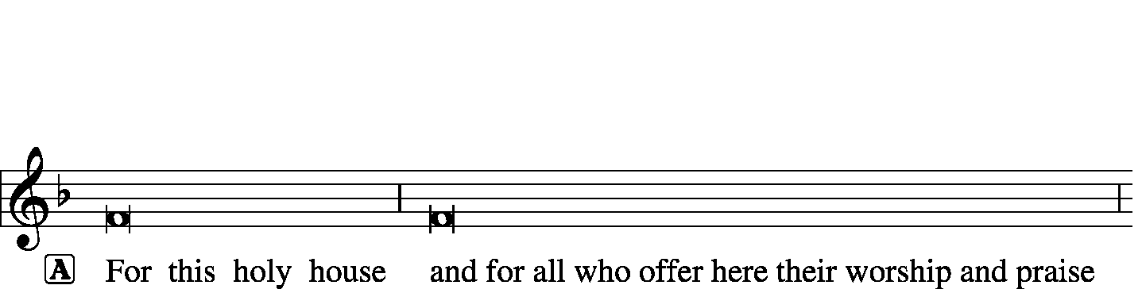



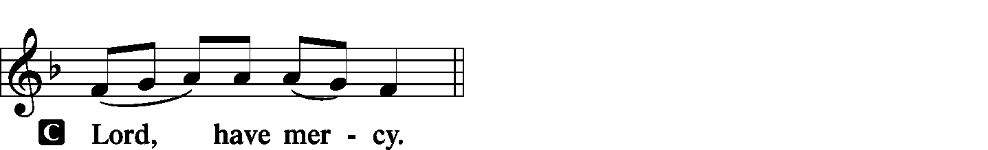

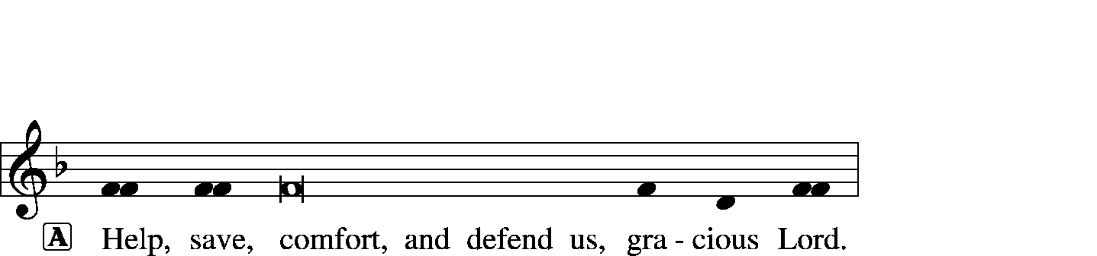



|  |  |  |  |
| --- | --- | --- | --- |
|  |  | | |
| HYMN OF PRAISE | | *Gloria in Excelsis* | Page 154 |
|  | |  |  |

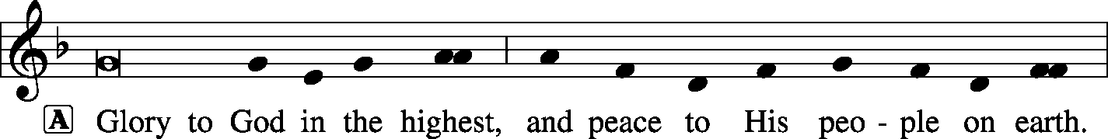

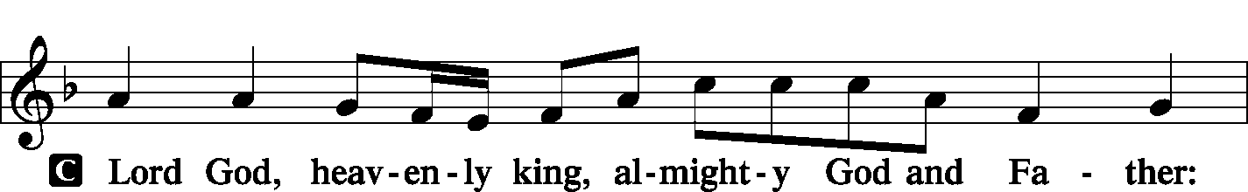

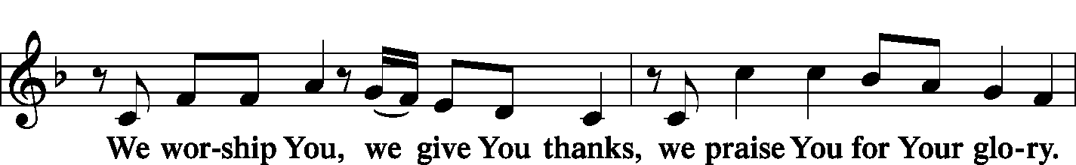

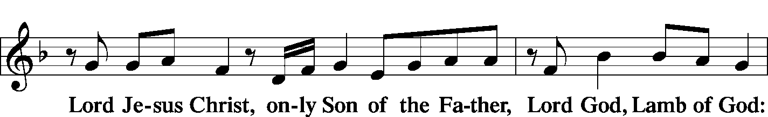

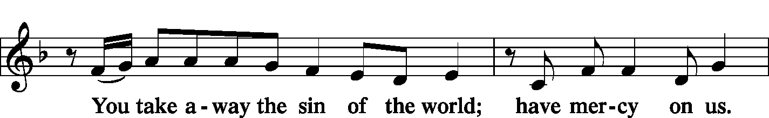

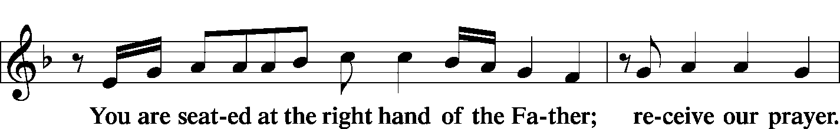

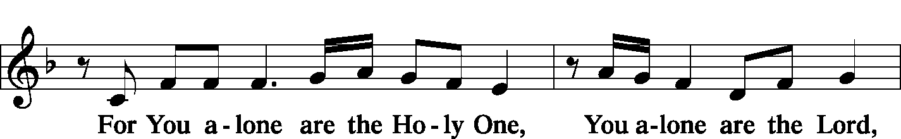

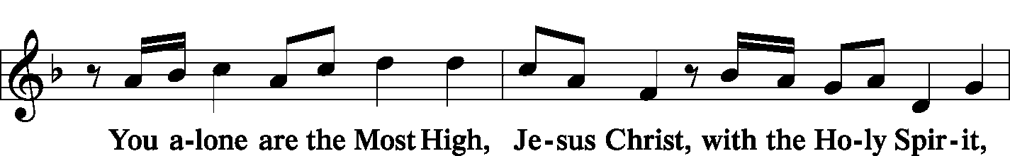

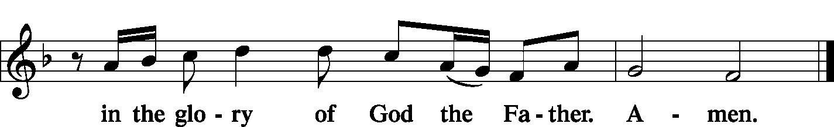

|  |  |  |
| --- | --- | --- |
|  |  | |
| SALUTATION | | *Page 156* |

|  |  |
| --- | --- |
|  |  |

|  |  |  |
| --- | --- | --- |
| COLLECT OF THE DAY | |  |
| P: | Let us pray. | |
| C: | O Son of God, our blessed Savior Jesus Christ, You called Matthew the tax collector to be an apostle and evangelist. Through his faithful and inspired witness, grant that we also may follow You, leaving behind all covetous desires and love of riches; for You live and reign with the Father and the Holy Spirit, one God, now and forever. Amen. | |
|  | |  |
| THE GOSPEL FOR YOUNGER FOLK | |  |
|  | |  |
| FIRST READING | | Ezekiel 2:8—3:11 |

8“But you, son of man, hear what I say to you. Be not rebellious like that rebellious house; open your mouth and eat what I give you.” 9And when I looked, behold, a hand was stretched out to me, and behold, a scroll of a book was in it. 10And he spread it before me. And it had writing on the front and on the back, and there were written on it words of lamentation and mourning and woe.

1And he said to me, “Son of man, eat whatever you find here. Eat this scroll, and go, speak to the house of Israel.” 2So I opened my mouth, and he gave me this scroll to eat. 3And he said to me, “Son of man, feed your belly with this scroll that I give you and fill your stomach with it.” Then I ate it, and it was in my mouth as sweet as honey.

4And he said to me, “Son of man, go to the house of Israel and speak with my words to them. 5For you are not sent to a people of foreign speech and a hard language, but to the house of Israel— 6not to many peoples of foreign speech and a hard language, whose words you cannot understand. Surely, if I sent you to such, they would listen to you. 7But the house of Israel will not be willing to listen to you, for they are not willing to listen to me. Because all the house of Israel have a hard forehead and a stubborn heart. 8Behold, I have made your face as hard as their faces, and your forehead as hard as their foreheads. 9Like emery harder than flint have I made your forehead. Fear them not, nor be dismayed at their looks, for they are a rebellious house.” 10Moreover, he said to me, “Son of man, all my words that I shall speak to you receive in your heart, and hear with your ears. 11And go to the exiles, to your people, and speak to them and say to them, ‘Thus says the Lord God,’ whether they hear or refuse to hear.”

|  |  |
| --- | --- |
|  |  |
| P: | This is the word of the Lord. |
| C: | Thanks be to God. |
|  |  |

|  |  |  |
| --- | --- | --- |
| PSALM | Psalm 119:33-40 | *(Sung responsively by verse)* |
|  |  |  |

Teach me, O Lord, the way of Your | statutes;*

and I will keep it | to the end.  
Give me understanding, that I may | keep Your law*

and observe it with my | whole heart.  
Lead me in the path of Your com- | mandments,*

for I de- | light in it.  
Incline my heart to Your testi- | monies,*

and not to | selfish gain!  
Turn my eyes from looking at | worthless things;*

and give me life | in Your ways.  
Confirm to Your servant Your | promise,*

that You | may be feared.  
Turn away the reproach | that I dread,*  
 for Your just de- | crees are good.  
Behold, I long for Your | precepts;*  
 in Your righteousness | give me life!

**Glory be to the Father and | to the Son\***

**and to the Holy | Spirit;**

**as it was in the be- | ginning,\***

**is now, and will be forever. | Amen.**

|  |  |  |  |
| --- | --- | --- | --- |
|  |  |  | |
| SECOND READING | | | Ephesians 4:7–16 |

17But grace was given to each one of us according to the measure of Christ’s gift. 8Therefore it says,

“When he ascended on high He led a host of captives, and He gave gifts to men.”

9(In saying, “He ascended,” what does it mean but that He had also descended into the lower parts of the earth? 10He who descended is the one Who also ascended far above all the heavens, that He might fill all things.) 11And He gave the apostles, the prophets, the evangelists, the pastors and teachers, 12to equip the saints for the work of ministry, for building up the body of Christ, 13until we all attain to the unity of the faith and of the knowledge of the Son of God, to mature manhood, to the measure of the stature of the fullness of Christ, 14so that we may no longer be children, tossed to and fro by the waves and carried about by every wind of doctrine, by human cunning, by craftiness in deceitful schemes. 15Rather, speaking the truth in love, we are to grow up in every way into Him Who is the head, into Christ, 16from Whom the whole body, joined and held together by every joint with which it is equipped, when each part is working properly, makes the body grow so that it builds itself up in love.

|  |  |  |
| --- | --- | --- |
|  |  | |
| P: | This is the word of the Lord. | |
| C: | Thanks be to God. | |
|  |  | |
| GOSPEL VERSE | | *Page 156* |

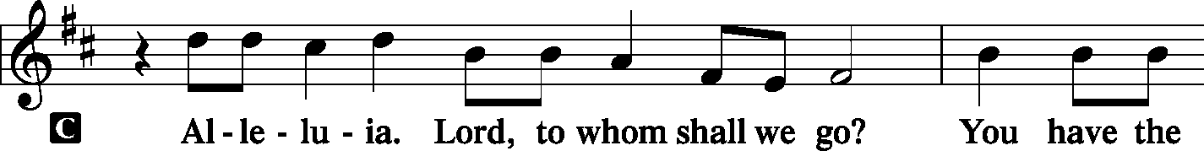

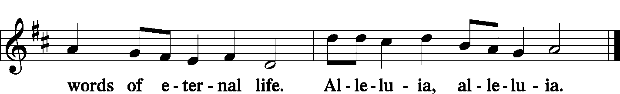

|  |  |  |
| --- | --- | --- |
|  | |  |
| INTRODUCTION | |  |
| P: | The Holy Gospel according to St. Matthew, the ninth chapter. | |
|  |  | |

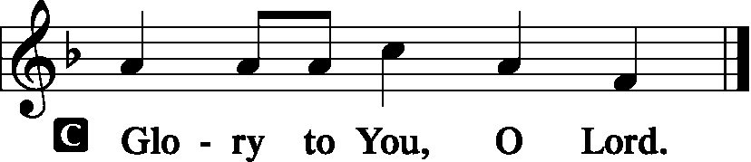

|  |  |
| --- | --- |
|  |  |
| GOSPEL LESSON | Matthew 9:9–13 |

9As Jesus passed on from there, He saw a man called Matthew sitting at the tax booth, and He said to him, “Follow Me.” And he rose and followed Him.

10And as Jesus reclined at table in the house, behold, many tax collectors and sinners came and were reclining with Jesus and His disciples. 11And when the Pharisees saw this, they said to His disciples, “Why does your teacher eat with tax collectors and sinners?” 12But when He heard it, He said, “Those who are well have no need of a physician, but those who are sick. 13Go and learn what this means, ‘I desire mercy, and not sacrifice.’ For I came not to call the righteous, but sinners.”

|  |  |
| --- | --- |
|  |  |
| P: | This is the Gospel of the Lord. |
|  |  |

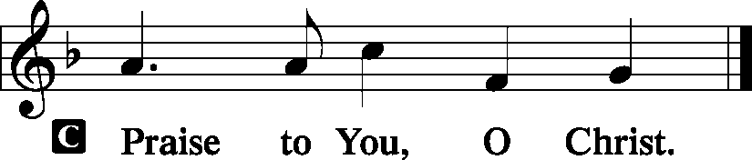

|  |  |  |  |  |  |  |  |  |
| --- | --- | --- | --- | --- | --- | --- | --- | --- |
|  | | |  | | | |  | |
| HYMN OF THE DAY | | | *LSB 688 Come Follow Me, the Savior Spake* | | | | | |
|  | | |  | | | |  | |
| SERMON | | |  | | | |  | |
| NICENE CREED | | | | *Page 158* | | | | |
| C: | I believe in one God, the Father Almighty, maker of heaven and earth and of all things visible and invisible.  And in one Lord Jesus Christ, the only-begotten Son of God, begotten of His Father before all worlds, God of God, Light of Light, very God of very God, begotten, not made, being of one substance with the Father, by Whom all things were made; Who for us men and for our salvation came down from heaven and was incarnate by the Holy Spirit of the virgin Mary and was made man; and was crucified also for us under Pontius Pilate. He suffered and was buried. And the third day He rose again according to the Scriptures and ascended into heaven and sits at the right hand of the Father. And He will come again with glory to judge both the living and the dead, Whose kingdom will have no end.  And I believe in the Holy Spirit, the Lord and giver of life, Who proceeds from the Father and the Son, Who with the Father and the Son together is worshiped and glorified, Who spoke by the prophets. And I believe in one holy Christian and apostolic Church, I acknowledge one Baptism for the remission of sins, and I look for the resurrection of the dead and the life **T** of the world to come. Amen. | | | | | | | |
|  |  | | | | | | | |
| PRAYER OF THE CHURCH | | | | | *Page 159* | | | |
|  | | | | |  | | | |
| OFFERTORY | | *What Shall I Render to the Lord*  Psalm 116 | | | | | | *Pages 159-60* |
|  | |  | | | |  | | |

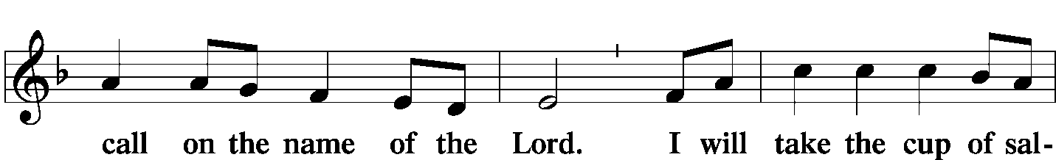

|  |  |  |  |  |  |
| --- | --- | --- | --- | --- | --- |
|  |  | | | |  |
| Hymn | | *LSB 550 Lamb of God* | | | |
|  | |  | |  | |
| PREFACE | | | Page 160 | | |
|  | | |  | | |

|  |  |  |  |  |
| --- | --- | --- | --- | --- |
|  | | |  | |
| PROPER PREFACE | | |  | |
| P: | It is truly good, right, and salutary that we should at all times and in all places give thanks to You, holy Lord, almighty Father, everlasting God; for You have mightily governed and protected Your holy Church, in which the blessed apostles and evangelists proclaimed Your divine and saving Gospel. Therefore with patriarchs and prophets, apostles and evangelists, with Your servant Matthew, and with all the company of heaven we laud and magnify Your glorious name, evermore praising You and singing: | | | |
|  |  | | | |
| SANCTUS | | *Holy, Holy, Holy Lord* | | *Page 161* |
|  | |  | |  |

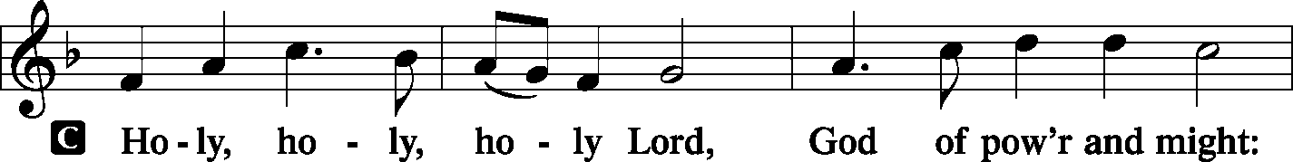

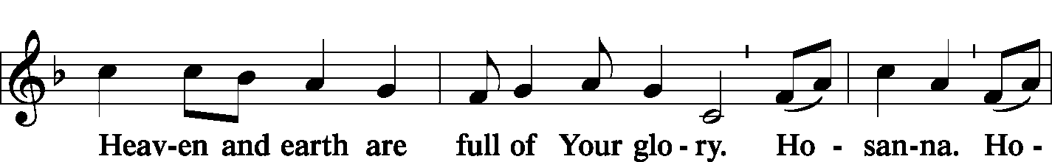

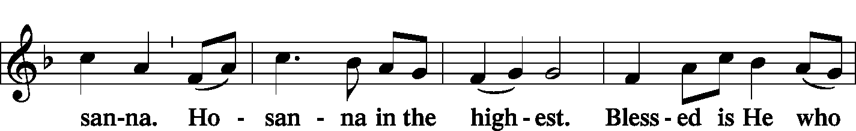

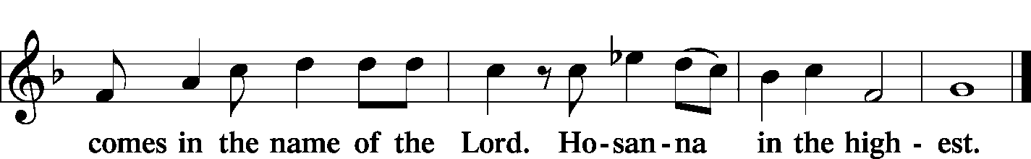

|  |  |  |  |  |  |  |  |  |  |
| --- | --- | --- | --- | --- | --- | --- | --- | --- | --- |
|  | |  | | | | |  | | |
| PRAYER OF THANKSGIVING | | | | | |  | *Page 161* | | |
| P: | Blessed are You, Lord of heaven and earth, for You have had mercy on those whom You created and sent Your only-begotten Son into our flesh to bear our sin and be our Savior. With repentant joy we receive the salvation accomplished for us by the all-availing sacrifice of His body and His blood on the cross.  Gathered in the name and the remembrance of Jesus, we beg You, O Lord, to forgive, renew, and strengthen us with Your Word and Spirit. Grant us faithfully to eat His body and drink His blood as He bids us do in His own testament. Gather us together, we pray, from the ends of the earth to celebrate with all the faithful the marriage feast of the Lamb in His kingdom, which has no end. Graciously receive our prayers; deliver and preserve us. To You alone, O Father, be all glory, honor, and worship, with the Son and the Holy Spirit, one God, now and forever. | | | | | | | | |
| C: | Amen. | | | | | | | | |
|  | | | | |  | | | | |
| LORD’S PRAYER | | | | | Page 162, Right Column | | | | |
| P: | Lord, remember us in Your kingdom and teach us to pray: | | | | | | | | |
| C: | Our Father Who art in heaven, hallowed be Thy name, Thy kingdom come, Thy will be done on earth as it is in heaven; give us this day our daily bread; and forgive us our trespasses as we forgive those who trespass against us; and lead us not into temptation, but deliver us from evil. For Thine is the kingdom and the power and the glory forever and ever. Amen. | | | | | | | | |
|  | | | |  | | | | | |
| WORDS OF OUR LORD | | | | *(Words of Institution)* | | | | | |
| P: | Our Lord Jesus Christ, on the night when He was betrayed, took bread, and when He had given thanks, He broke it and gave it to the disciples and said: “Take, eat; this is My T body, which is given for you. This do in remembrance of Me.”  In the same way also He took the cup after supper, and when He had given thanks, He gave it to them, saying: “Drink of it, all of you; this cup is the new testament in My T blood, which is shed for you for the forgiveness of sins. This do, as often as you drink it, in remembrance of Me.” | | | | | | | | |
|  | | |  | | | | |  | |
| PAX DOMINI | | | *The Peace of the Lord* | | | | | | *Page 163* |
|  | | |  | | | | |  | |

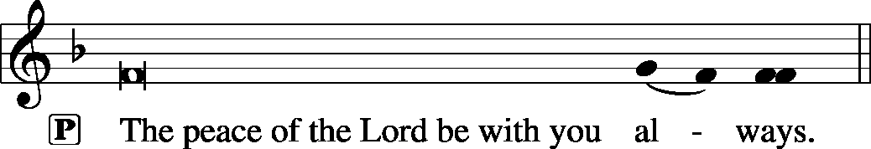



|  |  |  |
| --- | --- | --- |
|  |  |  |

|  |  |  |
| --- | --- | --- |
| AGNUS DEI | *Lamb of God* | *Page 163* |

|  |  |  |  |  |  |
| --- | --- | --- | --- | --- | --- |
|  | | |  | |  |
|  | *Prayer before Communing: Dear Savior, at Your gracious invitation I come to Your table to eat and drink Your holy body and blood. Let me find favor in Your eyes to receive this holy Sacrament in faith for the salvation of my soul and to the glory of Your holy name; for You live and reign with the Father and the Holy Spirit, one God, now and forever. Amen.* | | | | |
|  |  | | | | |
|  | *Thanksgiving after Receiving the Sacrament: Almighty and everlasting God, I thank and praise You for feeding me the life-giving body and blood of Your beloved Son, Jesus Christ. Send Your Holy Spirit that, having with my mouth received the holy Sacrament, I may by faith obtain and eternally enjoy Your divine grace, the forgiveness of sins, unity with Christ, and life eternal; through Jesus Christ, my Lord. Amen.* | | | | |
|  |  | | | | |
| DISTRIBUTION | | | |  | |
|  | *LSB* | *619 Thy Body, Given for Me, O Savior* | | | |
|  | *LSB* | *652 Father, We Thank Thee* | | | |
|  |  |  | | | |
| POST-COMMUNION BLESSING | | | | | |
| P: | May the true Body of our Lord Jesus Christ, and His most precious Blood, strengthen you in true faith, granting you the forgiveness of sins, unto life everlasting. Depart in Peace. | | | | |
| C: | Amen. | | | | |
|  |  | | | | |

|  |  |  |
| --- | --- | --- |
| POST-COMMUNION CANTICLE | *Nunc Dimittis – Song of Simeon*  *Lord, Now You Let Your Servant* | Page 165 |
|  |  |  |

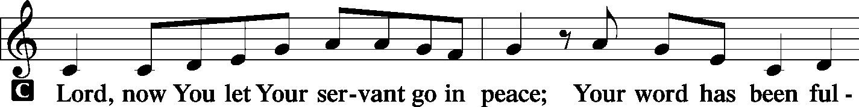

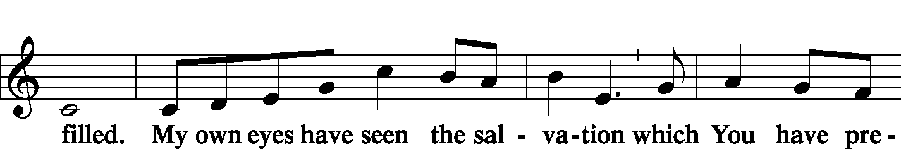

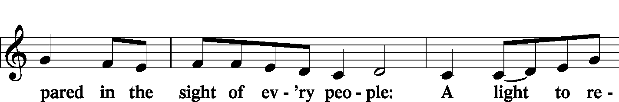

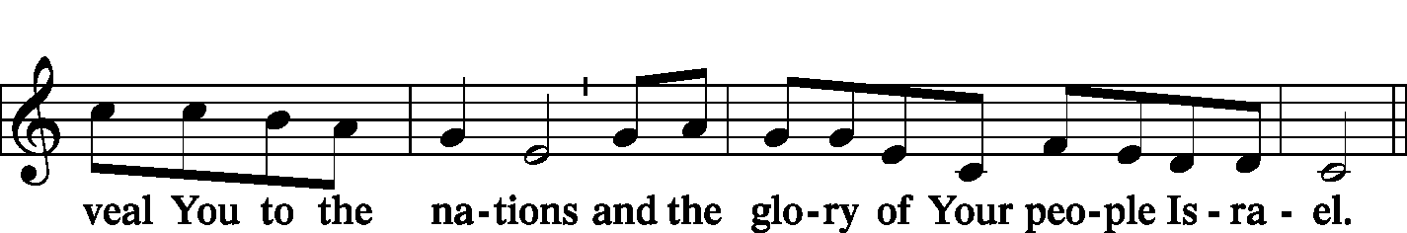

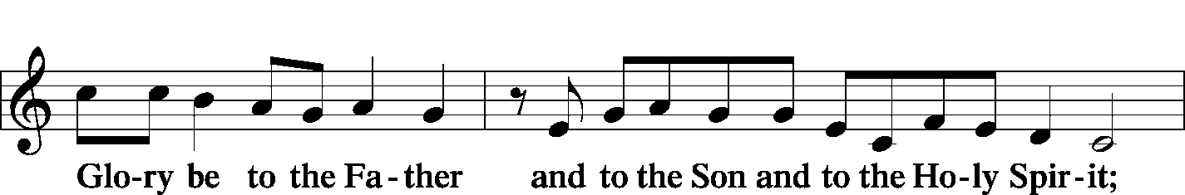

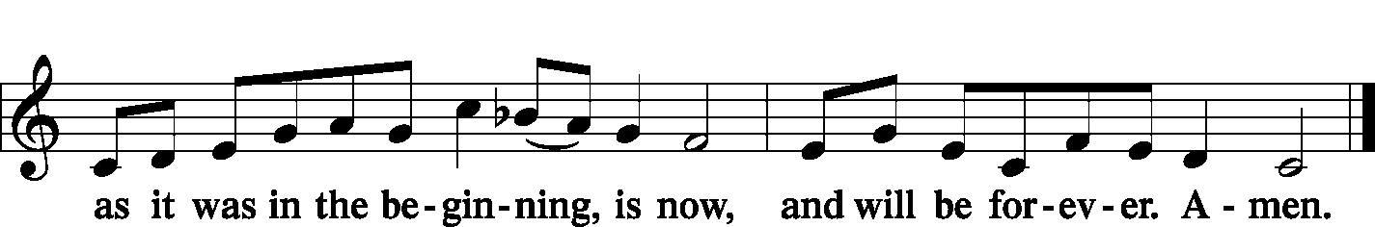

|  |  |  |  |
| --- | --- | --- | --- |
| POST-COMMUNION COLLECT | |  | Page 166 |
| P: | Let us pray.  We give thanks to You, almighty God, that You have refreshed us through this salutary gift, and we implore You that of Your mercy You would strengthen us through the same in faith toward You and in fervent love toward one another; through Jesus Christ, Your Son, our Lord, Who lives and reigns with You and the Holy Spirit, one God, now and forever. | | |
| C: | **Amen.** | |
|  |  | |

|  |  |  |
| --- | --- | --- |
| BENEDICTION |  | Page 166 |
|  |  |  |

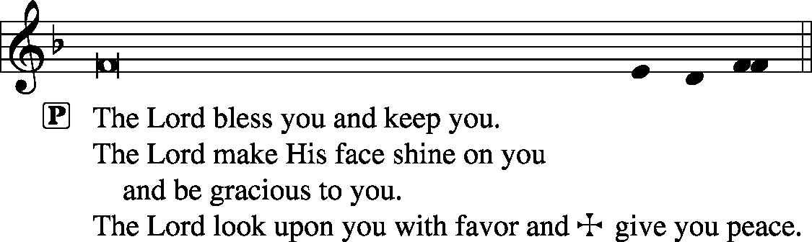



|  |  |  |  |  |  |
| --- | --- | --- | --- | --- | --- |
|  | | |  | |  |
| CLOSING HYMN | | *LSB 643 Sent Forth by God’s Blessing* | | | |
|  | |  | |  | |
| SILENT PRAYER | |  | |  | |
|  | *Almighty and merciful God, I have again worshiped in Your presence and received both forgiveness for my many sins and the assurance of Your love in Jesus Christ. I thank You for this undeserved grace and ask You to keep me in faith until, with all Your saints, I inherit eternal salvation; through Jesus Christ, my Lord. Amen.* | | | | |
|  |  | | | | |
| ANNOUNCEMENTS | | | | | |
|  | | | | | |
| POSTLUDE | | | | | |

T T T

Acknowledgments

Divine Service, Setting One from Lutheran Service Book

Unless otherwise indicated, all scripture quotations are from *The Holy Bible, English Standard Version*, copyright © 2001 by Crossway Bibles, a division of Good News Publishers. Used by permission. All rights reserved.

Created by Lutheran Service Builder © 2006 Concordia Publishing House.

|  |  |  |
| --- | --- | --- |
| PASTOR |  | The Rev. Barry Long |
| ELDER | - | Phil King |
| ORGANIST |  | Carol Wessler |