Third Sunday in Advent
December 14, 2025, 2025
+ The Order of Matins +
Lutheran Service Book – Pages 219-228

Prayer Before Worship
O Lord, my Creator, Redeemer, and Comforter, as I come to worship You in spirit and in truth, I humbly pray that You would open my heart to the preaching of Your Word so that I may repent of my sins, believe in Jesus Christ as my only Savior, and grow in grace and holiness. Hear me for the sake of His name. Amen.
PRELUDE
RINGING BELL CALLS US TO WORSHIP
WELCOME
OPENING HYMN |  | LSB 347 Comfort, Comfort Ye My People
CONFESSION AND ABSOLUTION |  |  | Page 151
P: | In the name of the Father and of the T Son and of the Holy Spirit.
C: | Amen.
P: | If we say we have no sin, we deceive ourselves, and the truth is not in us.
C: | But if we confess our sins, God, Who is faithful and just, will forgive our sins and cleanse us from all unrighteousness.
 | (Silence for reflection on God’s Word and for self-examination.)
P: | Let us then confess our sins to God our Father.
C: | Most merciful God, we confess that we are by nature sinful and unclean. We have sinned against You in thought, word, and deed, by what we have done and by what we have left undone. We have not loved You with our whole heart; we have not loved our neighbors as ourselves. We justly deserve Your present and eternal punishment. For the sake of Your Son, Jesus Christ, have mercy on us. Forgive us, renew us, and lead us, so that we may delight in Your will and walk in Your ways to the glory of Your holy name. Amen.
P: | Almighty God in His mercy has given His Son to die for you and for His sake forgives you all your sins. As a called and ordained servant of Christ, and by His authority, I therefore forgive you all your sins in the name of the Father and of the T Son and of the Holy Spirit.
C: | Amen.
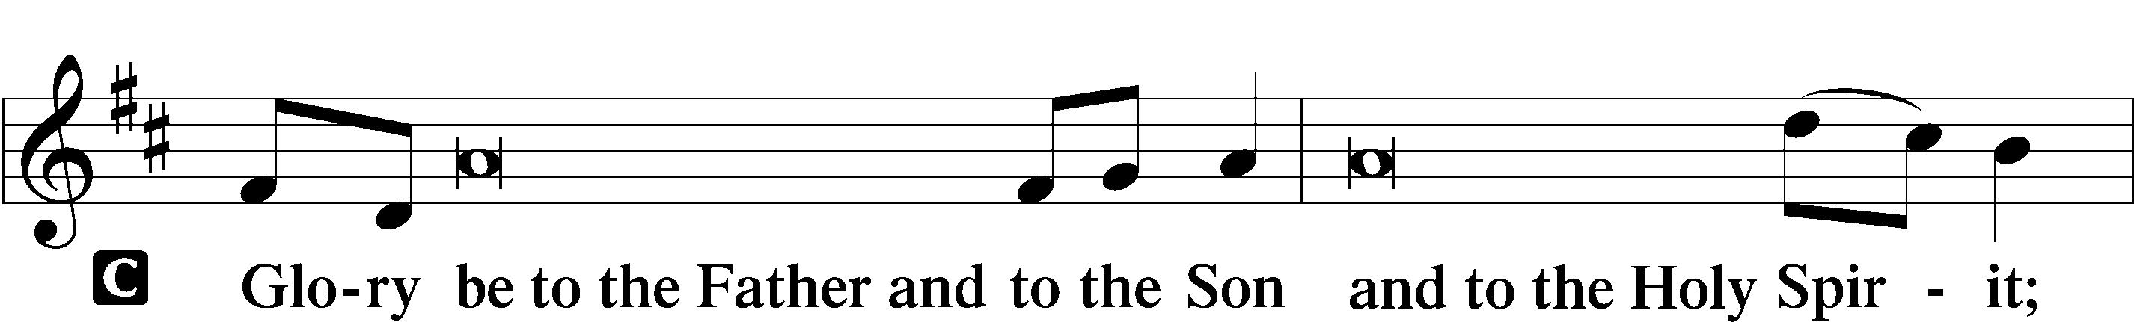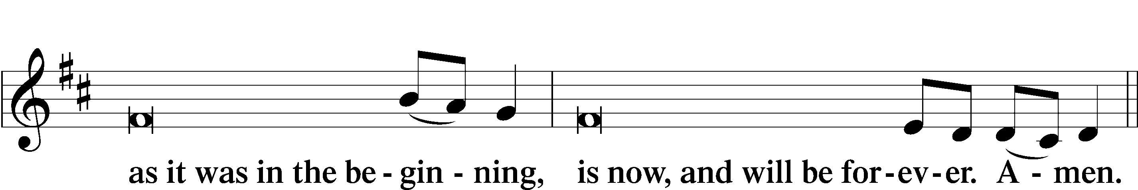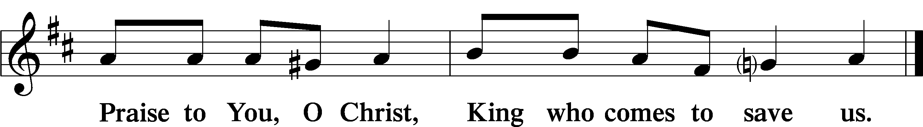

PSALMODY |  | Venite | O Come, Let Us Sing
 | Antiphon
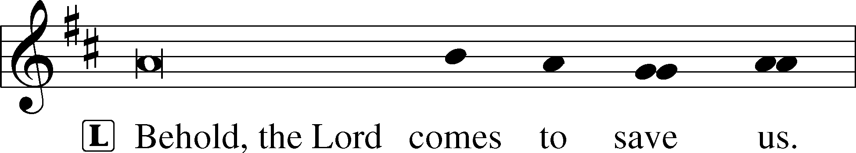


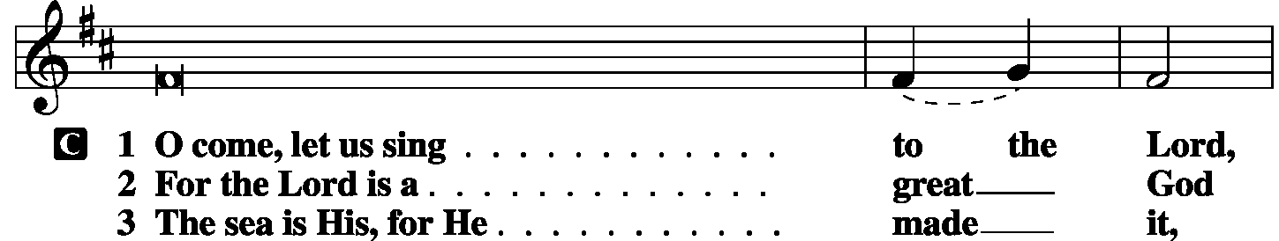
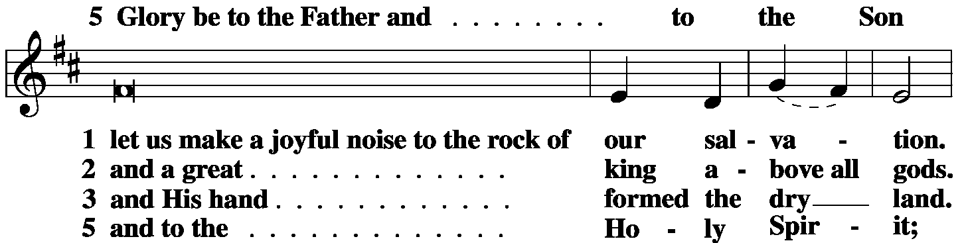
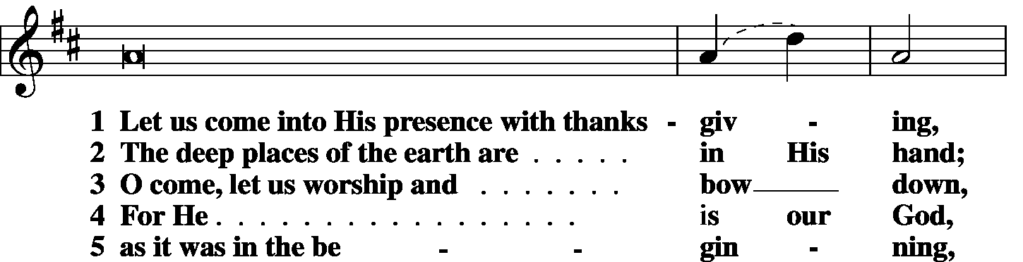
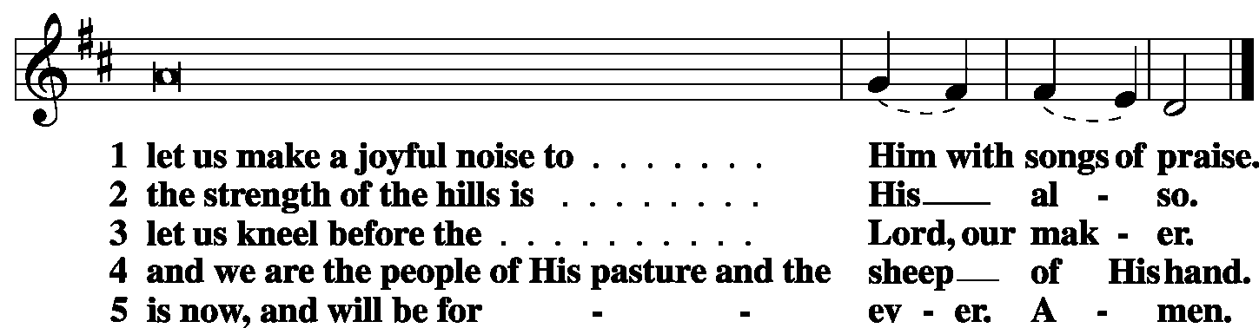

 | Second Psalm | Psalm 146 | (Sung responsively by verse)

Praise | the Lord!*
Praise the Lord, | O my soul!
I will praise the Lord as long | as I live;*
I will sing praises to my God while I have my | being.
Put not your trust in | princes,*
in a son of man, in whom there is no sal- | vation.
When his breath departs he returns | to the earth;*
on that very day his plans | perish.
Blessèd is he whose help is the God of | Jacob,*
whose hope is in the | Lord his God,
Who made heaven and earth, the sea, and all that is | in them,*
Who keeps faith for- | ever;
Who executes justice for | the oppressed,*
Who gives food to the | hungry.
the Lord opens the eyes | of the blind.*
The Lord sets the prisoners free; The Lord lifts up those
who are bowed down; the Lord loves the | righteous.
The Lord watches over the sojourners; He upholds the widow
and the | fatherless,*
but the way of the wicked He brings to | ruin.
The Lord will reign for- | ever,*
your God, O Zion, to all generations. | Praise the Lord!
Glory be to the Father and | to the Son*
and to the Holy | Spirit;
as it was in the be- | ginning,*
is now, and will be forever. | Amen.
LIGHTING OF THE ADVENT CANDLE: JOY
P: | Rejoice in the Lord always, again I will say, rejoice!
C: | Lord you have been favorable to Your land; You have brought back the captivity of Jacob.
P: | Behold, the name of the Lord comes from far;
C: | Let the whole earth be filled with His glory.
P: | Out of Zion, the perfection of beauty, God has shined;
C: | Our God shall come.
P: | As we wait to celebrate Christmas,
C: | We also wait for the glorious day of our Lord’s return.
P: | As the faithful waited with joy for the coming of the Messiah;
C: | So we wait with joy for His return.
P: | Let us then remember all God’s promises, and light this candle as a sign;
C: | A sign of joy because He is with us even as we wait to see His glory; for in Him is life, and that life is the light of all.
P: | Let us pray:  Gracious Savior, in this time of waiting, bring us the joy that comes from knowing You as our Lord and King, our Savior and Redeemer. Let our minds be set upon Your life, Your love, and Your mercy. Let us prepare to greet you with repentant hearts and watchful eyes; anticipating the joy You have promised to all whom You redeem. We ask this in Your blessed name.
C: | Amen.
 | (the candle is lighted)
OFFICE HYMN |  | LSB 333 Once He Came in Blessing
THE GOSPEL FOR YOUNG FOLK
FIRST LESSON |  |  |  | Isaiah 35:1-10
¹The wilderness and the dry land shall be glad;
the desert shall rejoice and blossom like the crocus;
²it shall blossom abundantly
and rejoice with joy and singing.
The glory of Lebanon shall be given to it,
the majesty of Carmel and Sharon.
They shall see the glory of the Lord,
the majesty of our God.
³Strengthen the weak hands,
and make firm the feeble knees.
⁴Say to those who have an anxious heart,
“Be strong; fear not!
Behold, your God
will come with vengeance,
with the recompense of God.
He will come and save you.”
⁵Then the eyes of the blind shall be opened,
and the ears of the deaf unstopped;
⁶then shall the lame man leap like a deer,
and the tongue of the mute sing for joy.
For waters break forth in the wilderness,
and streams in the desert;
⁷the burning sand shall become a pool,
and the thirsty ground springs of water;
in the haunt of jackals, where they lie down,
the grass shall become reeds and rushes.
⁸And a highway shall be there,
and it shall be called the Way of Holiness;
the unclean shall not pass over it.
It shall belong to those who walk on the way;
even if they are fools, they shall not go astray.
⁹No lion shall be there,
nor shall any ravenous beast come up on it;
they shall not be found there,
but the redeemed shall walk there.
¹⁰And the ransomed of the Lord shall return
and come to Zion with singing;
everlasting joy shall be upon their heads;
they shall obtain gladness and joy,
and sorrow and sighing shall flee away.
P: | O Lord, have mercy on us.
C: | Thanks be to God.

SECOND LESSON | James 5:7-11
⁷Be patient, therefore, brothers, until the coming of the Lord. See how the farmer waits for the precious fruit of the earth, being patient about it, until it receives the early and the late rains. ⁸You also, be patient. Establish your hearts, for the coming of the Lord is at hand. ⁹Do not grumble against one another, brothers, so that you may not be judged; behold, the Judge is standing at the door. ¹⁰As an example of suffering and patience, brothers, take the prophets who spoke in the name of the Lord. ¹¹Behold, we consider those blessed who remained steadfast. You have heard of the steadfastness of Job, and you have seen the purpose of the Lord, how the Lord is compassionate and merciful.
P: | O Lord, have mercy on us.
C: | Thanks be to God.
GOSPEL VERSE |  | Matthew 11:10b
P: | Alleluia. Behold, I send my messenger before your face,
C: | who will prepare your way before you. Alleluia.
HOLY GOSPEL |  | Matthew 11:2-15
P: | The Holy Gospel according to St. Matthew, the eleventh chapter.
C: | Glory to You, O Lord.
²When John heard in prison about the deeds of the Christ, he sent word by his disciples ³and said to Him, “Are you the one who is to come, or shall we look for another?” ⁴And Jesus answered them, “Go and tell John what you hear and see: ⁵the blind receive their sight and the lame walk, lepers are cleansed and the deaf hear, and the dead are raised up, and the poor have good news preached to them. ⁶And blessed is the one who is not offended by Me.”
⁷As they went away, Jesus began to speak to the crowds concerning John: “What did you go out into the wilderness to see? A reed shaken by the wind? ⁸What then did you go out to see? A man dressed in soft clothing? Behold, those who wear soft clothing are in kings’ houses. ⁹What then did you go out to see? A prophet? Yes, I tell you, and more than a prophet. ¹⁰This is he of whom it is written,
“ ‘Behold, I send my messenger before your face,
who will prepare your way before you.’
¹¹Truly, I say to you, among those born of women there has arisen no one greater than John the Baptist. Yet the one who is least in the kingdom of heaven is greater than he. ¹²From the days of John the Baptist until now the kingdom of heaven has suffered violence, and the violent take it by force. ¹³For all the Prophets and the Law prophesied until John, ¹⁴and if you are willing to accept it, he is Elijah who is to come. ¹⁵He who has ears to hear, let him hear.”

P: | This is the Gospel of the Lord.
C: | Praise to You, O Christ.
RESPONSORY
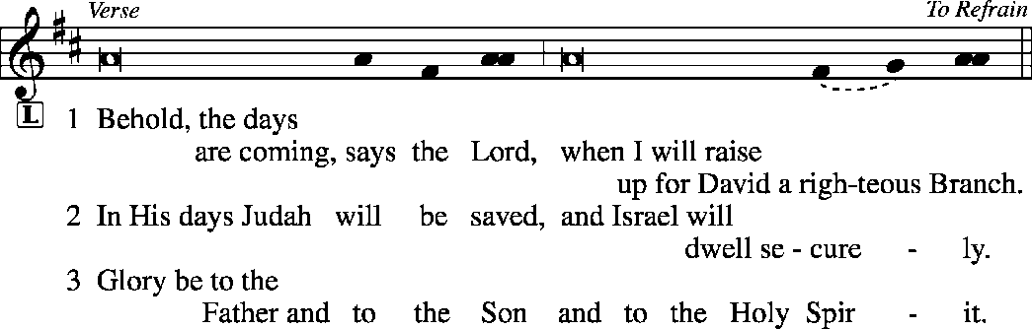
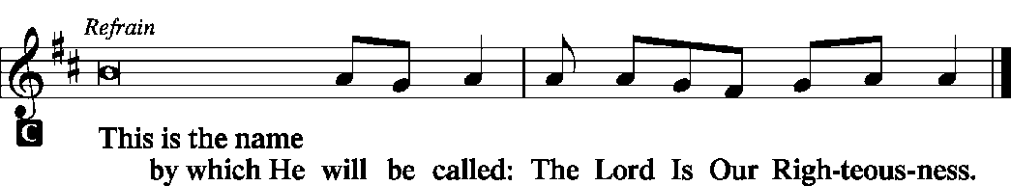
HYMN OF THE DAY |  | LSB 349 Hark, the Glad Sound
SERMON
CANTICLE | Te Deum (We Praise You O God) |  |  | LSB p. 223
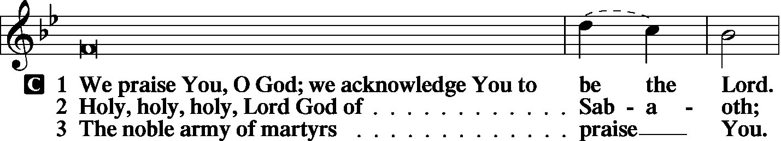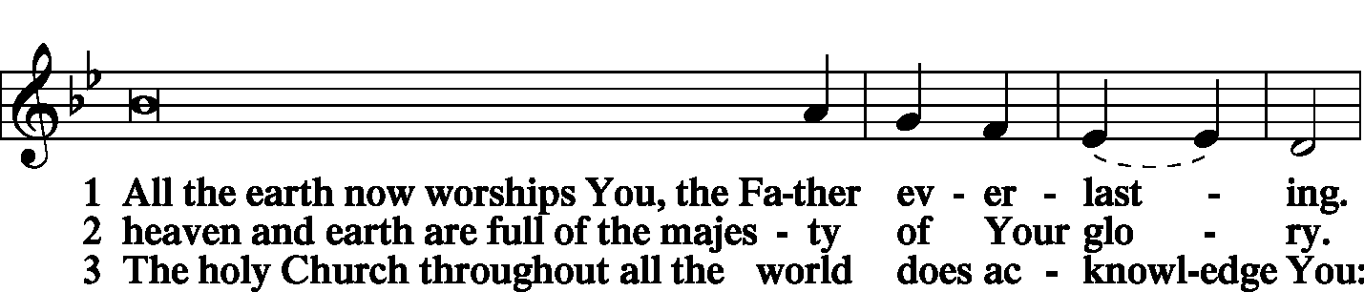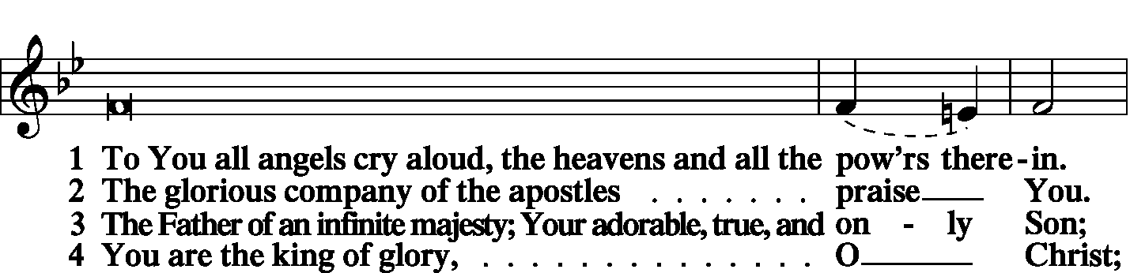
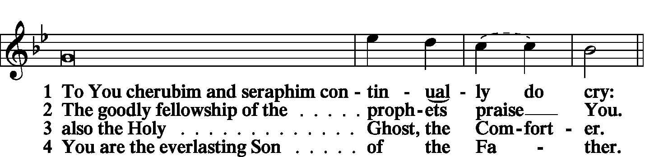
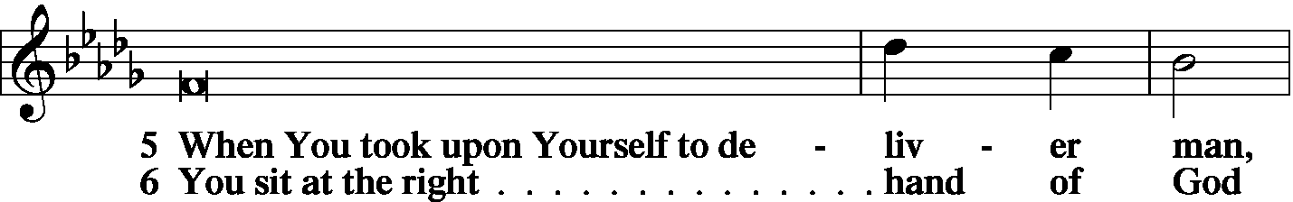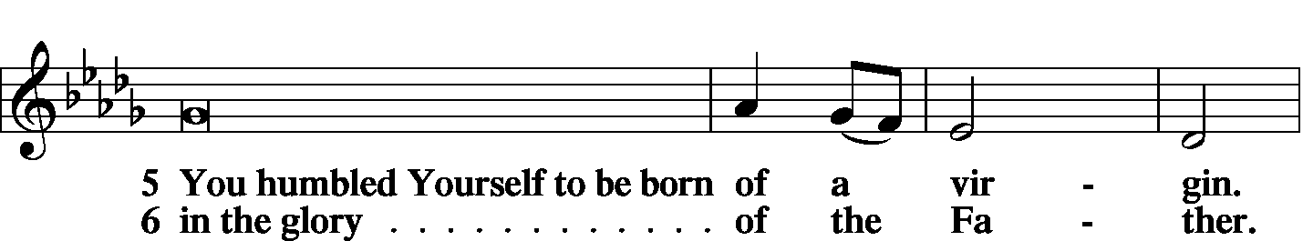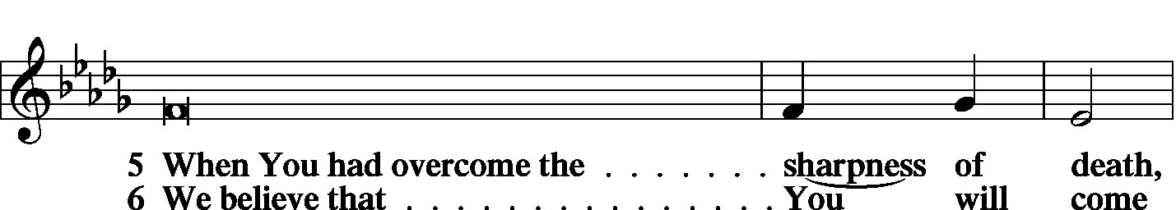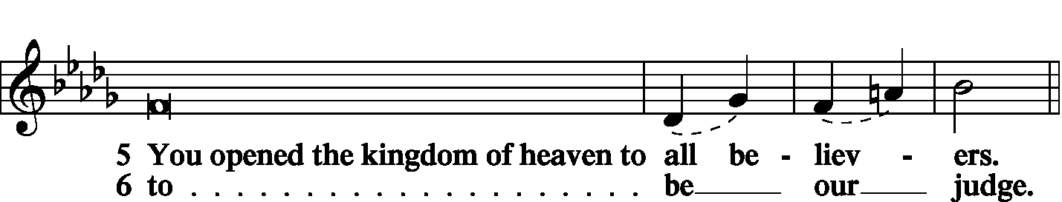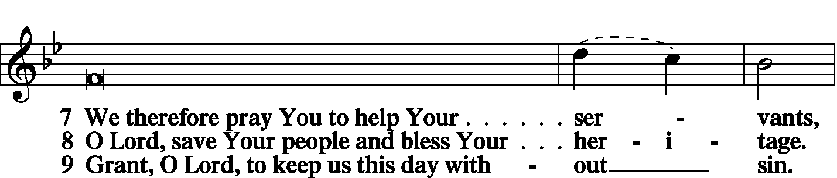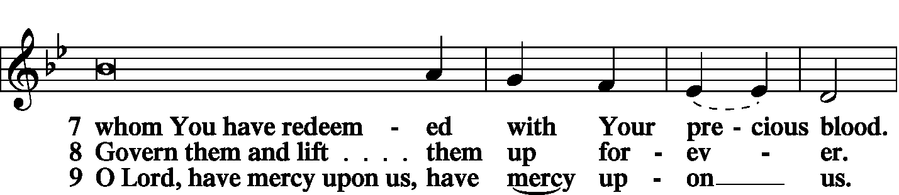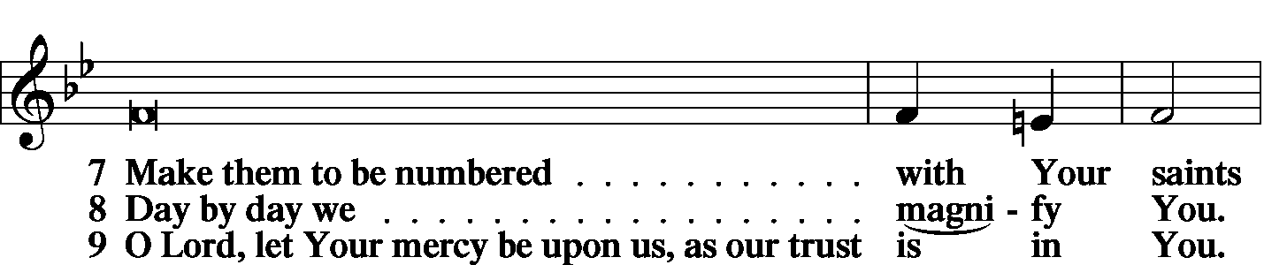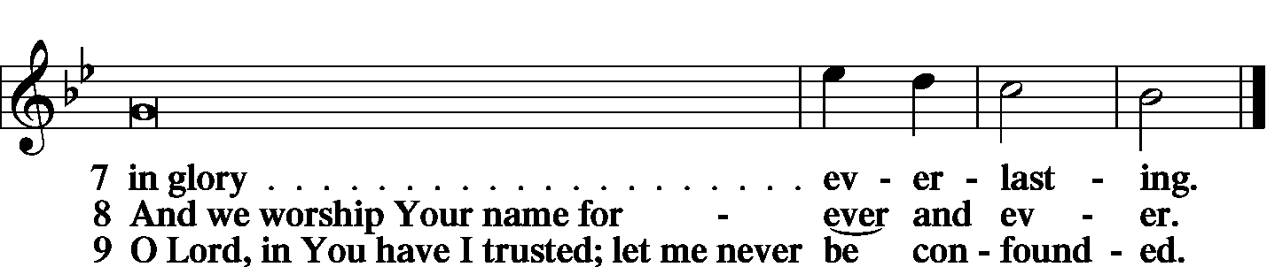
PRAYER OF THE CHURCH
KYRIE
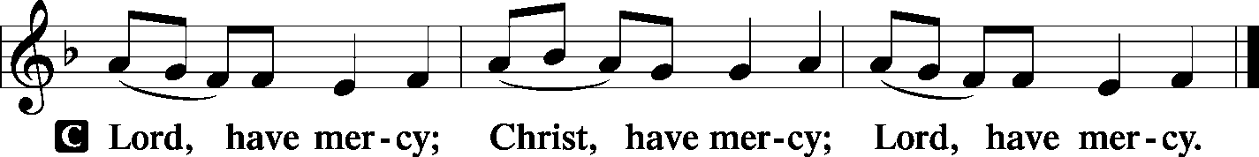
LORD’S PRAYER
C: | Our Father Who art in heaven, hallowed be Thy name, Thy kingdom come, Thy will be done on earth as it is in heaven; give us this day our daily bread; and forgive us our trespasses as we forgive those who trespass against us; and lead us not into temptation, but deliver us from evil. For Thine is the kingdom and the power and the glory forever and ever. Amen.
Collects:
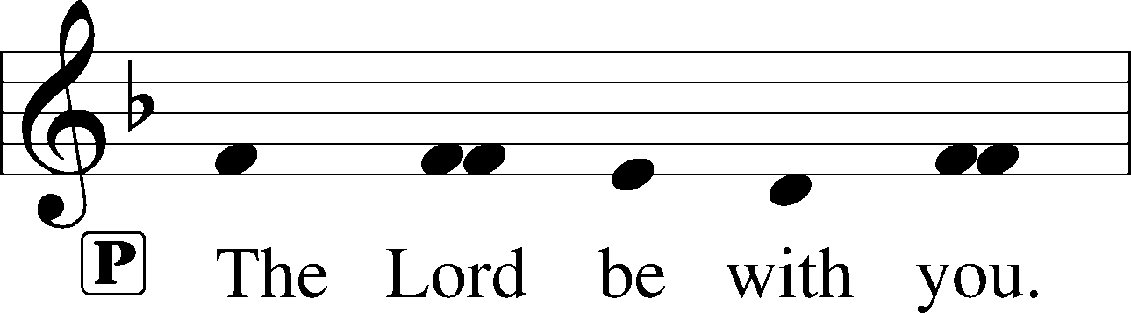
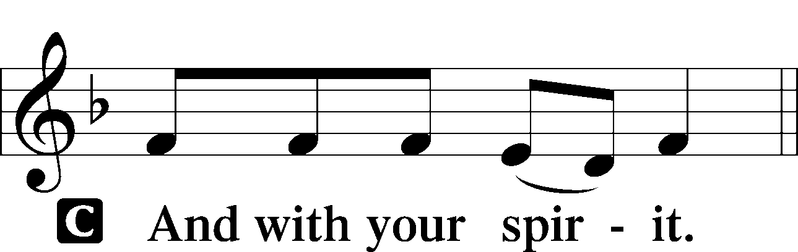

Collect of the Day:
P: | Lord Jesus Christ, we implore You to hear our prayers and to lighten the darkness of our hearts by Your gracious visitation through Jesus Christ our Lord,

Collect for Matins
P: | Almighty God, heavenly Father, Your mercies are new to us every morning, and You abundantly provide for all our wants of body and soul. Give us we humbly pray, Your Holy Spirit that we may heartily acknowledge Your merciful goodness toward us, give thanks for all Your benefits, and cheerfully serve You.
For Guidance in Our Calling |  | LSB p. 311
P: | Lord God, You have called Your servants to ventures of which we cannot see the ending, by paths as yet untrodden, through perils unknown. Give us faith to go out with good courage, not knowing where we go but only that Your hand is leading us and Your love supporting us; through Jesus Christ, our Lord.
For Responsible Citizenship |  | LSB p.313
P: | Lord, keep this nation under Your care. Bless the leaders of our land that we may be a people at peace among ourselves and a blessing to the other nations of the earth. Grant that we may choose trustworthy leaders, contribute to wise decisions for the general welfare, and serve You faithfully in our generation; through Jesus Christ, our Lord.

Collect for Grace |  | LSB p.228
P: | O Lord, our heavenly Father, almighty and everlasting God, You have safely brought us to the beginning of this day. Defend us in the same with Your mighty power and grant that this day we fall into no sin, neither run into any kind of danger, but that all our doings, being ordered by Your governance, may be righteous in Your sight; through Jesus Christ, Your Son, our Lord, Who lives and reigns with You and the Holy Spirit, one God, now and forever.
BENEDICAMUS |  | LSB p. 227
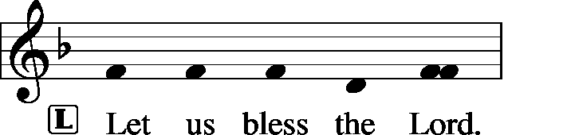
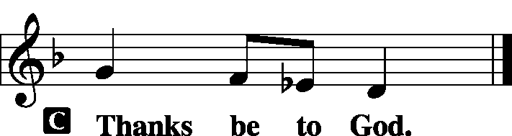
BENEDICTION
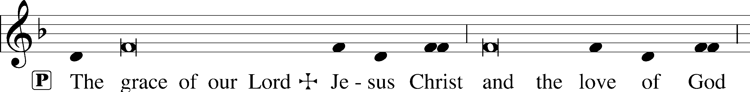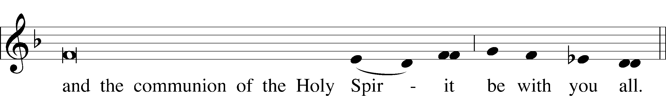
CLOSING HYMN | LSB 352 Let the Earth Now Praise the Lord

SILENT PRAYER
Almighty and merciful God, I have again worshiped in Your presence and received both forgiveness for my many sins and the assurance of Your love in Jesus Christ. I thank You for this undeserved grace and ask You to keep me in faith until, with all Your saints, I inherit eternal salvation; through Jesus Christ, my Lord. Amen.
T T T
Pastor: The Rev. Barry Long
Elder: Gary Beenders
Organist: Carol Wessler

Acknowledgments
Matins from Lutheran Service Book
Unless otherwise indicated, all scripture quotations are from The Holy Bible, English Standard Version, copyright © 2001 by Crossway Bibles, a division of Good News Publishers. Used by permission. All rights reserved.
Created by Lutheran Service Builder © 2006 Concordia Publishing House.

