Fourth Sunday of Advent – Festival of St. Thomas, Apostle
December 21, 2025
Divine Service I/Holy Communion
LSB Page 151
REGISTRATION FOR HOLY COMMUNION
Members of Mt. Calvary and visitors, who are confirmed members in good standing of congregations of the Lutheran Church-Missouri Synod, are asked to announce attendance at Holy Communion by means of the registration cards in the pews. Non-member visitors and guests, who may desire to attend Holy Communion, are asked to speak in person with the pastor before doing so. Those who desire a blessing, but choose not to commune, may come forward and simply cross their hands over their chest.
In accord with Holy Scripture, our church teaches that Holy Communion is open only to those who: (1) have been baptized in the name of the Triune God; Matt. 28:19, Acts 2:41-42; (2) are able to examine themselves both as to what this meal is and also its purpose; 1 Cor. 11:26-30; (3) have confessed and repented of their sins; 1 John 1:8-2:3; (4) believe that in, with, and under the bread and wine all communicants receive the true body and blood of our Lord Jesus Christ for the forgiveness of sins: 1 Cor. 11:23-27, 1 Cor. 10:16, Matt. 26:26-28; and who (5) are united in belief in the same teaching: 1 Cor. 10:17, Rom. 16:18, 2 John 10-11, Matt. 28:20, Heb. 13:9.

Looking for extra help in focusing your thoughts for the Lord’s Supper? “Christian Questions with Their Answers” was prepared by Luther to address just that. They can be found in your hymnal on pages 329-330. Review them if you get to church early, or during the offering, or if you are waiting to be invited forward.

Prayer before Worship:
O Lord, my Creator, Redeemer, and Comforter, as I come to worship You in spirit and in truth, I humbly pray that You would open my heart to the preaching of Your Word so that I may repent of my sins, believe in Jesus Christ as my only Savior, and grow in grace and holiness. Hear me for the sake of His name. Amen.
PRELUDE
RINGING BELL CALLS US TO WORSHIP
WELCOME

OPENING HYMN |  | LSB 357 O Come, O Come, Emmanuel
CONFESSION AND ABSOLUTION |  |  |  | Page 151
P: | In the name of the Father and of the T Son and of the Holy Spirit.
C: | Amen.
P: | If we say we have no sin, we deceive ourselves, and the truth is not in us.
C: | But if we confess our sins, God, Who is faithful and just, will forgive our sins and cleanse us from all unrighteousness.
 | (Silence for reflection on God’s Word and for self-examination.)
P: | Let us then confess our sins to God our Father.
C: | Most merciful God, we confess that we are by nature sinful and unclean. We have sinned against You in thought, word, and deed, by what we have done and by what we have left undone. We have not loved You with our whole heart; we have not loved our neighbors as ourselves. We justly deserve Your present and eternal punishment. For the sake of Your Son, Jesus Christ, have mercy on us. Forgive us, renew us, and lead us, so that we may delight in Your will and walk in Your ways to the glory of Your holy name. Amen.
P: | Almighty God in His mercy has given His Son to die for you and for His sake forgives you all your sins. As a called and ordained servant of Christ, and by His authority, I therefore forgive you all your sins in the name of the Father and of the T Son and of the Holy Spirit.
C: | Amen.
INTROIT |  |  | Psalm 130:5–8; antiphon: Isaiah 64:1
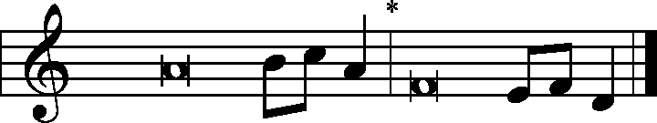
Oh that You would rend the heavens | and come down,*
that the mountains might quake at Your | presence.
I wait for the Lord, my | soul waits,*
and in HIs | word I hope;
my soul waits for the Lord more than watchmen for the | morning,*
more than watchmen for the | morning.
O Israel, hope in the Lord! For with the Lord there is | steadfast love,*
and with Him is plentiful re- | demption.
And He will redeem | Israel*
from all His in- | iquities.
Glory be to the Father and | to the Son*
and to the Holy | Spirit;
as it was in the be- | ginning,*
is now, and will be forever. | Amen.
Oh that you would rend the heavens | and come down,*
that the mountains might quake at your | presence.
KYRIE | Pages 152-53
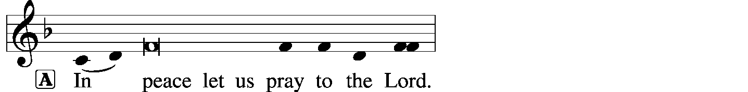
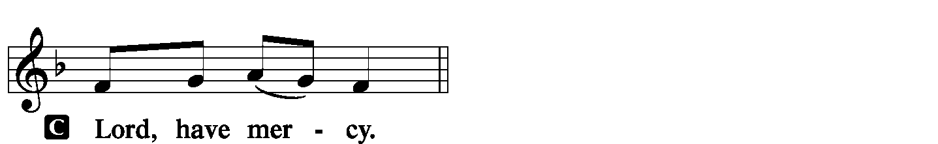
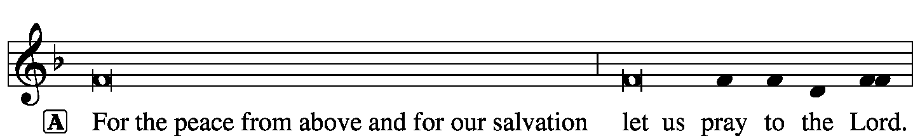
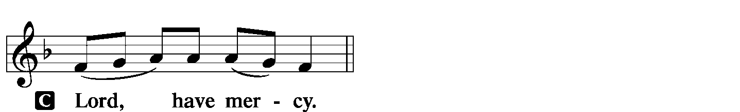
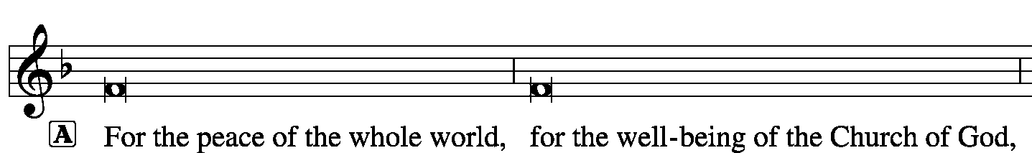

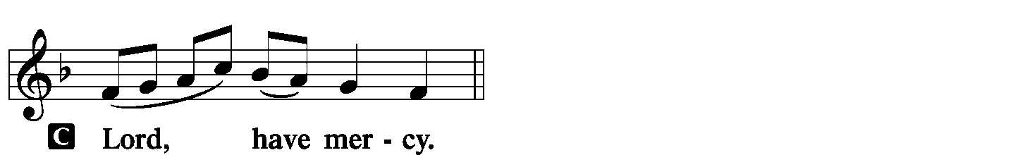
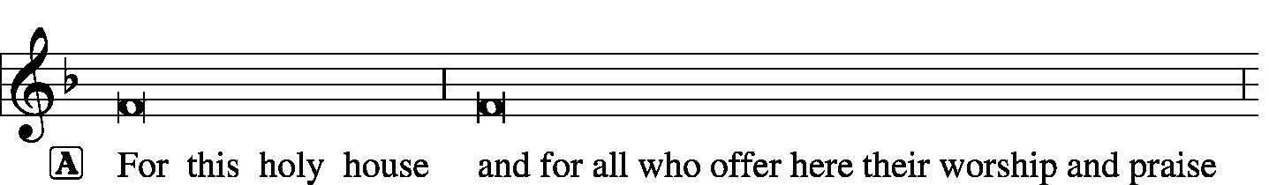
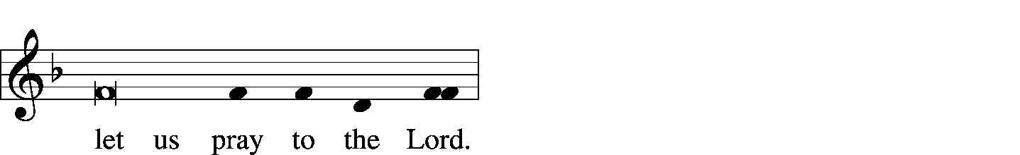
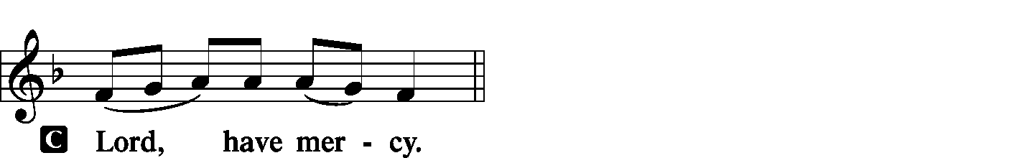
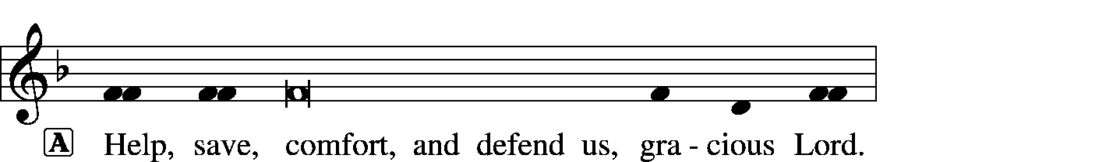

HYMN OF PRAISE |  | LSB 333 Once He Came in Blessing
SALUTATION |  |  | Page 156
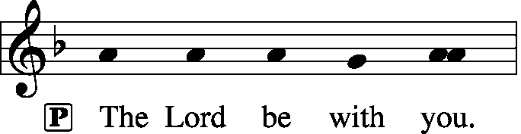
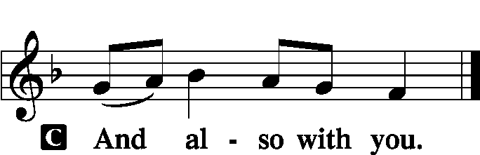
COLLECT OF THE DAY
P: | Let us pray.
C: | Stir up Your power, O Lord, and come and help us by Your might, that the sins which weigh us down may be quickly lifted by Your grace and mercy; in Your Name we pray. Amen,

COLLECT FOR ST. THOMAS, APOSTLE
C: | Almighty and ever-living God, You strengthened Your Apostle Thomas with firm and certain faith in the resurrection of Your Son. Grant us such faith in Jesus Christ, our Lord and our God, that we may never be found wanting in Your sight; through the same Jesus Christ, Who lives and reigns with You and the Holy Spirit one God, now and forever. Amen.
LIGHTING OF THE ADVENT CANDLE: LOVE
P: | Drop down, you heavens, from above; and let the skies pour down righteousness.
C: | The heavens declare the glory of God; and the firmament shows His handiwork.
P: | Behold, the name of the Lord comes from far;
C: | Let the whole earth be filled with His glory.
P: | Out of Zion, the perfection of beauty, God has shined;
C: | Our God shall come.
P: | As we wait to celebrate Christmas,
C: | We also wait for the glorious day of our Lord’s return.
P: | As the birth of Jesus revealed the greatest gift of God’s love and made us members of the Lord’s household;
C: | So we live with God’s love poured out on us in Christ and seek to share that love in this time of waiting for Christ’s return.
P: | Let us then remember the great love God has lavished upon us, and light this candle as a sign;
C: | A sign that points us to God’s love which sent His Son so that whoever believes in Him should not perish but have eternal life; for of Him are all things and to Him is all glory.
P: | Let us pray:  Gracious Savior, in this time of waiting, pour out Your redeeming love upon us so that by faith we may have new birth and share in Your life, Your love, and Your mercy. Let us prepare to greet you with repentant hearts and watchful eyes; anticipating the joy You have promised to all whom You redeem. We ask this in Your blessed name.
C: | Amen.
 | (the candle is lighted)

GOSPEL FOR YOUNG FOLK
FIRST READING | Isaiah 7:10-17
¹⁰Again the Lord spoke to Ahaz, ¹¹“Ask a sign of the Lord your God; let it be deep as Sheol or high as heaven” ¹²But Ahaz said, “I will not ask, and I will not put the Lord to the test.” ¹³And he said, “Hear then, O house of David! Is it too little for you to weary men, that you weary my God also? ¹⁴Therefore the Lord Himself will give you a sign. Behold, the virgin shall conceive and bear a son, and shall call his name Immanuel. ¹⁵He shall eat curds and honey when he knows how to refuse the evil and choose the good. ¹⁶For before the boy knows how to refuse the evil and choose the good, the land whose two kings you dread will be deserted. ¹⁷The Lord will bring upon you and upon your people and upon your father’s house such days as have not come since the day that Ephraim departed from Judah—the king of Assyria.”

P: | This is the word of the Lord.
C: | Thanks be to God.
PSALM |  | Psalm 24 | (Sung responsively by verse)
O Dayspring, splendor of light ever- | lasting*
Come and enligihten those who sit in darkness
and in the shad-| ow of death.

The earth is the Lord’s and the full- | ness thereof,*
the world and those who | dwell therein,
for He has founded it up- | on the seas*
and established it upon the | rivers.
Who shall ascend the hill | of the Lord?*
And who shall stand in His | holy place?
He who has clean hands and a | pure heart,*
who does not lift up his soul to what is false
and does not swear de- | ceitfully.
He will receive blessing | from the Lord*
and righteousness from the God of his sal- | vation.
Such is the generation of those who | seek Him,*
who seek the face of the God of | Jacob.
Lift up your heads, O gates!
And be lifted up, O | ancient doors,*
that the King of glory | may come in.
Who is this King of | Glory?*
The Lord, strong and mighty,
the Lord, mighty in | battle!
Lift up your heads, O gates!
And lift them up, O | ancient doors,*
that the King of Glory | may come in.
Who is this King of | Glory?*
The Lord of hosts,
he is the King of | Glory!
Glory be to the Father and | to the Son*
and to the Holy | Spirit;
as it was in the be- | ginning,*
is now, and will be forever. | Amen.

O Dayspring, splendor of light ever- | lasting*
Come and enligihten those who sit in darkness
and in the shad-| ow of death.
SECOND READING | Romans 1:1-7
¹Paul, a servant of Christ Jesus, called to be an apostle, set apart for the gospel of God, ²which He promised beforehand through His prophets in the holy Scriptures, ³concerning his Son, Who was descended from David according to the flesh ⁴and was declared to be the Son of God in power according to the Spirit of holiness by His resurrection from the dead, Jesus Christ our Lord, ⁵through Whom we have received grace and apostleship to bring about the obedience of faith for the sake of His name among all the nations, ⁶including you who are called to belong to Jesus Christ,
⁷To all those in Rome who are loved by God and called to be saints:
Grace to you and peace from God our Father and the Lord Jesus Christ.
P: | This is the word of the Lord.
C: | Thanks be to God.

GOSPEL VERSE | Page 156
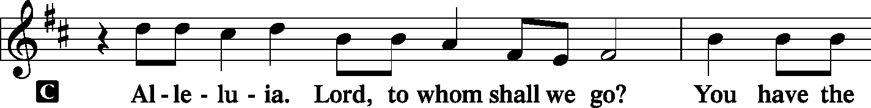
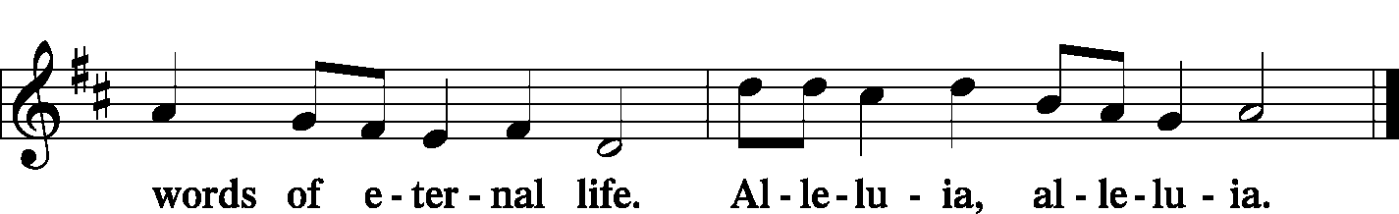
INTRODUCTION
P: | The Holy Gospel according to St. Matthew, the first chapter.
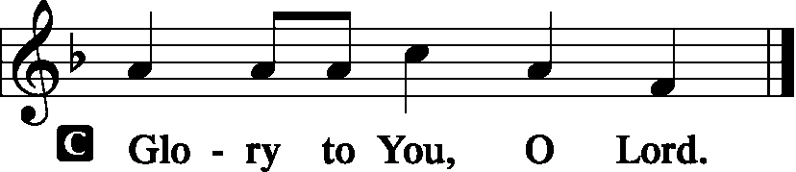
GOSPEL LESSON | Matthew 1:18-25
¹⁸Now the birth of Jesus Christ took place in this way. When his mother Mary had been betrothed to Joseph, before they came together she was found to be with child from the Holy Spirit. ¹⁹And her husband Joseph, being a just man and unwilling to put her to shame, resolved to divorce her quietly. ²⁰But as he considered these things, behold, an angel of the Lord appeared to him in a dream, saying, “Joseph, son of David, do not fear to take Mary as your wife, for that which is conceived in her is from the Holy Spirit. ²¹She will bear a son, and you shall call his name Jesus, for he will save his people from their sins”. ²²All this took place to fulfill what the Lord had spoken by the prophet:
²³“Behold, the virgin shall conceive and bear a son,
and they shall call his name Immanuel”(which means, God with us).
²⁴When Joseph woke from sleep, he did as the angel of the Lord commanded him: he took his wife, ²⁵but knew her not until she had given birth to a son. And he called his name Jesus.
P: | This is the Gospel of the Lord.
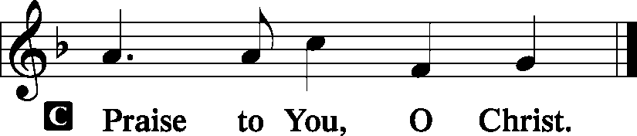
HYMN OF THE DAY |  |  | LSB 350 Come Thou Precious Ransom Come
SERMON
NICENE CREED |  |  |  | Page 158
C: | I believe in one God, the Father Almighty, maker of heaven and earth and of all things visible and invisible.  And in one Lord Jesus Christ, the only-begotten Son of God, begotten of His Father before all worlds, God of God, Light of Light, very God of very God, begotten, not made, being of one substance with the Father, by Whom all things were made; Who for us men and for our salvation came down from heaven and was incarnate by the Holy Spirit of the virgin Mary and was made man; and was crucified also for us under Pontius Pilate. He suffered and was buried. And the third day He rose again according to the Scriptures and ascended into heaven and sits at the right hand of the Father. And He will come again with glory to judge both the living and the dead, Whose kingdom will have no end.  And I believe in the Holy Spirit, the Lord and giver of life, Who proceeds from the Father and the Son, Who with the Father and the Son together is worshiped and glorified, Who spoke by the prophets. And I believe in one holy Christian and apostolic Church, I acknowledge one Baptism for the remission of sins, and I look for the resurrection of the dead and the life T of the world to come. Amen.
PRAYER OF THE CHURCH |  |  |  |  | Page 159
OFFERTORY |  | What Shall I Render to the Lord  Psalm 116 |  |  |  |  | Pages 159-60
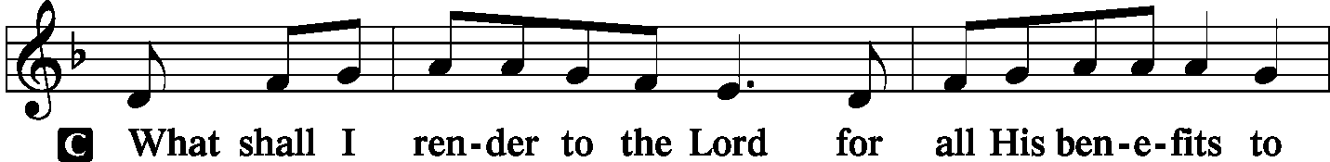
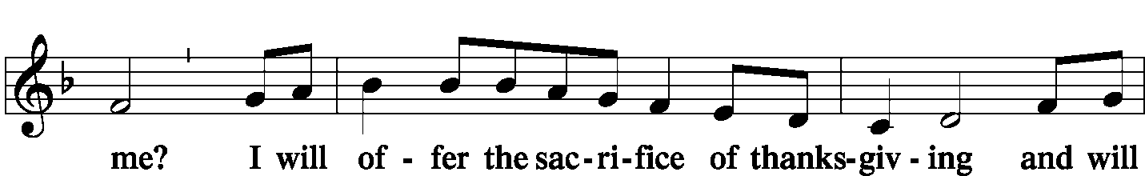
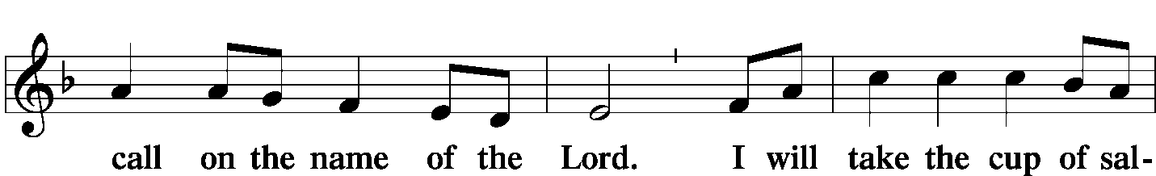
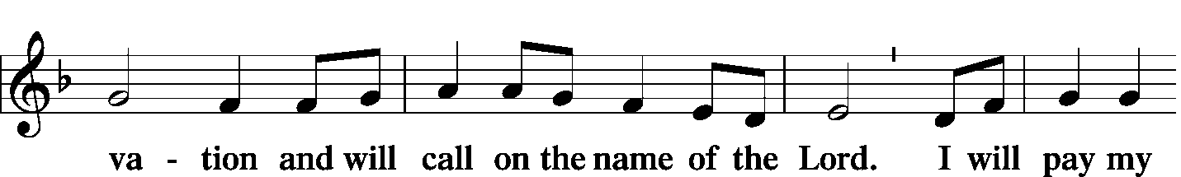
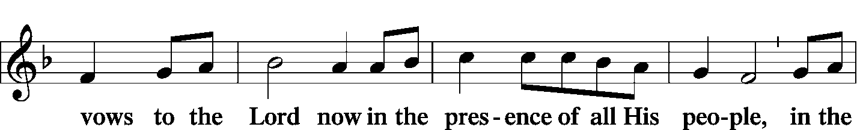
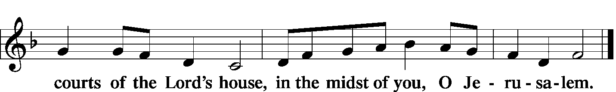
 | Hymn: LSB 550 Lamb of God
PREFACE |  | Page 160
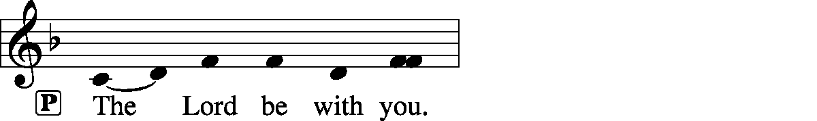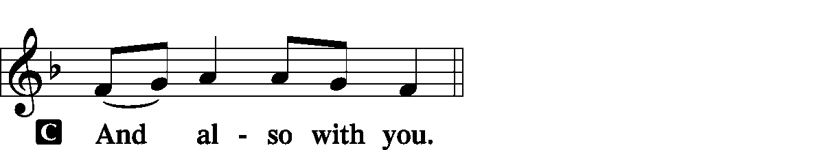
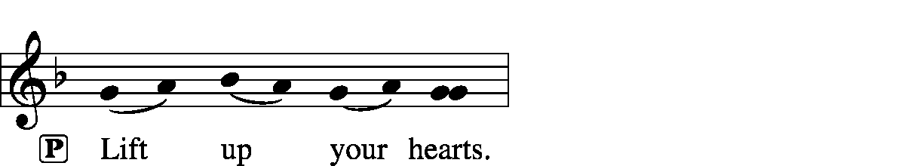
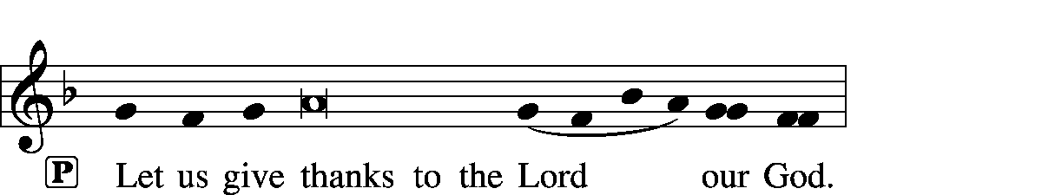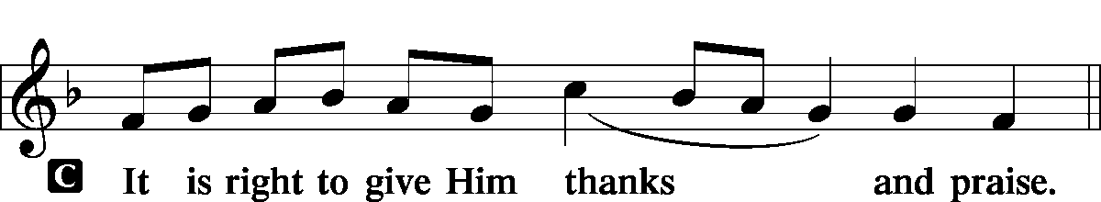
PROPER PREFACE
P: | It is truly meet, right, and salutary that we should at all times and in all places give thanks to You, holy Lord, almighty Father, everlasting God, through Jesus Christ, our Lord, Whose way John the Baptist prepared, proclaiming Him the promised Messiah, the very Lamb of God Who takes away the sin of the world, and calling sinners to repentance that they might escape from the wrath to be revealed when He comes again in glory. Therefore with angels and archangels and with all the company of heaven we laud and magnify Your glorious name, evermore praising You and singing:
SANCTUS |  | Holy, Holy, Holy Lord |  | Page 161
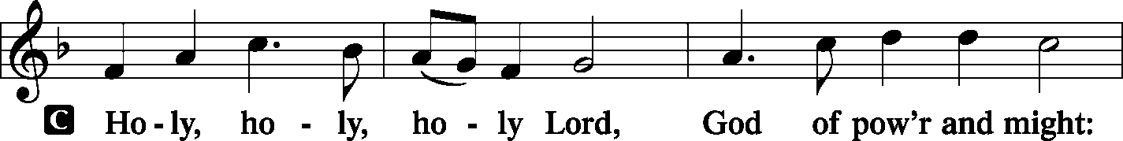
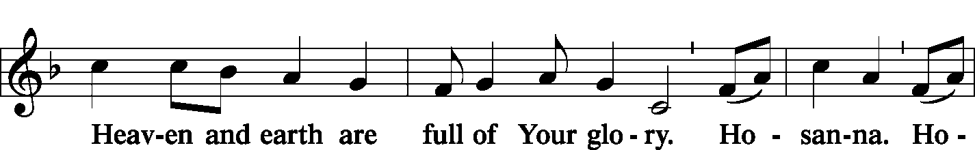
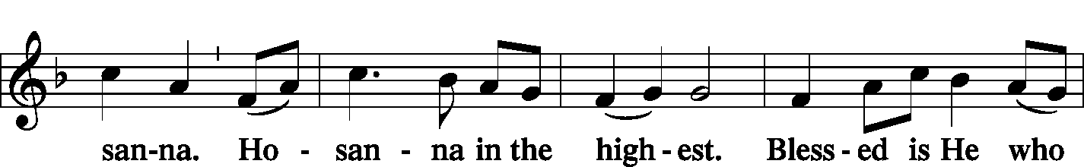
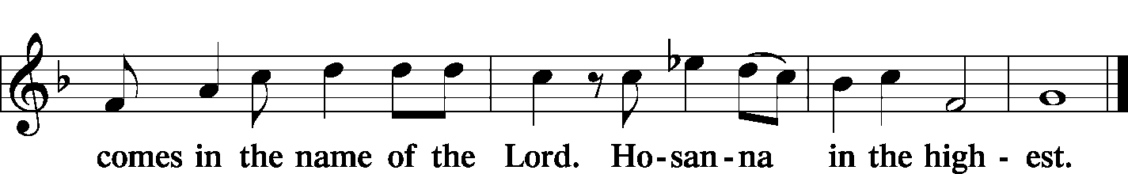
PRAYER OF THANKSGIVING |  |  |  |  |  | Page 161
P: | Blessed are You, Lord of heaven and earth, for You have had mercy on those whom You created and sent Your only-begotten Son into our flesh to bear our sin and be our Savior. With repentant joy we receive the salvation accomplished for us by the all-availing sacrifice of His body and His blood on the cross.  Gathered in the name and the remembrance of Jesus, we beg You, O Lord, to forgive, renew, and strengthen us with Your Word and Spirit. Grant us faithfully to eat His body and drink His blood as He bids us do in His own testament. Gather us together, we pray, from the ends of the earth to celebrate with all the faithful the marriage feast of the Lamb in His kingdom, which has no end. Graciously receive our prayers; deliver and preserve us. To You alone, O Father, be all glory, honor, and worship, with the Son and the Holy Spirit, one God, now and forever.
C: | Amen.
LORD’S PRAYER |  |  |  | Page 162, Right Column
P: | Lord, remember us in Your kingdom and teach us to pray:
C: | Our Father Who art in heaven, hallowed be Thy name, Thy kingdom come, Thy will be done on earth as it is in heaven; give us this day our daily bread; and forgive us our trespasses as we forgive those who trespass against us; and lead us not into temptation, but deliver us from evil. For Thine is the kingdom and the power and the glory forever and ever. Amen.
WORDS OF OUR LORD |  |  | (Words of Institution) |  |  |  | Page 162, Right Column
P: | Our Lord Jesus Christ, on the night when He was betrayed, took bread, and when He had given thanks, He broke it and gave it to the disciples and said: “Take, eat; this is My T body, which is given for you. This do in remembrance of Me.”  In the same way also He took the cup after supper, and when He had given thanks, He gave it to them, saying: “Drink of it, all of you; this cup is the new testament in My T blood, which is shed for you for the forgiveness of sins. This do, as often as you drink it, in remembrance of Me.”
PAX DOMINI |  |  | The Peace of the Lord |  |  |  |  | Page 163
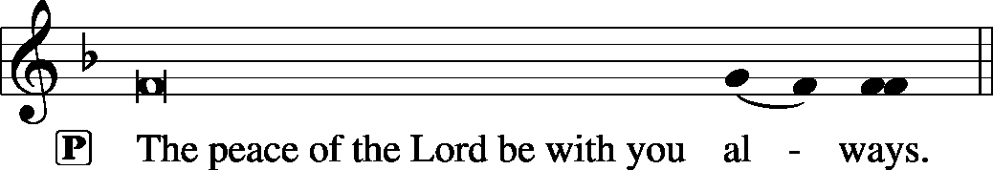

AGNUS DEI | Lamb of God | Page 163
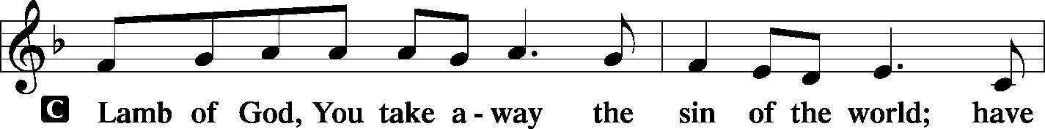
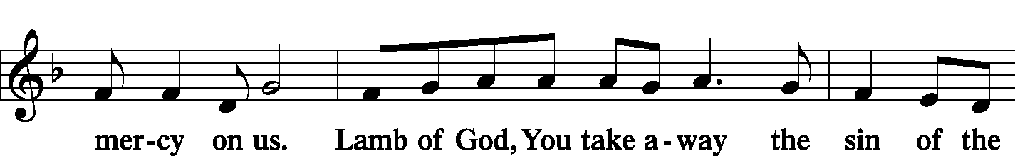
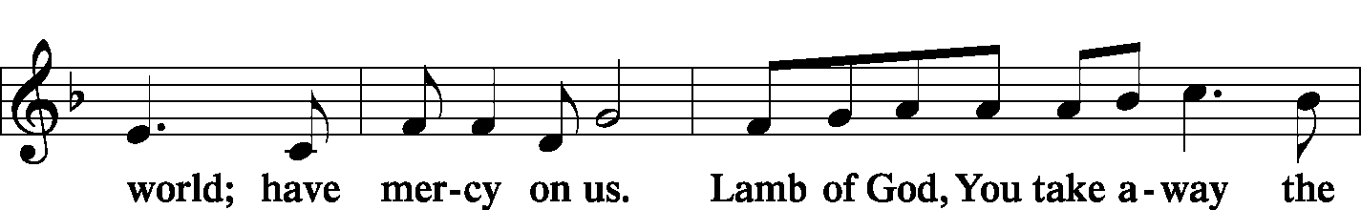
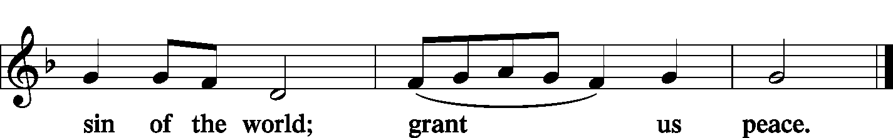
 |  | Prayer before Communing: Dear Savior, at Your gracious invitation I come to Your table to eat and drink Your holy body and blood. Let me find favor in Your eyes to receive this holy Sacrament in faith for the salvation of my soul and to the glory of Your holy name; for You live and reign with the Father and the Holy Spirit, one God, now and forever. Amen.
 |  | Thanksgiving after Receiving the Sacrament: Almighty and everlasting God, I thank and praise You for feeding me the life-giving body and blood of Your beloved Son, Jesus Christ. Send Your Holy Spirit that, having with my mouth received the holy Sacrament, I may by faith obtain and eternally enjoy Your divine grace, the forgiveness of sins, unity with Christ, and life eternal; through Jesus Christ, my Lord. Amen.
DISTRIBUTION
 |  | Hymn: LSB 517 vv. 1, 6, 3 By All Your Saints in Warfare
 |  | Hymn: LSB 625 Lord Jesus Christ, Life-Giving Bread
POST-COMMUNION BLESSING
P: | May the true Body of our Lord Jesus Christ, and His most precious Blood, strengthen you in true faith, granting you the forgiveness of sins, unto life everlasting. Depart in peace.
C: | Amen.

POST-COMMUNION CANTICLE | Nunc Dimittis – Song of Simeon  Lord, Now You Let Your Servant | Page 165
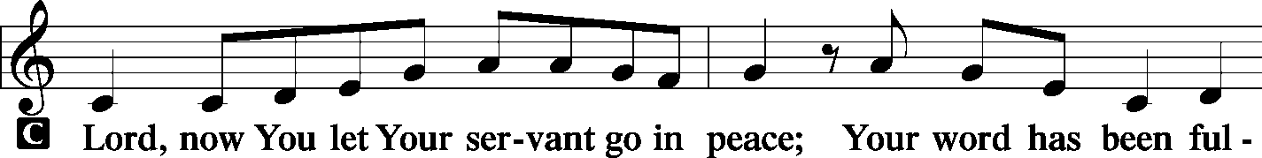
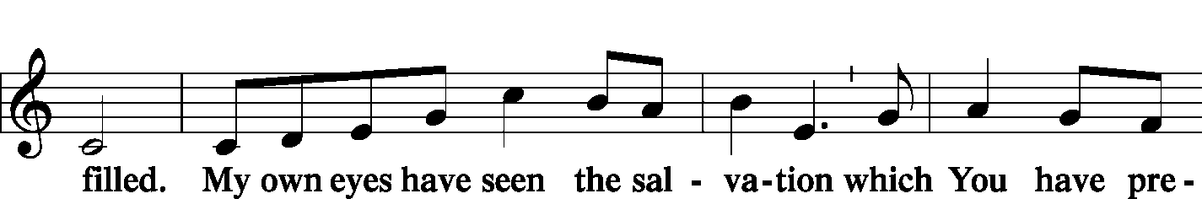
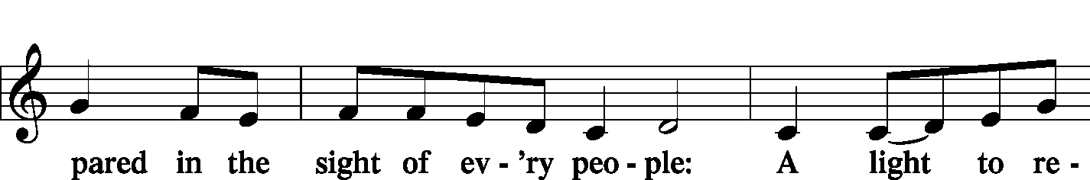
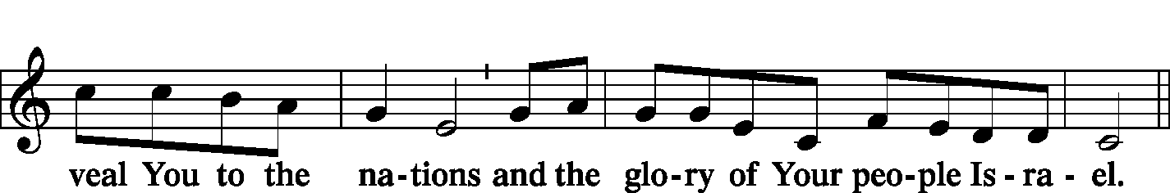
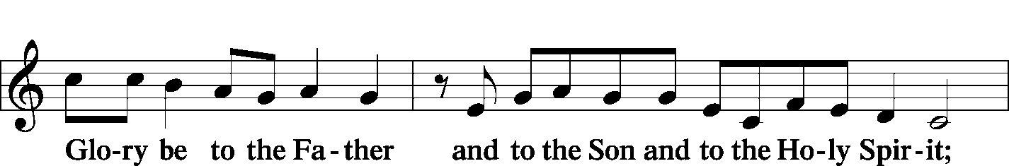
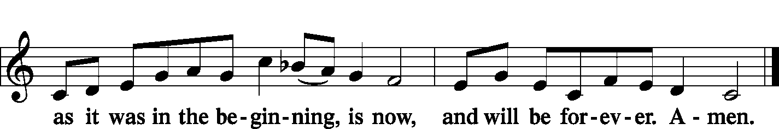
POST-COMMUNION COLLECT |  |  | Page 166
P: | Let us pray.  We give thanks to You, almighty God, that You have refreshed us through this salutary gift, and we implore You that of Your mercy You would strengthen us through the same in faith toward You and in fervent love toward one another; through Jesus Christ, Your Son, our Lord, Who lives and reigns with You and the Holy Spirit, one God, now and forever.
C: | Amen.

BENEDICTION |  | Page 166
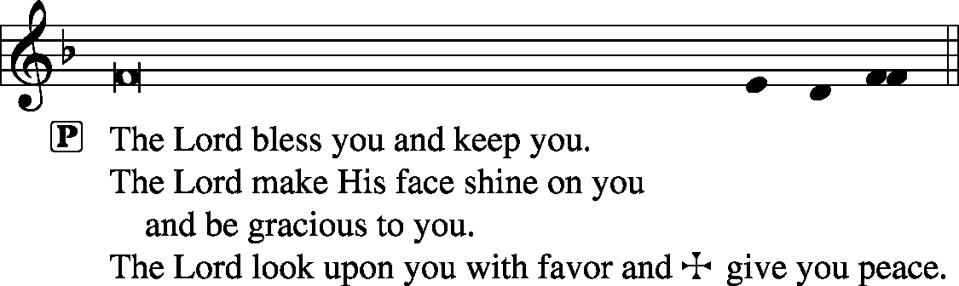
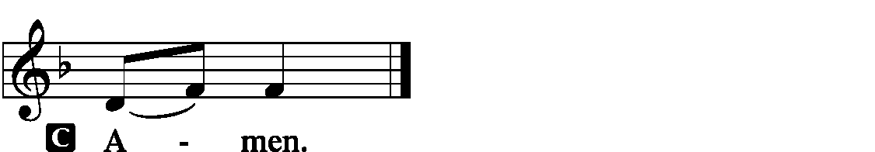
CLOSING HYMN |  | LSB 355 O Savior, Rend the Heavens Wide
SILENT PRAYER
 | Almighty and merciful God, I have again worshiped in Your presence and received both forgiveness for my many sins and the assurance of Your love in Jesus Christ. I thank You for this undeserved grace and ask You to keep me in faith until, with all Your saints, I inherit eternal salvation; through Jesus Christ, my Lord. Amen.
ANNOUNCEMENTS
POSTLUDE

T T T

PASTOR | - | The Rev. Barry Long
ELDER | - | Tom Brosowske

Acknowledgments
Divine Service, Setting One from Lutheran Service Book
Unless otherwise indicated, all scripture quotations are from The Holy Bible, English Standard Version, copyright © 2001 by Crossway Bibles, a division of Good News Publishers. Used by permission. All rights reserved.
Created by Lutheran Service Builder © 2006 Concordia Publishing House.

SCHEDULE OF WORSHIP SERVICES

FOR THE CHRISTMAS SEASON

Wednesday, December 24th, Christmas Eve
 | Spoken Communion Service | 3:00 pm
 | Family Candlelight Service/Holy Communion | 7:00 pm
Thursday, December 25th, Christmas Day
 | Chorale Divine Service/Holy Communion | 9:00 am
Sunday, December 28th, First Sunday After Christmas – Holy
Innocents
 | Divine Service (Note: only one service) | 9:00 am
Sunday, January 4th, 2nd Sunday after Christmas
 | Spoken Matins Service (Note: only one service) | 9:00 am
Tuesday, January 6th, The Epiphany of Our Lord
 | Spoken Divine Service | 11:15 am
 | Spoken Divine Service | 6:00 pm

