Fourth Sunday after Pentecost
June 21, 2026
Divine Service I/Holy Communion
LSB Page 151
REGISTRATION FOR HOLY COMMUNION
Members of Mt. Calvary and visitors, who are confirmed members in good standing of congregations of the Lutheran Church-Missouri Synod, are asked to announce attendance at Holy Communion by means of the registration cards in the pews. Non-member visitors and guests, who may desire to attend Holy Communion, are asked to speak in person with the pastor before doing so. Those who desire a blessing, but choose not to commune, may come forward and simply cross their hands over their chest.
In accord with Holy Scripture, our church teaches that Holy Communion is open only to those who: (1) have been baptized in the name of the Triune God; Matt. 28:19, Acts 2:41-42; (2) are able to examine themselves both as to what this meal is and also its purpose; 1 Cor. 11:26-30; (3) have confessed and repented of their sins; 1 John 1:8-2:3; (4) believe that in, with, and under the bread and wine all communicants receive the true body and blood of our Lord Jesus Christ for the forgiveness of sins: 1 Cor. 11:23-27, 1 Cor. 10:16, Matt. 26:26-28; and who (5) are united in belief in the same teaching: 1 Cor. 10:17, Rom. 16:18, 2 John 10-11, Matt. 28:20, Heb. 13:9.

Looking for extra help in focusing your thoughts for the Lord’s Supper? “Christian Questions with Their Answers” was prepared by Luther to address just that. They can be found in your hymnal on pages 329-330. Review them if you get to church early, or if you are waiting to be invited forward.

Prayer Before Worship
O Lord, my Creator, Redeemer, and Comforter, as I come to worship You in spirit and in truth, I humbly pray that You would open my heart to the preaching of Your Word so that I may repent of my sins, believe in Jesus Christ as my only Savior, and grow in grace and holiness. Hear me for the sake of His name. Amen.
PRELUDE
RINGING BELL CALLS US TO WORSHIP
WELCOME
PRAYER FOR FATHERS

OPENING HYMN |  | LSB 725 Children of the Heavenly Father
CONFESSION AND ABSOLUTION |  |  | Page 151
P: | In the name of the Father and of the T Son and of the Holy Spirit.
C: | Amen.
P: | If we say we have no sin, we deceive ourselves, and the truth is not in us.
C: | But if we confess our sins, God, Who is faithful and just, will forgive our sins and cleanse us from all unrighteousness.
 | (Silence for reflection on God’s Word and for self-examination.)
P: | Let us then confess our sins to God our Father.
C: | Most merciful God, we confess that we are by nature sinful and unclean. We have sinned against You in thought, word, and deed, by what we have done and by what we have left undone. We have not loved You with our whole heart; we have not loved our neighbors as ourselves. We justly deserve Your present and eternal punishment. For the sake of Your Son, Jesus Christ, have mercy on us. Forgive us, renew us, and lead us, so that we may delight in Your will and walk in Your ways to the glory of Your holy name. Amen.
P: | Almighty God in His mercy has given His Son to die for you and for His sake forgives you all your sins. As a called and ordained servant of Christ, and by His authority, I therefore forgive you all your sins in the name of the Father and of the T Son and of the Holy Spirit.
C: | Amen.
INTROIT |  |  | Psalm 56:3–4, 10–11; antiphon: v. 13

For you have delivered my soul from death, yes, my feet
from | falling,*
that I may walk before God in the | light of life.
When I | am afraid,*
I put my | trust in you.
In God, Whose word I praise, in God I trust; I shall not | be afraid.*
What can flesh | do to me?
In God, Whose | word I praise,*
in the Lord, whose | word I praise,
in God I trust; I shall not | be afraid.*
What can man | do to me?
Glory be to the Father and | to the Son*
and to the Holy | Spirit;
as it was in the be- | ginning,*
is now, and will be forever. | Amen.
For you have delivered my soul from death, yes, my feet
from | falling,*
that I may walk before God in the | light of life.
KYRIE | Pages 152-53


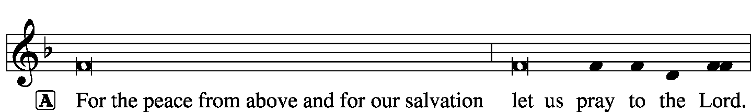

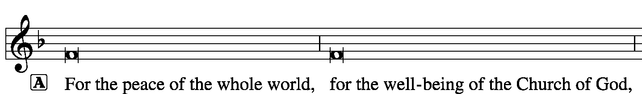


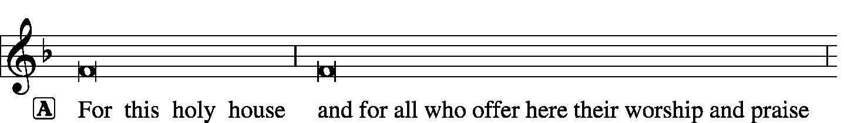


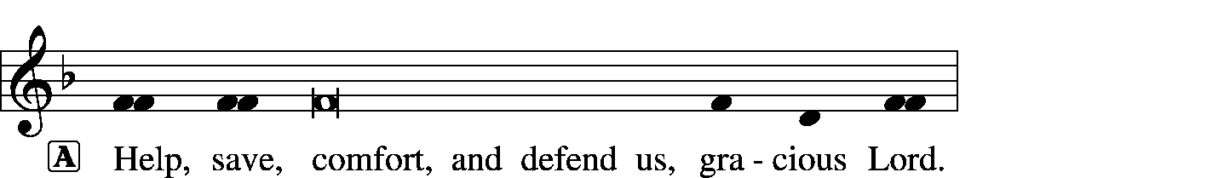

HYMN OF PRAISE |  | Gloria in Excelsis | Page 154
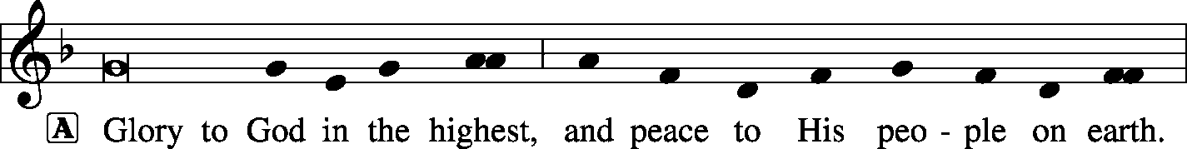
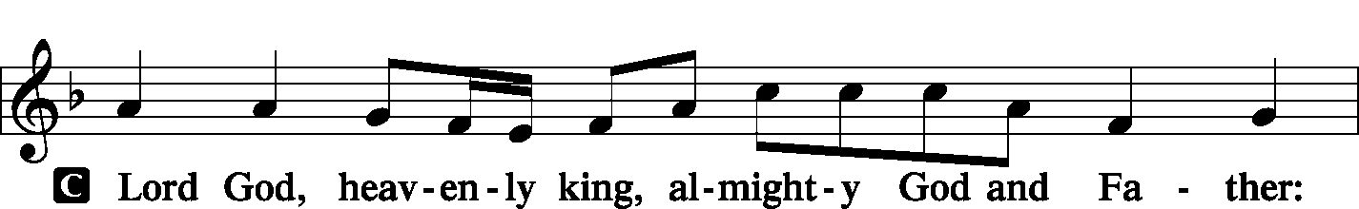
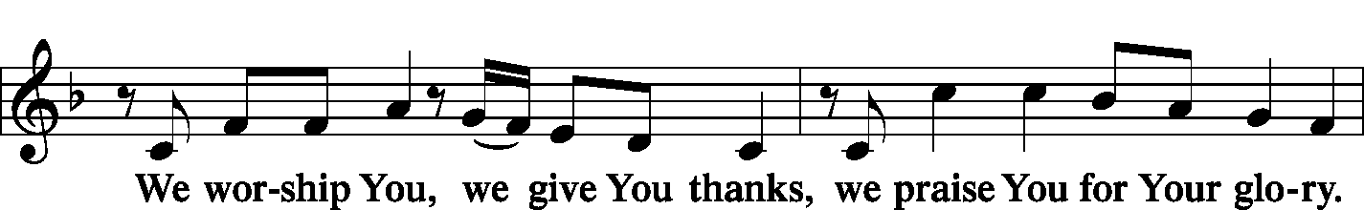
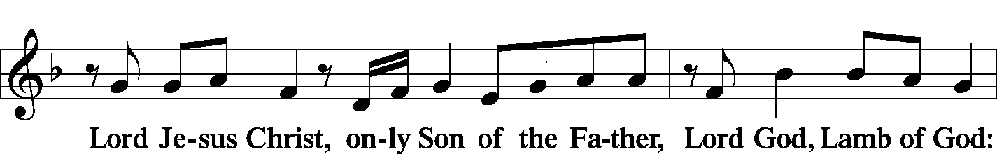
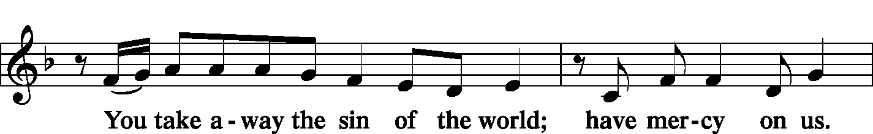
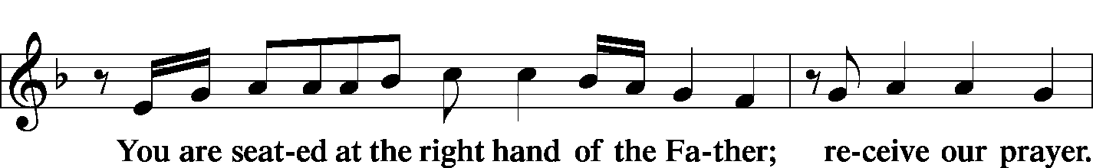
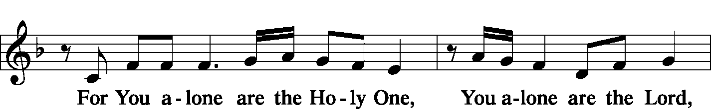

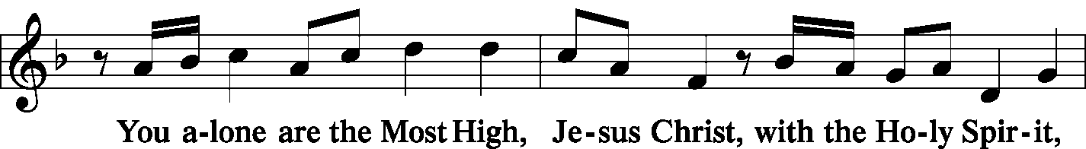
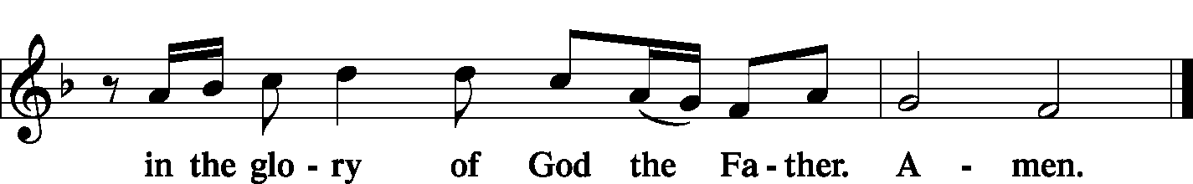
SALUTATION |  | Page 156
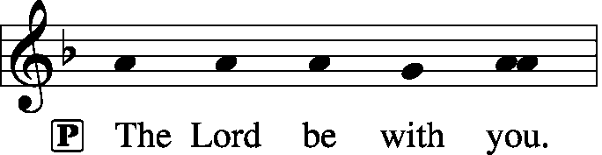
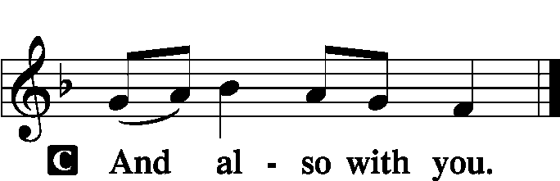

COLLECT OF THE DAY
P: | Let us pray.
C: | O God, because Your abiding presence always goes with us, keep us aware of Your daily mercies that we may live secure and content in Your eternal love; through Jesus Christ, Your Son, our Lord, Who lives and reigns with You and the Holy Spirit, one God, now and forever. Amen.
FIRST READING |  | Jeremiah 20:7-13
⁷O Lord, You have deceived me,
and I was deceived;
You are stronger than I,
and You have prevailed.
I have become a laughingstock all the day;
everyone mocks me.
⁸For whenever I speak, I cry out,
I shout, “Violence and destruction!”
For the word of the Lord has become for me
a reproach and derision all day long.
⁹If I say, “I will not mention Him,
or speak any more in His Name,”
there is in my heart as it were a burning fire
shut up in my bones,
and I am weary with holding it in,
and I cannot.
¹⁰For I hear many whispering.
Terror is on every side!
“Denounce Him! Let us denounce Him!”
say all my close friends,
watching for my fall.
“Perhaps he will be deceived;
then we can overcome him
and take our revenge on him.”
¹¹But the Lord is with me as a dread warrior;
therefore my persecutors will stumble;
they will not overcome me.
They will be greatly shamed,
for they will not succeed.
Their eternal dishonor
will never be forgotten.
¹²O Lord of hosts, Who tests the righteous,
Who sees the heart and the mind,
let me see Your vengeance upon them,
for to You have I committed my cause.
¹³Sing to the Lord;
praise the Lord!
For He has delivered the life of the needy
from the hand of evildoers.
P: | This is the word of the Lord.
C: | Thanks be to God.
PSALM |  | Psalm 91:1-16 | (Sung responsively by verse)
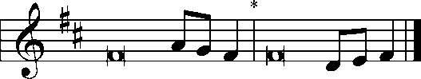
He Who dwells in the shelter of the | Most High*
will abide in the shadow of the Al- | mighty.
I will say to the Lord, “My refuge and my | fortress,*
my God, in | Whom I trust.”
For He will deliver you from the snare of the | fowler*
and from the deadly | pestilence.
He will cover you with his pinions,
and under His wings you will find | refuge;*
His faithfulness is a shield and | buckler.
You will not fear the terror | of the night,*
nor the arrow that | flies by day,
nor the pestilence that stalks in | darkness,*
nor the destruction that wastes at | noonday.
A thousand may fall at your side,
ten thousand at your | right hand,*
but it will not come | near you.
You will only look | with your eyes*
and see the recompense of the | wicked.
Because you have made the Lord your | dwelling place—*
the Most High, Who is my | refuge—
no evil shall be allowed to be- | fall you,*
no plague come | near your tent.
For He will command His angels con- | cerning you*
to guard you in | all your ways.
On their hands they will | bear you up,*
lest you strike your foot a- | gainst a stone.
You will tread on the lion and the | adder;*
the young lion and the serpent you will trample | underfoot.
“Because he holds fast to Me in love, I will de- | liver him;*
I will protect him, because he | knows My Name.
When he calls to Me, I will answer him;
I will be with him in | trouble;*
I will rescue him and | honor him.
With long life I will sat- | isfy him*
and show him My sal- | vation.”
Glory be to the Father and | to the Son*
and to the Holy | Spirit;
as it was in the be- | ginning,*
is now, and will be forever. | Amen.
SECOND READING |  |  | Romans 6:12-23
¹²Let not sin therefore reign in your mortal bodies, to make you obey their passions. ¹³Do not present your members to sin as instruments for unrighteousness, but present yourselves to God as those who have been brought from death to life, and your members to God as instruments for righteousness. ¹⁴For sin will have no dominion over you, since you are not under law but under grace.
¹⁵What then? Are we to sin because we are not under law but under grace? By no means! ¹⁶Do you not know that if you present yourselves to anyone as obedient slaves, you are slaves of the one whom you obey, either of sin, which leads to death, or of obedience, which leads to righteousness? ¹⁷But thanks be to God, that you who were once slaves of sin have become obedient from the heart to the standard of teaching to which you were committed, ¹⁸and, having been set free from sin, have become slaves of righteousness. ¹⁹I am speaking in human terms, because of your natural limitations. For just as you once presented your members as slaves to impurity and to lawlessness leading to more lawlessness, so now present your members as slaves to righteousness leading to sanctification.
²⁰When you were slaves of sin, you were free in regard to righteousness. ²¹But what fruit were you getting at that time from the things of which you are now ashamed? The end of those things is death. ²²But now that you have been set free from sin and have become slaves of God, the fruit you get leads to sanctification and its end, eternal life. ²³For the wages of sin is death, but the free gift of God is eternal life in Christ Jesus our Lord.

P: | This is the word of the Lord.
C: | Thanks be to God.
GOSPEL VERSE |  | Page 156
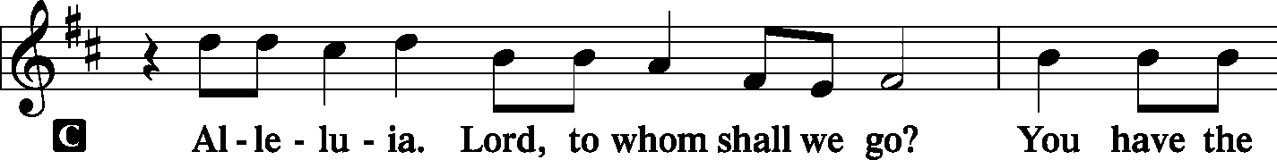
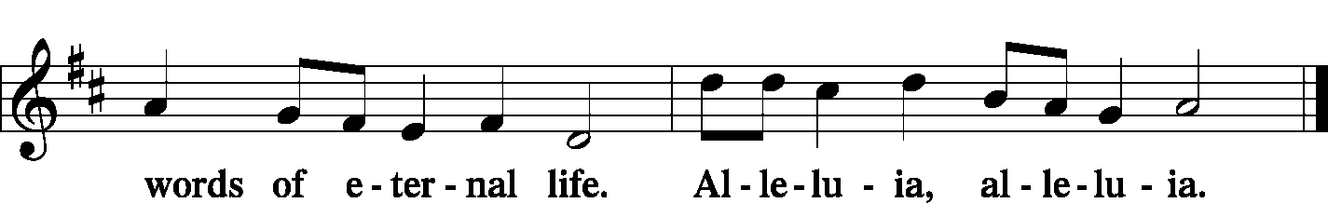
INTRODUCTION
P: | The Holy Gospel according to St. Matthew, the tenth chapter.
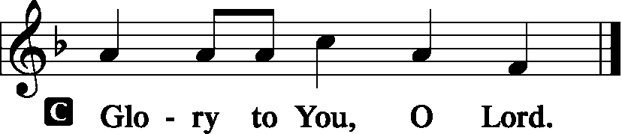
GOSPEL LESSON | Matthew 10:5a, 21-33
⁵These twelve Jesus sent out, instructing them, . . .
²¹“Brother will deliver brother over to death, and the father his child, and children will rise against parents and have them put to death^{, 22}and you will be hated by all for My Name’s sake. But the one who endures to the end will be saved. ²³When they persecute you in one town, flee to the next, for truly, I say to you, you will not have gone through all the towns of Israel before the Son of Man comes.
²⁴“A disciple is not above his teacher, nor a servant above his master. ²⁵It is enough for the disciple to be like his teacher, and the servant like his master. If they have called the master of the house Beelzebul, how much more will they malign those of his household.
²⁶“So have no fear of them, for nothing is covered that will not be revealed, or hidden that will not be known. ²⁷What I tell you in the dark, say in the light, and what you hear whispered, proclaim on the housetops. ²⁸And do not fear those who kill the body but cannot kill the soul. Rather fear him who can destroy both soul and body in hell. ²⁹Are not two sparrows sold for a penny? And not one of them will fall to the ground apart from your Father. ³⁰But even the hairs of your head are all numbered. ³¹Fear not, therefore; you are of more value than many sparrows. ³²So everyone who acknowledges Me before men, I also will acknowledge before My Father Who is in heaven, ³³but whoever denies Me before men, I also will deny before My Father Who is in heaven.”

P: | This is the Gospel of the Lord.
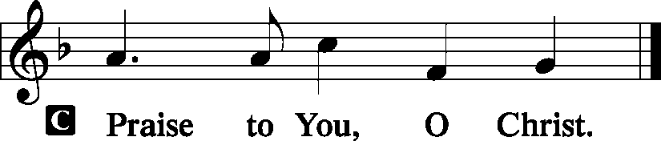
SERMON HYMN |  |  | LSB 666 O Little Flock, Fear Not the Foe
SERMON
NICENE CREED |  |  |  |  | Page 158
C: | I believe in one God, the Father Almighty, maker of heaven and earth and of all things visible and invisible.  And in one Lord Jesus Christ, the only-begotten Son of God, begotten of His Father before all worlds, God of God, Light of Light, very God of very God, begotten, not made, being of one substance with the Father, by Whom all things were made; Who for us men and for our salvation came down from heaven and was incarnate by the Holy Spirit of the virgin Mary and was made man; and was crucified also for us under Pontius Pilate. He suffered and was buried. And the third day He rose again according to the Scriptures and ascended into heaven and sits at the right hand of the Father. And He will come again with glory to judge both the living and the dead, Whose kingdom will have no end.  And I believe in the Holy Spirit, the Lord and giver of life, Who proceeds from the Father and the Son, Who with the Father and the Son together is worshiped and glorified, Who spoke by the prophets. And I believe in one holy Christian and apostolic Church, I acknowledge one Baptism for the remission of sins, and I look for the resurrection of the dead and the life T of the world to come. Amen.
PRAYER OF THE CHURCH |  |  |  |  |  | Page 159
INSTALLATION OF OFFICERS, BOARDS, AND COMMITTEES

OFFERTORY | What Shall I Render to the Lord  Psalm 116 |  | Pages 159-60
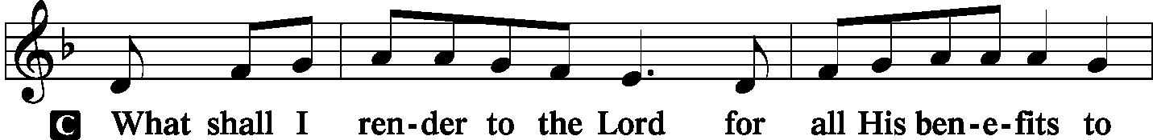
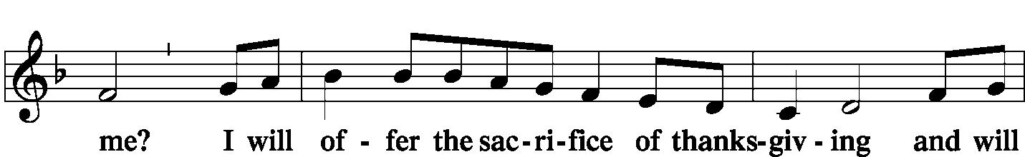
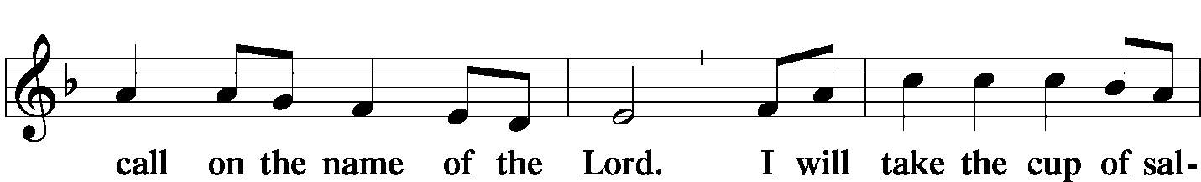
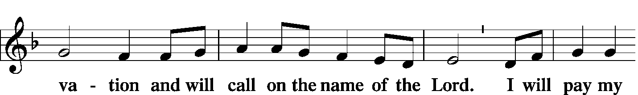
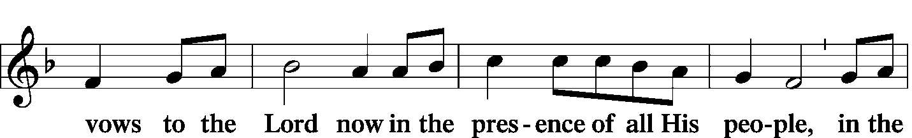
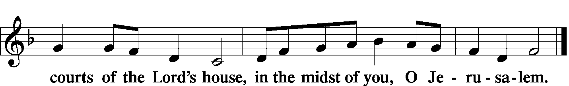
 | The Hymn: LSB 550 Lamb of God
PREFACE |  |  | Page 160


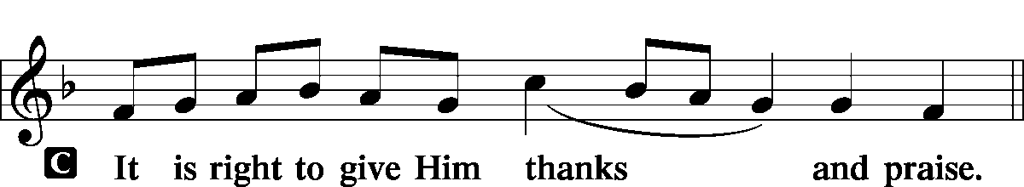
PROPER PREFACE
P: | It is truly good, right, and salutary that we should at all times and in all places give thanks to You, holy Lord, almighty Father, everlasting God, through Jesus Christ, our Lord, Who on this day overcame death and the grave and by His glorious resurrection opened to us the way of everlasting life. Therefore with angels and archangels and with all the company of heaven we laud and magnify Your glorious name, evermore praising You and singing:
SANCTUS |  | Holy, Holy, Holy Lord |  | Page 161
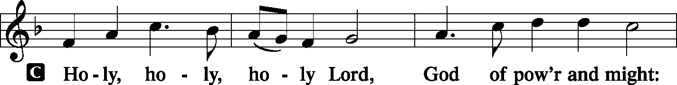
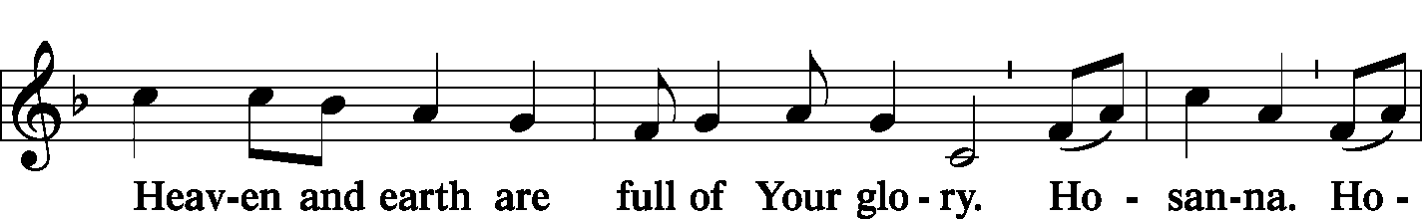
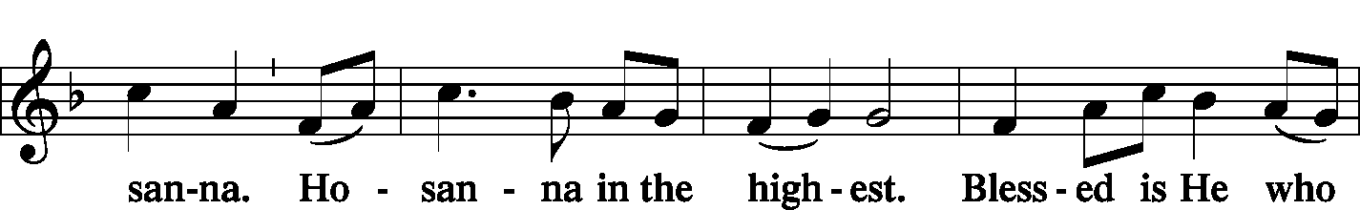
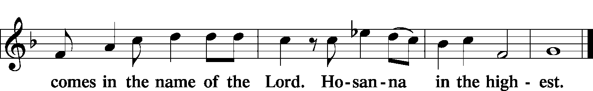
PRAYER OF THANKSGIVING |  |  |  |  |  | Page 161
P: | Blessed are You, Lord of heaven and earth, for You have had mercy on those whom You created and sent Your only-begotten Son into our flesh to bear our sin and be our Savior. With repentant joy we receive the salvation accomplished for us by the all-availing sacrifice of His body and His blood on the cross.  Gathered in the name and the remembrance of Jesus, we beg You, O Lord, to forgive, renew, and strengthen us with Your Word and Spirit. Grant us faithfully to eat His body and drink His blood as He bids us do in His own testament. Gather us together, we pray, from the ends of the earth to celebrate with all the faithful the marriage feast of the Lamb in His kingdom, which has no end. Graciously receive our prayers; deliver and preserve us. To You alone, O Father, be all glory, honor, and worship, with the Son and the Holy Spirit, one God, now and forever.
C: | Amen.
LORD’S PRAYER |  |  |  | Page 162, Right Column
P: | Lord, remember us in Your kingdom and teach us to pray:
C: | Our Father Who art in heaven, hallowed be Thy name, Thy kingdom come, Thy will be done on earth as it is in heaven; give us this day our daily bread; and forgive us our trespasses as we forgive those who trespass against us; and lead us not into temptation, but deliver us from evil. For Thine is the kingdom and the power and the glory forever and ever. Amen.
WORDS OF OUR LORD |  |  | (Words of Institution) |  |  |  | Page 162, Right Column
P: | Our Lord Jesus Christ, on the night when He was betrayed, took bread, and when He had given thanks, He broke it and gave it to the disciples and said: “Take, eat; this is My T body, which is given for you. This do in remembrance of Me.”  In the same way also He took the cup after supper, and when He had given thanks, He gave it to them, saying: “Drink of it, all of you; this cup is the new testament in My T blood, which is shed for you for the forgiveness of sins. This do, as often as you drink it, in remembrance of Me.”

PAX DOMINI | The Peace of the Lord |  | Page 163
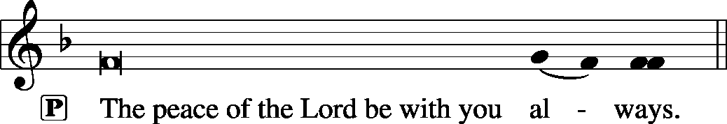

AGNUS DEI | Lamb of God | Page 163
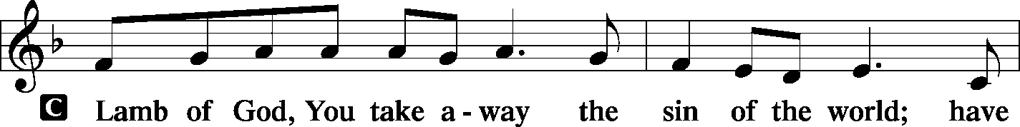
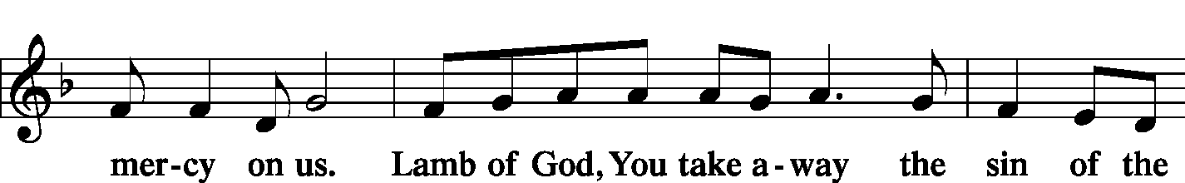
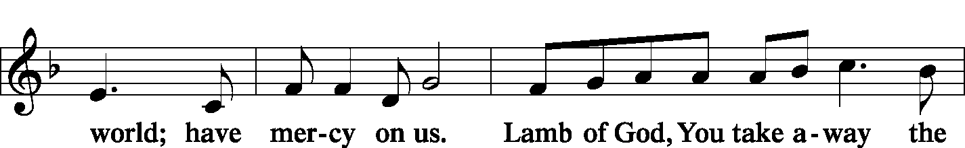
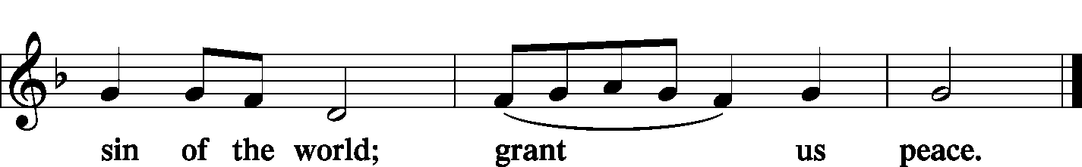
Prayer before Communing: Dear Savior, at Your gracious invitation I come to Your table to eat and drink Your holy body and blood. Let me find favor in Your eyes to receive this holy Sacrament in faith for the salvation of my soul and to the glory of Your holy name; for You live and reign with the Father and the Holy Spirit, one God, now and forever. Amen.
Thanksgiving after Receiving the Sacrament: Almighty and everlasting God, I thank and praise You for feeding me the life-giving body and blood of Your beloved Son, Jesus Christ. Send Your Holy Spirit that, having with my mouth received the holy Sacrament, I may by faith obtain and eternally enjoy Your divine grace, the forgiveness of sins, unity with Christ, and life eternal; through Jesus Christ, my Lord. Amen.

DISTRIBUTION
HYMN |  |  | LSB 941 We Praise You and Acknowledge You, O God
HYMN |  |  | LSB 617 O Lord, We Praise You
POST-COMMUNION BLESSING
P: | May the true Body of our Lord Jesus Christ, and His most precious Blood, strengthen you in true faith, granting you the forgiveness of sins, unto life everlasting. Depart in peace.
C: | Amen.
POST-COMMUNION CANTICLE |  |  |  |  |  | Nunc Dimittis – Song of Simeon  Lord, Now You Let Your Servant |  |  |  | Page 165
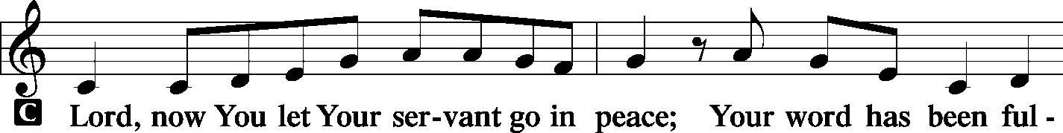
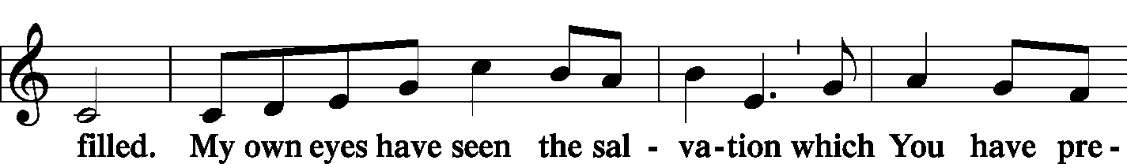
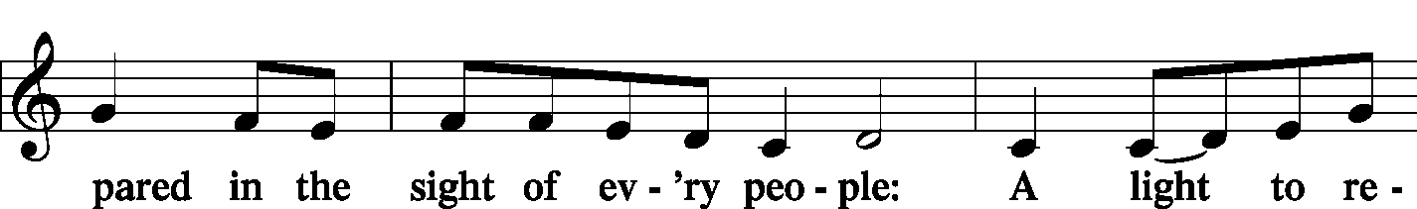
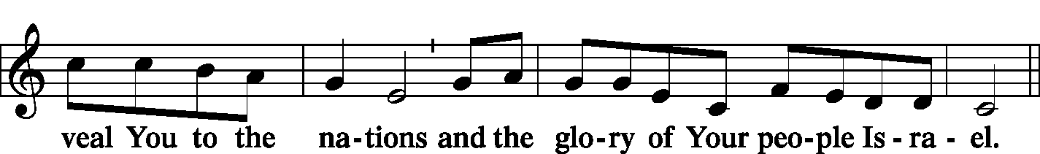
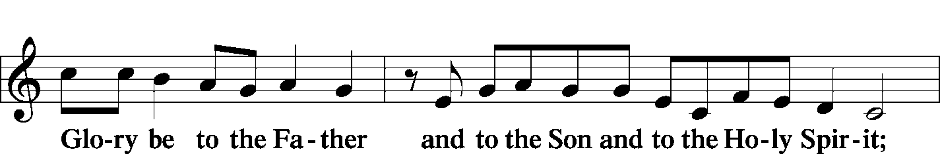
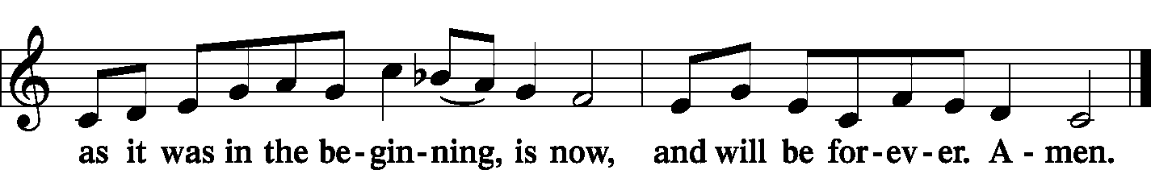

POST-COMMUNION COLLECT |  |  |  | Page 166
P: | Let us pray.  We give thanks to You, almighty God, that You have refreshed us through this salutary gift, and we implore You that of Your mercy You would strengthen us through the same in faith toward You and in fervent love toward one another; through Jesus Christ, Your Son, our Lord, Who lives and reigns with You and the Holy Spirit, one God, now and forever.
C: | Amen.
BENEDICTION |  |  |  | Page 166
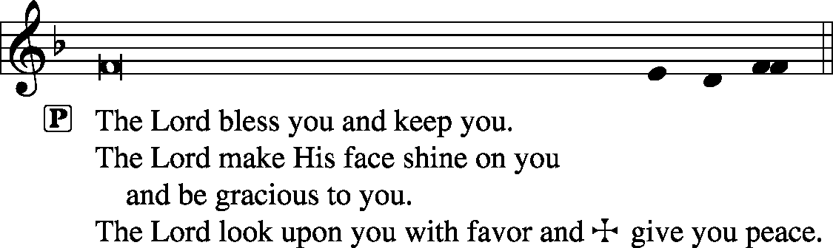

CLOSING HYMN |  | LSB 645 Built on the Rock
SILENT PRAYER
 | Almighty and merciful God, I have again worshiped in Your presence and received both forgiveness for my many sins and the assurance of Your love in Jesus Christ. I thank You for this undeserved grace and ask You to keep me in faith until, with all Your saints, I inherit eternal salvation; through Jesus Christ, my Lord. Amen.
ANNOUNCEMENTS
POSTLUDE
T T T

Acknowledgments
Divine Service, Setting One from Lutheran Service Book
Unless otherwise indicated, all scripture quotations are from The Holy Bible, English Standard Version, copyright © 2001 by Crossway Bibles, a division of Good News Publishers. Used by permission. All rights reserved.
Created by Lutheran Service Builder © 2026 Concordia Publishing House.

PASTOR | - | The Rev. Barry Long
ELDER | - | Phil King
ORGANIST | - | Carol Wessler

