Sixteenth Sunday after Pentecost
September 13, 2026
+ The Order of Matins +
Lutheran Service Book – Pages 219-228

Prayer Before Worship
 | O Lord, my Creator, Redeemer, and Comforter, as I come to worship You in spirit and in truth, I humbly pray that You would open my heart to the preaching of Your Word so that I may repent of my sins, believe in Jesus Christ as my only Savior, and grow in grace and holiness. Hear me for the sake of His name. Amen.
WELCOME
PRELUDE
OPENING HYMN |  | LSB 797 Praise to the Lord
CONFESSION AND ABSOLUTION |  |  |  | Page 151
P: | In the name of the Father and of the T Son and of the Holy Spirit.
C: | Amen.
P: | If we say we have no sin, we deceive ourselves, and the truth is not in us.
C: | But if we confess our sins, God, Who is faithful and just, will forgive our sins and cleanse us from all unrighteousness.
 | (Silence for reflection on God’s Word and for self-examination.)
P: | Let us then confess our sins to God our Father.
C: | Most merciful God, we confess that we are by nature sinful and unclean. We have sinned against You in thought, word, and deed, by what we have done and by what we have left undone. We have not loved You with our whole heart; we have not loved our neighbors as ourselves. We justly deserve Your present and eternal punishment. For the sake of Your Son, Jesus Christ, have mercy on us. Forgive us, renew us, and lead us, so that we may delight in Your will and walk in Your ways to the glory of Your holy name. Amen.
P: | Almighty God in His mercy has given His Son to die for you and for His sake forgives you all your sins. As a called and ordained servant of Christ, and by His authority, I therefore forgive you all your sins in the name of the Father and of the T Son and of the Holy Spirit.
C: | Amen.




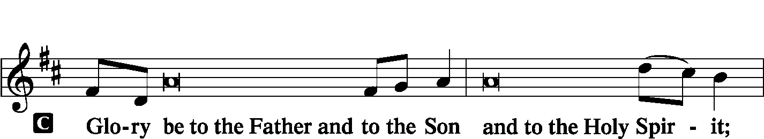
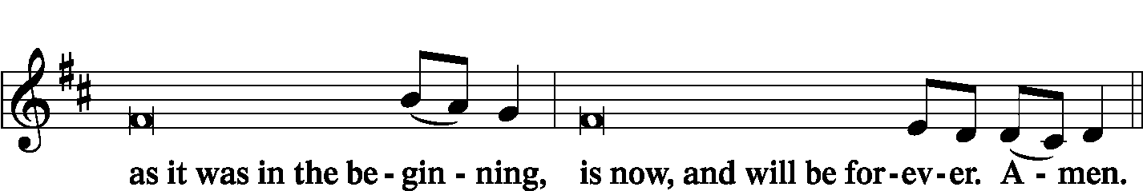
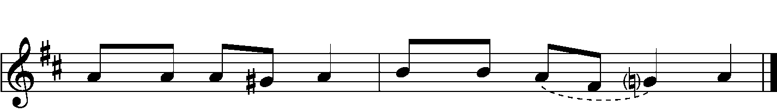
PSALMODY |  | Venite | O Come, Let Us Sing
 | Antiphon
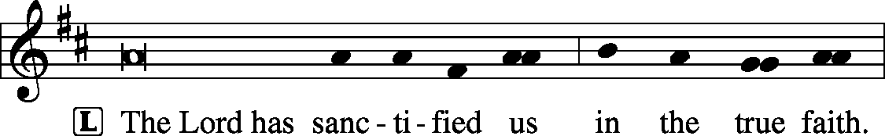

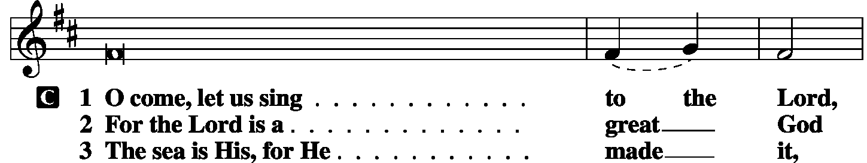
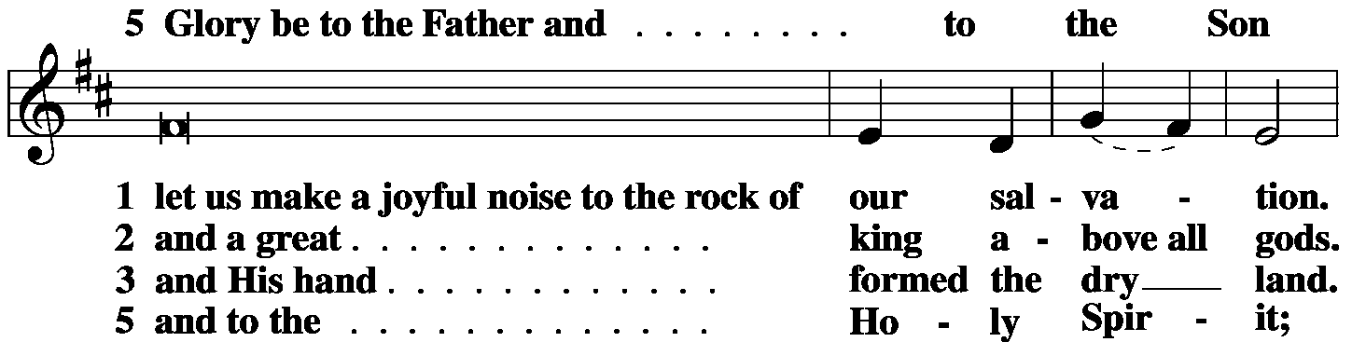
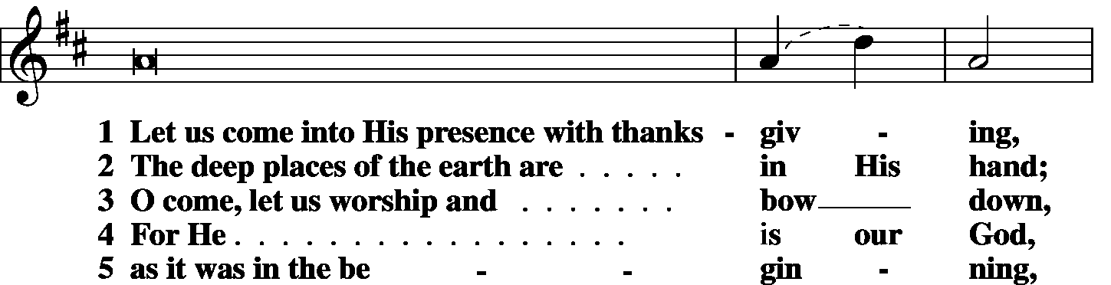
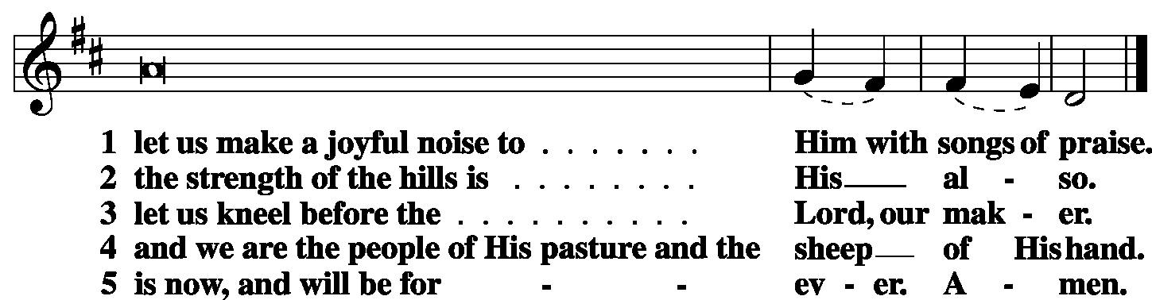

 | Second Psalm | Psalm 103:1-12 | (Sung responsively by verse)

Bless the Lord, | O my soul,*
and all that is within me, bless His | holy name!
Bless the Lord, | O my soul,*
and forget not all His | benefits,
Who forgives all your in- | iquity,*
Who heals all your dis- | eases,
Who redeems your life | from the pit,*
Who crowns you with steadfast love and | mercy,
Who satisfies | you with good*
so that your youth is renewed like the | eagle’s.
The Lord works | righteousness*
and justice for all who | are oppressed.
He made known His ways to | Moses,*
His acts to the people of | Israel.
The Lord is merciful and | gracious,*
slow to anger and abounding in | steadfast love.
He will not | always chide,*
nor will He keep His anger for- | ever.
He does not deal with us according | to our sins,*
nor repay us according to our in- | iquities.
For as high as the heavens are a- | bove the earth,*
so great is His steadfast love toward those who | fear Him;
as far as the east is | from the west,*
so far does He remove our transgres- | sions from us.
Glory be to the Father and | to the Son*
and to the Holy | Spirit;
as it was in the be- | ginning,*
is now, and will be forever. | Amen.

OFFICE HYMN | LSB 872 Come, Thou Bright and Morning Star
FIRST READING |  | Genesis 50:15–21
¹⁵When Joseph’s brothers saw that their father was dead, they said, “It may be that Joseph will hate us and pay us back for all the evil that we did to him.” ¹⁶So they sent a message to Joseph, saying, “Your father gave this command before he died, ¹⁷‘Say to Joseph, Please forgive the transgression of your brothers and their sin, because they did evil to you.’ And now, please forgive the transgression of the servants of the God of your father.” Joseph wept when they spoke to him. ¹⁸His brothers also came and fell down before him and said, “Behold, we are your servants.” ¹⁹But Joseph said to them, “Do not fear, for am I in the place of God? ²⁰As for you, you meant evil against me, but God meant it for good, to bring it about that many people should be kept alive, as they are today. ²¹So do not fear; I will provide for you and your little ones.” Thus he comforted them and spoke kindly to them.
P: | O Lord, have mercy on us.
C: | Thanks be to God.
SECOND READING |  | Romans 14:1–12
¹As for the one who is weak in faith, welcome him, but not to quarrel over opinions. ²One person believes he may eat anything, while the weak person eats only vegetables. ³Let not the one who eats despise the one who abstains, and let not the one who abstains pass judgment on the one who eats, for God has welcomed him. ⁴Who are you to pass judgment on the servant of another? It is before his own master that he stands or falls. And he will be upheld, for the Lord is able to make him stand.
⁵One person esteems one day as better than another, while another esteems all days alike. Each one should be fully convinced in his own mind. ⁶The one who observes the day, observes it in honor of the Lord. The one who eats, eats in honor of the Lord, since he gives thanks to God, while the one who abstains, abstains in honor of the Lord and gives thanks to God. ⁷For none of us lives to himself, and none of us dies to himself. ⁸If we live, we live to the Lord, and if we die, we die to the Lord. So then, whether we live or whether we die, we are the Lord’s. ⁹For to this end Christ died and lived again, that He might be Lord both of the dead and of the living.
¹⁰Why do you pass judgment on your brother? Or you, why do you despise your brother? For we will all stand before the judgment seat of God; ¹¹for it is written, “As I live, says the Lord, every knee shall bow to Me, and every tongue shall confess to God.” ¹²So then each of us will give an account of himself to God.
P: | O Lord, have mercy on us.
C: | Thanks be to God.

GOSPEL VERSE |  | Matt. 6:14
P: | Alleluia. If you forgive others their trespasses,
C: | your heavenly Father will also forgive you. Alleluia.
HOLY GOSPEL
P: | The Holy Gospel according to St. Matthew, the eighteenth chapter.
C: | Glory to You, O Lord.
 | Matthew 18:21–35
²¹ Peter came up and said to [Jesus], “Lord, how often will my brother sin against me, and I forgive him? As many as seven times?”
²²Jesus said to him, “I do not say to you seven times, but seventy times seven. ²³“Therefore the kingdom of heaven may be compared to a king who wished to settle accounts with his servants. ²⁴When he began to settle, one was brought to him who owed him ten thousand talents. ²⁵And since he could not pay, his master ordered him to be sold, with his wife and children and all that he had, and payment to be made. ²⁶So the servant fell on his knees, imploring him, ‘Have patience with me, and I will pay you everything.’ ²⁷And out of pity for him, the master of that servant released him and forgave him the debt. ²⁸But when that same servant went out, he found one of his fellow servants who owed him a hundred denarii, and seizing him, he began to choke him, saying, ‘Pay what you owe.’ ²⁹So his fellow servant fell down and pleaded with him, ‘Have patience with me, and I will pay you.’ ³⁰He refused and went and put him in prison until he should pay the debt. ³¹When his fellow servants saw what had taken place, they were greatly distressed, and they went and reported to their master all that had taken place. ³²Then his master summoned him and said to him, ‘You wicked servant! I forgave you all that debt because you pleaded with me. ³³And should not you have had mercy on your fellow servant, as I had mercy on you?’ ³⁴And in anger his master delivered him to the jailers, until he should pay all his debt. ³⁵So also my heavenly Father will do to every one of you, if you do not forgive your brother from your heart.”
P: | This is the Gospel of the Lord.
C: | Praise to You, O Christ.

RESPONSORY
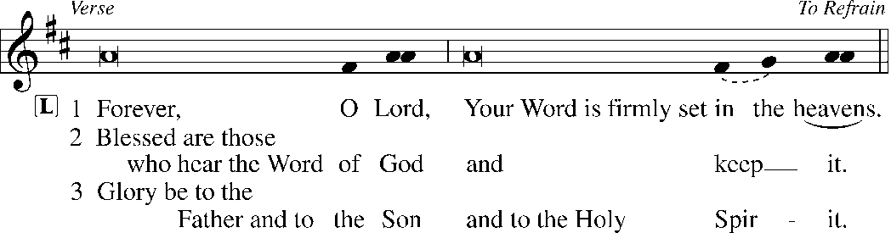
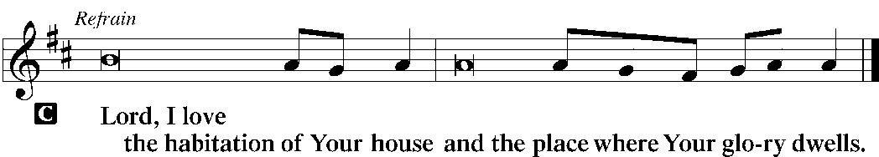
HYMN OF THE DAY |  | LSB 842 Son of God, Eternal Savior
SERMON
CANTICLE | Te Deum |  | LSB p. 223
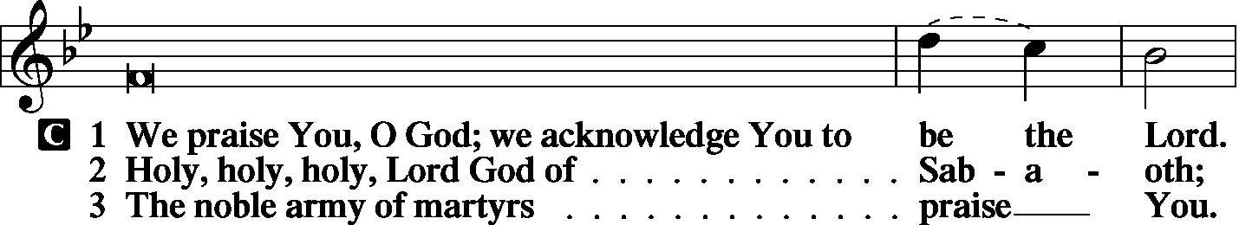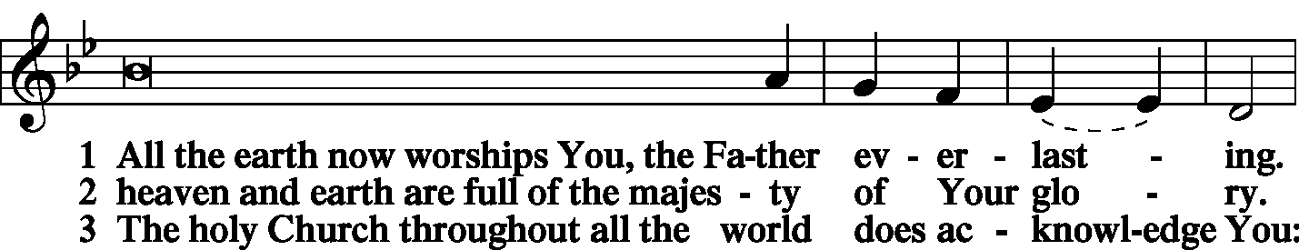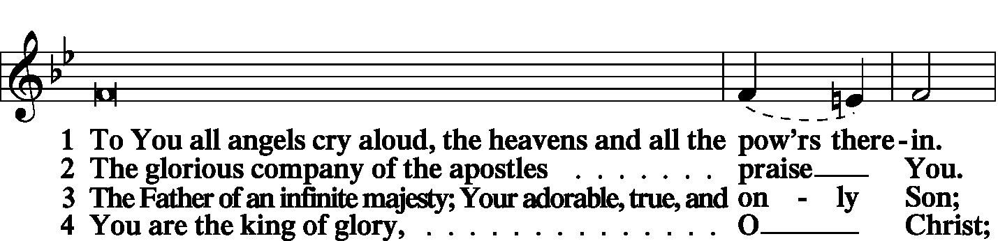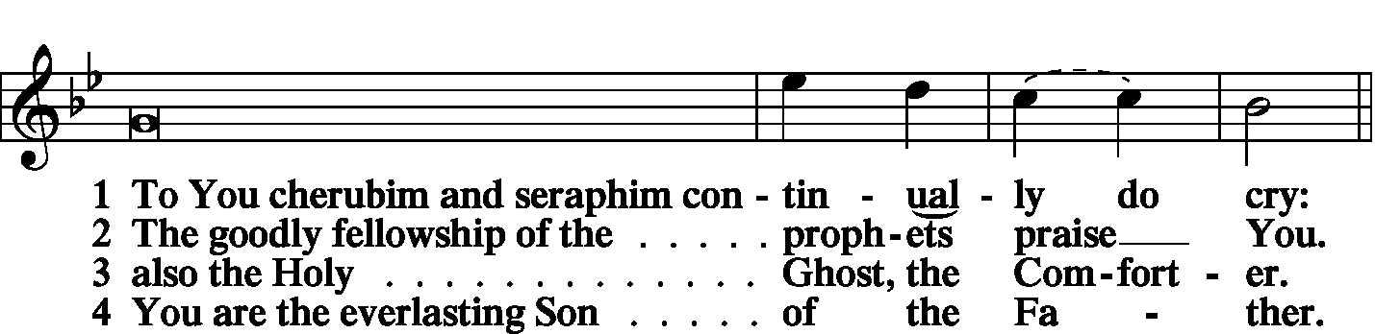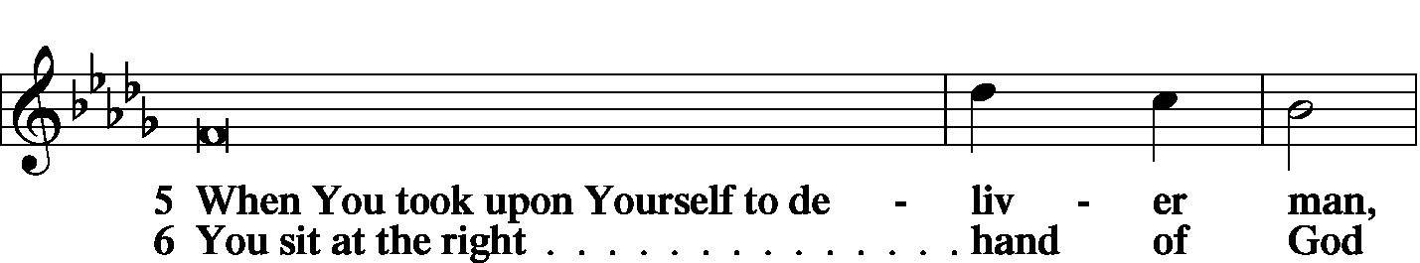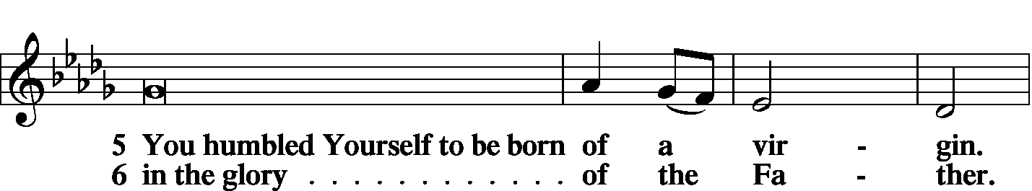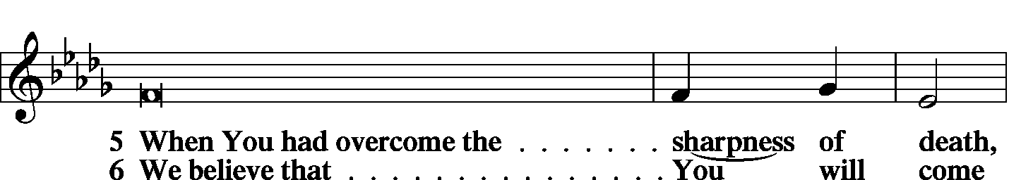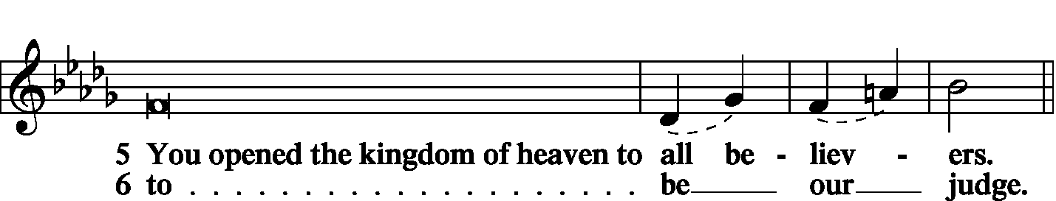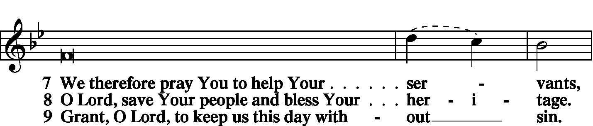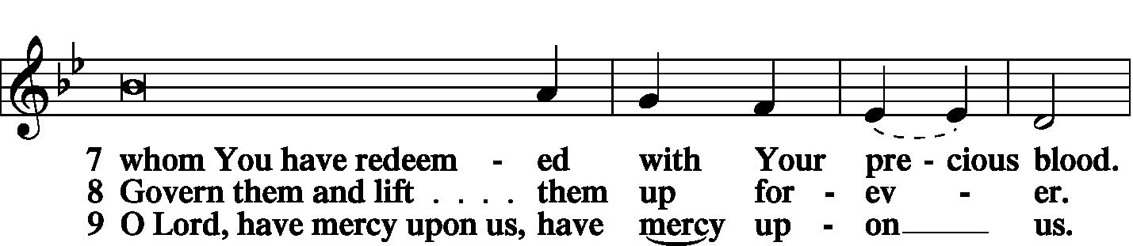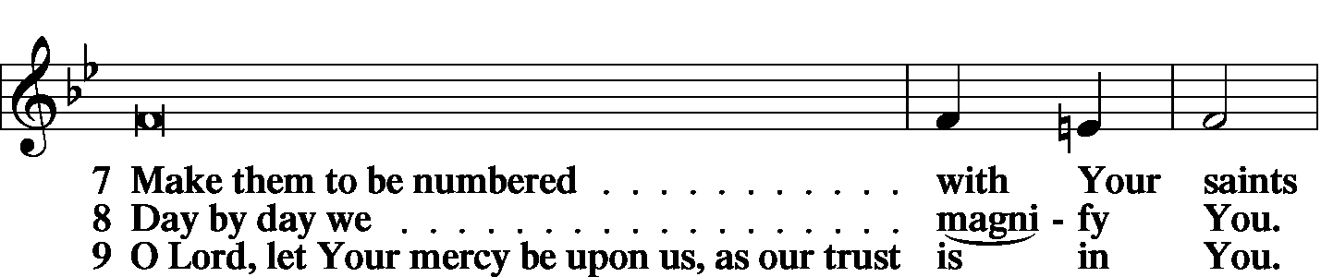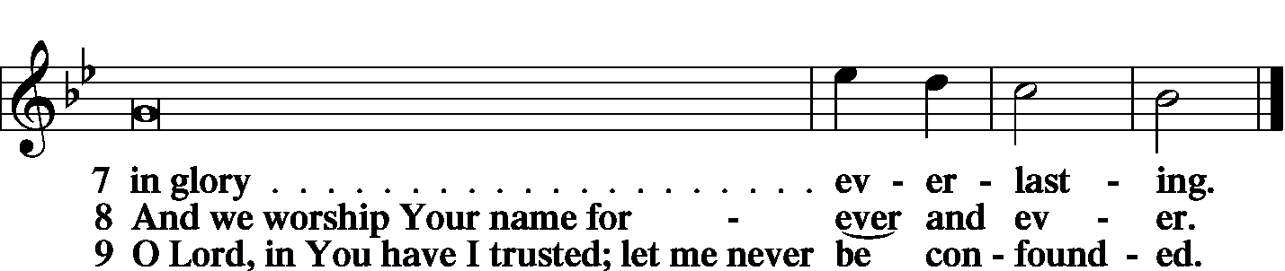
PRAYER OF THE CHURCH | LSB p. 227
KYRIE
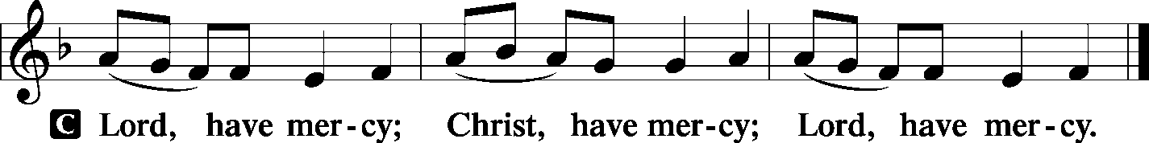
LORD’S PRAYER
C: | Our Father Who art in heaven, hallowed be Thy name, Thy kingdom come, Thy will be done on earth as it is in heaven; give us this day our daily bread; and forgive us our trespasses as we forgive those who trespass against us; and lead us not into temptation, but deliver us from evil. For Thine is the kingdom and the power and the glory forever and ever. Amen.
COLLECTS
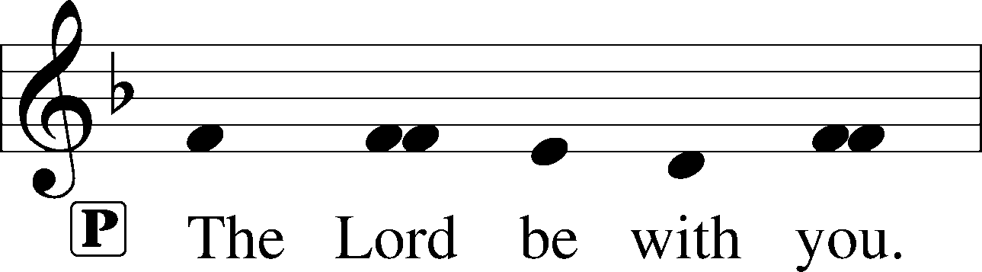
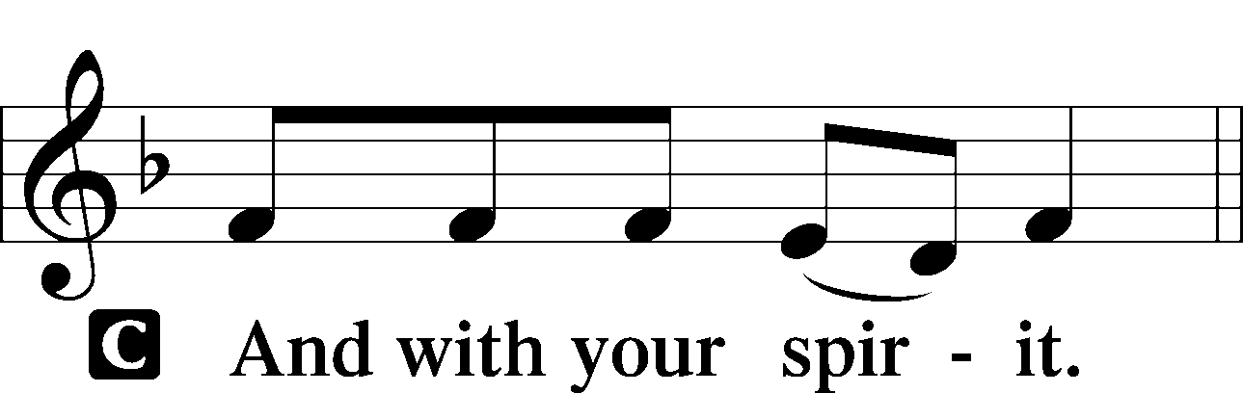
 | Collect of the Day
P: | O God, our refuge and strength, the author of all godliness, hear the devout prayers of Your Church, especially in times of persecution, and grant that what we ask in faith we may obtain; through Jesus Christ our Lord.


 | Collect for Matins
P: | Almighty God, heavenly Father, Your mercies are new to us every morning, and You abundantly provide for all our wants of body and soul. Give us we humbly pray, Your Holy Spirit that we may heartily acknowledge Your merciful goodness toward us, give thanks for all Your benefits, and cheerfully serve You.
For Guidance in Our Calling |  | LSB p. 311
P: | Lord God, You have called Your servants to ventures of which we cannot see the ending, by paths as yet untrodden, through perils unknown. Give us faith to go out with good courage, not knowing where we go but only that Your hand is leading us and Your love supporting us; through Jesus Christ, our Lord.

For Responsible Citizenship |  | LSB p.313
P: | Lord, keep this nation under Your care. Bless the leaders of our land that we may be a people at peace among ourselves and a blessing to the other nations of the earth. Grant that we may choose trustworthy leaders, contribute to wise decisions for the general welfare, and serve You faithfully in our generation; through Jesus Christ, our Lord.

 | Collect for Grace
P: | O Lord, our heavenly Father, almighty and everlasting God, You have safely brought us to the beginning of this day. Defend us in the same with Your mighty power and grant that this day we fall into no sin, neither run into any kind of danger, but that all our doings, being ordered by Your governance, may be righteous in Your sight; through Jesus Christ, Your Son, our Lord, Who lives and reigns with You and the Holy Spirit, one God, now and forever.
BENEDICAMUS |  | LSB p. 227
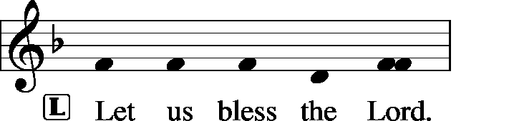
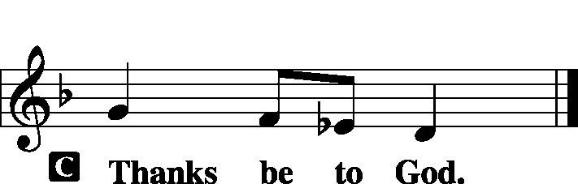
BENEDICTION
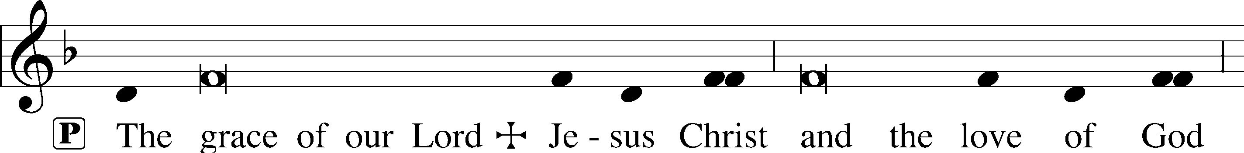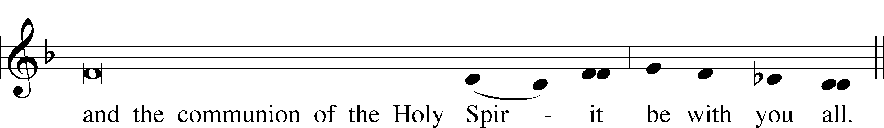
CLOSING HYMN |  | LSB 845 Where Charity and Love Prevail
SILENT PRAYER
 | Almighty and merciful God, I have again worshiped in Your presence and received both forgiveness for my many sins and the assurance of Your love in Jesus Christ. I thank You for this undeserved grace and ask You to keep me in faith until, with all Your saints, I inherit eternal salvation; through Jesus Christ, my Lord. Amen.
T T T

Pastor: The Rev. Barry Long
Elder: Phil King
Organ: Carol Wessler

Acknowledgments
Matins from Lutheran Service Book
Unless otherwise indicated, all scripture quotations are from The Holy Bible, English Standard Version, copyright © 2001 by Crossway Bibles, a division of Good News Publishers. Used by permission. All rights reserved.
Created by Lutheran Service Builder © 2026 Concordia Publishing House.

